Module2

Ques 1

Already done selecting source file

------------------------------------------------------------------------------------------------------------------------------------------

Ques 2

CREATE TABLE "hffhf"."PRODUCTS_99"

( "ROW_ID" NUMBER(10,0) NOT NULL ENABLE,

"PRODUCT_ID" VARCHAR2(50 BYTE),

"CATEGORY" VARCHAR2(50 BYTE),

"SUB CATEGORY" VARCHAR2(50 BYTE),

"PRODUCT NAME" VARCHAR2(100 BYTE),

"SALES" NUMBER(35,10),

"QUANTITY" NUMBER(10,0),

"DISCOUNT" NUMBER(10,0)

)

CREATE TABLE "wewew"."ORDERS_99"

( "ROW_ID" NUMBER(10,0) NOT NULL ENABLE,

"ORDER_ID" VARCHAR2(50 BYTE),

"ORDER_DATE" DATE,

"SHIP_DATE" DATE,

"SHIP_MODE" VARCHAR2(50 BYTE),

"CUSTOMER_ID" VARCHAR2(50 BYTE),

"CUSTOMER_NAME" VARCHAR2(50 BYTE),

"SEGMENT" VARCHAR2(50 BYTE),

"COUNTRY" VARCHAR2(50 BYTE),

"CITY" VARCHAR2(50 BYTE),

"STATE" VARCHAR2(50 BYTE),

"POSTAL_CODE" NUMBER(10,0),

"REGION" VARCHAR2(50 BYTE)

Ques 3

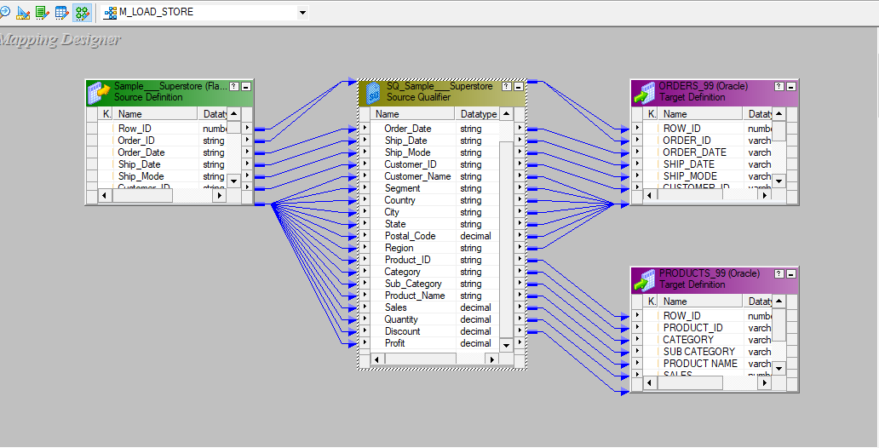

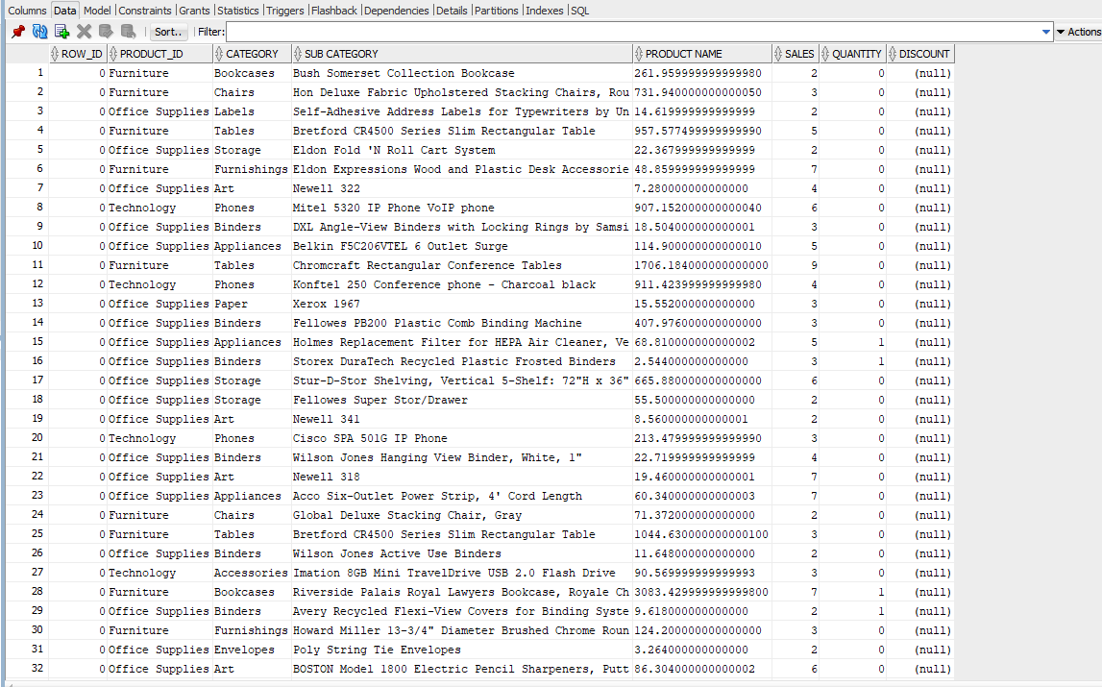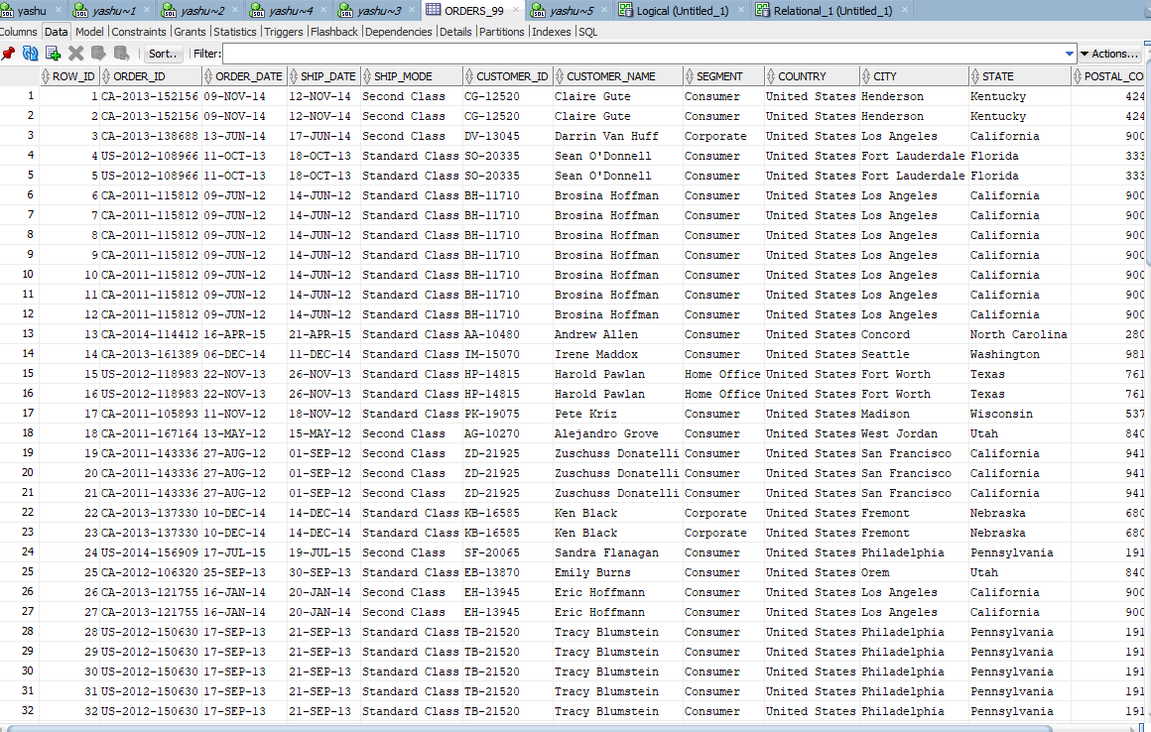

Ques 4

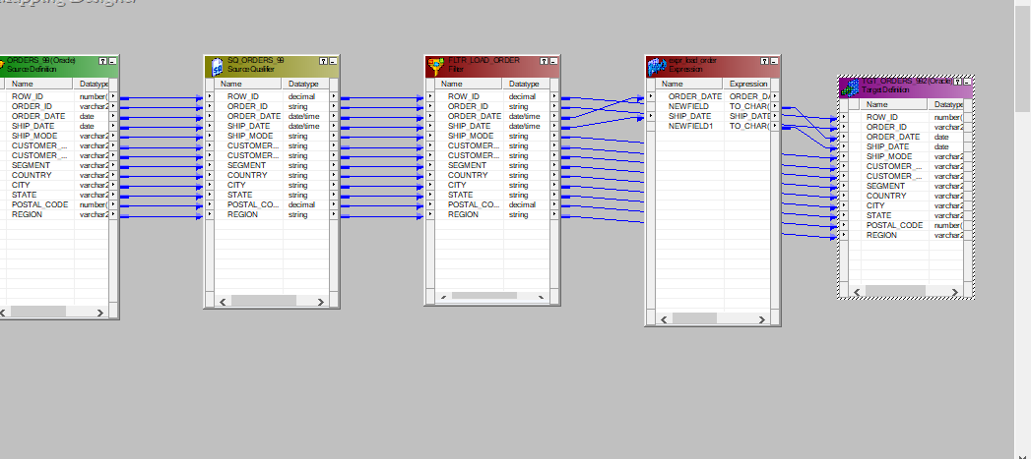

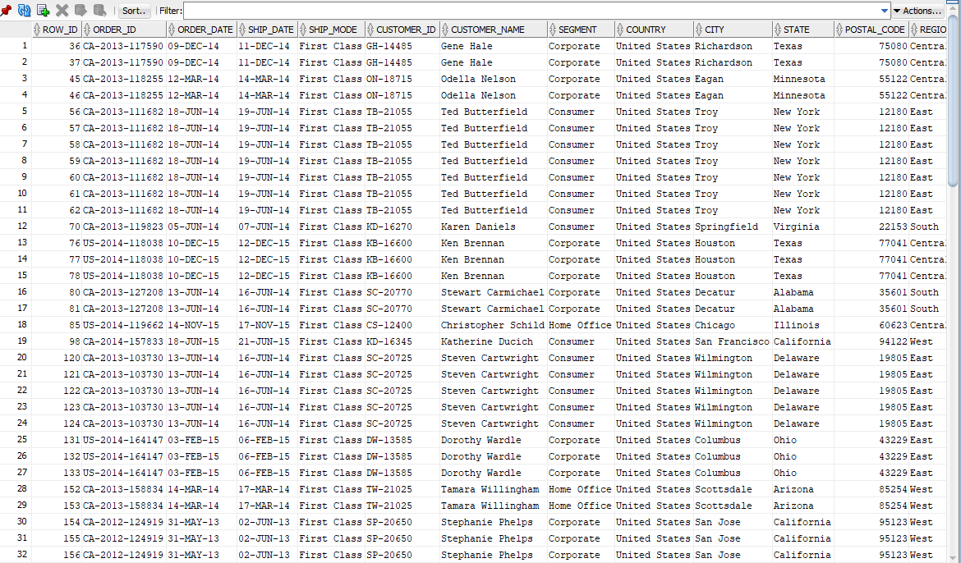

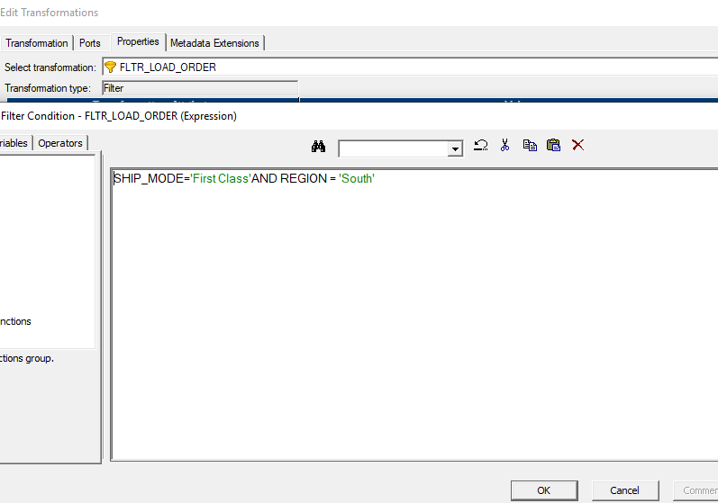

Ques 5

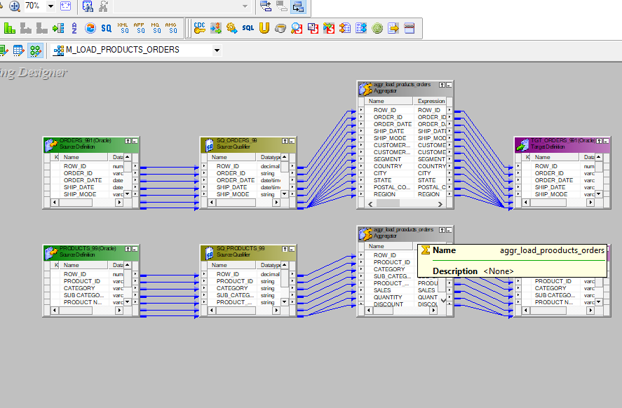

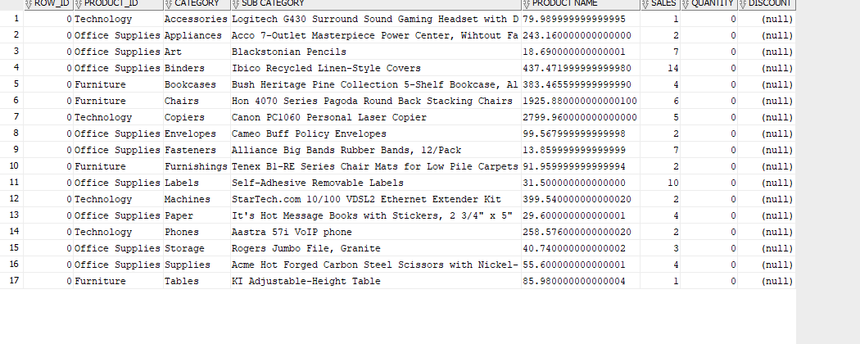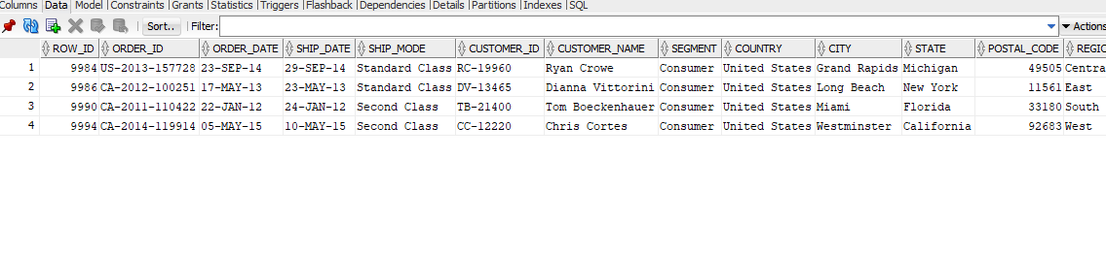

Ques 6

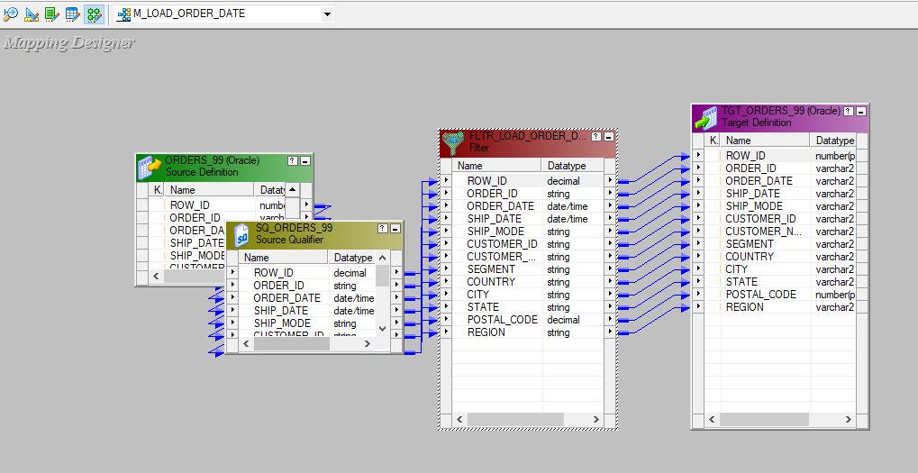



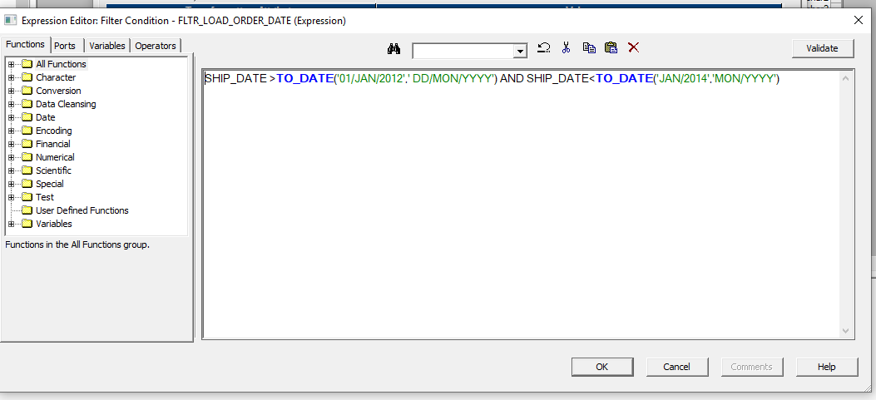

Ques 7

