🧪 VWO A/B Testing Platform –

Test Plan
📅 Date: May 03, 2025
✍️ Prepared by: Sireesha Mudili

1. Objective
- To validate the functional, non-functional, and integration quality of app.vwo.com’s A/B testing platform.
- Ensure accurate reporting, stable campaign management, and reliable integrations.
- Success Criteria: 95% test pass rate, response time <2s for major workflows, zero Sev1/Sev2 defects in production.
- Stakeholder Expectations: Deliver an intuitive, accurate experimentation platform supporting marketing, product, and customer success goals.

2. Scope
**In Scope:**
- Core functionalities: Project creation, Variant creation, Campaign activation, Result reporting.
- Integrations: Google Analytics, Tag Managers.
- Device/Browser coverage (see Section 5)
**Out of Scope:**
- Backend infrastructure testing (owned by DevOps)
- Third-party services beyond integration touchpoints

3.Inclusions
Introduction: This section would provide an overview of the test plan, including its purpose, scope, and goals.

Test Objectives: This section would outline the specific objectives of the testing, such as identifying and fixing defects, improving the user experience, or achieving a certain level of performance.

- Login
- Dashboard Page
- Create Account

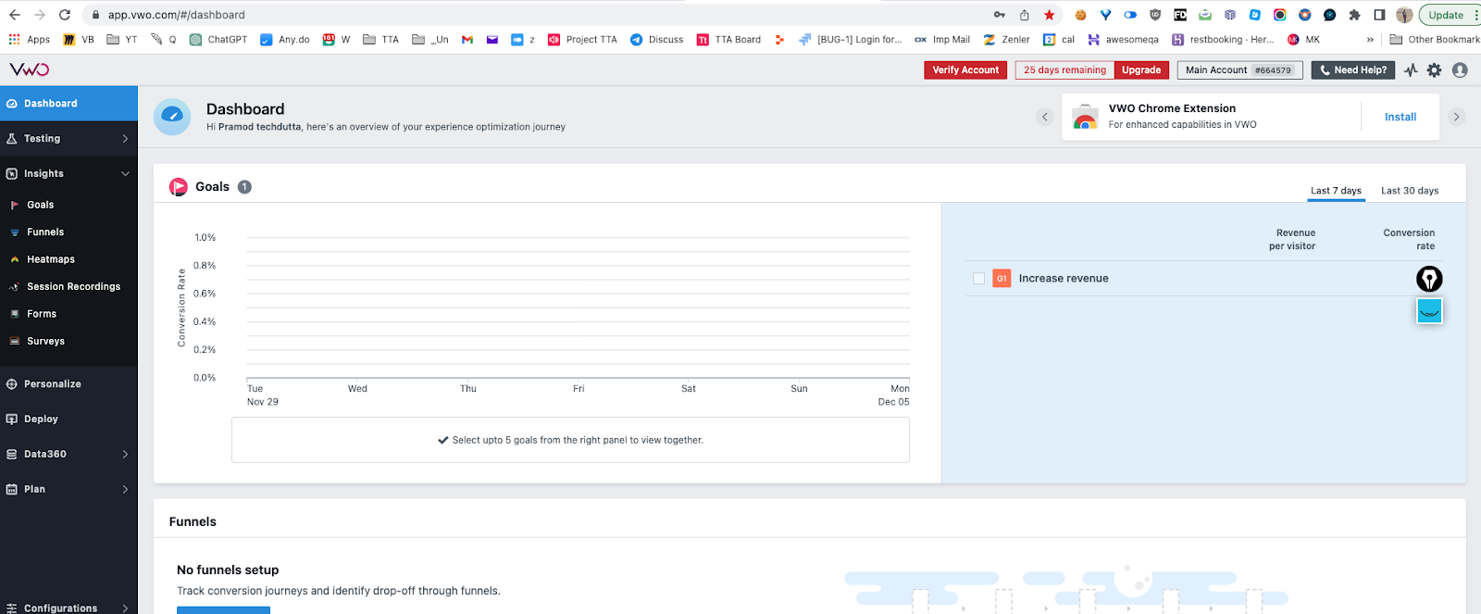

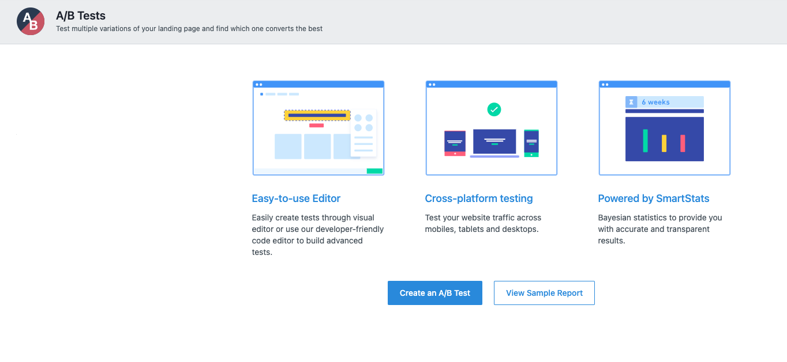

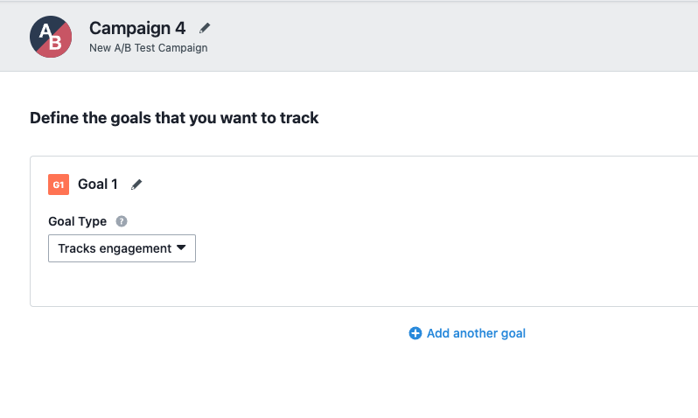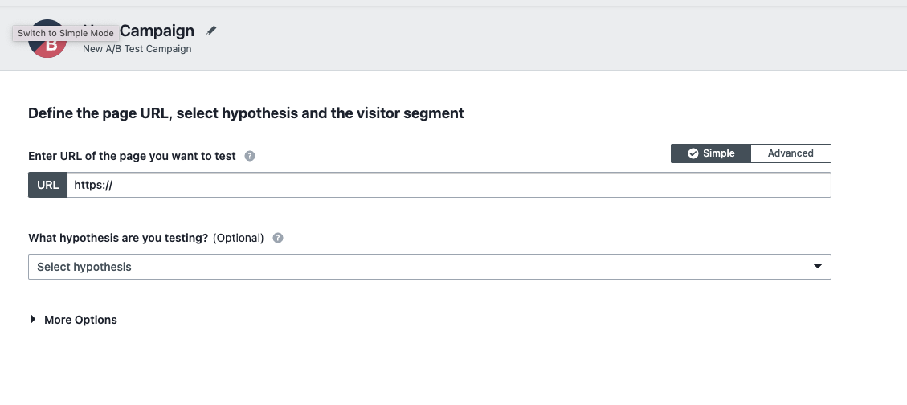

Exclusion
- Support Page
- Support Widget - ZOHO chat

4. Test Environments

The operating systems and versions that will be used for testing, such as Windows 10, macOS, or Linux.

The browsers and versions that will be tested, such as Google Chrome, Mozilla Firefox, or Microsoft Edge.
The device types and screen sizes that will be used for testing, such as desktop computers, laptops, tablets, and smartphones.

The network connectivity and bandwidth that will be available for testing, such as Wi-Fi, cellular, or wired connections.

The hardware and software requirements for running the test cases, such as a specific processor, memory, or storage capacity.

The security protocols and authentication methods that will be used to access the test environment, such as passwords, tokens, or certificates.

The access permissions and roles of the team members who will be using the test environment, such as testers, developers, or stakeholders.

Name | Env url
QA | qa.vwo.com
Pre Prod | preprod.vwo.com
UAT | uat.vwo.com
Prod | app.vwo.com

Windows 10 – Chrome, Firefox and Edge
• Mac OS – Safari Browser
• Android Mobile OS – Chrome
• iPhone Mobile OS - Safari

5. Defect Reporting Procedure

The criteria for identifying a defect, such as deviation from the requirements, user experience issues, or technical errors.

The steps for reporting a defect, such as using a designated template, providing detailed reproduction steps, and attaching screenshots or logs.

The process for triaging and prioritizing defects, such as assigning severity and priority levels, and assigning them to the appropriate team members for investigation and resolution.

The tools and systems that will be used for tracking and managing defects, such as a defect tracking software or a project management tool.

The roles and responsibilities of the team members involved in the defect reporting process, such as testers, developers, and the test lead.

The communication channels and frequencies for updating stakeholders on the progress and status of defects.

The metrics and metrics that will be used to measure the effectiveness of the defect reporting process, such as the number of defects found, the time taken to resolve them, and the percentage of defects that were successfully fixed.
Tools - JIRA

6. Test Strategy
- Functional Testing: Manual (TestRail)
- Automation Testing:
- Selenium (UI)
- REST Assured (API)
- Allure (Reporting)
- Performance Testing: JMeter (Load Testing 1000 concurrent users)
- Accessibility Testing: Axe, WCAG 2.1 compliance
- Security Testing:
- SQL Injection, XSS testing
- Session management and token expiry tests

7. Test Schedule
Following is the test schedule planned for the project –
Task Time Duration

Task | Dates
▪ Creating Test Plan
▪ Test Case Creation
▪ Test Case Execution
▪ Summary Reports Submission Date

8. Test Deliverables

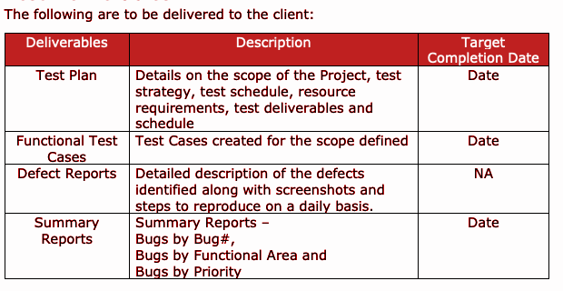

9. Entry and Exit Criteria
**Entry:** Signed-off requirements, stable test environment, test data available
**Exit:** 95% test cases passed, no Sev1/Sev2 open defects, stakeholder sign-off

10. Tools
- Test Management: TestRail
- Automation: Selenium, REST Assured
- Performance: JMeter
- Accessibility: Axe
- Reporting: Allure, Confluence
- Communication: Slack, Zoom
- Defect Tracking: JIRA

11. Risks and Mitigation

The following are the list of risks possible and the ways to mitigate them:
Risk: Non-Availability of a Resource
Mitigation: Backup Resource Planning
Risk: Build URL is not working
Mitigation: Resources will work on other tasks
Risk: Less time for Testing
Mitigation: Ramp up the resources based on the Client needs dynamically

12. Approvals

Team will send different types of documents for Client Approval like below:
• Test Plan
• Test Scenarios
• Test Cases
• Reports
Testing will only continue to the next steps once these approvals are done

