IMPLEMENTATION APPROACH EBOOK
From Contract to Go-Live in Weeks: A Proven Methodology for Healthcare RCM Technology Success

TABLE OF CONTENTS
Page 1: Cover & Introduction
Pages 2-3: Chapter 1 - Why Healthcare Technology Implementations Fail (And How to Avoid It)
Pages 4-7: Chapter 2 - The CognitiveHealth Implementation Methodology
Pages 8-9: Chapter 3 - Integration Without the Headaches
Pages 10-11: Chapter 4 - Real Customer Success Stories
Pages 12-13: Chapter 5 - Your Pre-Go-Live Readiness Checklist
Pages 14-15: Chapter 6 - Measuring Success & Continuous Optimization

PAGE 1: COVER & INTRODUCTION
From Contract to Go-Live in Weeks
A Proven Methodology for Healthcare RCM Technology Success

How to deploy AI-powered revenue cycle automation without the pain, cost, and risk of traditional implementations
![CognitiveHealth Logo]
CognitiveHealth Implementation Guide
15 Pages • 2026 Edition

INTRODUCTION
If you're reading this guide, you've likely experienced the frustration of healthcare technology implementations that:
- Take 12-18 months instead of the promised 3-6 months
- Cost 2-3X the original budget
- Require armies of consultants and IT resources
- Disrupt operations for months
- Fail to deliver the promised ROI
You're not alone. According to industry research, 60-70% of healthcare IT implementations fail to meet their objectives, go over budget, or are abandoned entirely.
But it doesn't have to be this way.
Over the past decade, CognitiveHealth has refined an implementation methodology that gets healthcare organizations operational in 4-6 weeks instead of 12-18 months—with lower risk, lower cost, and faster time to value.
This guide shares our proven approach, real customer experiences, and practical checklists you can use to ensure your next technology implementation succeeds.
What You'll Learn:
✓ Why healthcare implementations fail and how to avoid common pitfalls
✓ Our 5-phase implementation methodology with week-by-week timelines
✓ Integration best practices that eliminate months of custom development
✓ Real customer stories with actual timelines and results
✓ Pre-go-live checklist to ensure readiness
✓ How to measure success and optimize continuously
Whether you're evaluating CognitiveHealth or any other revenue cycle technology, these principles will help you achieve implementation success.
Let's get started.

PAGES 2-3: CHAPTER 1
Why Healthcare Technology Implementations Fail (And How to Avoid It)

The Ugly Truth About Healthcare IT Implementations
Industry Statistics:
- 68% of healthcare IT projects exceed their budgets
- 54% take longer than planned
- 41% fail to deliver expected ROI
- 23% are abandoned before completion
Average Implementation Timeline:
- Promised: 6 months
- Reality: 14-18 months
- CognitiveHealth: 4-6 weeks

The Five Most Common Failure Patterns
1. Integration Complexity Underestimated
The Problem:
"We'll just connect to your EMR" sounds simple. In reality, healthcare integrations are incredibly complex
The Result:
60% of implementation time gets consumed by integration work. Projects stall for months waiting for IT resources. Custom development costs spiral.
The CognitiveHealth Difference:
200+ pre-built integrations with major EMRs, clearinghouses, and payers. We've already done the integration work—you benefit from our experience across hundreds of deployments.

2. Scope Creep & Requirements Inflation
The Problem:
Initial requirements are defined in sales process. During implementation, stakeholders realize: "Our process is unique—we need it to work differently"
As the project drags on, business needs evolve. By month 12, you're implementing solutions to problems that didn't exist when you started.
The Result:
Projects that were scoped for 6 months stretch to 18+ months. Budgets double or triple. Teams burn out. Implementation becomes the goal instead of business outcomes.
The CognitiveHealth Difference:
Pre-configured workflows based on industry best practices cover 90% of use cases out of the box. Phased deployment approach—start with core workflows, add complexity later. Get to ROI fast, then optimize.

3. Resource Exhaustion
The Problem:
Healthcare organizations are already stretched thin. Implementation projects require resources for from different departments for different phases, from IT to executive time.
When implementations drag on for 12-18 months, teams burn out. People leave. New priorities emerge. The implementation that seemed critical 18 months ago feels less important now.
The Result:
Projects lose momentum. Executive sponsors move on to other priorities. Implementation teams become demoralized. The vendor gets blamed for delays even when it's resource constraints.
The CognitiveHealth Difference:
4-6 week implementation timeline means your team stays engaged. Fast time-to-value maintains executive sponsorship. Quick wins build momentum instead of exhaustion.

4. Big Bang vs Phased Approach
The Problem:
Traditional vendors push for "big bang" implementations: Turn off old system and turn on new system
This creates enormous risk: If anything goes wrong, entire operation is down
The Result:
Organizations delay go-live because the risk is too high. When they finally flip the switch, inevitable issues create chaos. Staff lose confidence. Some organizations go back to old systems.
The CognitiveHealth Difference:
Risk-mitigated phased approach. Start with one workflow (e.g., payment posting). Validate success. Build confidence. Then expand to additional workflows. Each phase takes 2-4 weeks. You see results quickly while limiting risk.

5. Vendor Over-Promises & Under-Delivers
The Problem:
Sales process: "Yes, we can do that. Absolutely. No problem."
Implementation reality: "That's not in scope. That requires custom development. That will cost extra. That wasn't in the contract."
The Result:
Finger-pointing between customer and vendor. Legal gets involved. Relationships deteriorate. Even if the project completes, it's viewed as a failure by the organization.
The CognitiveHealth Difference:
We're RCM veterans who've lived your challenges. We don't over-promise because we know what works and what doesn't. Our sales team is held accountable for realistic scoping. Implementation team has authority to escalate if sales made commitments we can't deliver.

The Implementation Success Formula
Based on hundreds of successful deployments, we've identified the key factors that determine implementation success:
Success = (Pre-Built Integrations × Phased Approach × Executive Sponsorship)
/ (Scope Creep + Resource Constraints + Vendor Promises Gap)
Maximize the numerator:
- Use pre-built integrations instead of custom development
- Deploy in phases instead of big bang
- Maintain executive sponsorship with quick wins
Minimize the denominator:
- Control scope with phased approach
- Reduce resource needs with short timelines
- Set realistic expectations from day one
The rest of this guide shows you exactly how to do this.

PAGES 4-7: CHAPTER 2
The CognitiveHealth Implementation Methodology

Overview: Five Phases in 6-8 Weeks
Our methodology is designed to get you operational fast while minimizing risk and maximizing adoption:
Phase 1: Discovery & Planning (Week 1-2)
Phase 2: Configuration & Integration (Week 3-4)
Phase 3: Testing & Training (Week 5-6)
Phase 4: Go-Live & Hypercare (Week 7-8)
Phase 5: Optimization & Scaling (Month 3+)

PHASE 1: Discovery & Planning (Week 1-2)
Objectives:
- Understand current-state workflows and pain points
- Define integration requirements and technical architecture
- Establish success metrics and baselines
- Create detailed project plan with clear ownership

Week 1: Discovery Sessions
Day 1-2: Executive Kickoff & Strategic Alignment
Participants: Executive sponsor, CFO, VP Revenue Cycle, CIO, CognitiveHealth leadership
Topics Covered:
- Strategic objectives for automation initiative
- Success criteria and how they'll be measured
- Organizational readiness assessment
- Change management approach
- Governance structure and decision-making authority
- Communication plan
Deliverables:
- Project charter document
- Success metrics defined with baseline measurements
- Governance structure (steering committee, working team, escalation paths)

Day 3-4: Operational Deep Dive
Participants: RCM managers, billing supervisors, IT technical leads, CognitiveHealth implementation team
Topics Covered:
Payment Posting Workflow: Example workflow
- Current payment sources (ERA, EOB, patient payments, lockbox)
- Posting process and exception handling
- Reconciliation procedures
- Pain points and workarounds
Deliverables:
- Current-state workflow documentation
- Pain point inventory with impact quantification
- Quick win opportunities identified

Day 5: Technical Architecture Session
Participants: IT architects, EMR administrators, interface team, CognitiveHealth integration specialists
Topics Covered:
- EMR/PM system architecture and interfaces
- Existing HL7 feeds and integration points
- Clearinghouse connectivity
- Payer portal access and credentials
- Network topology and security requirements
- Data flow and system dependencies
Deliverables:
- Integration architecture diagram
- Data mapping specifications
- Security and compliance requirements documented

Week 2: Planning & Configuration Design
Implementation Planning:
- Detailed project timeline with milestones
- Resource allocation (your team and ours)
- Risk identification and mitigation strategies
- Communication plan and stakeholder matrix
Configuration Design:
- Workflow configurations customized to your processes
- User roles and permissions structure
- Business rules and validation logic
- Report and dashboard requirements
- Alert and notification setup
Testing Strategy:
- Test scenarios covering core and edge cases
- Test data preparation requirements
- User acceptance testing plan
- Go-live readiness criteria
Training Plan:
- Training audience identification (executives, managers, end users)
- Role-based training curriculum
- Training schedule and logistics
- Train-the-trainer approach for ongoing support
Deliverables:
- Comprehensive implementation plan (Gantt chart with owners and dates)
- Configuration specifications document
- Testing strategy and test case library
- Training plan and materials outline

Your Time Investment (Week 1-2):
- Executives: 4-6 hours (kickoff, reviews, approvals)
- RCM Leadership: 15-20 hours (discovery sessions, planning, reviews)
- IT Team: 10-15 hours (technical sessions, architecture review)
- End Users: 2-3 hours (workflow interviews)

PHASE 2: Configuration & Integration (Week 3-4)
Objectives:
- Configure platform to match your workflows and requirements
- Establish integrations with EMR, clearinghouse, payers, and other systems
- Build and populate test environment
- Prepare for user acceptance testing

Week 3: Environment Setup & Configuration
Production & Test Environments:
- Day 1: Provision dedicated customer environment (cloud or on-prem based on deployment model)
- Day 2: Configure system settings (facility information, payer setup, user hierarchy)
- Day 3: Build workflows based on configuration specifications
- Day 4: Configure user roles and permissions
- Day 5: Set up reports, dashboards, and alerts
Security Configuration:
- Single Sign-On (SSO) integration if applicable
- Multi-factor authentication setup
- VPN or secure connectivity if on-premises
- Audit logging and compliance settings
Your Involvement:
- Review and approve configurations
- Provide facility/payer master data
- User list with role assignments
- Approve security settings

Week 4: Integration Development & Testing ( As applicable for the workflow)
EMR/PM Integration:
- Day 1-2: Configure HL7 or FHIR interfaces using pre-built connectors or UI based service agents
- Day 3: Set up patient demographic feeds (ADT messages) as needed
- Day 4: Configure charge/transaction feeds (DFT messages) or file transfers via FTP
- Day 5: Test bidirectional communication
Clearinghouse Integration:
- Configure claim submission and ERA retrieval
- Set up payer enrollment and connectivity
- Test claim file generation and submission
- Validate ERA processing and payment posting
Payer Portal Integration:
- Configure automated portal access for eligibility and status checks
- Set up credential management (secure credential storage)
- Test portal navigation and data extraction
Banking/Lockbox Integration:
- Configure bank file feeds (BAI/BAI2 format)
- Set up lockbox file processing if applicable
- Test payment file reconciliation
Integration Testing:
- Unit testing of each integration point
- End-to-end testing of data flows
- Error handling and retry logic validation
- Performance testing with production-like volumes
Deliverables:
- Fully configured production and test environments
- All integrations operational and tested
- Integration testing report with results
- Environment handoff to your team for UAT

Your Time Investment (Week 3-4):
- IT Team: 10-15 hours (integration testing, troubleshooting, validation)
- RCM Leadership: 5-8 hours (configuration reviews, approvals)
- End Users: 0 hours (not yet involved)

PHASE 3: Testing & Training (Week 5-6)
Objectives:
- Validate platform functionality through user acceptance testing
- Train all user groups on their respective roles
- Document procedures and create reference materials
- Prepare for go-live

Week 5: User Acceptance Testing (UAT)
UAT Planning:
- Kick off UAT with testing team (superusers from each department)
- Review test scenarios and expected outcomes
- Set up test schedule and reporting structure
Test Execution:
Payment Posting Scenarios:
- Post ERA files with various payment types
- Handle partial payments and adjustments
- Process patient payments and refunds
- Reconcile batch totals
- Handle exceptions and variances
Edge Cases & Exception Handling:
- How system handles data quality issues
- Escalation workflows for low-confidence AI decisions
- Manual override procedures
- Error recovery and retry logic
UAT Tracking:
- Test case execution tracking (pass/fail/blocked)
- Issue log with priority and assignments
- Daily standup meetings to review progress
- Resolution of defects and retesting
Deliverables:
- UAT completion report (test cases passed)
- Issue resolution log (all critical issues closed)
- UAT sign-off from business owners

Some visual like below – please change with cognitive logo
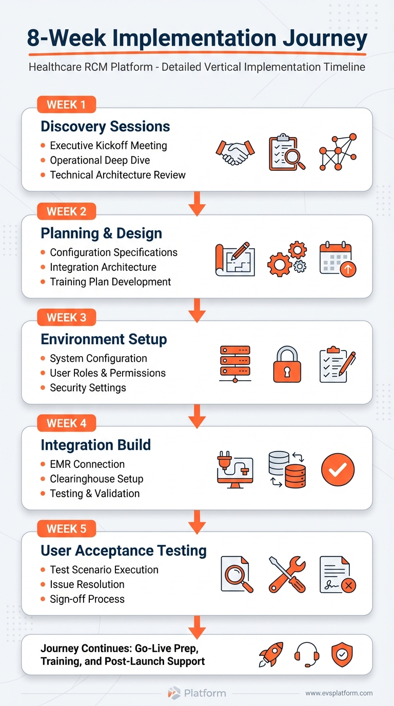

Week 6: Training & Documentation
Training Programs:
Executive Overview (1 hour webinar):
- Platform overview and strategic value
- Success metrics and ROI tracking
- Rollout plan and communication strategy
- How to access executive dashboards
Administrator Training (4 hours, hands-on):
- System configuration and settings
- User management and role assignments
- Report builder and dashboard creation
- Troubleshooting and support procedures
Operational Manager Training (3 hours, hands-on):
- Workflow monitoring and queue management
- Exception handling and decision support
- Performance analytics and trending
- Team productivity tracking
End User Training (2 hours, hands-on):
- Daily task processing
- System navigation and workflows
- Quality checks and validation
- How to escalate issues
Documentation Delivery:
- User Guides: Role-based step-by-step instructions
- Quick Reference Cards: 1-page cheat sheets for common tasks
- FAQs: Answers to common questions
- Process Maps: Visual workflow diagrams
Training Validation:
- Post-training assessments (quiz or practical exercise)
- Certification for power users
- Identification of users needing additional support
Deliverables:
- All users trained and certified
- Documentation library published
- Training attendance and assessment records
- Go-live support team identified

Your Time Investment (Week 5-6):
- Testing Team: 20-30 hours (UAT execution)
- Managers: 10-15 hours (UAT review, training)
- End Users: 2-4 hours (training)
- Executives: 1 hour (executive overview)

PHASE 4: Go-Live & Hypercare (Week 7-8)
Objectives:
- Execute phased go-live with minimal disruption
- Provide intensive support during transition period
- Monitor performance and address issues rapidly
- Validate success metrics

Week 7: Phased Go-Live
Go-Live Strategy Options:
Option A: By Workflow (Recommended)
- Day 1-2: Payment posting only
- Day 3-4: Add eligibility verification
- Day 5+: Add denial management, then claims processing
Option B: By Volume
- Day 1-2: Process 10% of volume
- Day 3-4: Increase to 50% of volume
- Day 5+: Process 100% of volume
Option C: Parallel Processing
- Run new system alongside old system for validation
- Compare results before fully transitioning
- Higher resource requirement but lower risk
Pre-Go-Live Checklist Review:
- All integrations tested and validated ✓
- UAT completed and signed off ✓
- All users trained and certified ✓
- Documentation published and accessible ✓
- Support team ready and briefed ✓
- Rollback plan documented ✓
- Communication sent to all stakeholders ✓
Go-Live Day:
Morning (6am-12pm):
- Final environment checks
- Data synchronization validation
- Integration connectivity verification
- Go-live decision checkpoint
Afternoon (12pm-6pm):
- Begin processing first workflow
- Monitor system performance in real-time
- Rapid issue resolution
- User support via dedicated hotline
Evening (6pm-10pm):
- End-of-day reconciliation
- Issue log review
- Day 2 planning adjustments
Go-Live Support:
- CognitiveHealth team on-site or available via video
- Dedicated hotline with <15 minute response
- Real-time performance monitoring
- Issue triage and rapid resolution

Week 8: Hypercare & Stabilization
Hypercare Activities:
Daily Standups (15 minutes):
- Review previous 24 hours performance
- Issue log review and prioritization
- Today's focus areas and action items
- Escalations if needed
Performance Monitoring:
- Volume metrics: Transactions processed, throughput rates
- Quality metrics: Error rates, exception volumes, accuracy
- User metrics: Login activity, task completion times
- Business metrics: Clean claim rates, posting accuracy, denial rates
Issue Management:
- Rapid response to user-reported issues
- Root cause analysis for recurring problems
- Workaround documentation while permanent fixes are implemented
- Issue resolution tracking and communication
Optimization:
- Configuration tuning based on actual usage patterns
- Workflow adjustments based on user feedback
- Performance optimization for high-volume processes
- Additional training for users struggling with specific tasks
Weekly Checkpoint (End of Week 8):
- Performance metrics review vs baseline
- UAT success criteria validation
- User satisfaction survey
- Decision to transition to steady-state support
Deliverables:
- Successful go-live with target workflows operational
- Performance metrics meeting success criteria
- Issue resolution log (all critical items closed)
- Hypercare completion report

Your Time Investment (Week 7-8):
- Leadership: 10-15 hours (go-live oversight, daily standups, issue resolution)
- End Users: Normal operational hours (using new system)
- Superusers: Additional 5-10 hours (peer support)

PHASE 5: Optimization & Scaling (Month 3+)
Objectives:
- Continuously improve performance based on data insights
- Expand to additional workflows or facilities
- Achieve long-term strategic objectives

Month 3: First Business Review
Performance Review:
- Baseline vs current metrics comparison
- ROI calculation (cost savings, revenue recovery, efficiency gains)
- User adoption and satisfaction metrics
- Issue trends and resolution
Optimization Opportunities:
- Configuration adjustments based on usage patterns
- Workflow refinements to improve efficiency
- Training reinforcement for struggling users
- Advanced features ready for adoption
Expansion Planning:
- Next workflows to automate
- Additional facilities to onboard
- Advanced use cases to enable

Ongoing Partnership:
Monthly Check-Ins:
- Performance review
- Optimization recommendations
- New feature awareness
- Issue escalation if needed
Quarterly Business Reviews:
- Executive-level performance reporting
- ROI analysis and benchmarking
- Strategic planning for next quarter
- Product roadmap alignment
Annual Strategic Planning:
- Review year accomplishments
- Multi-year automation roadmap
- Technology strategy alignment
- Investment planning
Continuous Improvement:
- AI models continuously learning and improving
- Platform updates and new features deployed monthly
- Best practices sharing across customer base
- Proactive recommendations based on data

PAGES 10-11: CHAPTER 4
Real Customer Success Stories

CASE STUDY 1: Regional Health System
Customer Profile
Organization: 4,000-bed multi-facility health system
Facilities: 3 hospitals + 12 specialty clinics
EMR: Epic (all facilities)
Annual Claims: 8M claims, $2.5B in revenue
RCM Challenges:
- High denial rates (12%) due to manual processes
- 45 days average A/R
- Limited visibility across facilities
- Heavy reliance on offshore teams

Implementation Journey
Week 1-2: Discovery & Planning
- Challenge: Three-facility operation with decentralized RCM processes
- Discovery Focus: Map current-state workflows across all three facilities, identify variation and standardization opportunities
- Key Decisions:
  - Start with payment posting (highest volume, clearest ROI)
  - Pilot at one facility, expand to others after validation
Week 3-4: Configuration & Integration
- Epic Integration: Used pre-built Epic connector, configured for their specific modules (Resolute Professional Billing, Hospital Billing)
- Clearinghouse: Connected to Change Healthcare for ERA retrieval
- Banking: Integrated with JPMorgan for daily bank feed reconciliation
- Challenge Overcome: Epic had customized charge router—worked with their IT to map data flow
Week 5-6: Testing & Training
- UAT Focus: Payment posting accuracy, exception handling, reconciliation
- Training: 45 payment posting staff trained in two sessions (2 hours each)
- Super Users: Identified 5 champions to support ongoing adoption
Week 7-8: Go-Live & Hypercare
- Phased Approach:
  - Day 1-2: Process ERA files only (easiest, highest volume)
  - Day 3-5: Add EOB processing
  - Week 2: Add patient payments
- Hypercare: Daily standup calls for first 2 weeks, resolved 8 minor issues rapidly
- Success Metric: 93.8% of payments posted automatically by end of Week 2

Results After 6 Months
Financial Impact:
- $450K annual savings from reduced manual posting labor
- 26% faster cash application - reduced posting lag from 3-5 days to <1 day
- $180K recovered from variance detection and underpayment appeals
Operational Impact:
- Payment posting staff reduced from 45 to 12 - redeployed to denial management
- 99.7% posting accuracy - virtually eliminated manual posting errors
- Real-time cash visibility - CFO can see cash position anytime, anywhere
Staff Impact:
- Job satisfaction improved - staff moved from tedious data entry to strategic work
- Reduced turnover - payment posting had 40% annual turnover, now 15%
- Work from home enabled - entire team transitioned to remote without disruption

Expansion Plan
Month 7-8: Denial management automation
Month 9-10: Eligibility verification
Month 11-12: Pre-bill validation and coding support
Quote from CFO:
"We were skeptical about the 6-week timeline, our previous vendor took 18 months and still didn't deliver. CognitiveHealth proved it's possible to implement fast without sacrificing quality. The ROI exceeded our business case projections."

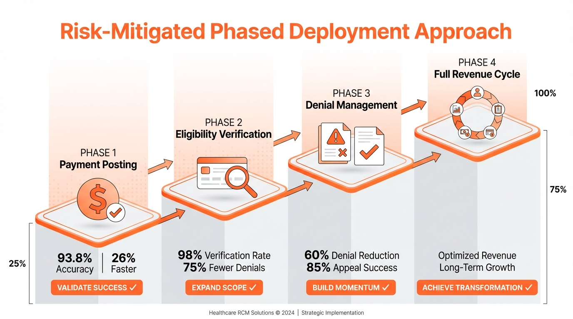

Common Success Patterns
Across all our customer implementations, we see consistent patterns:
✅ Quick Wins Build Momentum - Early success (Week 7-8) creates organizational excitement
✅ Phased Approach Reduces Risk - Start small, validate, expand with confidence
✅ Staff Become Champions - Once they experience time savings, staff become advocates
✅ Executive Sponsorship Sustained - Fast ROI maintains leadership support
✅ Expansion Happens Naturally - Success in one workflow leads to requests for more

Final Thoughts: Implementation is Just the Beginning
Getting the system operational in 4-6 weeks is exciting, but the real value comes from continuous optimization over months and years:
✅ Month 1-3: Focus on adoption and stability
✅ Month 4-6: Drive efficiency and quick wins
✅ Month 7-12: Expand capabilities and scale
✅ Year 2+: Transform organization and achieve strategic goals
The CognitiveHealth Commitment:
We're not just a software vendor - we're your long-term partner in revenue cycle transformation. Our Customer Success team is here to ensure you achieve and exceed your objectives.
Your success is our success.

Ready to Get Started?
If you're ready to experience implementation without the pain, cost, and risk of traditional approaches, we'd love to talk.
Next Steps:
- Schedule a Demo - See the platform in action
- Discuss Your Needs - Share your challenges and goals
- Review Implementation Plan - See how our methodology applies to you
- Begin Your Transformation - 4-6 weeks to operational
Contact Us:
📧 Email: [info@cognitivehealth.com]
📞 Phone: [(646) 701-5030]
🌐 Web: [www.cognitivehealthit.com]
📅 Schedule Demo: [calendar link]

From Contract to Go-Live in Weeks
Not months. Not years. Weeks.
CognitiveHealth: Healthcare RCM automation done right.
![CognitiveHealth Logo]
© 2026 CognitiveHealth Technologies. All rights reserved.

