Assignment 3: Understanding Algorithm Efficiency and Scalability
Introduction:
In this assignment, I would like to explain two important concepts: Randomized Quicksort and Hashing with Chaining. The main idea was to understand not just how these algorithms are implemented, but how they behave in real situations with different types of inputs.
Sometimes, an algorithm may look efficient in theory, but when we test it, the performance depends a lot on things like input order, number of elements, and how internal operations like pivot selection or collisions are handled. This assignment helped me connect both theory and practical behavior.

Part 1: Randomized Quicksort Analysis
1. Implementation Overview
For this part, I implemented two versions of quicksort:
- Deterministic Quicksort: - always picks the first element as pivot
- Randomized Quicksort: - picks a random element as pivot
The rest of the logic is the same in both cases. After selecting the pivot, the array is partitioned into two parts:
- Elements smaller than pivot
- Elements greater than pivot
Then the same process is applied recursively.
2. How Randomized Quicksort Works
In a normal quicksort, if the pivot choice is poor (for example always picking first element), the partitions can become very uneven. This causes deep recursion and increases time complexity.
In Randomized Quicksort, we select a random index as pivot. Because of this:
- The pivot is not dependent on input order
- Even if the array is already sorted, we don’t keep getting bad splits
- It avoids repeated worst-case behavior
So overall, it makes the algorithm more stable.
3. Time Complexity Explanation
The performance of quicksort depends on how balanced the partitions are.
- Best case → pivot divides array evenly → O(n log n)
- Average case (randomized) → still close to balanced → O(n log n)
- Worst case → very uneven split → O(n²)
For Randomized Quicksort, the average case is important because:
- Each pivot is chosen randomly
- Over multiple recursive calls, it avoids consistently bad partitions
So the expected running time becomes: O(n log n)
Even though worst case is still O(n²), the probability of hitting it repeatedly is very low.
4. Observations from Testing
I tested both algorithms on different types of arrays:
- Random Arrays
Both versions performed well, but randomized quicksort was slightly more consistent.
- Sorted Arrays
Deterministic quicksort became slow because it always picked the first element, leading to unbalanced partitions. Randomized quicksort handled this much better since pivot was random.
- Reverse Sorted Arrays
Same issue as sorted case, deterministic quicksort performed poorly, while randomized worked fine.
- Arrays with Repeated Values
Both algorithms worked, but sometimes performance slightly dropped due to repeated comparisons.
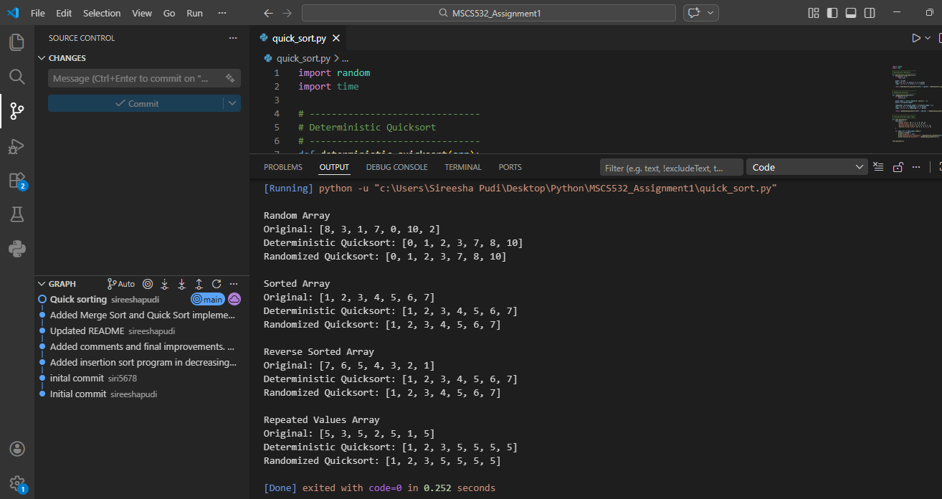
This code implements two versions of quicksort. In deterministic quicksort, the first element is always selected as the pivot. In randomized quicksort, the pivot is chosen randomly. I used a few sample arrays to check how both algorithms behave on different types of input such as sorted, reverse-sorted, random, and repeated values.

Part 2: Hashing with Chaining
1. Implementation Overview
In this part, I implemented a hash table using chaining.
Instead of storing a single value at each index, each slot contains a list (or chain). When multiple keys hash to the same index, they are stored in that list.
So the structure looks like:
Index → List of (key, value) pairs
2. Basic Operations
Insert
- Compute hash index
- Add key-value pair to that list
- If key already exists, update value
Search
- Go to the correct index
- Traverse the list and find the key
Delete
- Find key in list
- Remove it
3. Load Factor
Load factor is defined as:
Load Factor = Number of elements / Table size
This is very important because it directly affects performance.
- Low load factor → fewer collisions → faster operations
- High load factor → more collisions → slower operations
4. Time Complexity Analysis
Under normal conditions (good hash function):
- Insert → O(1) average
- Search → O(1) average
- Delete → O(1) average
But if too many elements go into the same bucket:
- Operations can become O(n)
This happens when collisions are high.
5. Handling Collisions and Improving Performance
To maintain good performance, we can:
- Use a Good Hash Function
It should distribute keys evenly across all slots.
- Resize the Table
When load factor becomes high (like > 0.75), it increases table size and rehash elements.
- Keep Chains Short
Shorter chains mean faster search and insert operations.

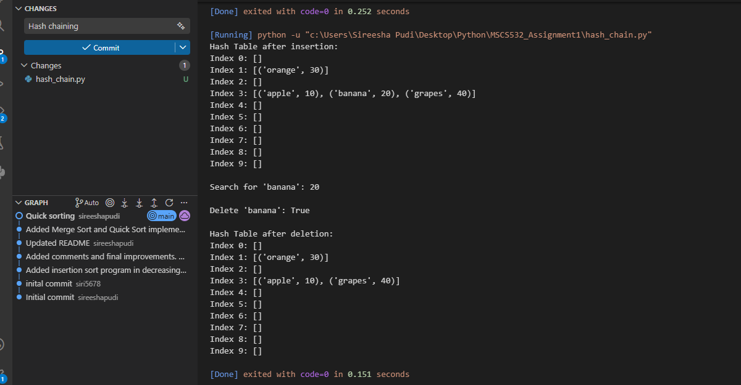
This code implements a hash table using chaining. Each index in the table stores a list, so when two keys map to the same location, both can still be stored. I implemented insert, search, delete, and display operations to show how chaining works in practice.
Conclusion
This assignment helped me understand how algorithm performance is not just about formulas, but also about implementation choices.
In quicksort, something as simple as pivot selection can completely change performance. Randomized quicksort avoids worst-case scenarios and gives consistent results.
In hashing, performance depends heavily on how evenly data is distributed. If collisions are handled properly and load factor is controlled, operations remain fast.
Overall, this assignment gave me a better understanding of efficiency and scalability in real systems.

Repository link:
https://github.com/sireeshapudi/MSCS532_Assignment1

