Assignment 5: Quicksort – Implementation, Analysis, and Randomization
1. Understanding and Implementing Quicksort
Quicksort is one of the most used sorting algorithms because it is efficient and works well for large datasets. The main idea behind Quicksort is to divide the array into smaller parts using a pivot element and then sort those parts recursively.
In my implementation, I followed three main steps:
- First selecting a pivot element (I used the last element for simplicity)
- Then rearranging the array so that elements smaller than the pivot go to the left and larger ones go to the right
- And recursively apply the same process to both sides
Deterministic Quicksort
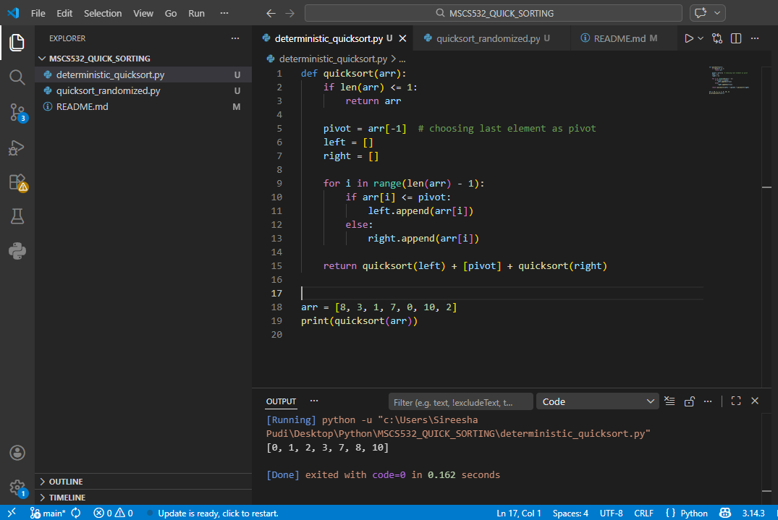
Implementation Details
The Quicksort algorithm was implemented using a recursive approach. In the deterministic version, the last element of the array is selected as the pivot. The array is then partitioned into two subarrays based on the pivot value.
For the randomized version, a pivot is selected randomly from the array, which helps avoid consistently unbalanced partitions.
Both implementations were tested separately using Python, and the code was organized into different files for clarity and better structure.
2. Performance Analysis
Quicksort performance mainly depends on how the pivot divides the array.
Best Case – O(n log n)
This happens when the pivot splits the array into two equal halves every time. Because of this balanced division, the recursion depth becomes log n, and each level processes n elements.
Average Case – O(n log n)
In most real-world scenarios, the pivot does not divide the array perfectly, but it still creates reasonably balanced partitions. That is why the average time complexity remains O(n log n).
Worst Case – O(n²)
This happens when the pivot is always the smallest or largest element (for example, already sorted arrays). In that case, one side becomes empty, and the recursion becomes linear instead of logarithmic.
Space Complexity
- Quicksort uses recursion, so it requires stack space.
- Average space complexity: O(log n)
- Worst case: O(n)
The reason Quicksort achieves O(n log n) in the best and average cases is because the array is divided into smaller parts at each step. When the partition is balanced, the depth of recursion becomes logarithmic.
However, in the worst case, the partition becomes highly unbalanced, where one side contains almost all elements. This increases the recursion depth to n, leading to O(n²) time complexity.

3. Randomized Quicksort
To improve performance, especially to avoid worst-case scenarios, we can randomize the pivot selection instead of always picking a fixed position.

Randomized Quicksort
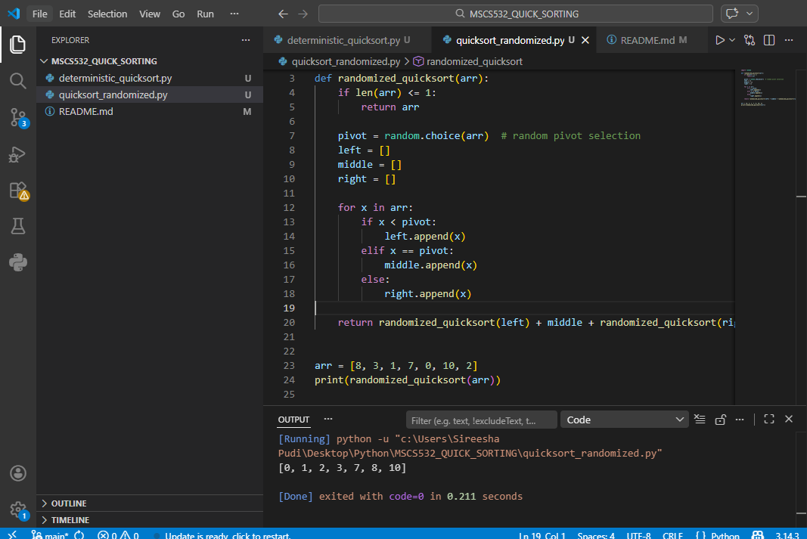
Randomization reduces the chance of consistently picking bad pivots. Even if the input is sorted, the algorithm is unlikely to behave poorly because the pivot is chosen randomly each time. This makes the performance more stable and closer to the average case.
4. Empirical Analysis (Observed Behavior)
To compare both versions, I tested them on:
- Random arrays
- Already sorted arrays
- Reverse sorted arrays
Observations
- For random inputs, both versions performed similarly and efficiently
- For sorted inputs, deterministic Quicksort slowed down noticeably
- Randomized Quicksort handled all cases more consistently
- The randomized version avoided extreme slowdowns seen in worst-case scenarios
This matches the theoretical understanding that randomization helps prevent poor pivot selection.
Real-World Applications
Quicksort is widely used in practical applications due to its efficiency. It is commonly used in sorting large datasets, database operations, and internal sorting functions in programming languages. Its performance makes it suitable for systems where speed is important.
Limitations
Although Quicksort is efficient, it has some drawbacks. It is not a stable sorting algorithm, and its performance depends heavily on pivot selection. In the worst case, it can still perform poorly with O(n²) complexity.
5. Conclusion
From this assignment, I understood that Quicksort is powerful but sensitive to pivot selection. While the deterministic version works well in many cases, it can perform badly for certain inputs. Randomized Quicksort improves reliability by reducing the chance of worst-case behavior.
Overall, this assignment helped me connect theory with practical implementation and understand how small design choices (like pivot selection) can significantly impact performance.

