Research Insights AI Platform

1. Overview
The Research Insights AI Platform is an end-to-end system that enables users to upload multiple research documents, ask natural language questions, and receive AI-generated insights grounded in document citations. The platform supports multi-format export, history tracking, and structured insight generation powered by a LangGraph-based AI agent.
This document outlines system requirements, technical specifications, architecture, workflows, sprint deliverables, and acceptance criteria.

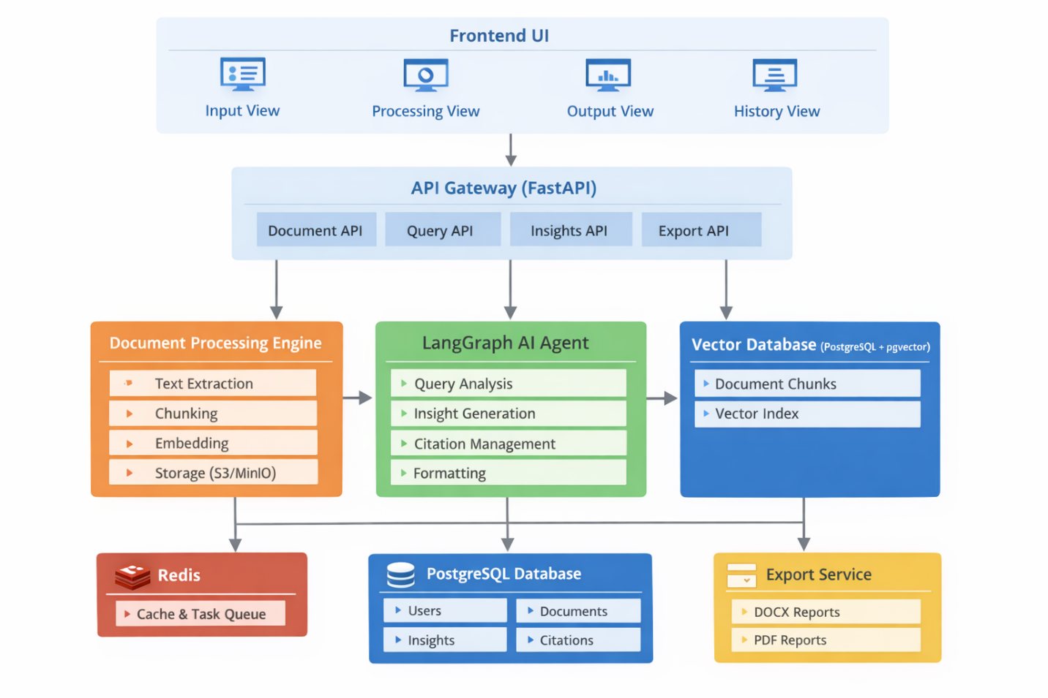

2. Functional Requirements
2.1 Document Management
- Upload multiple files (PDF, DOCX, TXT).
- Validate file type and size.
- Store documents in local.
- Track metadata: filename, size, upload date, user ownership, status (pending → processing → completed).
- Option to delete documents.
2.2 Document Processing Pipeline
- Extract text from uploaded files using:
  - pypdf / pdfplumber for PDFs
  - python-docx for Word files
  - plain-text parsing for TXT
- Chunk documents (1000 chars, 200 overlap).
- Generate embeddings using Claude/OpenAI embedding models.
- Store chunks and vectors in PostgreSQL with pgvector.
- Background processing job.
2.3 RAG-Based Insight Generation
- Retrieve top-K relevant chunks using vector similarity search.
- Use LangGraph agent pipeline to orchestrate:
  - Query analysis
  - Chunk retrieval
  - Insight generation (structured JSON output)
  - Citation extraction
  - Output formatting
2.4 Insight Output Formats
- Simplified – concise bullet points
- Detailed – full structured analysis:
  - Key Findings
  - What Users Want
  - Strategic Quick Wins
  - Common Problems
  - Recommended Next Steps
- Executive Summary
2.5 Insight History
- Paginated history list.
- Filters:
  - Date range
  - Format
  - Search query text
- Access full past insights.
- Option to delete items.
2.6 Export Functionality
- Export insights to:
  - DOCX (via python-docx)
  - PDF (via reportlab or weasyprint)
- Include all sections + citations.

