**JavaScript if...else Statement**

In computer programming, there may arise situations where you have to run a block of code among more than one alternatives. For example, assigning grades **A**, **B** or **C** based on marks obtained by a student.

In such situations, you can use the JavaScript if...else statement to create a program that can make decisions.

In JavaScript, there are three forms of the if...else statement.

1. **if** statement
2. **if...else** statement
3. **if...else if...else** statement

## JavaScript if Statement

The syntax of the if statement is:

if (condition) {

// the body of if

}

The if statement evaluates the condition inside the parenthesis ().

1. If the condition is evaluated to true, the code inside the body of if is executed.
2. If the condition is evaluated to false, the code inside the body of if is skipped.

**Note:** The code inside { } is the body of the if statement.

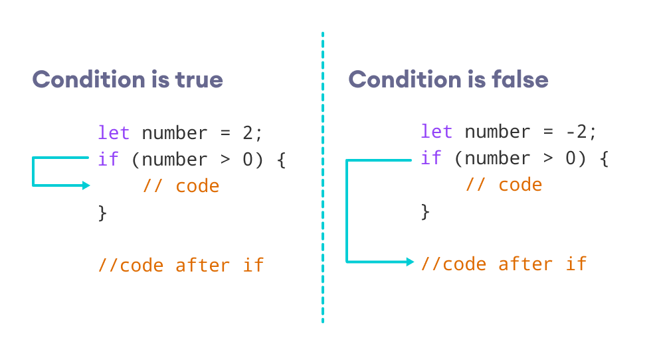

Working of the if Statement

## JavaScript if...else statement

An if statement can have an optional else clause. The syntax of the if...else statement is:

if (condition) {

// block of code if condition is true

} else {

// block of code if condition is false

}

The if..else statement evaluates the **condition** inside the parenthesis.

If the condition is evaluated to true,

1. the code inside the body of if is executed
2. the code inside the body of else is skipped from execution

If the condition is evaluated to false,

1. the code inside the body of else is executed
2. the code inside the body of if is skipped from execution

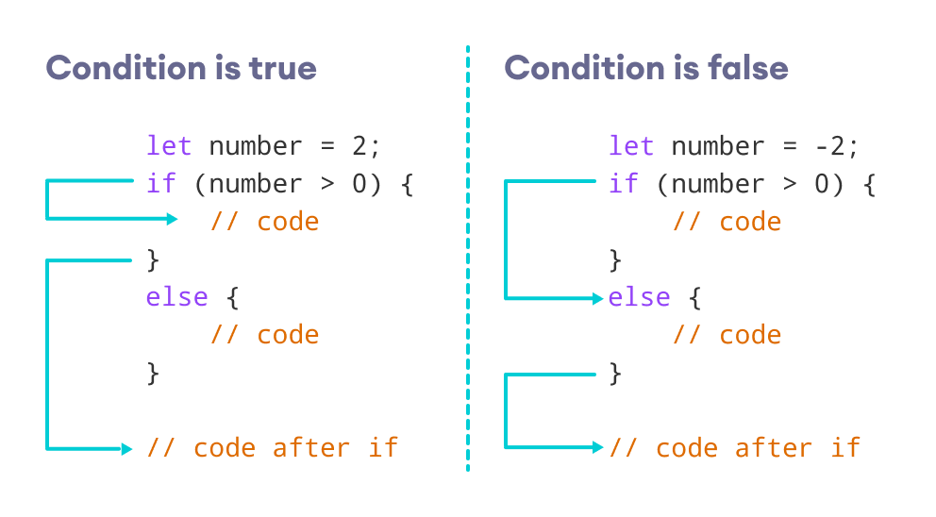

Working of the if...else statement

## JavaScript if...else if statement

The if...else statement is used to execute a block of code among two alternatives. However, if you need to make a choice between more than two alternatives, if...else if...else can be used.

The syntax of the if...else if...else statement is:

if (condition1) {

// code block 1

} else if (condition2){

// code block 2

} else {

// code block 3

}

* If **condition1** evaluates to true, the **code block 1** is executed.
* If **condition1** evaluates to false, then **condition2** is evaluated.
  + If the **condition2** is true, the **code block 2** is executed.

If the **condition2** is false, the **code block 3** is executed.

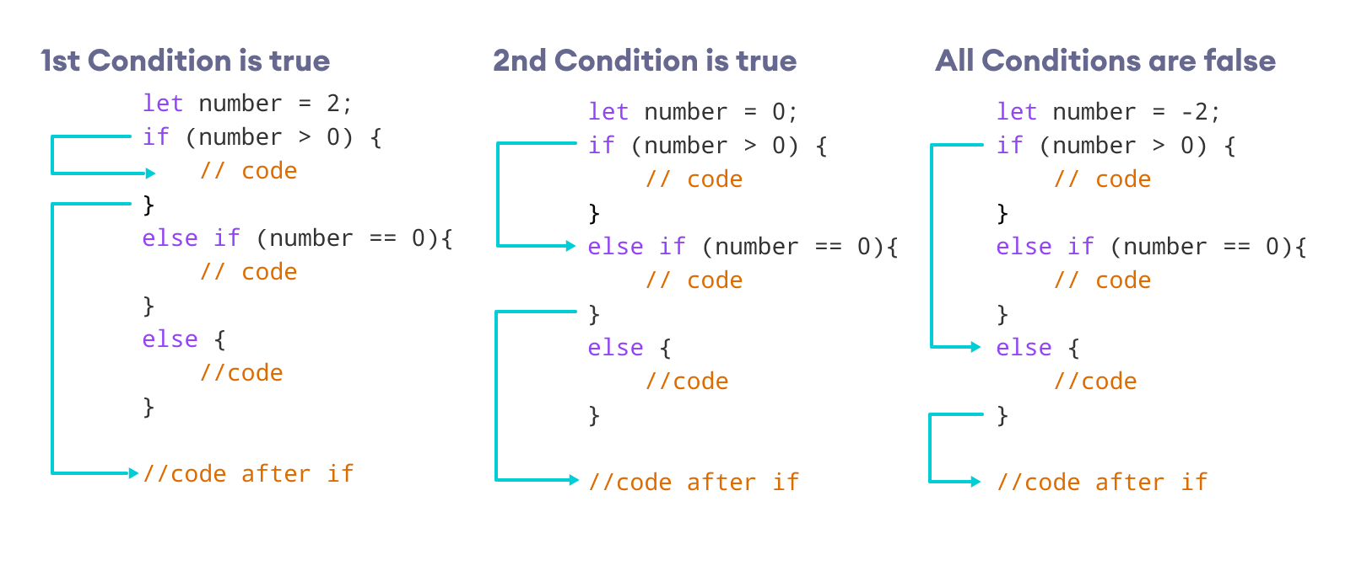

Working of the if...else if...else statement

# JavaScript Comparison and Logical Operators

In this tutorial, you will learn about the Comparison operators and Logical operators with the help of examples.

## JavaScript Comparison Operators

Comparison operators compare two values and give back a boolean value: either true or false. Comparison operators are used in [decision making](https://www.programiz.com/javascript/if-else) and [loops](https://www.programiz.com/javascript/for-loop).

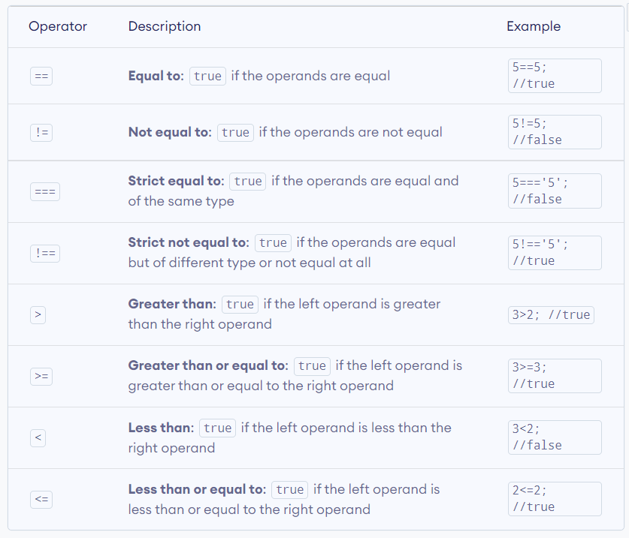

## JavaScript Logical Operators

Logical operators perform logical operations: **AND**, **OR** and **NOT**.

