**JavaScript for loop**

In programming, loops are used to repeat a block of code.

For example, if you want to show a message 100 times, then you can use a loop. It's just a simple example; you can achieve much more with loops.

**JavaScript for loop**

The syntax of the for loop is:

for(initialExpression; condition; updateExpression) {

// for loop body

}

Here,

1. The **initialExpression** initializes and/or declares variables and executes only once.
2. The **condition** is evaluated.
   * If the condition is false, the for loop is terminated.
   * if the condition is true, the block of code inside of the for loop is executed.
3. The **updateExpression** updates the value of **initialExpression** when the condition is true.
4. The **condition** is evaluated again.This process continues until the condition is false.

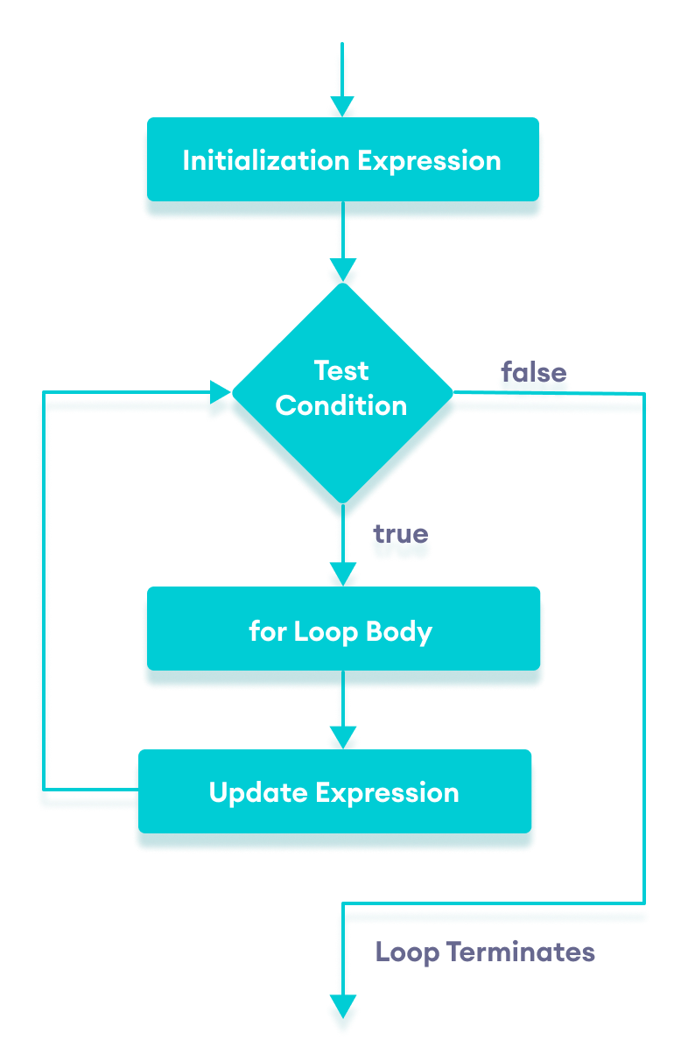

Flowchart of JavaScript for loop

### Example 1: Display a Text Five Times

// program to display text 5 times

const n = 5;

// looping from i = 1 to 5

for (let i = 1; i <= n; i++) {

console.log(`I love JavaScript.`);

}

**Output**

I love JavaScript.

I love JavaScript.

I love JavaScript.

I love JavaScript.

I love JavaScript.

Here is how this program works.

|  |  |  |  |
| --- | --- | --- | --- |
| Iteration | Variable | Condition: i <= n | Action |
| 1st | i = 1 n = 5 | true | I love JavaScript. is printed. i is increased to **2**. |
| 2nd | i = 2 n = 5 | true | I love JavaScript. is printed. i is increased to **3**. |
| 3rd | i = 3 n = 5 | true | I love JavaScript. is printed. i is increased to **4**. |
| 4th | i = 4 n = 5 | true | I love JavaScript. is printed. i is increased to **5**. |
| 5th | i = 5 n = 5 | true | I love JavaScript. is printed. i is increased to **6**. |
| 6th | i = 6 n = 5 | false | The loop is terminated. |

# JavaScript while and do...while Loop

In programming, loops are used to repeat a block of code. For example, if you want to show a message 100 times, then you can use a loop. It's just a simple example; you can achieve much more with loops.

**JavaScript while Loop**

The syntax of the while loop is:

while (condition) {

// body of loop

}

Here,

1. A while loop evaluates the **condition** inside the parenthesis ().
2. If the **condition** evaluates to true, the code inside the while loop is executed.
3. The **condition** is evaluated again.
4. This process continues until the **condition** is false.
5. When the **condition** evaluates to false, the loop stops.

**JavaScript while and do...while Loop**

In programming, loops are used to repeat a block of code. For example, if you want to show a message 100 times, then you can use a loop. It's just a simple example; you can achieve much more with loops.

**JavaScript while Loop**

The syntax of the while loop is:

while (condition) {

// body of loop

}

Here,

1. A while loop evaluates the **condition** inside the parenthesis ().
2. If the **condition** evaluates to true, the code inside the while loop is executed.
3. The **condition** is evaluated again.
4. This process continues until the **condition** is false.
5. When the **condition** evaluates to false, the loop stops.

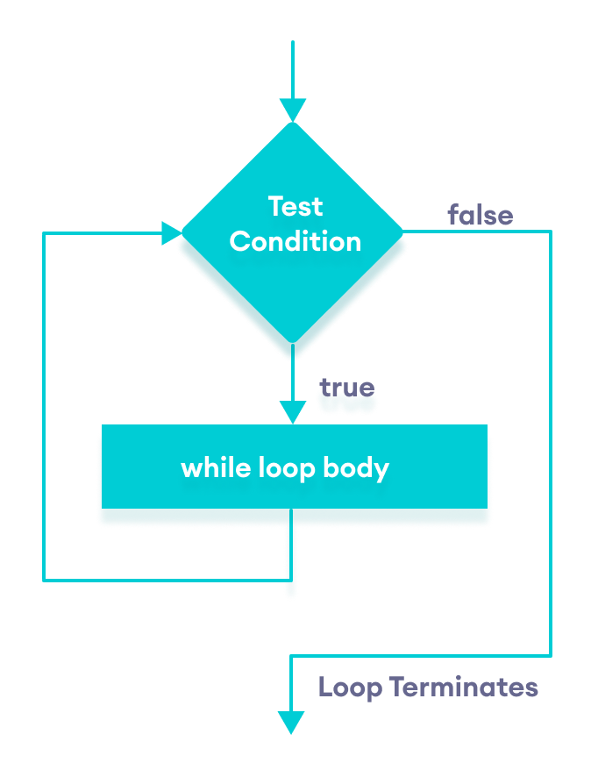Flowchart of JavaScript while loop

### Example 1: Display Numbers from 1 to 5

// program to display numbers from 1 to 5

// initialize the variable

let i = 1, n = 5;

// while loop from i = 1 to 5

while (i <= n) {

console.log(i);

i += 1;

}

**Output**

1

2

3

4

5

Here is how this program works.

|  |  |  |  |
| --- | --- | --- | --- |
| Iteration | Variable | Condition: i <= n | Action |
| 1st | i = 1 n = 5 | true | 1 is printed. i is increased to **2**. |
| 2nd | i = 2 n = 5 | true | 2 is printed. i is increased to **3**. |
| 3rd | i = 3 n = 5 | true | 3 is printed. i is increased to **4**. |
| 4th | i = 4 n = 5 | true | 4 is printed. i is increased to **5**. |
| 5th | i = 5 n = 5 | true | 5 is printed. i is increased to **6**. |
| 6th | i = 6 n = 5 | false | The loop is terminated |

## JavaScript do...while Loop

The syntax of do...while loop is:

do {

// body of loop

} while(condition)

Here,

1. The body of the loop is executed at first. Then the **condition** is evaluated.
2. If the **condition** evaluates to true, the body of the loop inside the do statement is executed again.
3. The **condition** is evaluated once again.
4. If the **condition** evaluates to true, the body of the loop inside the do statement is executed again.
5. This process continues until the **condition** evaluates to false. Then the loop stops.

**Note**: do...while loop is similar to the while loop. The only difference is that in do…while loop, the body of loop is executed at least once.

### Flowchart of do...while Loop

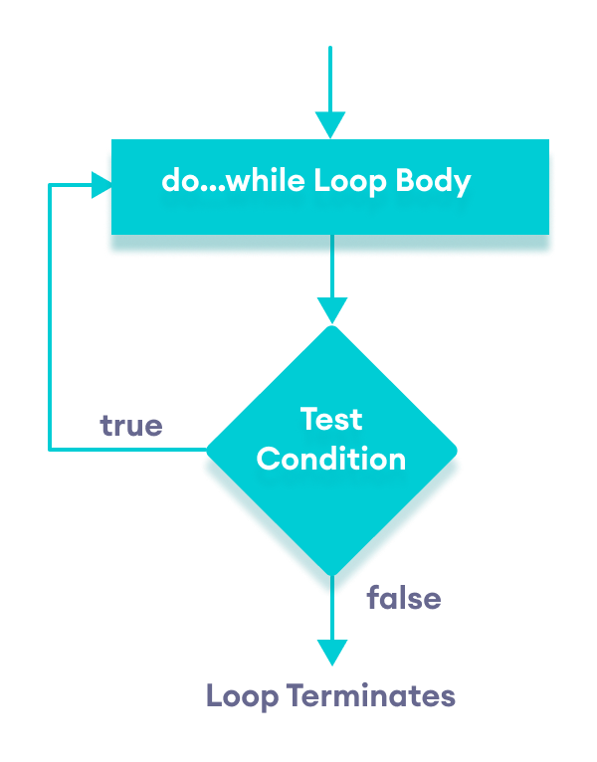Flowchart of JavaScript do...while loop

Let's see the working of do...while loop.

### Example 3: Display Numbers from 1 to 5

// program to display numbers

let i = 1;

const n = 5;

// do...while loop from 1 to 5

do {

console.log(i);

i++;

} while(i <= n);

**Output**

1

2

3

4

5

Here is how this program works.

|  |  |  |  |
| --- | --- | --- | --- |
| Iteration | Variable | Condition: i <= n | Action |
|  | i = 1 n = 5 | not checked | 1 is printed. i is increased to **2**. |
| 1st | i = 2 n = 5 | true | 2 is printed. i is increased to **3**. |
| 2nd | i = 3 n = 5 | true | 3 is printed. i is increased to **4**. |
| 3rd | i = 4 n = 5 | true | 4 is printed. i is increased to **5**. |
| 4th | i = 5 n = 5 | true | 5 is printed. i is increased to **6**. |
| 5th | i = 6 n = 5 | false | The loop is terminated |

## for Vs while Loop

A for loop is usually used when the number of iterations is known. For example,

// this loop is iterated 5 times

for (let i = 1; i <=5; ++i) {

// body of loop

}

And while and do...while loops are usually used when the number of iterations are unknown. For example,

while (condition) {

// body of loop

}

Brick game:

