**Data Types:**

The value we store in a variable can be of any type. Such as Number, String(word), boolean, undefined, null.

Number : integers eg: 0,1,2,3 etc

String: alpha- numeric-symbol

Eg: hello@5

Boolean: true or false

Undefined: when no value is assigned to variable

null : nothing

We can also group the data and store in one variable. To group, we can use arrays

**Arrays:**

Array is basically a collection of items. Whenever we have to store multiple elements, usually of the same type, we create an array object.

For e.g. To store only your name we can store it in a variable. But if we have to store multiple names then we will have to create a lot of variables or we create an array for names.

In an array, you can store numbers, strings, or a mix of different data types.

An array using indices to refer to a value inside the list. If an array has an ‘n’ number of elements inside it then indices will be from 0 to n-1(0,1,2,...,n-1). For example, If I want to access the first element of the array, we will have to use an index as ‘0’.

In our array, there are 5 elements so n=5 here. Now to access the 5th element of an array, we will have to pass index n-1 which is (5-1) = 4.

We can also print the entire array by just passing the name of the array without any index. : console.log(array_name);

We can also add elements to the existing array using the push() function.

Similarly, we can remove the last element from an existing array using the pop() function.

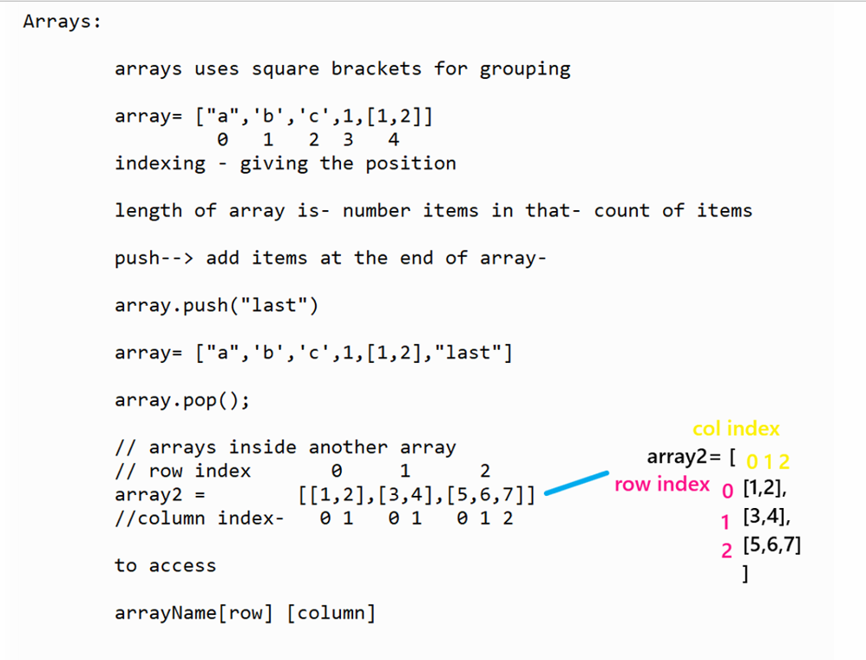

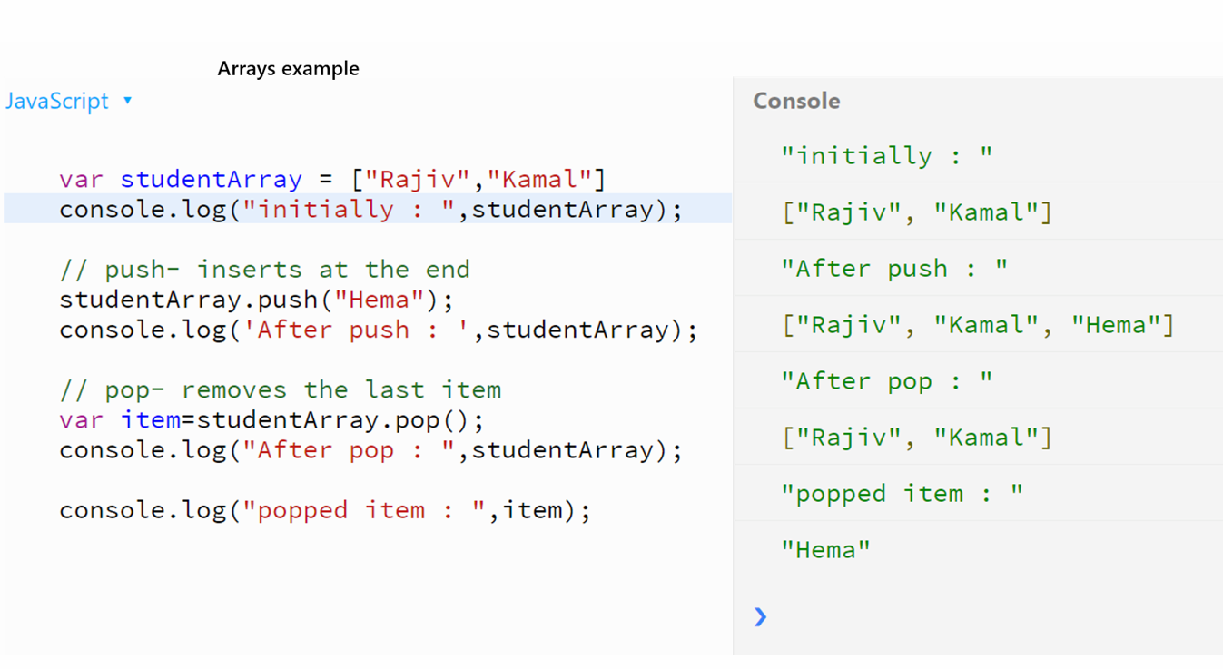

To add customization in the bounceOff() function, we need to pass a **callback()** function inside bounceOff() function **which will be called every time** bounceOff takes place.

**playSound:**

We want to play some sound, there seems to be an instruction to do just that! It is called - playSound()

When we write the instruction playSound(), you will get an option to choose the sounds as popup and just below the playSound() instruction. You can choose the sounds from the library of sounds that is already there OR you can make new sounds by uploading a file or recording some sound.

**text command**

In JavaScript, we can use the **‘text’ command** to display any string on the canvas at a fixed position. text("string", x, y); takes 3 parameters: - String to be displayed. - x position on canvas - y position on canvas.

We can use different text functions available to increase the size or change the font type of the text as we do in text editors. (Microsoft Word, Notepad, etc)

● **textSize**(int size); helps specify the size of text.

● **textFont**("font_name"); helps specify the font of the text.

It is easier to check if some condition is true by writing it directly, but when we have to check if that condition is not true. In such cases, we use **the logical Not operator** denoted by ‘!’.

For e.g. if(!raining) { //don’t take an umbrella. }