**Game States**

1. To start or restart the game.
2. To decide when to give the instruction to the computer to serve the ball and remove the same as game starts

As in real life, matter changes from solid to liquid to gaseous likewise, in the game there is a change of state (mode) like “Start, Playing, and End.”

For e.g. Water kept in the refrigerator changes to solid state (ice); if it is boiled, it changes to gaseous state (vapors). We will define game states for our game to figure out which state the game is in and display the relevant messages as per the current state.

Every game has 3 modes in common:

1) The **Initial** Mode where the game objects are at rest.

2) The **Play** Mode where the game is played.

3) The **GameOver** Mode where the game comes to a halt.

These States or Modes always follow the same order as given above. ● The first state (mode) is when the ball is at the center and the user needs to “click" to serve the ball. We can call this state in the game "SERVE" STATE (Serve Mode).

● The second state (mode) is when the play starts, and the ball is in motion. We can call this state(mode) in the game "PLAY" STATE (Play Mode).

● The third state (mode) is when the ball goes off the screen. The game then ends and the player needs to press "Reset" to restart the game. We can call this "GAME OVER" STATE (Game Over Mode).

The objects in the game behave differently at different stages. Even Information displayed is different at different stages. We can store the information about the state (mode) of a game and use conditional programming to instruct the computer to behave differently for different states (modes).

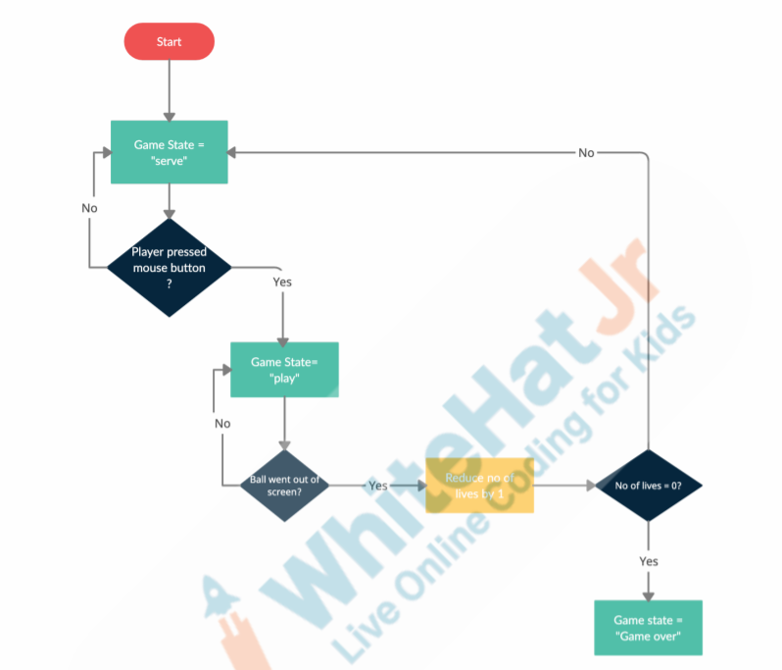

We can store information about the state (mode) of the game Using variables

We change the gamestate variable to "play" after the space key is pressed.

The values inside the variables can change! That's why they are called "variables".

The display text disappear when we press the mouse click and the game is in play mode

This is because the gamestate (mode) changes on mouse click and we have asked the computer to display text only when the game state (mode) is in ‘serve the state (mode)’.

There is still another problem though. Pressing the mouse at any point of time changes the speed and direction of the ball. We want to give speed and direction to the ball only when the user presses the spacebar in the ‘serve state (mode).’

We can instruct the computer as follows: If the game is in SERVE state (mode), then only serve the ball. Add these instructions inside the ‘if condition’ .

Game over state should start when all the lives of the player are over.

a player will lose a life when the ball goes off the screen

Though we have successfully detected and changed the states, we still need to display a few more text instructions for the player to know if it’s a serve state or game over state.

For every key press, there are 3 events fired in JavaScript:

i) ***keyWentDown***(key): fires once as soon as the key is pressed down.

ii) ***keyDown***(key): keeps firing till the key is Down.

iii) ***keyWentUp***(key): fires once as soon as the key is released.

**Pause** and **resume** functionality in our game

