**String Concatenation:**

Joining two strings

Eg:

1+1 =2 but “1”+1 =11

**Logical operators:**

LOGICAL NOT OPERATOR

! is a logical not operator. It returns true if the operand is false and vice versa. For eg. !false = true & !true = false.

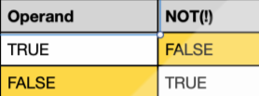

LOGICAL AND

&& operator which returns true only if both the operands are true else it returns false. As the name suggests 'and' that means both operands should be true. For e.g. I need cake and a toy which means I need both.

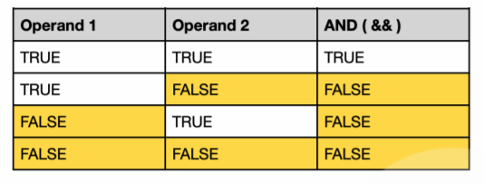

LOGICAL OR

|| operator which returns false only if both the operands are false, otherwise it returns true if either of the operands is true. For e.g. I need a cake or a car. Here I will be happy if I get any one of them or both. I will be sad only if I get neither of them.

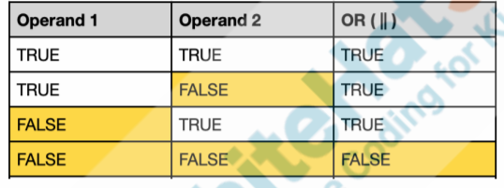

These operators are generally used in the if statements to write complex conditions. For e.g to check the leap year we need to see if the month is ‘Feb’ and num of days are ‘29’ then it's a leap year.

**Modulo operator**

represented by percentage symbol.(%)

The mod ‘ % ’ operator returns the remainder when number1 is divided by number2.

E.g. when 5 is divided by 2, the remainder will be 1.

**By assigning AI to our Paddle**

Make the computer play the game on its own.

Though Computers have zero IQ of their own but with some intelligence provided by the programmers/coders, they can do wonders.