**For loop for traversing:**

If we want to display all the elements of an array, we don’t have to write it manually for each element. We can directly use the for loop for this.

In the for loop we first define a variable and give it a **starting condition**, in our case it is 0 because the index of the array starts from 0, then we provide the **stopping condition**, here we are setting it as the length of the array (Number of elements in the array). At the end we set the **increment** for the variable i.e, here we are incrementing i by 1 every time our loop runs.

Then in the curly brackets of the for loop we will write: console.log(marks[i]) so that when the loop runs, it will give us the elements from the marks array.

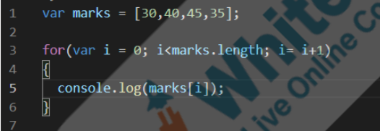

**Code Indentation:**

computers don't mind or read spaces. But it is important to give spaces in your code to make it easily readable. Remember, you want other programmers to easily read your code. Giving proper spaces in your code makes your code easily readable.

We try to leave a line after a meaningful block of code.

There is no fixed rule for leaving these spaces. It is just like leaving spaces between paragraphs when you write a story.

We also add some code indentation to lines to show that they are contained inside a block of code.

We show it by **indenting** these lines by adding some space in front of these lines. This spacing should be consistent.

Code indentation helps us understand the program structure easily. It also makes us less likely to make mistakes while typing out text - like missing out on closing curly brackets.

**Bugs :**

Bugs are parts of the program that do not work as we want. We have two such bugs that we will solve today. –

One bug is that our dinosaur is running a little over the ground, instead we want it to run a little below the ground.

The Trex right now is supported by the ground sprite. Collision with the ground sprite is not letting the Trex fall off the ground. As our Trex looks like it’s running a little above the ground, we’ll fix this by creating an invisible ground just below the original ground and make our Trex run on the invisible ground so that it looks like the Trex is running on the ground. Let us create an invisible ground sprite just below this ground. We want to do this so that rather than being supported by the ground and being above the ground, the Trex gets supported by an invisible ground just below the actual ground.

Make this ground sprite invisible using an instruction in the p5.play library named **sprite.visible.** You need to make it false to make the ground invisible.

Other bug, the dinosaur jumping in mid-air when the space key is pressed.

We want the dinosaur to be able to jump only when it is touching the ground. It should be able to jump again only when it falls back on the ground.

We want to make it jump when the space key is pressed and when it is on the ground as well.

trex.y reduces when the Trex jumps.

By adding an additional condition inside the if block where we make the Trex jump.