JavaScript and most other languages have different data structures to hold multiple values. One popular data structure to hold multiple values is called an "array". An array is created inside square brackets and can store a list of the same or different types of data separated by a comma.

Each value in the array is indexed by a number. The first value has an index of '0', the second value has an index of '1' and so on. If we want to access the first element of our arr3 array, we can access it by using arr3[0].

A new value can be pushed inside an array by using array.push(). Similarly, the last values can be popped out of the arrays using array.pop().

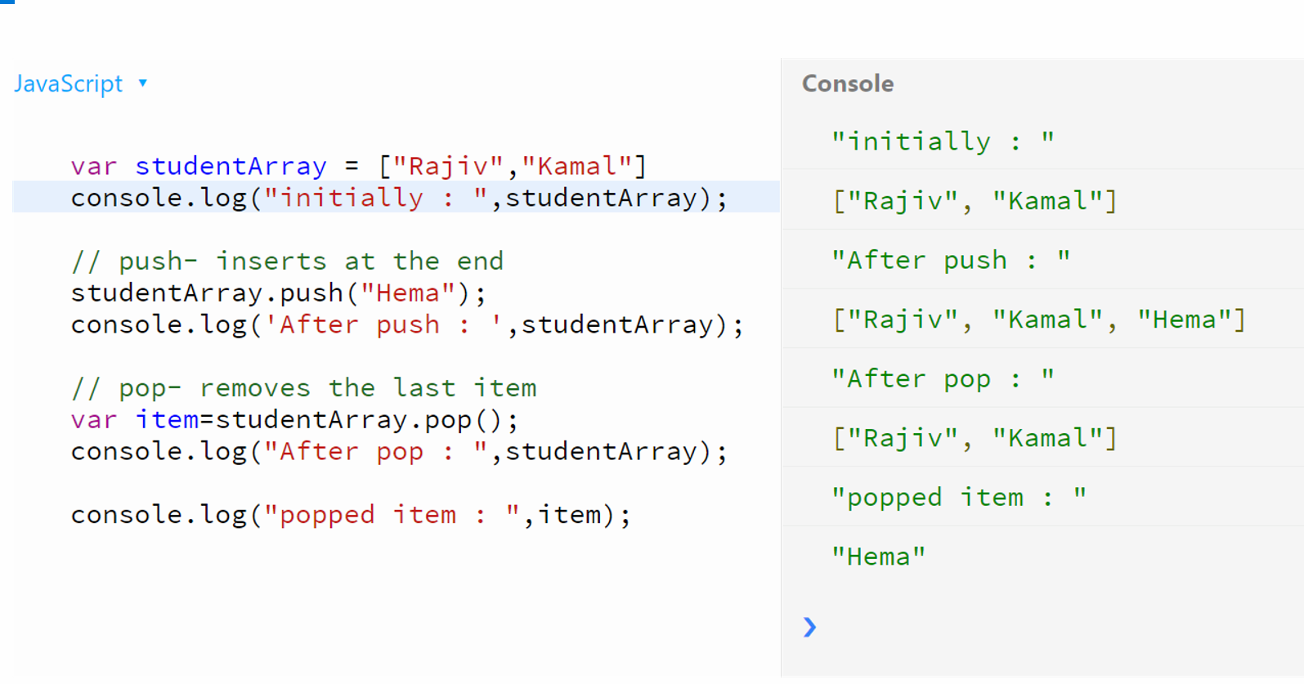

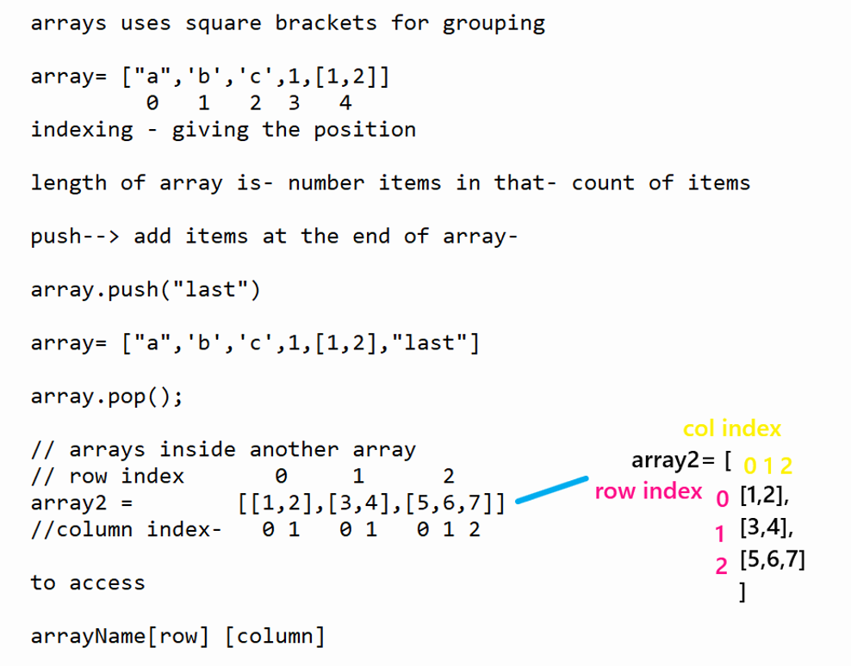

To access Arrays, we can use for loop.

For loop has three expressions. Initialisation, conditional and increment

Initialisation:

As array indexing starts from 0, we take variable with initial value 0

var i=0;

conditional: Since we want for loop to iterate for all items, our variable should be less than or equal to highest index of array.

highest index of array is one less than length of array . so,

i<=array.length -1

increment: as the difference between two arrays is 1, we increment variable by one for every iteration.

i=i+1

**Events:**

Actions of mouse and keys are called events. Like mouse clicked, key pressed, key released.

keyPressed same as keyWentDown

keyReleased same as keyWentUp

Trajectory: the path through which the ball travels

The positions of the ball are x,y coordinates.so it is also array.

So we push each position array to another array, when ball has some velocity.

To display the trajectory path, we iterate through the array to get the positions, and add image for every position.