PYXIS Network

100% Decentralized Staking Platform for the Community

White Paper R.7

(02/04/2021)

1

Table of Contents

**Disclaimer** **2-3**

**Introducing Pyxis** **4**

**The reasons to join Pyxis network** **5**

**Tokens** **6**

PYX Token 6

CMPS Token 6

**Staking Reward Pool** **7**

**PYX Staking** **8-9**

**BNS Staking** **10-11**

**Unstaking** **12-13**

Early unstake Penalty 13

Late unstake Penalty 13

**Archived** **15-19**

2

The information currently provided within this White Paper does not purport to be complete, and is subject to and qualified in its entirety by reference to the actual text of the Offering Memorandum, and other relevant documents, which will be provided, upon request, to each prospective purchaser that meets the definition of “accredited investor” under Regulation D under the us Securities Act of 1933, as amended (the “Securities Act”).

Neither the [SAFTs/Purchase Agreements] nor PYX/CMPS Tokens issuable thereunder have been registered under the Securities Act, under the laws of any US states, or under the laws of any non-US jurisdictions. Accordingly, PYXIS Network is offering the [SAFTs/Purchase Agreements] and the underlying PYX/CMPS Token pursuant to the Offering Memorandum only in exempt transactions to “accredited investors” (as defined in Rule 501(a) of Regulation D under the Securities Act) pursuant to Rule 506(c) of Regulation D under the Securities Act. Offers and sales of the SAFTs and PYX/CMPS Token issuable thereunder outside the United States will also be made in accordance with the laws and regulations of the relevant jurisdictions.

Subscribing for [a SAFTs and] the underlying PYX/CMPS Token involves a high degree of risk and illiquidity. A prospective purchaser should thoroughly review the Offering Memorandum upon its release and carefully consider whether purchasing [a SAFT and] the underlying PYX/CMPS Token is suitable to the purchaser’s financial situation and goals, particularly in light of the significant legal and contractual restrictions on the resale of [the SAFTs and] PYX/CMPS Token issuable thereunder. Prior to any purchase decision, PYXIS Network will give prospective purchasers the opportunity to ask additional questions and receive additional information concerning the terms and conditions of the proposed offering and other relevant matters, to the extent PYXIS Network possesses the same or can acquire such information without unreasonable effort or expense. Purchasers should inform themselves as to the tax consequences to them of the acquisition, holding, and disposition of [a SAFT and] PYX/CMPS Token issuable thereunder, as applicable.

The information contained in this White Paper was created by PYXIS Network from its own internal records and from published and unpublished sources it believes to be reliable. Neither this White Paper nor any supplementary data purports to be inclusive, and, accordingly, each prospective purchaser is strongly encouraged to read the Offering Memorandum in its entirety before purchasing [a SAFT and] the underlying PYX/CMPS Token. In addition, any projections and estimates contained in this White Paper involve numerous and significant subjective

3

determinations. Accordingly, no representation or warranty can be or is made as to the accuracy or attainability of such estimates and projections. PYXIS Network does not expect to update or otherwise revise this White Paper or any projections attached thereto unless required by law. Such projections have been prepared by and are the sole responsibility of PYXIS Network and have not been reviewed or compiled by PYXIS Network’s independent auditors.

This White Paper does not constitute an offer to sell, or a solicitation of an offer to buy, [SAFTs or] PYX/CMPS Token issuable thereunder in any jurisdiction in which it is unlawful to make such an offer or solicitation and is for informational purposes only. Neither the United States Securities and Exchange Commission nor any other federal, state or foreign regulatory authority has approved an investment in [SAFTs or] PYX/CMPS Token issuable thereunder. Furthermore, the foregoing authorities have not confirmed the accuracy or determined the adequacy of any information in this White Paper or the Offering Memorandum, nor is it intended that the foregoing authorities will do so. Any representation to the contrary would be a criminal offense.

Prospective purchasers should make their own investigations and evaluations of [the SAFTs and] the underlying PYX/CMPS Token, including the merits and risks involved in a purchase thereof. Nothing in this White Paper or the associated Offering Memorandum is intended to create a contract for the purchase of [a SAFT or] the underlying PYX/CMPS Token. A purchase of [a SAFT and] the underlying PYX/CMPS Token is not an investment in PYXIS Network and instead represents only the limited rights and attributes relating thereto described in the Offering Memorandum pertaining to the PYXIS Network platform.

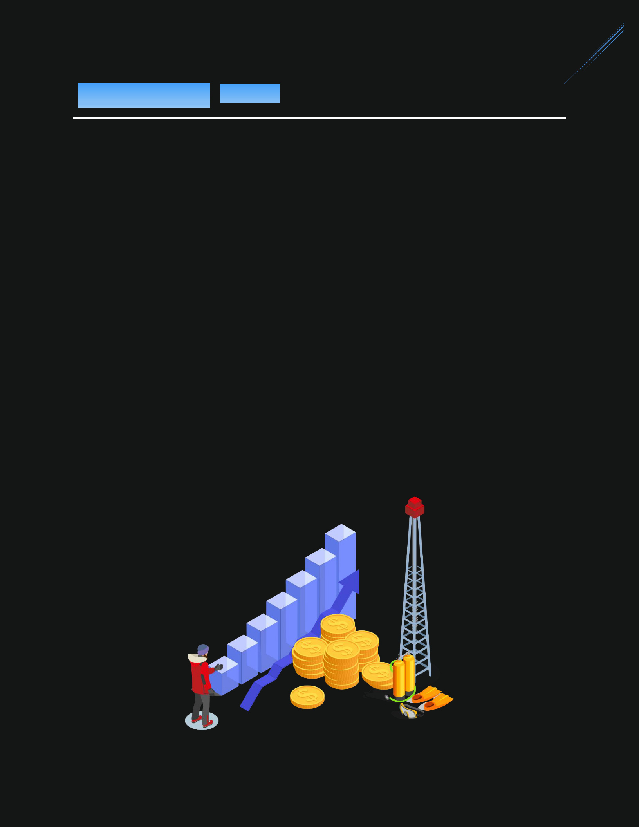4

PYXIS is a 100% decentralized project with the goal of increasing the token price and rewards to the stakers over time. The development team optimized smart contract logic to maximize the benefit to the community. Our project is real, and it is not just another retirement plan for the founders.

PYXIS is a currency on the Binance Smart Chain, and the operation is governed by immutable smart contracts. Once the contracts are deployed on the mainnet, the admin keys will be burned, so the owners will not have special access to the smart contracts. This makes everyone equal. There are no special privileges for referrers, founders, and insiders. We are all just community.

The development is all done by the founder from the ground up. The team is a group of passionate people who want to bring a high DEFI standard to the world.

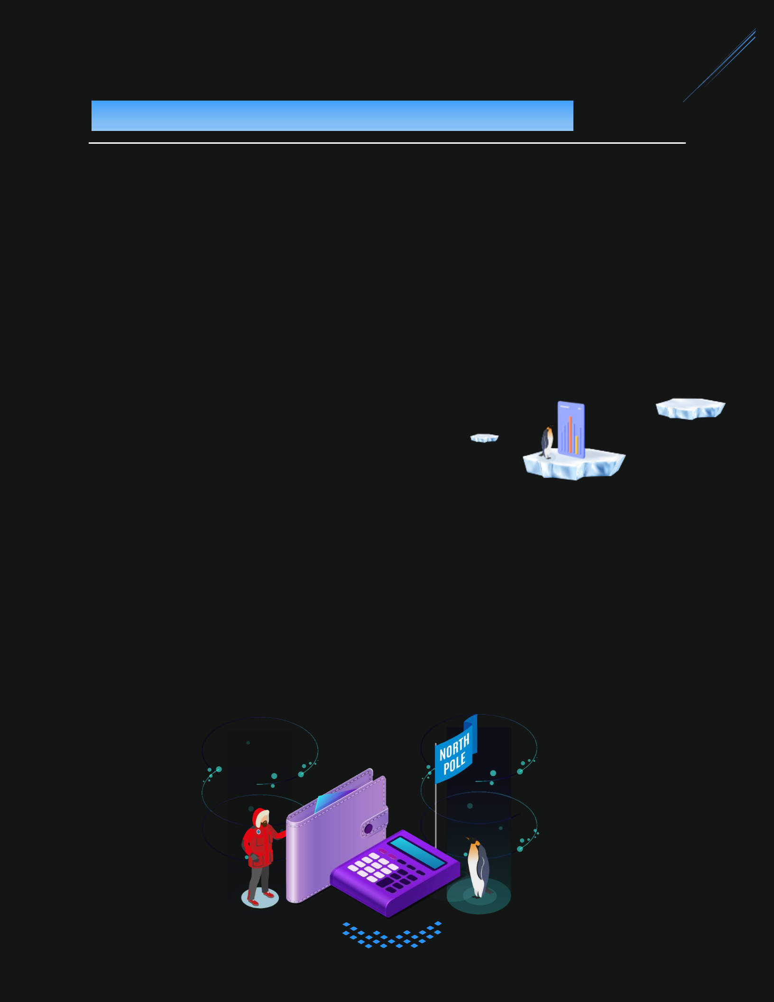5

* Smart contracts are immutable, non-upgradable, and no proxy. So there will never be changes to them in the future.
* PYXIS token will never be used to pay for development or marketing, so no one can ever dump the price.
* Binance Smart Chain (Super low gas fees).
* 100% tokens buyback to increase the token price over time.
* High staking reward.
* This is not a fork project. The concepts are new, and the code is written from the ground up by CTO.
* All the processes are done via smart contracts with no human interactions.
* This is a long-term project that will evolve over time. New functionalities will be added with new smart contracts and apps.

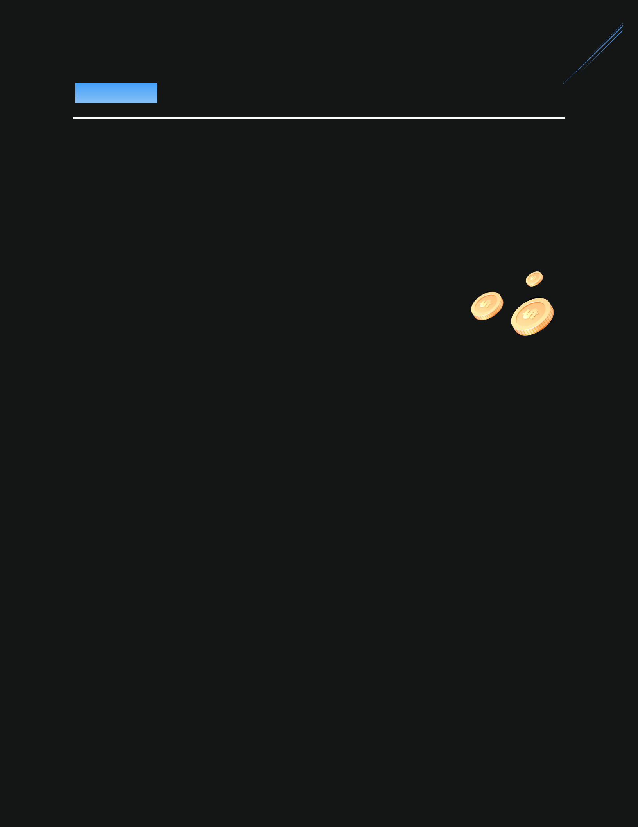6

**PYX (Main token)**

* PYX is the main token that is used for staking and trading.

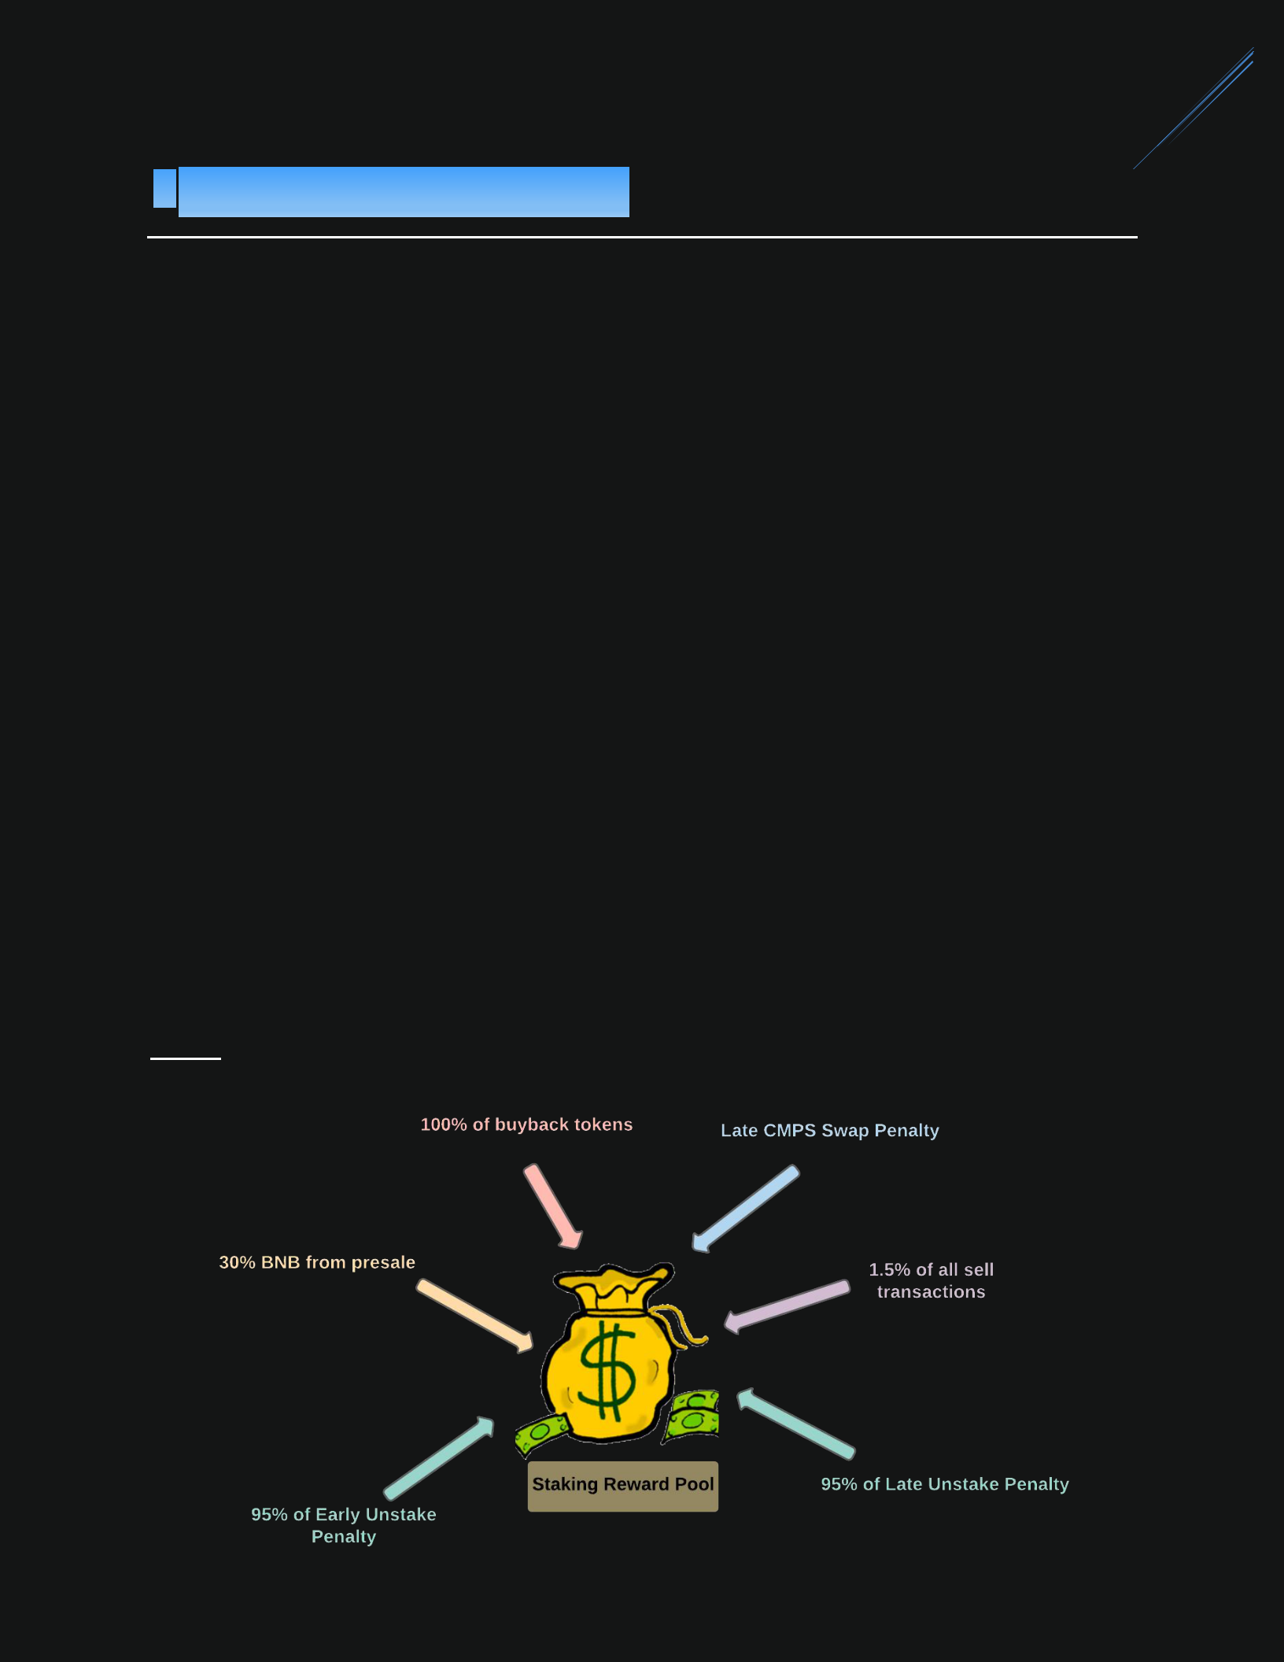7

The "Staking Reward Pool" is used to accumulate PYX tokens that will be paid to the stakers as the staking reward when the stake is matured.

**There are several ways tokens are added to this pool:**

* 30% of the presale BNB. (BNB will be used to buy back PYX from Pancakeswap)
* All of the late CMPS swap penalties.
* 95% of the early unstake penalties. (5% will be burned)
* 95% of the late unstake penalties. (5% will be burned)
* 100% of the buyback tokens.
* 1.5% of the sell transactions. (another 1.5% will be burned) If you sell PYX on Pancakeswap or transfer it to other people.

**Note:** There is no fee for the buy transactions!

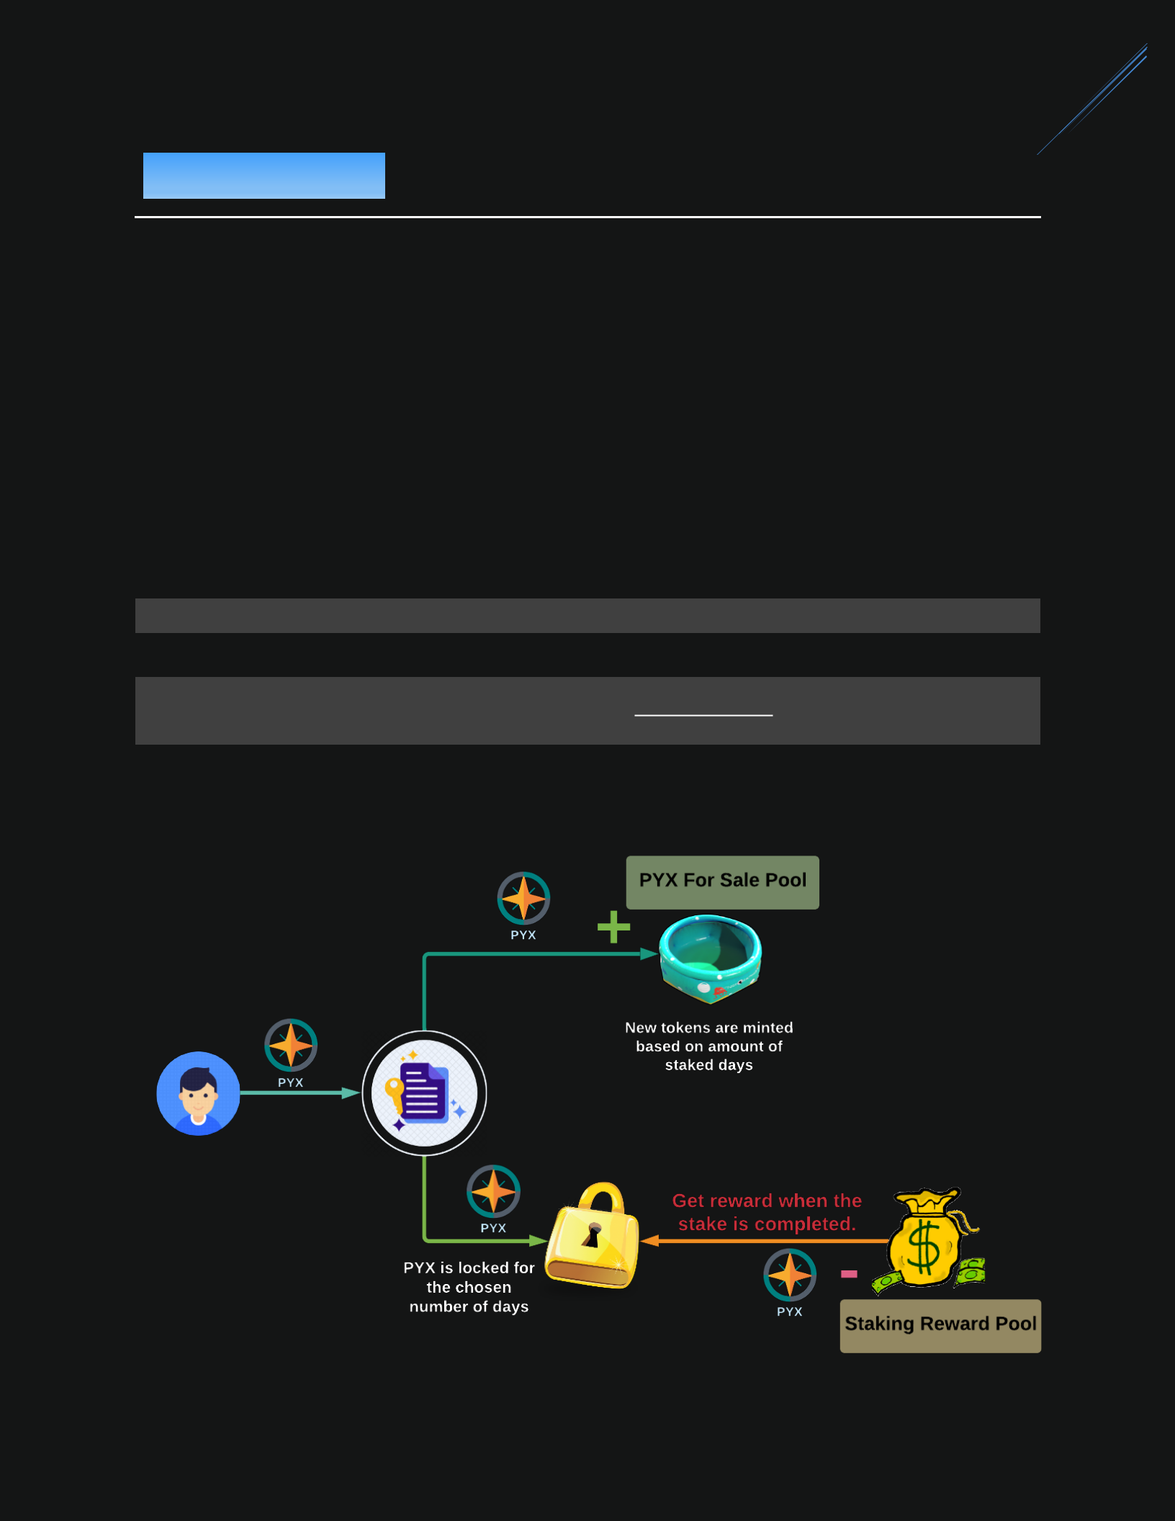8

Staking involves locking up PYX for a chosen number of days (from 1 to 1,820 days). In the end, the user will get rewards proportional to the staked shares.

* staked shares are calculated from the PYX amount and the number of staked days.

= × × ×

∗ = 1 (1.2 )

2

∗ =(100+ )

14

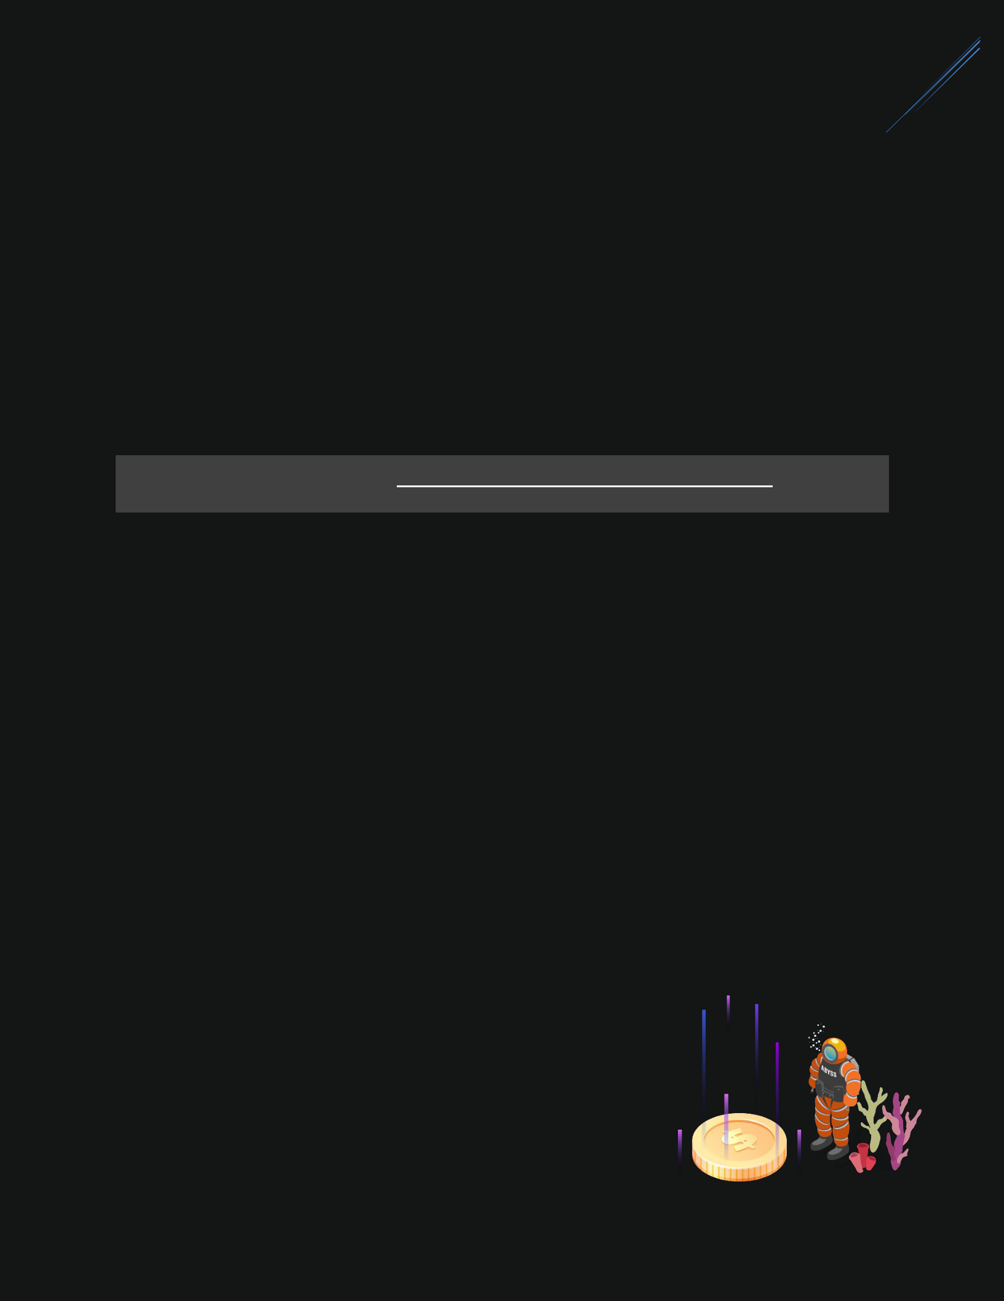9

As part of this process, new tokens will be minted based on the amount of PYX and staked days. All of them will be added to the “For Sale Pool”.

The “For Sale pool” is the pool where users can use BNB to purchase PYX and immediately stake it.

(see the BNB Staking below for more information)

= × ×49% 364

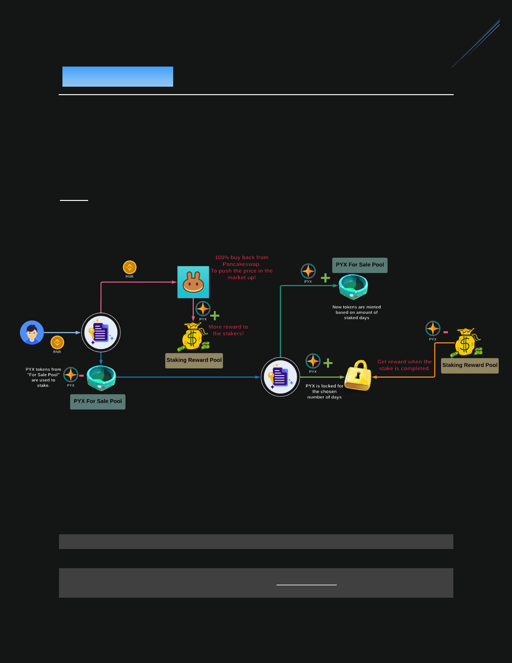10

PYX token will be removed from the “PYX for sale pool” and staked (see PYX Staking section above).

**Note:** The amount of PYX purchased/staked is calculated based on the price at thetime from Pancakeswap.

* By using BNB to stake, you will get 20% extra shares.
* You can choose to stake from 28 to 1,820 days.

= × × ×

∗ =1.2

2

∗ =(100+ )

14

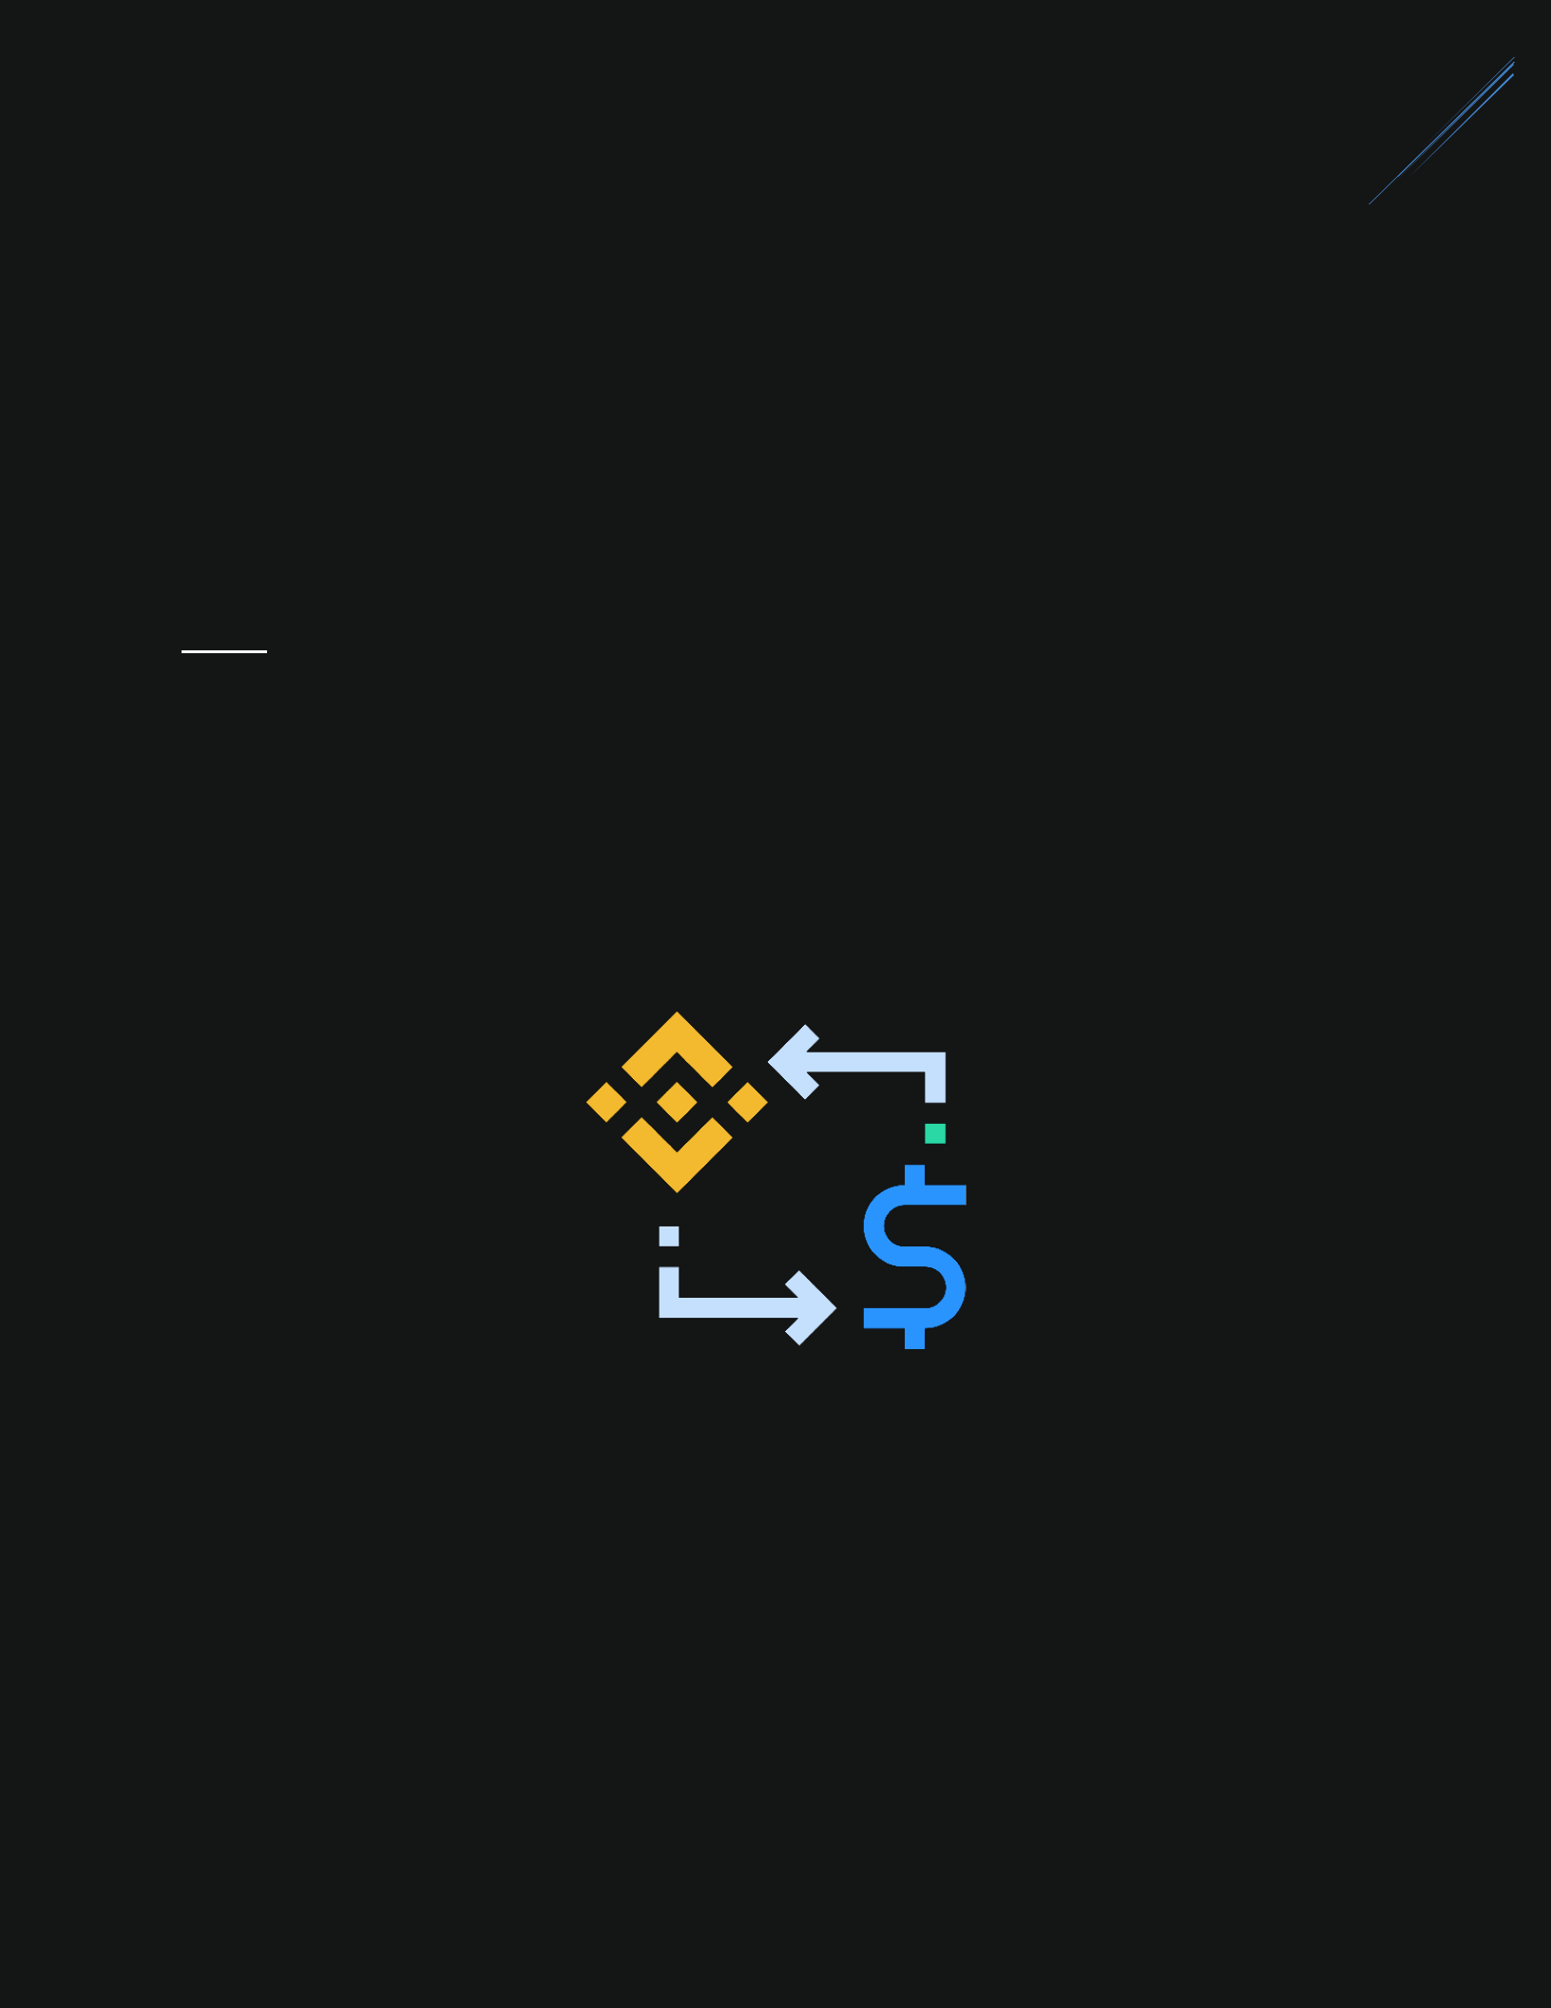11

*BNB Staking is an* ***important*** *process in the ecosystem because 100% OF BNB FROM THE USER IS USED TO BUYBACK PYX FROM PANCAKESWAP (TO PUSH THE PRICE UP).*

*ALL THE PYX FROM PANCAKESWAP WILL BE ADDED TO THE “STAKING REWARD POOL” (HIGHER REWARDS TO STAKERS).*

**Note:**

1. The community can use BNB to stake only when there is enough PYX in the

“PYX for sale pool”.

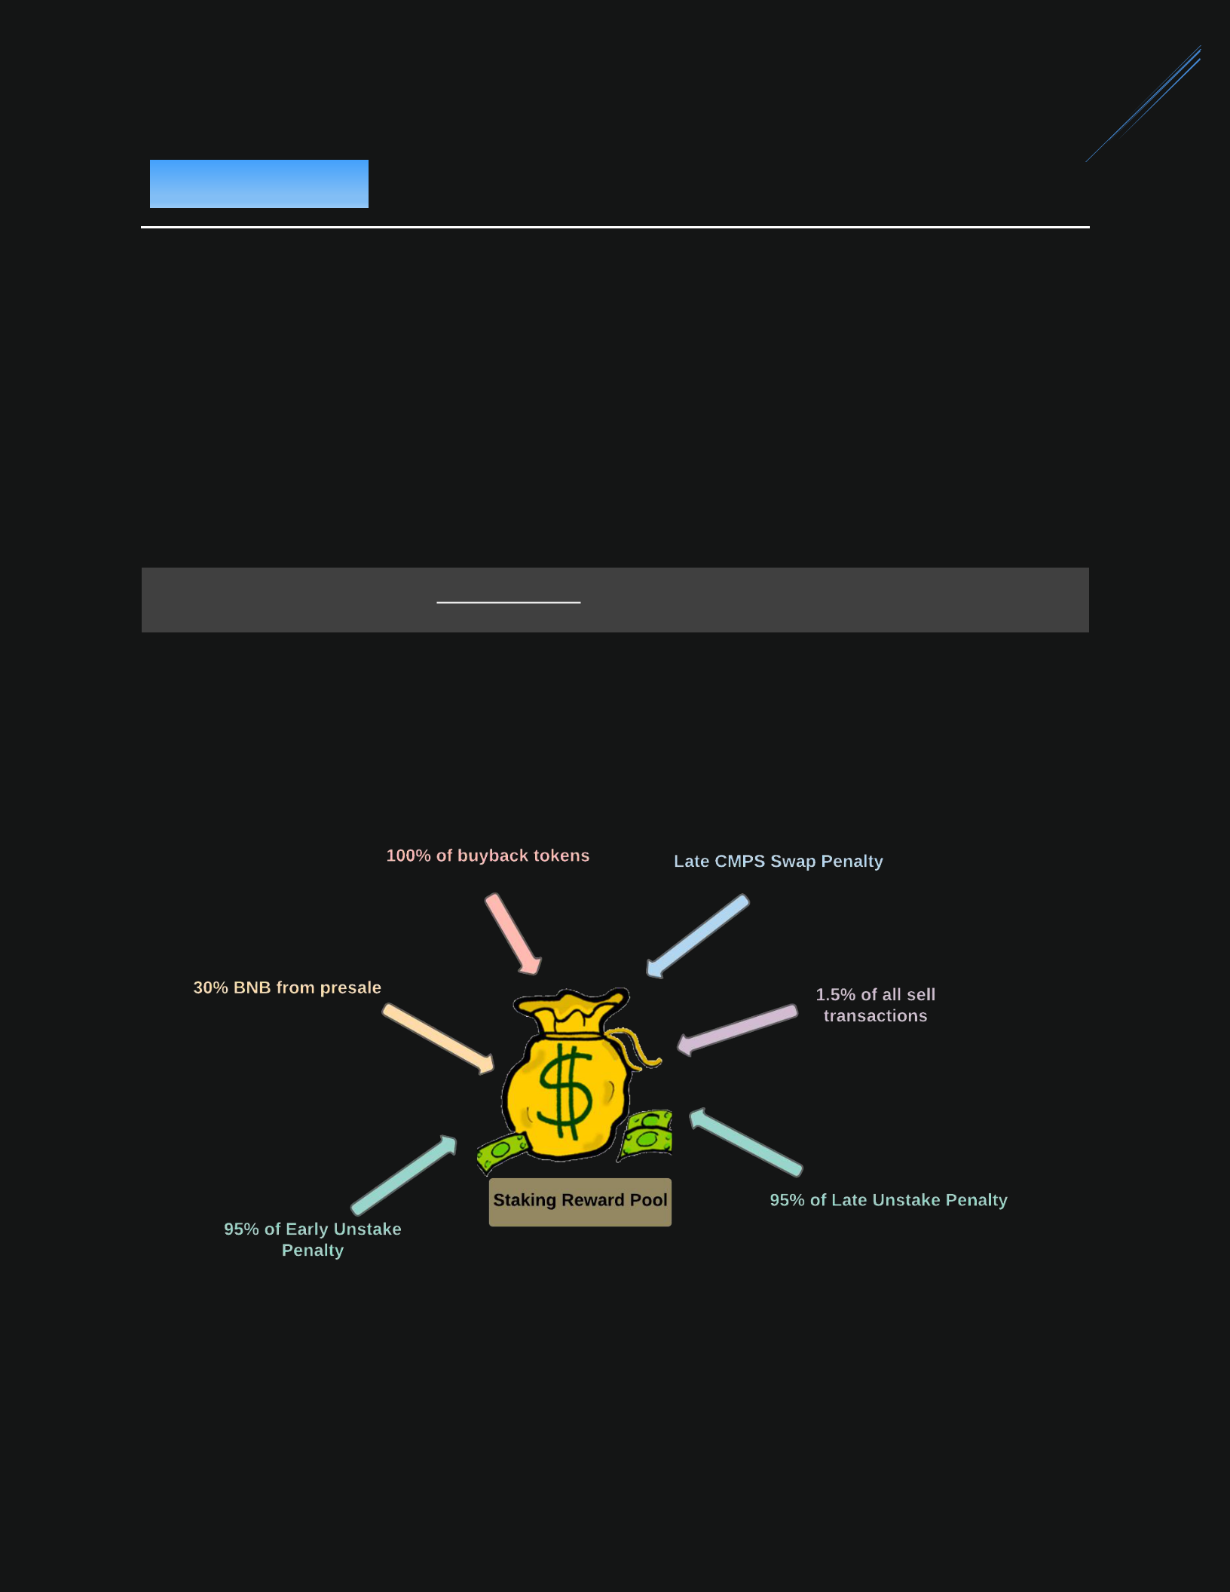12

When the stake is matured, the users can unstake to get the capital plus the interest. The amount of reward is depending on the number of shares from staking.

ℎ

=  ℎ ×

13

**Unstaking penalty:**

* Without penalty (The stake is matured)

1. The withdrawn amount is the original amount PYX staked + the reward PYX (interest)

= +

* Early unstake penalty

1. There is a penalty if you unstake before the stake is matured. The

penalty is a function of how many days before the staking period was to end.

1. **You will not get any reward and lose your capital.**

= × −

= −

* Late unstake penalty

1. After the stake is matured, there is 14 days grace period to withdraw without penalty.

= ( + ) × ( − 14) × 1%

= ( + ) −

14

Thank you for checking out the project.

If you like the ideas, it will be very kind if you can share this white paper.

If you have any suggestions or questions, feel free to reach us at

<https://t.me/pyxiscommunity>

Sincerely,

PYXIS TEAM

15

**Archived**

16

**PYX (Main token)**

* PYX is the main token that is used for staking and trading.

**CMPS (Presale token)**

* The only way to get CMPS is from the presale.
* After mainnet launch, there will be a web page to swap CMPS to PYX.
* There is no reason to hold CMPS after mainnet launch.

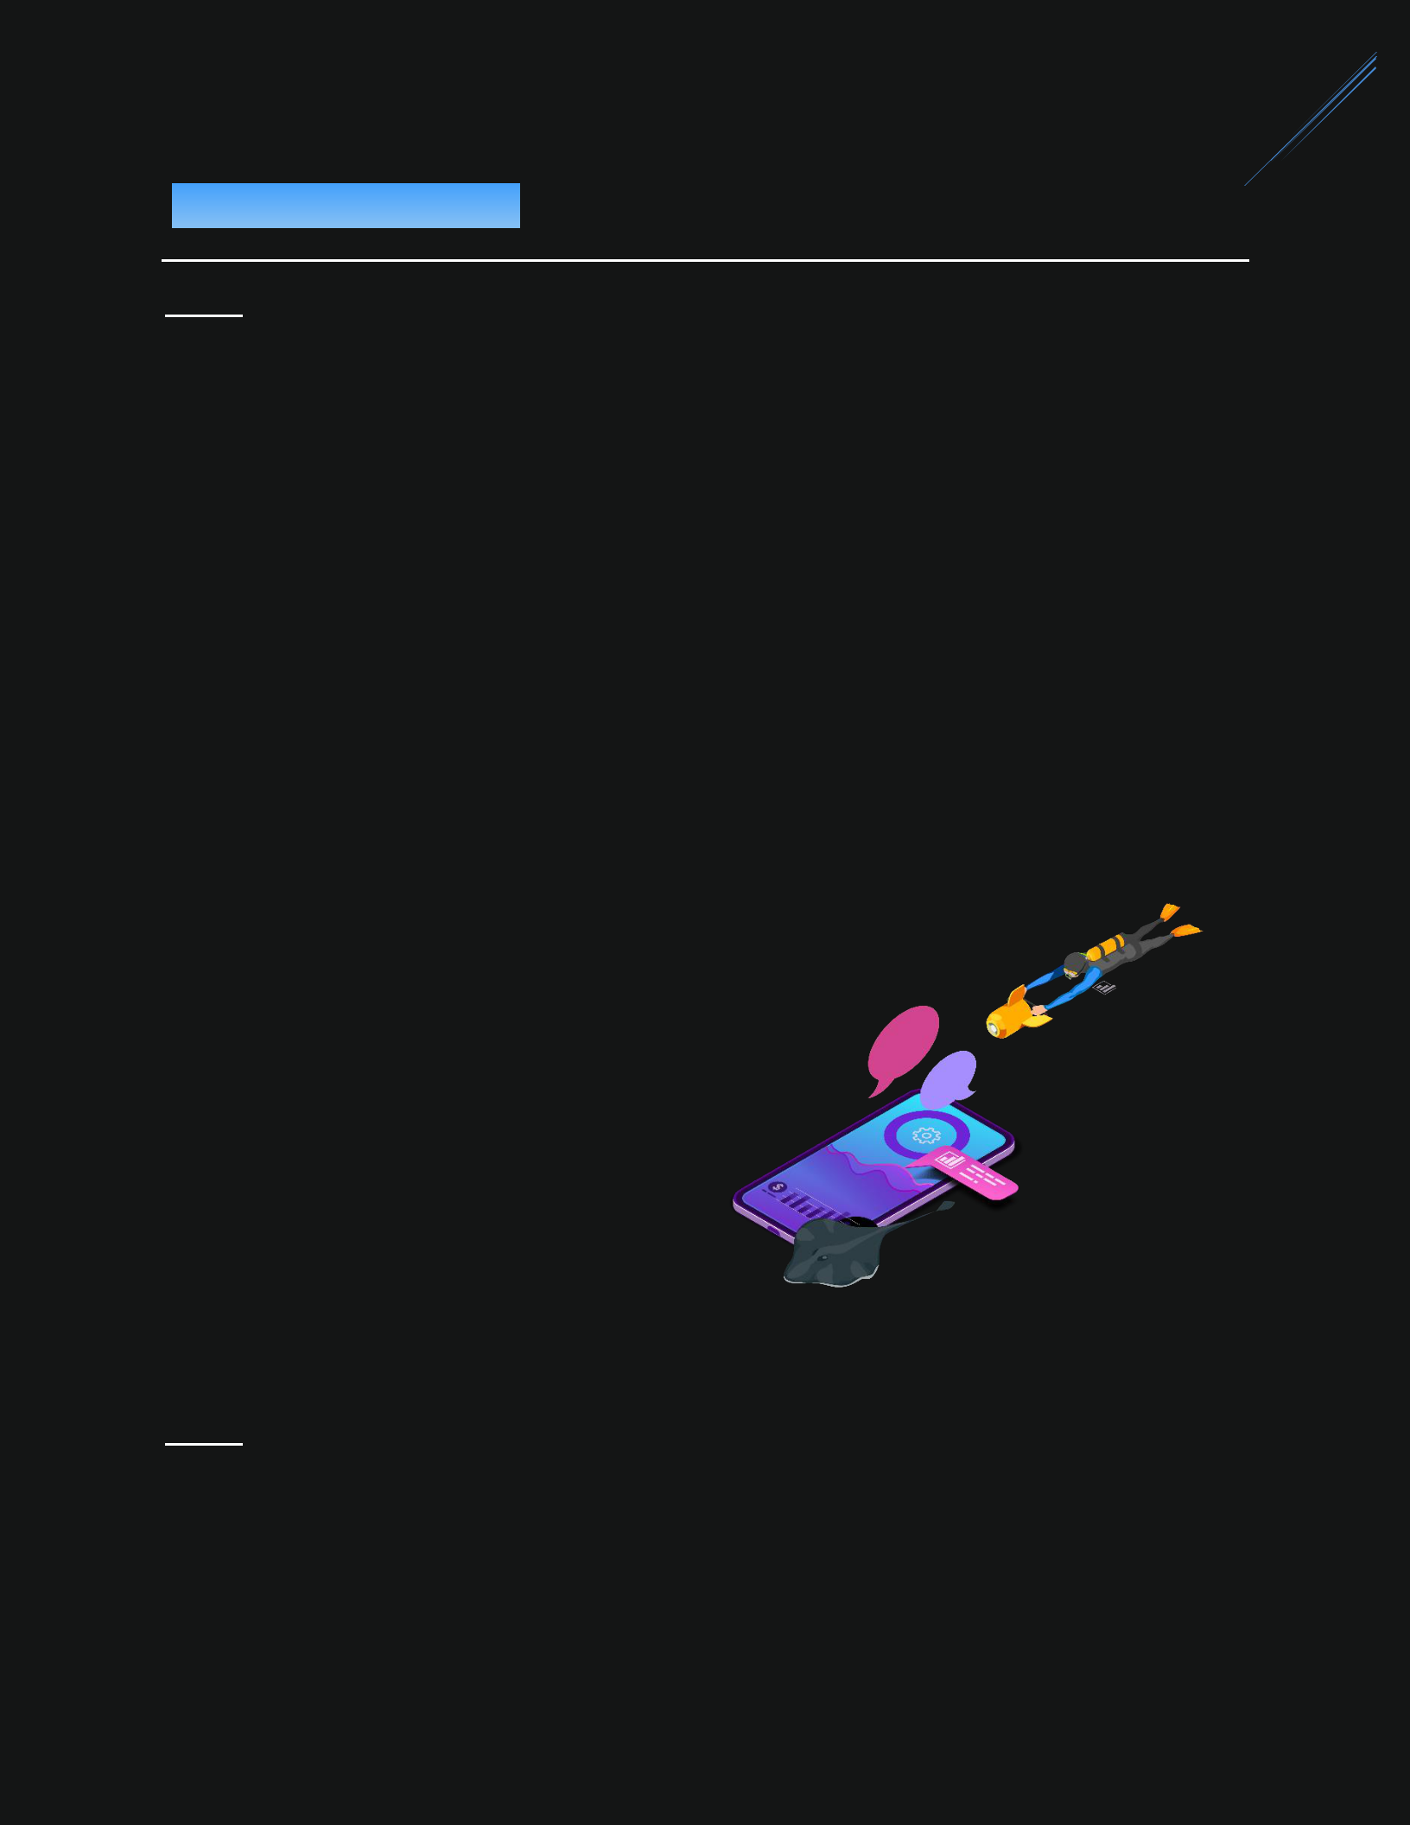17

**Note:** This section will be removed after presale is done.

**The fund from the presale will be used for:**

* 40% for the liquidity. (Liquidity will be locked forever).
* 30% will be used for buyback.

1. 100% of the buyback tokens will be added to the staking reward pool.
   1. This process will be done 6 times (5% each time) over 6 weeks. The first time will be done just after adding the initial liquidity (So the initial price will be higher than the presale price).

* 10% for marketing.
* 5% for the audit.
* 15% for the development.

**Initial token supply:**

* 71.5%: public sale
* 28.5%: liquidity pool

**Note:** The actual number will depend on the number of tokens sold in the presalephase. All of the unsold tokens will be burned.

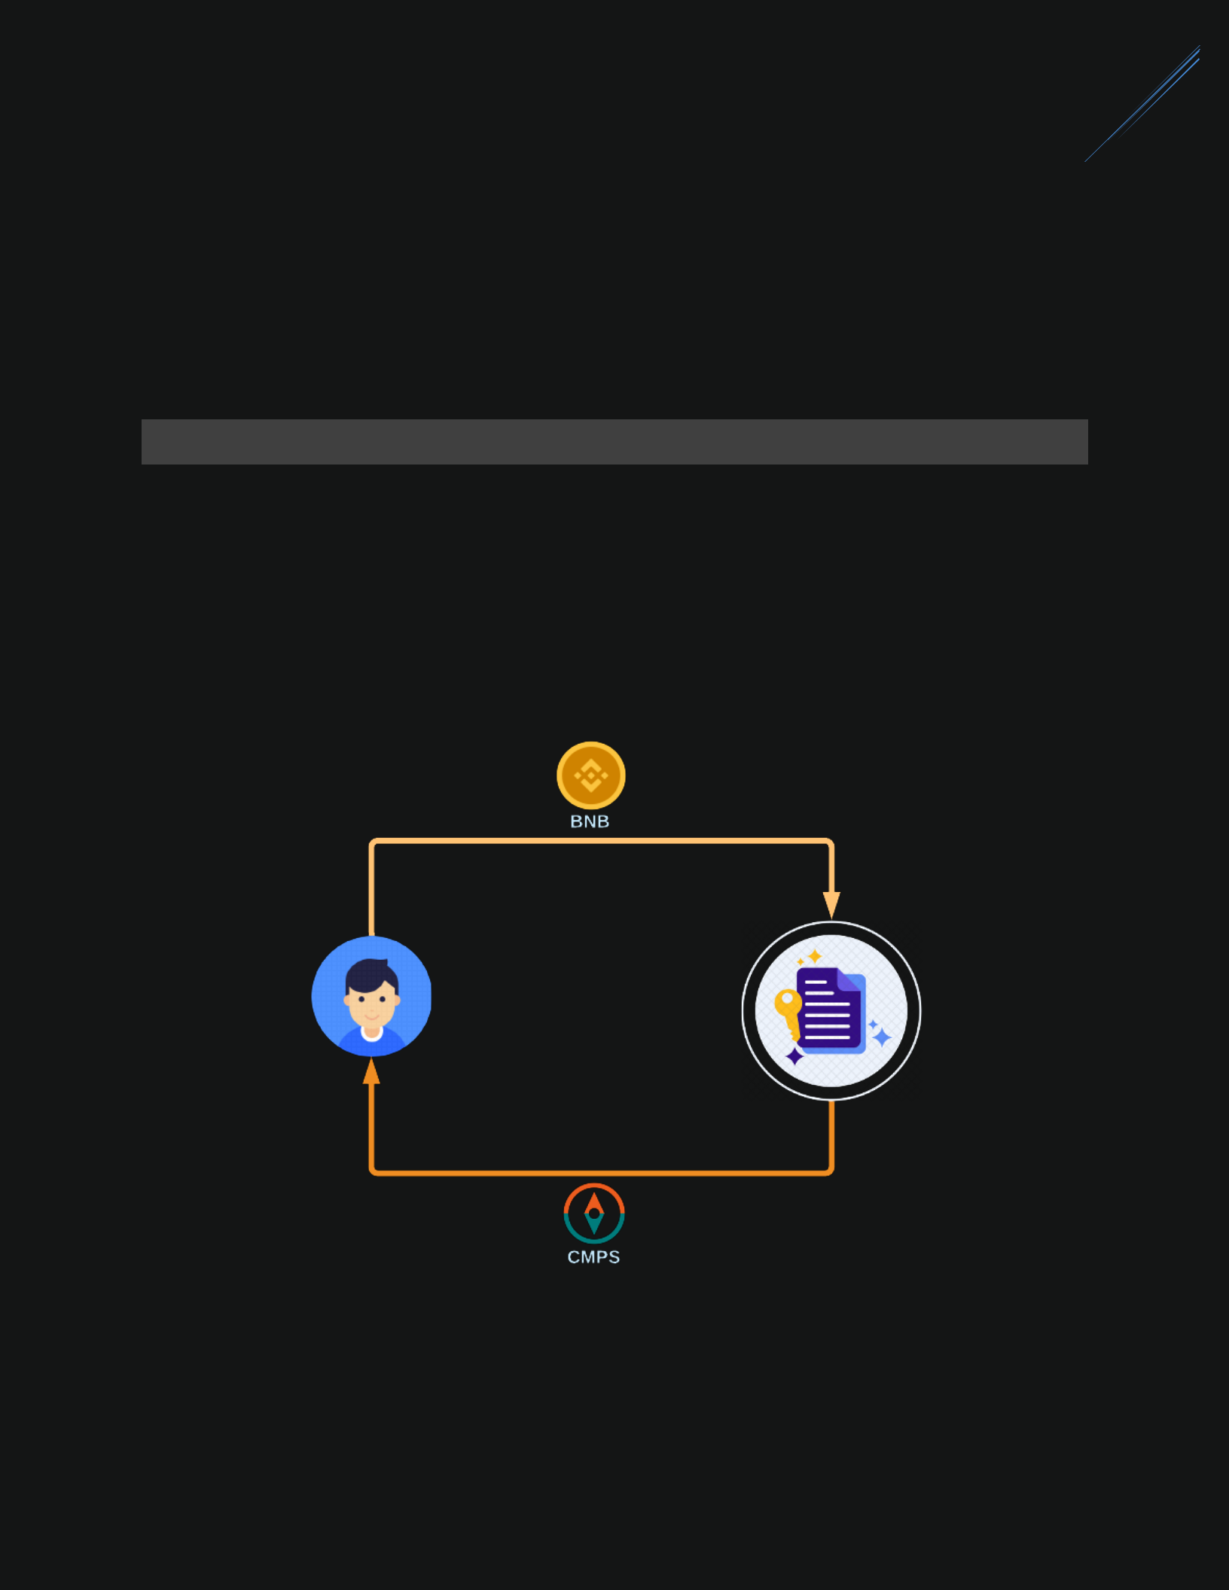18

1. **Getting CMPS – SAT 27 MAR, 01:00 PM (UTC)**

* This process will be done by a presale contract. The community can purchase CMPS using BNB.
  1. **BNB = 1,000 CMPS**
* CMPS can later be swapped to PYX.

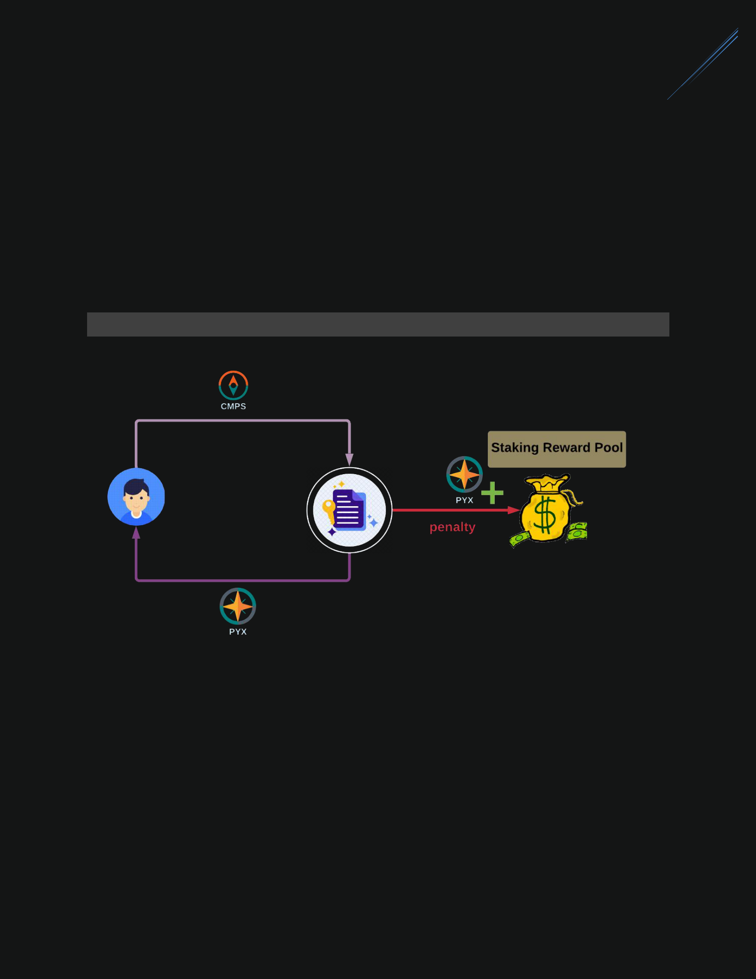19

1. **Swapping CMPS to PYX – WED 31 MAR, 01:00 PM (UTC)**

When the mainnet launch, there will be a swapping page for the users to swap CMPS to PYX. For the first 24 hours, there will be no swapping penalty. After that, the late penalty will be increased by 1% per day. **So make sure to swap on the** **first day.**

= × × %

* The late swap penalty will be added to the “Staking Reward Pool”.
* If CMPS has not been converted by the end of the swap period (100 days), it will be converted to PYX and added to the “Staking Reward Pool”.
* CMPS is only used during the presale phase. It must be swapped to PYX.