

<Project Title>

Final Year Project Report

DT228

BSc in Computer Science

**<Student Name>**

**<Supervisor>**

School of Computing

Dublin Institute of Technology

**<Date>**



Abstract

Declaration

I hereby declare that the work described in this dissertation is, except where otherwise stated, entirely my own work and has not been submitted as an exercise for a degree at this or any other university.

Signed:

_________________________

<Student Name>

<Date>

Acknowledgements

Body text

1. Introduction
   1. Overview of the project and the background behind it.
   2. Project Objectives
   3. Project Challenges
   4. Structure of the document
2. Research
   1. Eg. Research related to identifying the problem that this project solves, research into solution definition
   2. An overview of the technologies evaluated and selected or rejected and the rationale behind the key decisions.
3. Design
   1. Identification of a design methodology including why it was chosen
   2. Design of each of the project components eg: the UI, Network, Project Demonstration, source code layout
   3. Clearly identifying the list of features and use cases supported within the project.
4. Architecture & Development
   1. Overview of the system architecture and a diagram to represent all of the key elements within the architecture.
   2. Details of each component within the project, problems encountered and resolved, challenges overcome or worked around.
   3. Identify key development components;
   4. Identification/explanation of external APIs used versus own code ; List of classes of your code etc .
5. System Validation
   1. Testing
      1. What testing was performed, why it was selected and what are the key use cases within the project.
   2. Demonstration
      1. Identify what features can be demonstrated and show screen shots or reference a video online to show the project demonstration (for audience not at demo)
6. Project Plan
   1. Project Plan analysis and review of how it changed from the initial proposal including explanation of what changed and why, and suggestions on how to address this if the project was repeated.
7. Conclusion
   1. Analysis of the projects key elements identify the key learning obtained from the project and recommendations and suggestions for how the work can be improved on continued into the future.
8. Bibliography
9. Appendix

Introduction

Overview of the project and the background behind it.

With the launch of so many Virtual Reality solutions it is clearly an area of interest and growth in the consumer electronics sector. These devices share a common issue, they can track the position and orientation of their Virtual Reality head mount and controllers, but the player cannot freely interact with the game world by moving in real world space.

Circuit Shock is a game made in unity and written in C#. It uses a custom made Arduino based controller and a Microsoft Kinect to track the players body and controller. These are rendered in-game and in game events can trigger haptic feedback in the controller. The Kinect tracking allows the player to move in real world space and see the results rendered in game. It also allows the player to dodge in game fire in real world space and have this affect the events of the game.

Project Objectives

Creating an interactive VR experience for demonstration purposes. I intend to combine the Microsoft Kinect, Oculus rift, and a custom built Arduino based controller to create a mapping of the player and their gun in-game. This mapping is used to control the players in-game actions and allow the player to control the game using only real life movements. The controller should have a servo motor to allow the game to send haptic feedback to the player. The game will be procedurally generated to allow the player to continue playing for as long as they are capable. There should be only one level, as multiple levels and replay ability are primarily issues for home release games, and Circuit shock has too many hardware requirements for home release to be a viable goal.

Project Challenges

This project has many challenges, from the fact that I couldn’t find a single example of a procedurally generated rail shooter in my research to the fact that I didn’t have a pc powerful enough to run a VR experience to learning how to design and build a custom hardware controller, there were many areas where I had to create my own solutions to proceed. I had to learn to solder and build hardware elements as well as design and implement software to interact with them. I had to research the requirements of VR and build a PC to match.

Structure of the document

<No idea what I’m supposed to say here>

Research

## Background Research

Firstly I researched the effects of VR on players, specifically the negative side effects. Virtual reality sickness is my far the most common side effect of exposure to virtual reality, and many of the causes are outside of my control, however the intensity of in game movement relative to real life movement has been linked to the intensity of the sickness felt(1). As such I decided I should a game type will little to no movement. Furthermore I looked at different controller types common in game systems. The most common types of controllers in the last 30 years and there were two standout controller types, guns and musical instruments. The prevalence of musical Instruments can be attributed to the rise and fall of rhythm games in the 2000s(2). Gun controllers were popularised in arcades in the 1980s and 90s, and fit my requirements very well. They are intuitive to use, and using a little haptic feedback the act of shooting the gun can become a visceral experience. With my controller type chosen it was time to choose a game type for my project, there are rather a number of different types of shooting game types, from fast paced arena shooters like quake to stationary light gun based games like duck hunt. Considering the nature of virtual reality sickness I quickly ruled out the fast paced genres like arena shooter, and focused on those will little or no movement. At first I considered the likes of Space Pirate Trainer VR (3)

Where players were mostly stationary while they were attacked by waves of enemies until they ran out of health. At the same time I looked into older genres that have not been represented recently and I arrived at the rail shooter genre. These were games where the player slowly progressed through a level on a set track and enemies would spawn in the player’s path. It was a good fit for my requirements, limited slow movement in an intuitive game type, and it allowed the player to progress instead of just loading in harder waves of enemies. It was for this reason that I decided on the rail-shooter as my genre of choice.

## Alternative Existing Solutions to Your Problem

There are a number of solutions to the issue of motion control in VR, though these all understandably focus more on broad appeal and the ability to play a number of different game types than on a focused parallel between the real and the virtual. The HTC Vive was the first of these existing solutions I considered, it achieves position and orientation tracking using valves new lighthouse. I had the opportunity to try out the HTC Vive first hand and it was very impressed by the accuracy and intuitive nature of the position and orientation tracking. This is achieved “by flooding a room with non-visible light, Lighthouse functions as a reference point for any positional tracking device (like a VR headset or a game controller) to figure out where it is in real 3D space”(4). This approach however requires attending a training course which costs $2,975(5) , so this approach was ruled out. The PlayStation VR is an upcoming VR headset which will work with the PlayStation move to allow for motion controlled VR. As the PlayStation VR is not out yet and only works with the PlayStation 4 it was quickly decided against. The PlayStation move however was much more interesting. It uses a camera called the PlayStation Eye which “has been programmed to recognize the exact size and shape of the ball on top of the Move remote. Once the Move controller is visible to the camera, it's able to detect the exact positioning of the ball in 3-D space”(6). This use of color and scale was strongly considered but it was simply more efficient to use a simplified version of skeletal tracking with the kinect. Finally users can use the Oculus Rift, which I am using, with Oculus Touch, which I am not. Oculus Touch is an upcoming VR controller which players hold in each hand and it tracks position, orientation, and button presses. As the Touch has not been released yet not much in known about how they work. I found a very similar project by a company called Striker VR, It is the “ARENA Infinity is a haptic VR gun which can simulate various weapon fire modes and other haptic effects”(7) It seems much more similar to the goal of my project than the other VR controllers, however as it hasn’t been released yet It is hard to tell how it works.

## Technologies Researched

I began by researching the Nintendo WII’s remote. It uses a remote and a sensor bar, which is “really nothing more than a shell for two infrared sources”. (8). The remove contains an IR sensor, which uses the two infrared sources to triangulate its position. As I later discovered this is essentially a precursor to valves lighthouse design. This setup has some serious limitations though, primarily that after a certain distance accuracy dropped off and position tracking becomes impossible(8). It also uses a built in accelerometer to track the forces acting on the remote, and uses a data converter to convert this analogue data into digital data for the Wii to use. The Wii gets the orientation of the remote using this and combines this with the position information to form the remotes position relative to the television.(9)

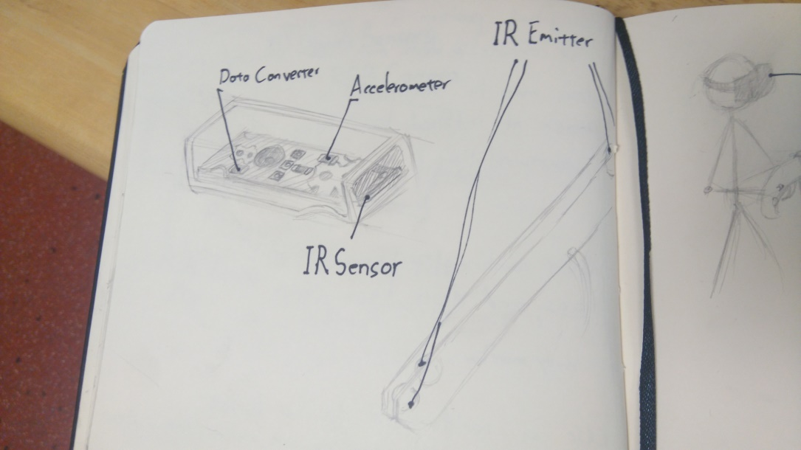

I then began research on how the Microsoft Kinect works. The kinect generates the user’s skeleton position via a two-step process. First it computes a depth map, and then it infers the skeleton from this depth map using machine learning. The depth map is constructed from three data sources, a speckle pattern, the focus of the image, and the stereo images. The speckle pattern is a known pattern, projected onto a scene and then the kinect records the distortion experienced by the pattern to define the 3-d shape. The focus of the image is used with the principle that objects further away from the focus of the camera is blurrier. It uses a special ‘astigmatic’ lens which can change its focus on the X and Y axes. It can cause a projected circle to become an ellipse whose orientation is defined by their depth. Depth from the stereo images uses the parallax between the images to generate the depth of objects in the scene.

With the depth map created stage two begins, inference of the skeleton. This is achieved via the use of a randomized decision forest, a decision tree with far too many possible decision nodes to calculate for each frame, so it uses a random subset of them to derive the body parts from the depth image. It then gets the position and orientation of each body part and creates a skeleton from this.(10)

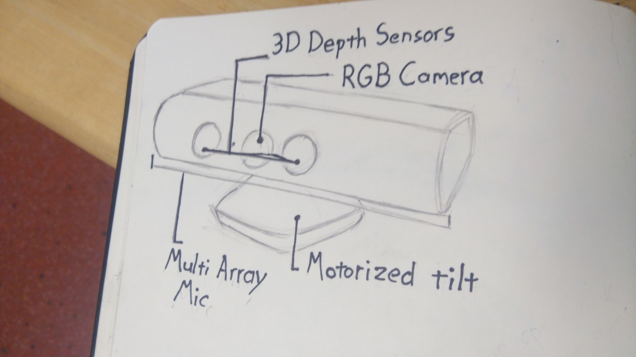

I researched color blob tracking, similar to the PlayStation move, and found a number of reasonable solutions. It is “is one of the quickest and easiest methods for tracking an object”(11) however it requires some limitation to the design scope of the controller itself, in that a number of solid colored objects or sections must be easily visible in order to track the controller. I considered using the Microsoft Kinect for this but quickly discovered that it is much more economic time wise to use the kinect skeleton tracking to track the position of the controller. When it came to orientation tracking I first looked into Zuforia, a target based AR system, however it my use case is not directly supported, so I kept looking. I considered tracking the orientation of the gun using both of the players hands, and I prototyped this approach, however I quickly ran into issues if the player’s hands were ever hidden from the kinect camera. Finally I looked into Arduino based solutions to orientation tracking and quickly found the bno055 sensor, “an intelligent 9-axis Absolute Orientation Sensor”. An Arduino will be housed inside the controller with this and two buttons, one to register pulling the trigger and another to register pumping the handle. These will provide the state of the gun itself, while the kinect manages its location tracking. I also researched 3-d printing for the creation of the controller itself once its design and requirements are finalised.

## Other Relevant Research Done

I spent some time researching game design concepts in an effort to bolster the immersion of my virtual world. I quickly discovered the concept of the magic circle(12) which is the players acceptance of the rules of the game, similar to the suspension of disbelief for a film. The magic circle is important to establish quickly and once broken is extremely difficult to re-establish. My approach will take advantage of this as the gameplay is understood almost fully by the knowledge of how to use a gun and the conceit that you shoot the red things. This allows me to frontload the tutorial and still keeps it short enough to remain interesting. I learned the importance of having the player act through what they need to learn(13), which can be easily achieved (see Game Design Document). With the player ready quickly the primary gameplay can begin, and given that VR headsets tend to block the outside world from the player which greatly lowers the chance that the magic circle will be broken. I also read up on what makes a rail shooter, in essence it is a shooting game where the player does not control the path they are taking through the world(12).

Once I had my technical and game specific research organised I began to research software development methodologies. Firstly I looked into the waterfall software development methodology, I quickly discovered that the waterfall method is simply too rigid to be a viable contender(14), so I quickly moved on. I then looked into the lean methodology, which had a number of attractive principals. I particularly liked the focus on keeping everything changeable and minimalism. I also appreciated the focus on completing as much as possible at any given time, as I have found that often solutions are discovered while working on a project as this is when you have the most relevant knowledge of the project. The lean methodology places huge focus on the customer(15), which is not a good fit for my project as, while I will be conducting some user trails, I lack the time and the resources to research the market heavily. I finally looked at the agile crystal methodology. This foregoes the more strict processes of other methodologies in favour of focusing on the people, skills and communication of the team in question(16). I was drawn to this as I found in my time in work placement that many of the teams using the agile scrum methodologies had tweaked the process heavily to suit themselves, yet they all accepted certain aspects of the methodology which they didn’t like simply because it was part of the methodology. Furthermore for this project I am working on a team of one person with a project manager, so I felt the processes were unnecessary.

Finally I came to choose which game engine to use for the project. I looked into the Unreal Engine, Bryans Game Engine, and Unity. All three Engines support Microsoft Kinect, Arduino interaction, and VR. Unreal Engine and Unity have continuous support both from their developers and online communities and there are many helpful tutorials online to help a new developer get accustomed to the new development environment. Unreal Engine and Bryans Game Engine both use C++ as their primary language. I have been using C++ for nearly three months at time of writing, and I am beginning to come to grips with the language. Unity uses C# and JavaScript as its primary languages. I have experience with JavaScript from various web development modules I have taken over the course of my college career, and I have some limited experience with C#. My language of choice is Java; I have used java as my main programming language in both of my more recent programming modules in college and in both of my internships. C# is very similar to java(17), and I have experience with the Unity game engine myself from my time in the Games Fleadh Games Studio Challenge.

## Resultant Findings and Requirements

Ultimately my research has led me to conclude that the best solution to the issue of translating a real life object into a virtual environment is to use a Kinect to track the players hand position to get position data and an orientation sensor to map the in game gun to the custom haptic controller. This solution has the most economic requirements of those I have researched in terms of time and complexity versus quality of the final product.

I will need to connect an Arduino to handle the orientation sensor and button inputs. I will have to design the controller in auto-CAD and get it 3-d printed. This will allow me to create a solid professional looking controller without having to learn how to actually make one.

The rail shooter seems to be the best type of game to showcase the controller and entertain the players. It downplays the issues of virtual reality sickness while allowing players to move in a time tested manner. The gameplay is intuitive and allows the tutorial to be quick and effective enough to avoid hampering the experience too much while still proving without doubt that the player has the skills required to play.

I will be using the Agile Crystal methodology and breaking my time into two week sprints. This will help mitigate the considerable risk that comes from combining disparate technologies in a new a novel way. I will be using the Unity game engine to create my game.

Design

Identification of a design methodology including why it was chosen

I used a bottom up design methodology as I had to begin with the solution to my hardware requirements, I started by designing a system where the game would be able to track the position and orientation of a gun and built on top of it. First I built on skeletal tracking to allow the player to move in the game world space. Then I built a system to move the player along a path controller by the game. Then I built enemies capable of interacting with the player. Finally I built a system to procedurally generate content for the player using these systems.

Design of each of the project components

Description of the design of the gun, with diagrams.

Description of the movement system, not sure if I can diagram this.

Description of the enemy behaviour, preferably with state transition diagrams, provided I manage to get the state machine design pattern implemented.

Description of the procedural generation system.

Clearly identifying the list of features and use cases supported within the project.

<Not sure what to put here, should I just list features and ignore the use cases?>

Architecture & Development

Overview of the system architecture and a diagram to represent all of the key elements within the architecture.

Description of the architecture of the game

-level builder creates rooms

-rooms contain waypoints to guide the player, these are linked by the level builder

-game tracker calls the rooms generate enemies function, passing in a number which is the total value of enemies the room can spawn.

-player is controlled by multiple inputs

-description of the gun controller

-camera and hitbox are moved by the kinect

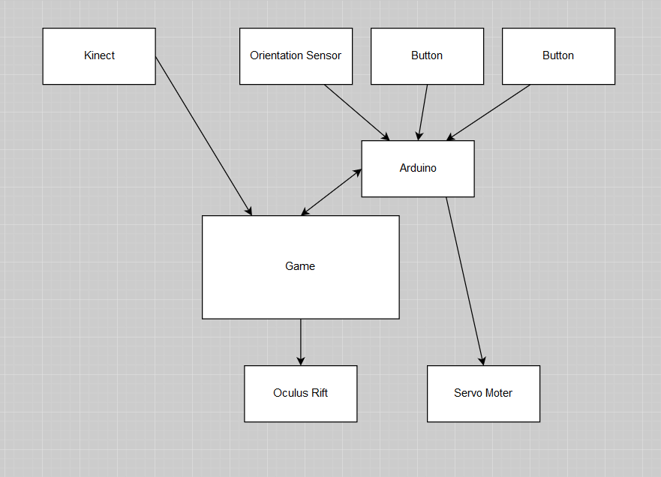

Details of each component within the project, problems encountered and resolved, challenges overcome or worked around.

Gun:

Difficulty sourcing the bno controller

Bno controller and unity uses a different orientation vector system

Offsetting the bno readout to match the orientation of the Kinect and oculus rift

Securing the internals, learning to solder

Kinect:

Jitter, implementing a simplistic jitter filter

Kinect couldn’t move camera, had to make the camera follow invisible ‘head’ object

No confidence score, won’t admit it can’t see hand, had to switch to a pistol controller

Placing the gun correctly, using the orientation sensor and bounds

Oculus rift:

Matching the orientation with the Kinect

Movement:

No proven design pattern to allow for stopping to fight, had the rooms themselves direct the player

Nausea, placing the player in a cart

Identify key development components;

<How is this different from the previous times I listed the components? Is it necessary?>

Identification/explanation of external APIs used versus own code ; List of classes of your code etc .

<Unity engine?>

<should I include the fact that you gave me the code for communicating between unity and the arduino?>

Kinect SDK

Mention that I edited ‘CubemanController’ script to introduce a crude jitter filter and to make it work for a first person cubeman.

<mention Oculus SDK? I call the reset orientation function of the oculus sdk at game start and that’s all>

Player mover

WaypointMovementController

cameraFollowHead

handSelector

handsTest (to be renamed gunController)

playerMove

shooty(to be renamed arduinoController)

spawnObj

splodeyChild(has to be renamed, not sure what yet)

splodeyParent(same)

levelBuilder

RoomController

enemySpawner

handSelectionController

loadScene

healthTracker

destroyAfterX

lookAtTester(to be renamed lookAtPlayer ot lookAtTarget)

splodeWhenShot(I have got to stop using the ‘word’ splode)

spawnShooter

spinner

barSpawner(to be renamed bat spawner)

batFlight(possibly rename flyToPlayer or flyToTarget)

< I’ll have more to add when I have the enemy spawning controller and (hopefully) the state machine design pattern implemented>

System Validation

Testing

Hardware testing via the Serial monitor in the arduino idk.

Personal functional testing via the Oculus rift, Kinect and gun

Personal functional testing via the unity idk.

User trials

Implementing the cart because of neasuea

Implementing the hand selection based on feedback

<Will have charts and more conclusions after more extensive user testing this weekend>

Demonstration

<will link to youtube video of me playing picture in picture>

Project Plan

Project Plan analysis and review of how it changed from the initial proposal including explanation of what changed and why, and suggestions on how to address this if the project was repeated.

I gotta reword this from what I will use to what I have used

I am going to use the agile crystal methodology with 2 week sprints as this allows a sizeable chunk of time to spend on feature development without leaving them so long that I risk losing several weeks being stuck working on a fruitless feature that was outside my capabilities. I have ordered my backlog of features to allow for a certain margin of error when planning my sprints meaning that features can run long if I decide it’s worth the risk, but it must be a conscious decision. My team consists of myself and my project manager, and we meet face to face for weekly meeting as per the agile methodology. I also intend on using working software as my measure of progress as per the same.

I am handling design and prototyping first in an attempt to reduce the risk involved in my project as many of the different aspects run the risk be being untenable. Once I have the various prototypes working I will being working on getting the minimum viable product ready, this will help to ensure I can finish the project, while leaving a few sprints to refine and add to the minimum viable product. This will allow me to work on the various features that would be nice but are not required without risking the required ones. Once the minimum viable product has been completed I will begin user trails at the end of each sprint before planning the next sprint. This will allow me to accept some customer input and change the plan accordingly, but only after the vast majority of the risk associated with the project has been removed as the minimum viable product has been completed.

Mention having to switch from two handed gun to pistol.

Mention how sometimes college work made it very hard to follow two week sprints

I would map out all my college submissions and plan around them. I would put a greater focus on sourcing the required components earlier. I would spend more time early on researching the components, discovering I couldn’t allow for hidden body parts was a nasty surprise.

Conclusion

Analysis of the projects key elements identify the key learning obtained from the project and recommendations and suggestions for how the work can be improved on continued into the future.

<can I really get away with listing the component parts of my project again?>

I learned a lot about researching, software and hardware design, time management, and working around hardware limitations.

I would implement the ability for unity to control how long the haptics in the gun lasted. I would implement a number of environmental obstacles that must be avoided by moving in real space. I would implement a number of different gun types that could be selected by using the players free hand to press buttons on their cart. I would have these different guns cause different haptic results in the gun. I would also implement more enemy types.

Bibliography

1. Pappas S, 20 LSC| A, ET 2016 01:15pm. Why Does Virtual Reality Make Some People Sick? [Internet]. Live Science. [cited 2016 Nov 23]. Available from: http://www.livescience.com/54478-why-vr-makes-you-sick.html

2. The History of Music Games [Internet]. IGN. [cited 2016 Nov 23]. Available from: http://www.ign.com/articles/2014/10/21/the-history-of-music-games

3. Home [Internet]. Space Pirate Trainer. [cited 2016 Nov 21]. Available from: http://www.spacepiratetrainer.com/

4. Buckley S. This Is How Valve’s Amazing Lighthouse Tracking Technology Works [Internet]. Gizmodo. [cited 2016 Nov 20]. Available from: http://gizmodo.com/this-is-how-valve-s-amazing-lighthouse-tracking-technol-1705356768

5. Lang B. Valve Opens Vive’s Tracking Tech to Third-parties for Free, Details Dev Kit for Licensees [Internet]. Road to VR. 2016 [cited 2016 Nov 20]. Available from: http://www.roadtovr.com/valve-third-party-lighthouse-api-steamvr-tracking-htc-vive-dev-kit-license-royalty/

6. How PlayStation Move Works [Internet]. HowStuffWorks. 2010 [cited 2016 Nov 23]. Available from: http://electronics.howstuffworks.com/playstation-move.htm

7. Lang B. Striker VR Shows off Working Prototype of ARENA Infinity Haptic VR Gun [Internet]. Road to VR. 2016 [cited 2016 Nov 21]. Available from: http://www.roadtovr.com/striker-vr-arena-infinity-v1-prototype-haptic-vr-gun/

8. Making Sense of the Sensor Bar [Internet]. IGN. [cited 2016 Nov 20]. Available from: http://www.ign.com/articles/2006/11/29/making-sense-of-the-sensor-bar

9. Chad Tower. How the Wii Remote Works [Internet]. 2008 [cited 2016 Dec 1]. Available from: https://www.youtube.com/watch?v=ETAKfSkec6A

10. MacCormick J. kinect. pdf, 09.06. 2011. Does Kinect Work.

11. Color Object Tracking [Internet]. [cited 2016 Nov 20]. Available from: http://www.roborealm.com/tutorial/color_object_tracking_2/slide010.php

12. Adams E. Fundamentals of Game Design. 3 edition. Berkeley, CA: New Riders; 2013. 576 p.

13. Extra Credits. Extra Credits: Tutorials 101 [Internet]. 2012 [cited 2016 Nov 23]. Available from: https://www.youtube.com/watch?v=BCPcn-Q5nKE

14. Software Development Methodologies [Internet]. [cited 2016 Nov 24]. Available from: http://www.itinfo.am/eng/software-development-methodologies/#chapter14

15. Poppendieck M, Poppendieck T. Lean Software Development: An Agile Toolkit. 01 edition. Boston, Mass.: Addison Wesley; 2003. 240 p.

16. Crystal Clear: A Human-Powered Methodology for Small Teams: Amazon.co.uk: Alistair Cockburn: 0785342699470: Books [Internet]. [cited 2016 Nov 24]. Available from: https://www.amazon.co.uk/Crystal-Clear-Human-Powered-Methodology-Small/dp/0201699478/ref=sr_1_1?ie=UTF8&qid=1480001888&sr=8-1&keywords=crystal+methodology

17. C# and Java: Comparing Programming Languages [Internet]. [cited 2016 Nov 24]. Available from: https://msdn.microsoft.com/en-us/library/ms836794.aspx

Appendix `

**Controller Design Document**

**Technologies Involved**

**Kinect**

- The Microsoft Kinect will track the position of the gun relative to the player in real space, and transfer this information to unity to map the virtual gun to. It will favour the hand closer to the player’s body where it can, and if it can track both hands it will track the distance between them.

If it loses track of the players close hand it will use the far hand and the orientation to generate the position of the close hand, this should reduce graphical errors greatly.

**Arduino**

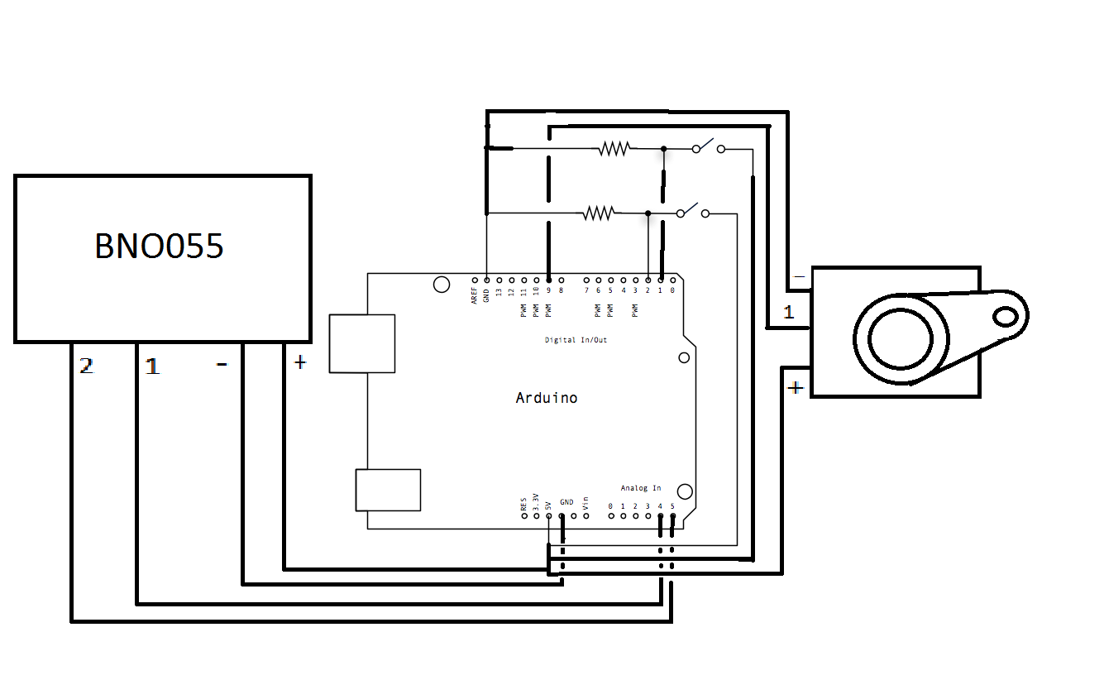

- The gun will use three circuits to track the players input. Two of these will be simple button circuits, one mapped to the virtual guns trigger, and the other linked to the in game guns reload function. These buttons will be controlled by the controllers trigger and pump respectively. The third input will be a BNO055 Absolute orientation sensor. This orientation tracking will be mapped to the in game guns orientation. The in controller output will be handled by a servo motor to provide haptic feedback.

**GUN DESIGN**

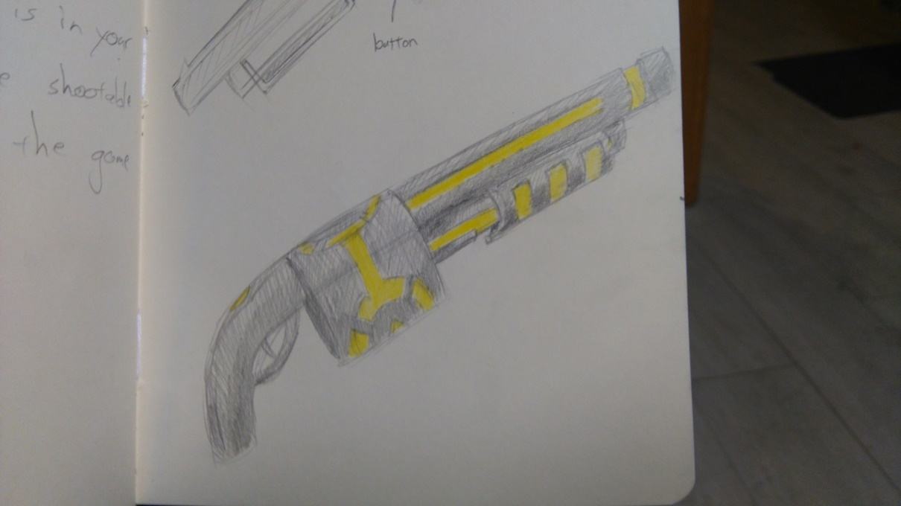**External**

**Internal**

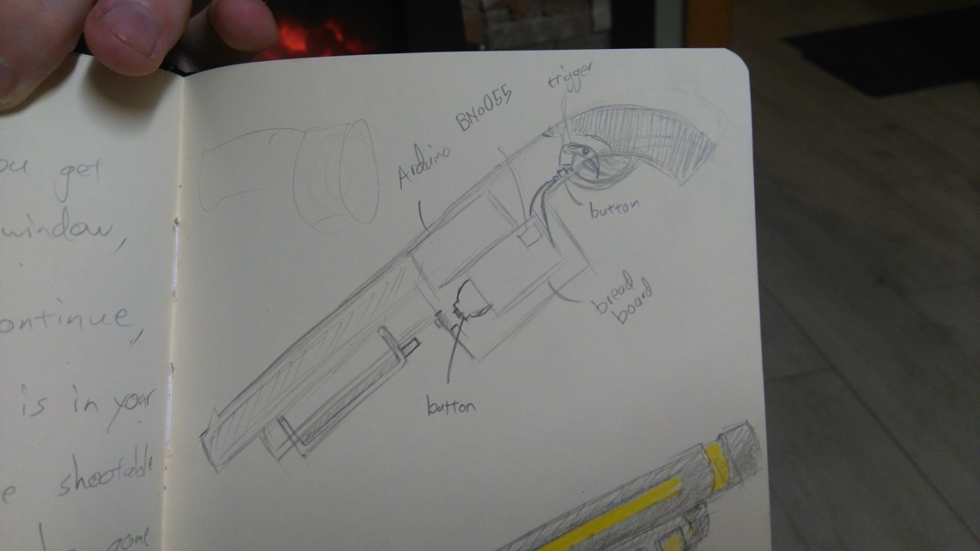

-The physical shell of the gun is modelled after a tommy gun. This was chosen as the large circular section in the middle of the gun provides fantastic space to house internal electronics. The trigger and pump will be placed in a manner which presses the button when extended to their limit allowing the player to control the button inputs via the controller itself.

Virtual Entanglement

**Game Design Document**

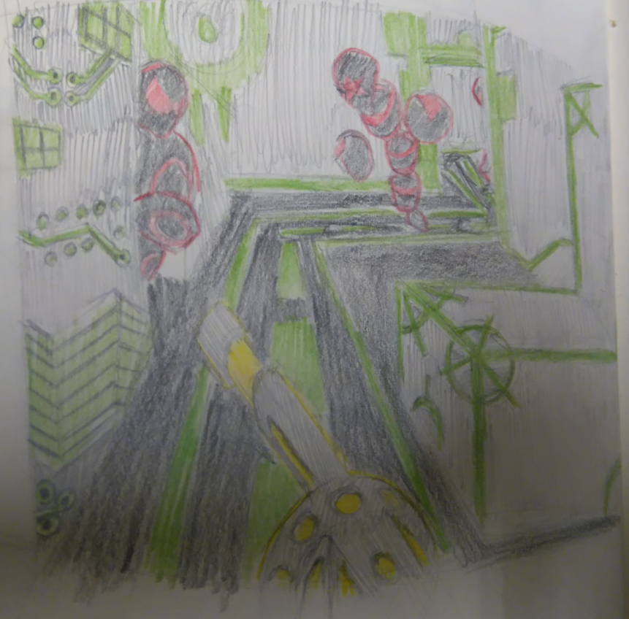

Revision: 0.0.0

GDD Template Written by: Benjamin “HeadClot” Stanley

Special thanks to Alec Markarian

Otherwise this would not have happened

Overview 18

Theme / Setting / Genre

Core Gameplay Mechanics Brief`

Targeted platforms

Project Scope

Influences (Brief)

- House of the Dead

- Tron

- Call of Duty

The elevator Pitch 19

Project Description (Brief):

Project Description (Detailed)

What sets this project apart?

Core Gameplay Mechanics (Detailed)

- Gun Tracking

- World Generation

- Enemy Generation

Story and Gameplay 20

Story (Brief)

Story (Detailed)

Gameplay (Brief)

Gameplay (Detailed)

Assets Needed 21

- 2D

- 3D

- Sound

- Code

Schedule 22

- Sprint 1

- Sprint 2

- Sprint 3

- Sprint 4

Concept Art 23

# 

# Overview

## Theme / Setting / Genre

- Action

- Virtual Reality

- Rail Shooter

## Core Gameplay Mechanics Brief

- Gun Tracking

- World Generation

- Enemy Generation

## Targeted platforms

- PC

## Project Scope

- Less than 200 euro

- 4.5 Months

## Influences (Brief)

### House of the Dead

Arcade Rail Shooter Video Game

- House of the dead was a series of rail shooters developed by Sega beginning in the early nineties. As the series progressed they had a focus on novelty in their gun controllers. Furthermore the house of the dead series ignored the cover mechanics popular in the genre in favor of constant progression. This series is a close match for Virtual Entanglement in terms of its functional restrictions and requirements.

### Tron

Sci-Fi Action Adventure Movie

- Tron is a major stylistic influence, the dark panels and clothes on everyone and everything with bright stripes of color is both relatively easy to implement and extremely useful in terms of clueing the player into the intent of different in game entities. The clean high contrast visuals achieve an excellent economy of time required to aesthetic achieved. This is strictly a stylistic influence, as Virtual Entanglement will not have the budget or the time to introduce any real story elements.

### Call of Duty

First Person Shooter Video Game

- Call of Duty is one of the most popular first person shooter series of all time. It stripped away many of the mechanics common to first person shooters, in favour of streamlining the core combat engagement. Specifically it introduced regenerating health, which allows for the player to experience peril when their health is low but they can return to the fray after a few seconds of hiding away to restore their health.

## The elevator Pitch

-VR Tron with a gun instead of a bike.

# What sets this project apart?

- Virtual Reality

- Specific Controller plugin

- Procedural Generation

## Core Gameplay Mechanics

### Gun Tracking

-Players will use an in game gun mapped to a real life gun controller, this will be their only way to interact with the game world.

It will use the Microsoft Kinect to tack the position and a BNO055 sensor to track the orientation of the gun.

### World Generation

- The maps players progress through will be procedurally generated each time the game is played. This will keep subsequent playthroughs engaging and prevent players from simply learning off the best way to deal with each area. A path finding script will set the players path through the game world which they will progress along at a constant rate.

### Enemy Generation

- Enemy type and placement will be chosen by a procedural generation algorithm. Certain enemies will have a higher chance to spawn in certain areas, and the frequency and difficulty of enemies spawned will increase with time.

# Story and Gameplay

## Story (Brief)

You are tasked with finding the root of a virus in the computer and destroying it.

## Story (Detailed)

You are a member of the Virtual Corps branch of the military, a select unit specialising in the use of the Entanglement Rifle, or the Ent Rifle for short, to protect vital computer systems from invasion. This rife exists in both the real and the virtual world, allowing members or the corps to interact directly with the virtual world. Players take control of members of this corps from the moment they enter the virtual world.

## Gameplay (Brief)

The player will progress along a track and fight off procedurally generated enemies in a procedurally generated environment.

## Gameplay (Detailed)

Gameplay can be split into two main sections, the tutorial and the core game.

Tutorial:

The player will being in a room with a closed door. This room will contain a window, through which the players can see people with guns similar to their own being attacked by the games enemies. In order to progress the player must shoot the door, this proves beyond doubt that the player knows how to shoot their gun. Once the player has left the starting room they themselves will be met with some the games enemies, as many enemies as the guns clip can hold, and another closed door. If the player can make it through this room we know they can both shoot and reload, both of the required skills to progress through the game.

Core:

The player will continue along a set track at a set rate. The world they progress through will be procedurally generated, with procedurally generated enemies placed throughout. The player will continue along their path with enemies attacking them when they get to close, they will have to shoot the enemies before their attacks land on the player.

When they are hit the players will lose health, which will be represented by their vision darkening and bloodlines being added at the edges of their vision. After a couple of seconds of not taking damage the player will recover any damage taken.

Players can gain combo points for each enemy slain without taking damage, these will both increase the points gained from killing enemies and increase the scale of the enemy’s death animation, providing both a functional and perceived value to the combo points.

# Assets Needed

## 2D

- Textures

- HUD Elements

## 3D

Characters List

- Flying Enemy

- Large Enemy

- Crawling Enemy

Environmental Art Lists

- Skybox

- Rooms

- Corridors

## Sound

Sound List (Ambient)

- Music

- Enemy Grunts

Sound List (Player)

- Character Hit / Collision Sound list

- Pained grunt

- Character on Injured / Death sound list

- Game over theme

## Code

Character Scripts (Player Pawn/Player Controller)

- Path finding script

- Movement script

- Object tracking script

- Gun controller script

- HUD script

- Player state/stats script

Ambient Scripts (Runs in the background)

- World generation script

- Enemy placement script

NPC Scripts

- Wander script

- Attack script

**Concept Art**

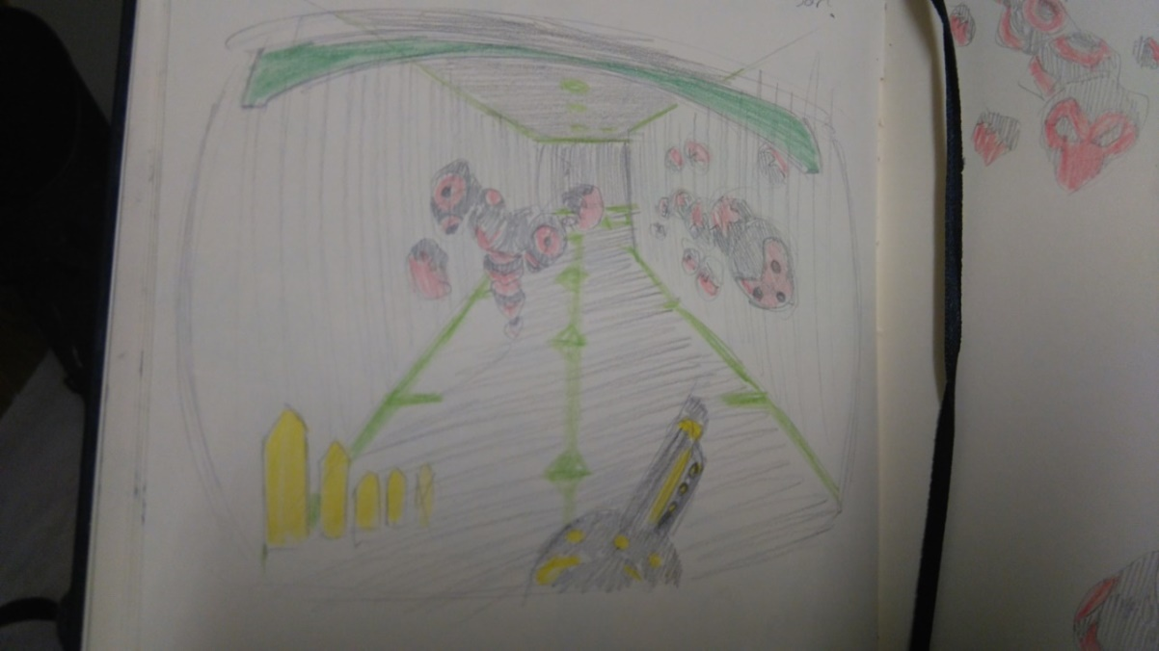**In game concept with heads up display (HUD)**

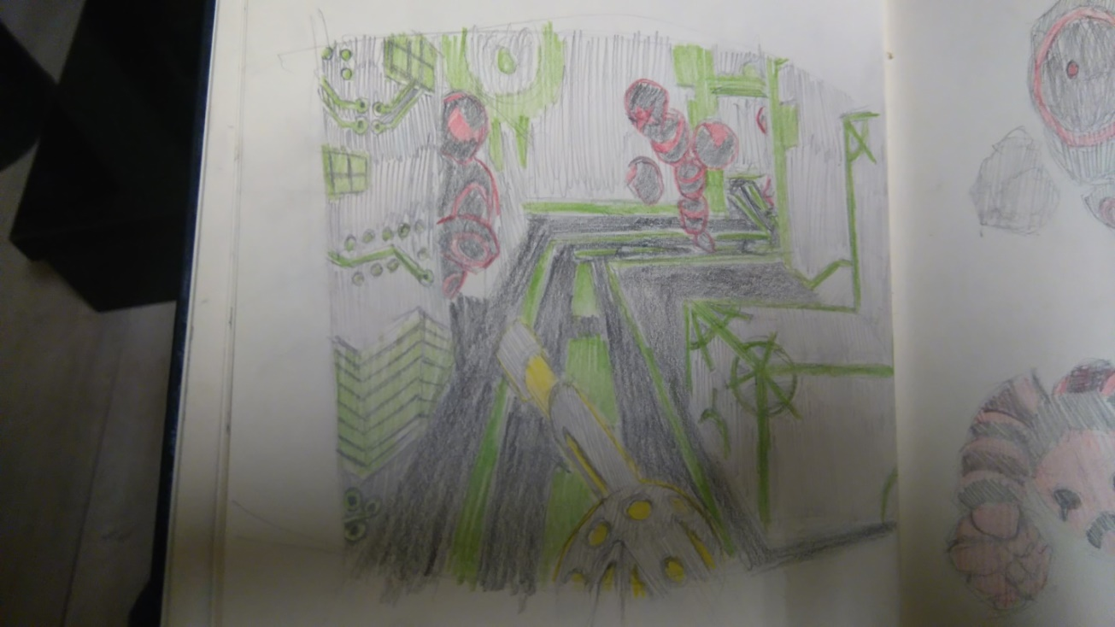**In game concept without HUD**

**Enemy concept art**

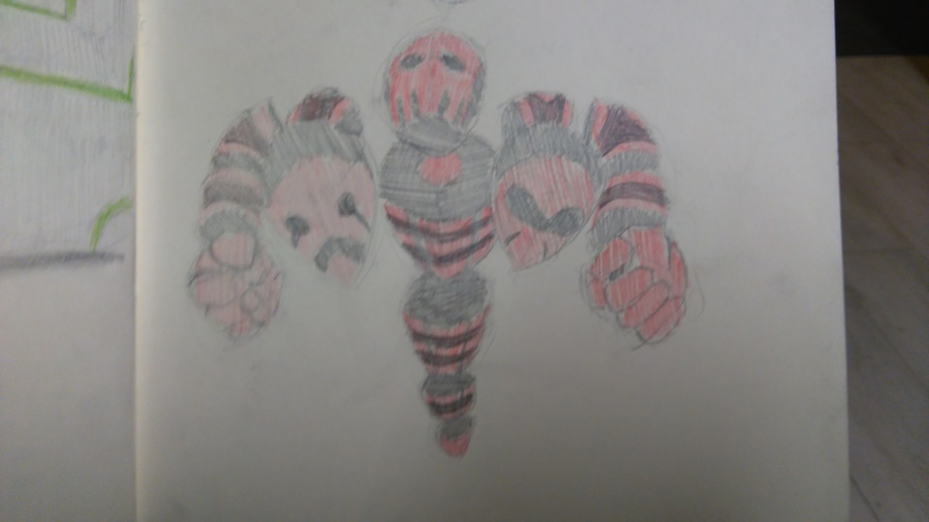

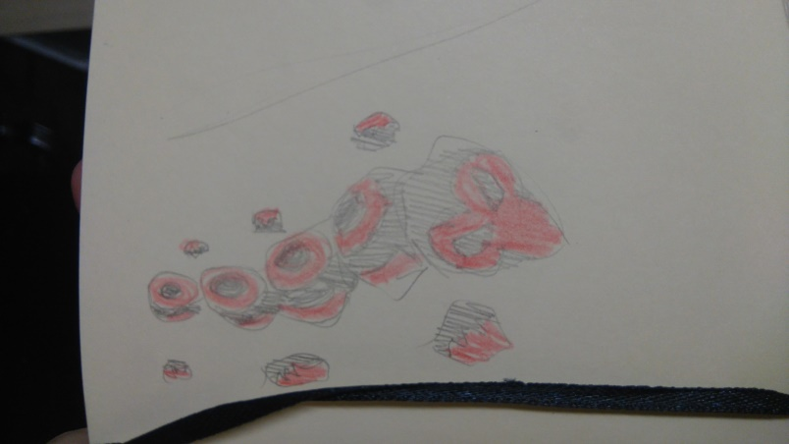(Above: Large three headed enemy. Possibly a boss)

(Left: Crawler concept. Can crawl on walls and ceilings)

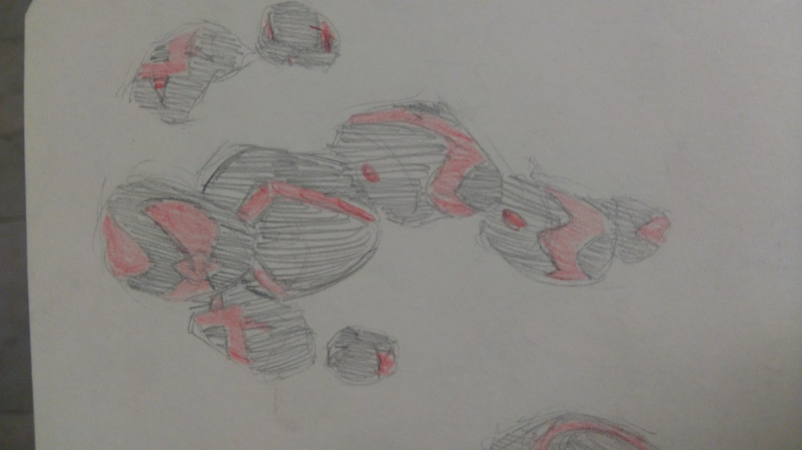(Left: Ranged enemy, can fire ranged projectiles at the player.)

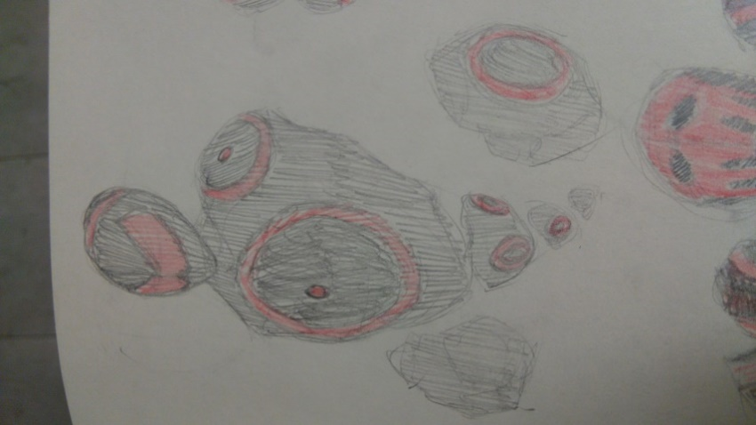

(Right: Melee enemy, can walk at player and damage them on contact.)