ENGINEERING MASTER DOCUMENT · B.TECH TEAM
Refill, built
How Refill is made, end to end: the architecture, the database, the frontend, the stack, the algorithms, the tests, and exactly what works today.
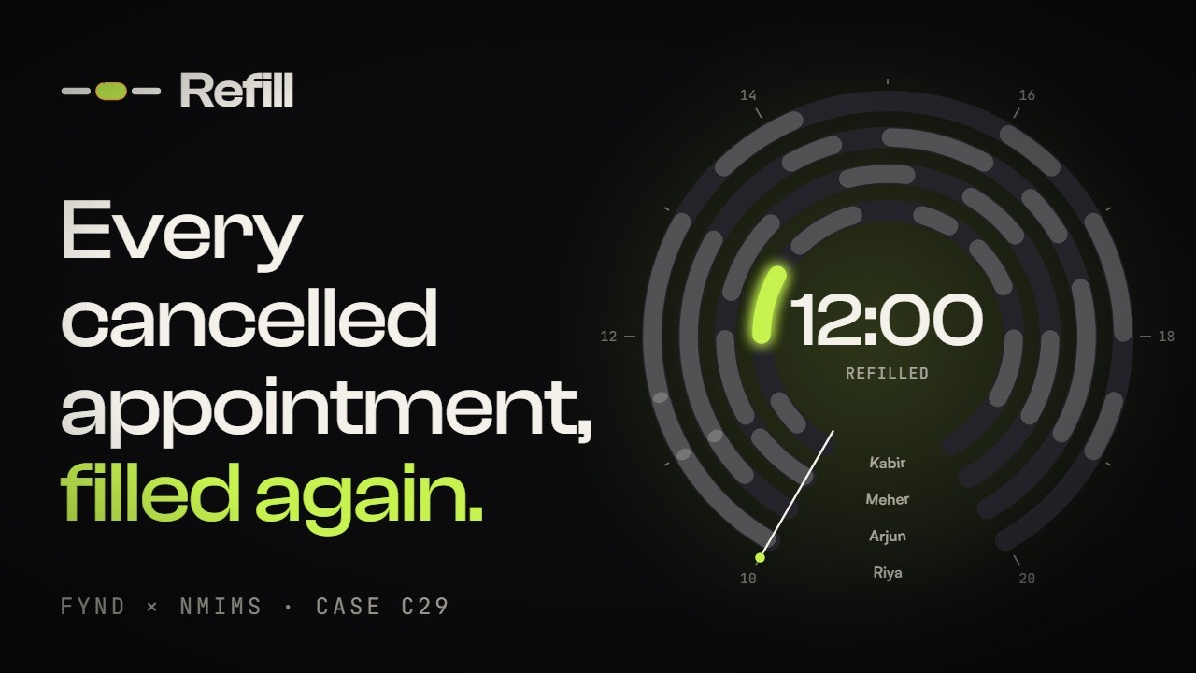

Case | C29 · Appointment Recovery Desk · Fynd × NMIMS Hyderabad, 17–18 October 2026
Live app | fillthechair.vercel.app · story page /splash · proof page /#/lab
Code | github.com/sirgreaseball/refill · main at commit e5daa23 (18 Oct 2026)
Film | youtu.be/5BfsKofkIHw (unlisted, 3:29)
Team | Dhruv Sonar (lead build) · Vedanth Raj (reliability, demo script) · Parth Kachhara (scenarios, real-phone tests, Lab) · Chirag Seervi (salon data, market shocks, splash page) · two MBA teammates
Data | Every name, price and booking in the demo is synthetic.

CONTENTS
What is in this document
Refill on one page 4
The three case checks and where each is proven 4
Refill in numbers 4
Architecture 5
Thin client, thick database 5
One request, step by step 6
Where state lives 6
The stack 7
Repository map 8
The rules engine and its algorithms 10
Data model 10
Validation: a bad file never gives a half-right answer 10
The fit test: one reason, in a fixed order 10
Matching: greedy, in queue order, nobody twice 11
Races: the same rule as the database 11
Notice: normal, late or past 11
Words for people 12
Worked example: Kabir's 12:00 opens up 12
Scenario files and the organiser fixture 12
The database 13
Security model 13
Tables 13
Indexes and constraints that carry guarantees 14
Concurrency: how one booking per slot is guaranteed 15
Offers: hold window, cap and lifecycle 16
Rate limits 16
Time: demo clock and live clock 17
Demo days and live businesses 17
Migrations, in order 17
Function catalogue 18
The frontend 19
Routes and who sees them 19
Data flow in the app 19
Accounts and sign-in 19
Design system 20
PWA, offline and headers 21
Performance and accessibility 21
The Lab and the splash 21
Testing and verification 23
Deployment and operations 24
Run it locally 24
Release rules the team follows 24
Observability 24
What works today 25
Known limits and the next engineering steps 25
Reference 27
Codes you will see 27
Technical questions judges ask 27

01 · SUMMARY

Refill on one page
Refill is an appointment recovery desk. When a client cancels, it offers the empty slot to the waiting clients who fit it and said yes to messages. The first to accept gets it, and only one booking can ever land in a slot. Every decision is logged with a reason.
The demo business is a salon (Kesar Salon, Jubilee Hills), but the wording and the data model are business-neutral: staff, services, clients. A tutoring centre and a spa already run on it as test businesses.

The three case checks and where each is proven
Check (points) | How Refill guarantees it | Proof
A 60-minute request cannot occupy a 30-minute slot (10) | reasonFor() returns DURATION_TOO_LONG; the database function fit_reason() re-checks inside send_offers() and again inside accept_offer(). | Tests C01, C02 · Lab check 1
Two requests for one slot: one confirmed booking, one waitlist entry (10) | accept_offer() locks the offer, the slot and the client row in a fixed order (FOR UPDATE). A partial unique index allows one confirmed booking per slot. | Tests C04, C09, C14, C15 · npm run race · Lab live race
A client without contact consent is excluded from outreach (5) | Consent is checked first; null (never asked) counts as no. Re-checked when offers are sent and again at the moment of booking. STOP revokes every open offer. | Tests C05, C06, C12 · Lab check 3

Refill in numbers
What | Count
Database functions (PL/pgSQL and SQL) | 83
Tables (row level security on, no policies) | 13
Migrations, applied in order | 11 (001 to 011), about 3,000 lines of SQL
Frontend source (TypeScript, TSX, CSS) | about 8,800 lines
Unit and scenario tests (npm test) | 51 passing
Live database checks (npm run dbtest) | 28
Cross-role flow checks (npm run flowtest) | 14
Race test (npm run race) | 8 simultaneous taps, 3 runs, exactly 1 booking each run
Main JavaScript bundle | 274 kB raw, 86 kB gzipped; pages load lazily

02 · THE SHAPE OF THE SYSTEM

Architecture
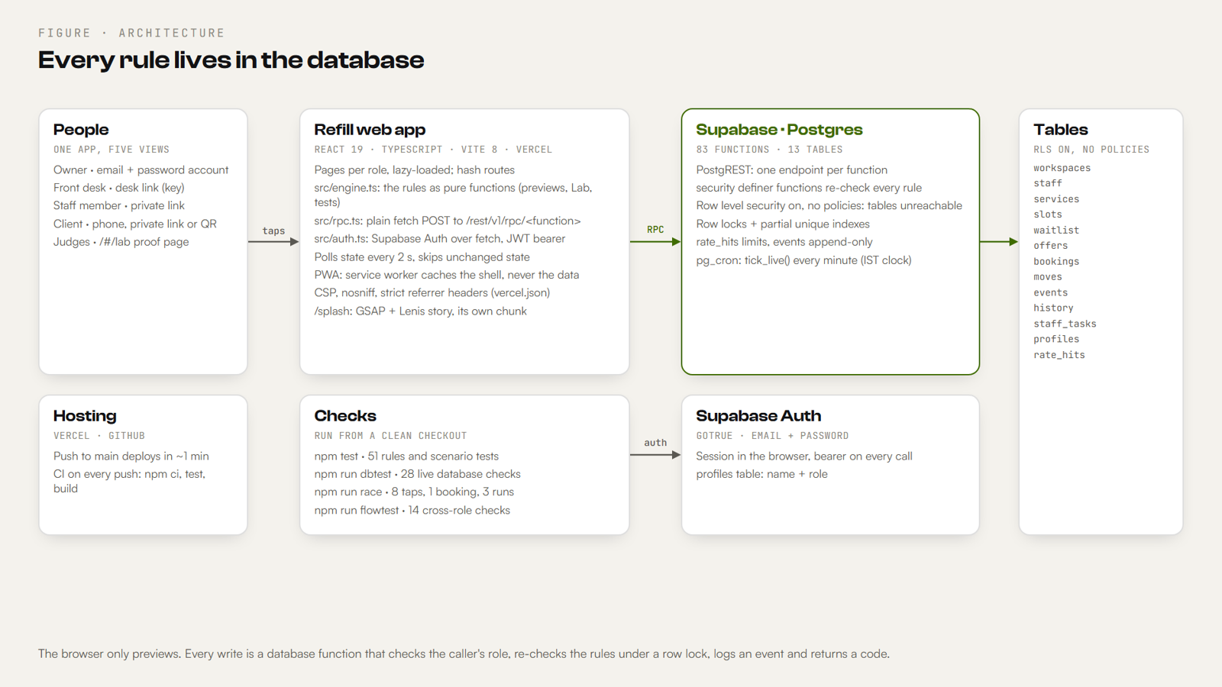
Figure 1. The browser previews; the database decides. Every write is a function that checks the role, re-checks the rules under a row lock, logs an event and returns a code.

Thin client, thick database
Refill has no application server of its own. The web app is a static single-page app on Vercel. It talks straight to Supabase, which gives us Postgres, an HTTP layer over it (PostgREST), authentication (GoTrue) and a scheduler (pg_cron).
The important decision: the browser is never trusted. It can preview anything (the Lab and the desk both run the rules engine locally to show who fits), but nothing it decides is written as-is. Every write is a Postgres function that:
- checks who is calling (owner account, front-desk key, staff key or client token);
- checks a rate limit for that caller;
- takes row locks in a fixed order;
- re-checks every rule against the current rows (consent, skill, duration, time, hold window, message cap);
- writes the change and an append-only event;
- returns a JSON result with an outcome code the page can show in plain words.
Why this matters
Two phones can both read "free" at the same instant. If the app checked availability and then booked, both would book (time-of-check to time-of-use). Moving the check and the write into one locked database transaction removes that window entirely.

One request, step by step
- A page calls rpc(fn, args) in src/rpc.ts.
- That is a plain fetch POST to https://<project>.supabase.co/rest/v1/rpc/<fn> with the publishable key as apikey, and, when someone is signed in, Authorization: Bearer <access token>.
- PostgREST maps the call onto the Postgres function of the same name. Only functions granted to anon / authenticated are reachable.
- The function runs security definer with a pinned search_path (public, pg_temp), so it can touch tables the caller cannot, and cannot be tricked by a malicious schema on the path.
- The result comes back as JSON. Errors raised in SQL (RATE_LIMITED, TOO_LARGE, role failures) become an ApiError with a human message.

Where state lives
State | Where | Notes
Bookings, offers, waitlist, staff, events | Postgres | The single source of truth. Never cached by the service worker.
Signed-in session | localStorage key refill.session | Access + refresh token from Supabase Auth; refreshed before expiry.
Demo or account mode, remembered name and email | localStorage (refill.mode, refill.name, refill.email) | Only prefills; the app works without them (private mode).
Owner / desk / staff / client keys | In the private link (URL) | Only a SHA-256 hash of each key is stored in the database.
UI state (current page, open sheet) | React state + the URL hash | Hash routes, so every view is linkable.

03 · WHAT IT IS BUILT WITH, AND WHY

The stack
Layer | Choice | Version | Why
UI | React + TypeScript (strict) | React 19.2 · TS 6.0 | Components per role; types shared with the engine and the scripts.
Build | Vite + @vitejs/plugin-react | Vite 8.3 | Instant dev server; code splitting per page; CSV files imported as text.
Tests | Vitest | 5.0 | Engine unit tests and JSON scenario files.
Lint | oxlint | 1.81 | Fast lint in CI and locally.
Database | Supabase Postgres | Free plan | Transactions, row locks, partial unique indexes, PL/pgSQL.
API | PostgREST (via Supabase) | - | Every SQL function becomes an HTTP endpoint; no server code to host.
Auth | Supabase Auth (GoTrue) over REST | - | Email + password; email confirmation off for the demo project.
Scheduler | pg_cron | - | tick_live() every minute moves the live clock (India time).
Hosting | Vercel | - | Push to main deploys in about a minute; rewrites, cache and security headers in vercel.json.
CI | GitHub Actions | Node 22 | npm ci, npm test, npm run build on every push and pull request.
QR codes | qrcode | 1.5 | Offer and sign-up QR codes on the desk.
Story page | GSAP + ScrollTrigger, Lenis | 3.15 · 1.3 | Only on /splash, in its own chunk; the app never loads them.
Fonts | Satoshi, Clash Display, JetBrains Mono | - | Fontshare + Google Fonts, allowed by the CSP.

What we deliberately did not add
No Supabase JS client (plain fetch is enough and keeps the bundle small), no component kit, no CSS framework, no global state library, no animation library in the app itself. Every dependency is listed above.

04 · WHERE EVERYTHING IS

Repository map
Path | What it holds
src/engine.ts | The rules engine: validation, fit test, matching, race, notice, plain-language reasons. Pure functions, no I/O.
src/engine.test.ts | Engine tests, the organiser fixture (W1 → S2), and every scenario file.
src/api.ts | Types for every database row, the useBook state hook (polling), role keys, conversions to engine types.
src/rpc.ts | The one function that calls the database (rpc), and ApiError with plain messages.
src/auth.ts | Sign up, sign in, refresh and sign out against Supabase Auth over REST.
src/config.ts | Supabase URL and publishable key (overridable with VITE_SUPABASE_URL / VITE_SUPABASE_KEY).
src/day.ts | Builds the demo salon day from the CSV files in data/salon/.
src/App.tsx | Routes, the shell (top bar, role pill, dock), the Home page.
src/desk/ | Front desk: Today.tsx, SlotSheet.tsx (every action on one appointment), Waitlist.tsx, Activity.tsx (evidence log), common.tsx.
src/Owner.tsx | Owner: Overview, Team, Rules, History.
src/StaffView.tsx | A staff member's own day and "I can't come in today".
src/Join.tsx, Me.tsx, Offer.tsx, Move.tsx, MovePicker.tsx | Client pages: sign-up with consent, own page, offer, choose a new time.
src/ClientHome.tsx, Directory.tsx, Manage.tsx | Client home (places), the directory of businesses, managing a booking.
src/SignIn.tsx, Setup.tsx, Settings.tsx | Accounts: sign-in/sign-up, business setup, account and business settings.
src/Lab.tsx, src/liveRace.ts | Proof page for judges: case checks live, fixture, scenarios, edge toggles, live database race.
src/Dial.tsx | The Day Dial (the day as a watch face) and its sub-dials.
src/styles.css, src/motion.css, src/motion.tsx, src/ui.tsx | Design tokens, motion layer, icons, shared UI pieces.
src/story/ | The /splash story page (GSAP + Lenis), its own dial and facts.
data/salon/*.csv | Synthetic demo data: 4 staff, 9 services, 26 appointments, 17 on the waitlist.
data/fixture/C29.fixture.json | The organiser fixture, kept byte for byte.
supabase/migrations/001…011 | The whole database: tables, indexes, functions, grants. Applied in order.
scripts/race-test.ts, db-test.ts, flow-test.ts | Tests against the live database with the public key.
tests/core-scenarios.json, tests/scenarios.json | 23 core scenarios and 12 more from Parth, run by npm test.
public/sw.js, manifest.webmanifest | Installable PWA: service worker and app manifest.
vercel.json | Rewrites for /splash, cache headers, security headers (CSP).
.github/workflows/ci.yml | CI: install, test, build.
docs/ | Demo script, known limits, setup check, market shocks, business explainer, team tasks.

05 · SRC/ENGINE.TS

The rules engine and its algorithms
The engine is a set of pure functions with no I/O. The desk preview, the Lab, every test and the scripts all call it. The database implements the same rules again in SQL (fit_reason()), so the engine is for explaining and previewing, and the database is for deciding.

Data model
Type | Fields | Meaning
Slot | id, start ("HH:MM"), minutes, skill, status (free · booked · blocked), staff?, customer?, service?, price_inr? | A time on someone's day. free slots are the gaps to fill; blocked slots are held (for example, a staff member is out).
Entry | id, minutes, skill, consent (true · false · null), name?, service?, price_inr?, free_from?, free_until? | A client on the waitlist: what they want, how long it takes, whether they said yes to messages, when they are free.
Staff | id, name?, skills[], present, shift_start?, shift_end? | Who works a slot (v2). A freed slot is that person's time, so it fits any service they can do.
Input | slots[], waitlist[], staff[]? | One day.

Validation: a bad file never gives a half-right answer
validate(raw) checks untrusted JSON (a pasted file, an import, a scenario) and returns typed input or the first problem. It accepts the organiser fixture shape ({ records: { slots, waitlist } }) too.
- Required fields: slots need id, start, minutes, skill, status; entries need id, minutes, skill, consent; staff need id, skills, present.
- Times must match ^([01]\d|2[0-3]):([0-5]\d)$; minutes must be positive whole numbers; status must be free, booked or blocked; consent must be true, false or null.
- Duplicate ids in any list stop the run with DUPLICATE_ID; a slot naming an unknown staff member stops it with INVALID_VALUE.
- Error codes: MISSING_FIELD, INVALID_VALUE, DUPLICATE_ID, each with a JSON path (slots[3].start) and a sentence.

The fit test: one reason, in a fixed order
reasonFor(entry, slot, staff) returns the first rule a client breaks for a slot, or null if they fit. The order is fixed so every skip has exactly one reason and the evidence log is deterministic:
export function reasonFor(entry, slot, staff) {
if (entry.consent !== true) return 'NO_CONSENT' // null (never asked) counts as no
if (staff ? !staff.skills.includes(entry.skill) // v2: what the staff member can do
: entry.skill !== slot.skill) return 'SKILL_MISMATCH'
if (entry.minutes > slot.minutes) return 'DURATION_TOO_LONG' // 60 min never fits 30
const start = toMin(slot.start)
if (entry.free_from && start < toMin(entry.free_from)) return 'NOT_AVAILABLE'
if (entry.free_until && start + slot.minutes > toMin(entry.free_until)) return 'NOT_AVAILABLE'
return null
}

Consent is first on purpose: a client who never said yes is never even evaluated for anything else, so their data is not used for outreach decisions.
A shorter service may take a longer slot (a 30-minute haircut fits a 60-minute gap). A longer one never takes a shorter slot.

Matching: greedy, in queue order, nobody twice
matchAll(input, opts) fills every free slot from the waitlist:
- Walk the slots in listed order; skip anything not free.
- If the slot starts sooner than now + minLead (10 minutes by default), mark it tooSoon. Nobody can get there in time.
- If the staff member who works it is absent, mark it staffAbsent.
- Otherwise split the waitlist into eligible (in queue order) and excluded (each with its reason) using reasonFor().
- Choose the first eligible client who has not already been matched; record the pair.
Cost: one pass over the waitlist per free slot, so O(S × W) for S free slots and W clients. A busy salon day is tens of slots and tens of clients, so this is instant.
Why greedy and not "optimal" matching
A maximum bipartite matching (or the Hungarian algorithm) could fill more slots in rare cases by giving someone a later place than their queue position. We chose fairness and explainability instead: whoever has waited longest and fits is first, and the reason for every decision fits in one sentence. This is a product decision, and the desk can still offer any slot to anyone who fits.

In the live app the desk works one gap at a time: it sees the eligible list and the skipped list for that slot, then sends offers to the first few (3 by default). The database decides who books.

Races: the same rule as the database
race(input, slotId, requests) simulates several clients accepting one slot in a given order. The first eligible request is confirmed; later eligible ones keep their waitlist place; ineligible ones are rejected with their reason; an unknown id is UNKNOWN_ID; a repeated id is the same request (it is de-duplicated). This mirrors what accept_offer() does with a row lock, so the Lab can show the expected answer next to the real one.

Notice: normal, late or past
export function notice(slotStart, now, cutoff = 120): 'NORMAL' | 'LATE' | 'PAST' {
const lead = slotStart - now
if (lead < 0) return 'PAST'
return lead < cutoff ? 'LATE' : 'NORMAL' // under 2 hours is a late cancellation
}

Words for people
explain(reason, entry, slot, staff) turns a code into one sentence for the evidence view ("Needs 90 min; the gap is 60 min"). LABEL gives the short words a business owner reads first ("Needs more time", "No permission to message"); the code stays alongside for the record.

Worked example: Kabir's 12:00 opens up
At 11:15 Harsh cancels his 12:00 hair spa (60 minutes) with Kabir, who does hair and nails. Seventeen clients are waiting. The engine gives 6 who fit and 11 who are skipped, each with one reason:
Client | Wants | Result | Why
Meera | Hair spa · 60 | Fits | -
Sameer | Manicure · 45 | Fits | -
Omar | Haircut · 30 | Fits | -
Tanvi | Gel polish · 60 | Fits | -
Vikram | Blow-dry · 30 | Fits | Free 10:00–13:00, so 12:00–13:00 works
Ira | Manicure · 45 | Fits | -
Arnav, Fatima | Hair spa, Hydra facial | NO_CONSENT | Never asked about messages (null)
Nisha, Yusuf | Blow-dry, Root colour | NO_CONSENT | Said no to messages
Rhea, Naina | Facials (skin) | SKILL_MISMATCH | Kabir does hair and nails
Leela, Aarav | Root colour 90, Global colour 120 | DURATION_TOO_LONG | The gap is 60 minutes
Zoya, Kiran, Priya | Haircut, Hair spa, Haircut | NOT_AVAILABLE | Free only 13:00–17:00, 17:00–20:00, 09:00–12:00

The desk sends 3 offers (Meera, Sameer, Omar). Meera and Sameer tap Book at the same instant; Meera books, Sameer keeps his place. ₹1,600 comes back into the book.

Scenario files and the organiser fixture
runScenario(s) runs one JSON scenario through the engine and lists every disagreement with its expect block (matches, exclusions with codes, input errors, race outcomes). tests/core-scenarios.json has 23 scenarios, tests/scenarios.json has 12 more. The organiser fixture data/fixture/C29.fixture.json reproduces its own expected_match (W1 → S2) in src/engine.test.ts.

06 · SUPABASE/MIGRATIONS

The database
The database is the product's core. It holds every guarantee: who may do what, the rules, one booking per slot, consent, holds, caps, rate limits and the audit log. Eleven migrations build it, each additive, so the deployed client keeps working between a migration and the next deploy.

Security model
- Row level security is on for every table, with no policies. The public (publishable) key therefore cannot read or write any table directly. Table privileges are also revoked from anon and authenticated.
- Every access goes through a function. Functions are security definer with set search_path = public, pg_temp. Only the functions a page needs are granted to anon / authenticated; internal helpers are not callable.
- Roles are proven on every call. Owner (a signed-in account that owns the business, or the owner key for demo days), front desk (a desk key), staff member (their own key), client (a private token). Helpers: role_of(), require_owner(), require_desk(), require_staff(), is_owner().
- Keys are never stored. new_key() makes a random key; only hash_key() (SHA-256, hex) is kept. A leaked database row does not leak a working link.
- Accounts (migration 009): Supabase Auth users; profiles holds name and role (owner or client); workspaces.owner_user ties a live business to its owner; waitlist.user_id ties a client's entries to their account.
- The audit log cannot be edited. A trigger on events raises EVENTS_ARE_APPEND_ONLY on any update or delete.

Tables
Table | Key columns | Purpose
workspaces | id, salon, kind (demo · live), now_min, day, late_cutoff_min, min_lead_min, hold_min, max_offers, owner_hash, desk_hash, owner_user, listed | One business or one demo day, with its rules and clock.
staff | ws, id, name, skills[], present, shift_start, shift_end, key_hash, active | Team members, their skills, working hours and in/out.
services | ws, id, name, minutes, skill, price_inr | What a live business offers.
slots | ws, id, start_min, minutes, skill, status, staff_id, customer, service, price_inr, refilled, cancelled_customer, blocked_reason | The day's appointments and gaps.
waitlist | ws, id, pos, name, minutes, skill, consent, consent_at, consent_source, free_from, free_until, status, user_id | Clients waiting, with consent and its source and time.
offers | id (uuid), ws, slot_id, entry_id, status, expires_min, created_at, responded_at | Every offer and how it ended.
bookings | id, ws, slot_id, entry_id, offer_id, status | Confirmed bookings made from offers.
moves | id, ws, slot_id, customer, reason, status, to_slot | Appointments that need a new time (staff out, client or business request).
events | id, ws, at, kind, code, slot_id, entry_id, booking_id, detail (jsonb) | The append-only evidence log.
history | ws, day, start_min, minutes, service, staff_name, customer, status, price_inr, refilled | Past days of live businesses (archived every night).
staff_tasks | ws, staff_id, text, done | Small to-dos for staff.
profiles | user_id, name, role | Account name and role.
rate_hits | key, window_start, hits | Fixed-window rate limit counters.

Indexes and constraints that carry guarantees
Index / constraint | What it guarantees
bookings_one_per_slot: unique (ws, slot_id) where status = 'confirmed' | Never two confirmed bookings in one slot, even if every other check failed.
offers_one_open: unique (ws, slot_id, entry_id) where status = 'sent' | One open offer per client per slot; re-sending is idempotent.
moves_one_open: unique (ws, slot_id) where status = 'open' | One open move per appointment.
Check constraints on workspace settings | now_min 0–1439, late_cutoff_min 0–1440, min_lead_min 0–240, hold_min 1–240, max_offers 1–20.
events append-only trigger | The log cannot be rewritten.
Indexes on (ws), (ws, id desc), (owner_user), (user_id), history (ws, day desc) | Fast per-business reads.

Concurrency: how one booking per slot is guaranteed
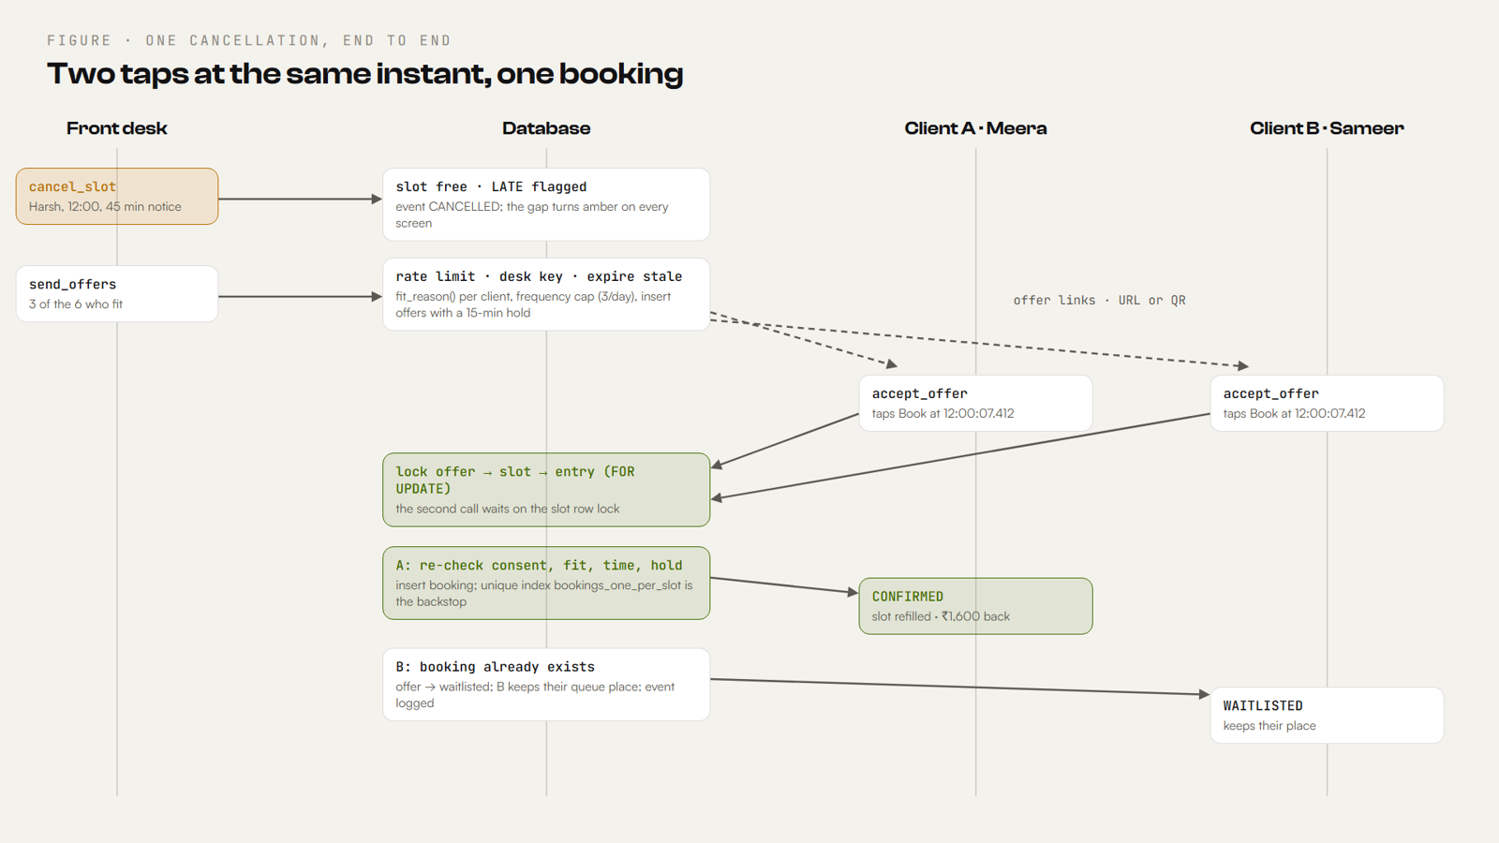
Figure 2. One cancellation, end to end. Two taps at the same millisecond queue on the slot row lock; the first books, the second keeps its place.
Every function that changes several rows locks them in one global order: moves, staff, offers, slots, waitlist. Two transactions can then never wait on each other in a circle, so there are no deadlocks.
accept_offer(p_offer) in detail:
- Rate limits: 600 taps a minute per IP, 30 a minute per offer.
- select … for update on the offer, then the slot, then the client's waitlist row. A second caller for the same slot now waits.
- If the offer is already accepted, return ALREADY_CONFIRMED and the same booking (a double tap books once).
- If it was declined, revoked, waitlisted or expired, return that state.
- If the hold window has passed, mark it expired (OFFER_EXPIRED).
- Re-check consent (NO_CONSENT), that the client is still waiting (ALREADY_BOOKED), fit_reason(), and that the slot is still open and in the future (SLOT_UNAVAILABLE). A failure revokes the offer and logs why.
- Insert the booking. The partial unique index is the backstop: a unique_violation is caught and treated as "someone else got there first".
- If a booking already exists, mark this offer waitlisted; the client keeps their queue place and is told so.
- Log every outcome in events.

Offers: hold window, cap and lifecycle
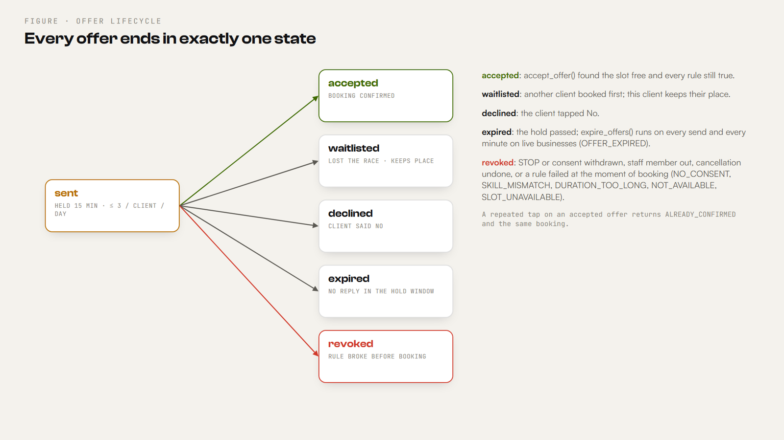
Figure 3. Every offer ends in exactly one state.
- Hold window. expires_min = least(now + hold_min, slot_start - min_lead_min): 15 minutes by default, but never past the point where the client could still arrive.
- Expiry. expire_offers(ws, now) marks overdue offers expired with OFFER_EXPIRED / NO_REPLY events. It runs on every send_offers() and every minute for live businesses.
- Message cap. Before sending, send_offers() counts offers already sent to that client; at max_offers (3 by default) it skips them with FREQUENCY_CAP. Nobody is nagged.
- Lead time. A slot starting within min_lead_min (10) is refused with SLOT_TOO_SOON.
- Payload cap. More than 50 clients in one call raises TOO_LARGE.

Rate limits
enforce_rate(key, limit, seconds) keeps a counter per key per fixed window in rate_hits (insert or increment) and raises RATE_LIMITED above the limit. Keys combine an action with a caller (the IP from the request headers via client_ip(), the workspace, or the offer).
Key | Limit | Protects
create:<ip> / create:all | 120 per 10 min per IP · 1,500 per 10 min overall | Making demo days
reset:<ip> | 30 per 10 min | Resetting a demo day
ws:<workspace> | 240 per min | Desk and owner actions on one business
tap:<ip> · offer:<id> | 600 per min · 30 per min | Accepting offers
join: · me: · move: · book: | 30 / 10 min · 120 / min · 30 / min · 30 / 10 min | Client sign-up, client pages, moves, self-booking
profile: · dir: · claim: | 60 / 10 min · 240 / min · 30 / 10 min | Accounts, directory, claiming entries

Retention: demo workspaces are deleted after 3 days and old rate counters after an hour (cleanup()). A global cap stops the project at 20,000 workspaces.

Time: demo clock and live clock
- Demo days keep their own clock (now_min, starting at 11:15 in the story). set_clock() moves it, expiring offers as it passes them, so a judge can replay a day.
- Live businesses run on India time. pg_cron calls tick_live() every minute: it archives yesterday into history on the first tick of a new day, sets now_min from ist_minute(), and expires overdue offers.

Demo days and live businesses
Migration 007 split workspaces into demo (made from the sample salon, synthetic, deleted after three days, demo clock) and live (made empty by its owner, any kind of service business, kept, real clock). Live businesses have their own services, staff, working hours, tasks and history. Migration 010 adds a directory (listed by default, owner can switch it off) that shows only business-level facts, never a client's name. Migration 011 lets clients book an open time themselves (open_times, book_time), with the waitlist as the fallback, and lets owners rename or delete a business and anyone delete their own account.

Migrations, in order
# | What it added
001 | Core tables, fit_reason, send_offers, accept_offer with row locks, the two partial unique indexes, RLS on with no policies.
002 | Rate limits, retention, stricter input, the offer hold window, the per-client message cap, undo for a mistaken cancellation, append-only events.
003 | Offers that lapse as the clock passes them; tighter privileges.
004 | Roles (owner, staff) proven by hashed keys; staff-aware matching; staff absence; client self sign-up with consent.
005 | Working hours; moving appointments (desk picks a time, or the client gets a link); a front-desk role; owner policies.
006 | The client's offer page and sign-up tell the truth about cancelled and withdrawn offers.
007 | Live businesses next to demo days: services, tasks, history, India time.
008 | Client pages know whether they belong to a demo or a live business.
009 | Accounts: Supabase Auth users, profiles, owner accounts, client entries tied to accounts.
010 | Directory of businesses; account actions on a client's own entries.
011 | Clients book open times themselves; the desk books a waiting client; the live clock on pg_cron; delete business and account.

Function catalogue
All 83 functions, grouped by what they are for (internal helpers are not callable from the browser):
Area | Functions
Rules and helpers | fit_reason, log_event, apply_consent, client_ip, enforce_rate, cleanup, events_append_only, hash_key, new_key, next_id, ist_minute, ist_date
Roles | role_of, is_owner, require_owner, require_desk, require_staff
Workspaces and setup | create_workspace, reset_workspace, load_day, create_business, update_business, delete_business, set_policy, set_listed, get_state, set_clock, sync_clock, tick_live, archive_day, get_history
Team and services | save_staff, remove_staff, save_service, remove_service, staff_link, desk_link, get_staff_day, set_staff_presence, add_task, set_task, remove_task
The day | cancel_slot, do_cancel, restore_slot, reassign_slot, add_appointment, open_times, book_time
Offers | send_offers, accept_offer, decline_offer, expire_offers, get_offer
Moves | move_options, apply_move, open_move, get_move_options, move_booking, move_link, get_move, choose_move, cancel_my_booking, my_move
Waitlist and consent | add_entry, set_consent, stop_messages, join_info, join_waitlist, get_my_entry, set_my_consent, leave_waitlist
Accounts and directory | get_profile, set_profile, my_businesses, my_entries, my_entry, my_entry_move, my_entry_leave, my_entry_consent, claim_entries, directory, delete_account

07 · SRC/

The frontend

Routes and who sees them
Route | Page | Who
/#/ | Sign in / sign up, or Home for the signed-in role | Everyone
/#/desk, /#/desk/slot/<id> | Today: needs-you-now queue, team in/out, the day as a dial or calendar; one sheet with every action on an appointment | Front desk
/#/desk/waitlist, /#/desk/activity | Waitlist with consent per person; evidence log with filters and CSV/JSON export | Front desk
/#/owner, /#/owner/team, /#/owner/rules, /#/owner/history | Money recovered and at risk, staff load; team and links; rules; past days | Owner
/#/s/<ws>/<staff>/<key> · /#/staff/<id> | A staff member's own day (private link) · the owner's preview of it | Staff
/#/join/<code> | Client sign-up with an explicit yes or no to messages (never pre-ticked) | Client
/#/me/<token> · /#/me | A client's own page · their places | Client
/#/o/<uuid> · /#/m/<uuid> | An offer (Book or No) · choose a new time | Client
/#/places | Directory of listed businesses | Anyone
/#/lab | Proof: case checks live, fixture, scenarios, edge toggles, live race | Judges
/#/settings | Account and business settings | Signed in
/splash | The scroll story (a real path, rewritten to index.html by Vercel) | Anyone

Data flow in the app
- useBook (in src/api.ts) loads the business with get_state and polls it every 2 seconds, skipping a re-render when nothing changed. Live businesses also sync the clock every minute.
- Every action calls one database function and then refreshes. The page never edits its copy of the data and hopes; it shows what the database says.
- The desk preview runs the engine locally (asSlot, asEntry, asStaff convert database rows), so "who fits" appears instantly; the database re-checks when offers are actually sent.
- Errors come back as codes and are shown in plain words (LABEL in the engine, SAID in auth.ts, messages in rpc.ts).

Accounts and sign-in
- SignIn.tsx: sign up (name, email, password) or sign in. auth.ts calls Supabase Auth /auth/v1/signup or /auth/v1/token?grant_type=password with fetch and saves the session.
- An AUTH_EVENT makes the app re-route itself: a new account picks a role (Welcome: "I run a business" or "I book appointments", stored with set_profile).
- An owner sets up the business (Setup.tsx then create_business); a client goes to their places.
- Every later database call carries the access token; it is refreshed before it expires. Sign-out clears it.
- The sign-in page (v8) adds: a switch link instead of tabs, show-password, a Caps Lock note, a strength sub-dial on sign-up, inline errors tied to fields with aria-describedby, the remembered email, and autofocus only when a mouse is present (so a phone keyboard does not cover the page).

Design system
The look is a chronograph: the day as a watch face, dark first, with a hand-tuned light theme. Colour always carries meaning.
Token | Dark | Light | Meaning
canvas · surface | #0a0a0c · #131316 | #f4f2ed · #ffffff | Page and raised surfaces
ink · ink-2 · ink-3 | #f4f1ea · #a9a59c · #6f6c66 | #121214 · #5a5852 · #8c8981 | Text, secondary text, hints
act (lime) | #c6f24e | #3f6b00 | You can act; also "refilled"
beat (amber) | #ffb547 | #d4820a | An open gap (it pulses)
danger (coral) | #ff5d4d | #d13a2b | Someone needs moving, or a staff member is out

- Type: Clash Display (headlines, big numbers), Satoshi (UI and text), JetBrains Mono (times, codes, labels).
- Shape: concentric radii 20 / 12 / 8; glass only on what floats (bar, dock, sheets); film grain at about 4%.
- The Day Dial (src/Dial.tsx): 10:00 to 20:00 clockwise over 300 degrees, one ring per staff member, one arc per appointment. Angle = −150° + (minute − 10:00) / 600 × 300°. Amber gaps pulse, lime refills draw in, coral needs moving, a hand marks the clock. Every arc opens its appointment.
- Motion (motion.tsx, motion.css): view transitions, ambient glow that follows the day, staggered rise, spring presses, count-up numbers. All of it switches off under reduced motion.
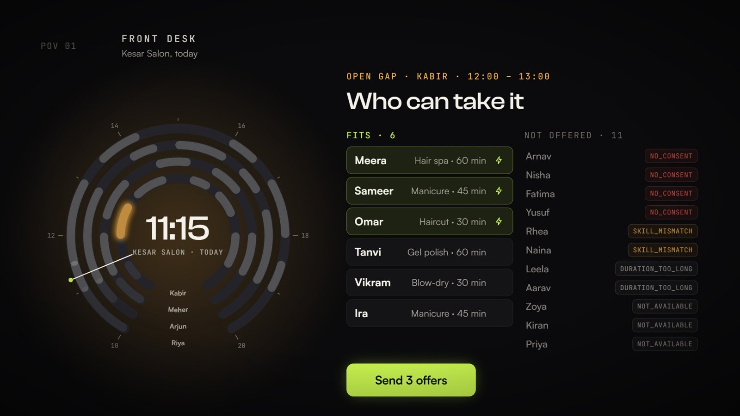
Figure 4. The front desk: the Day Dial on the left, who fits and who is skipped (with codes) on the right.

PWA, offline and headers
- public/sw.js caches the app shell (refill-shell-v3). Navigation is network-first, so a new deploy shows at once; the cached shell is used only offline. Requests to Supabase are never cached: bookings are always live.
- Installable from the browser menu ("Install app" / "Add to Home Screen").
- vercel.json sets a Content-Security-Policy (scripts only from self; fonts from Fontshare and Google; connections to our Supabase project), X-Content-Type-Options: nosniff, a strict referrer policy, and a Permissions-Policy that turns off camera, microphone and geolocation. Hashed assets are cached for a year; sw.js is never cached.

Performance and accessibility
- Pages are lazy-loaded; the main bundle is 86 kB gzipped. The splash page's GSAP and Lenis live in their own 63 kB (gzipped) chunk that only /splash loads.
- Inputs are 16 px (no zoom on iPhone), touch targets at least 42 px, no horizontal scroll at 375 px; checked in light and dark themes.
- Labels on every field, aria-invalid and role="alert" on errors, aria-live updates, reduced-motion support.

The Lab and the splash
/#/lab is for judges. It runs the three case checks live, loads the organiser fixture, runs every scenario file, lets you edit any input, flips edge cases (late cancellation, staff absent, duration change, consent withdrawn) with a before/after export, and fires a real race at the real database (liveRace.ts).
/splash (built by Chirag, PR #22) tells one salon day on the Day Dial, scrubbed by the scroll with GSAP ScrollTrigger and Lenis: the gap, who fits, the race, staff out, and the proof figures, each naming the command that produces it.

08 · HOW WE KNOW IT WORKS

Testing and verification
Command | What it checks | Against
npm test | 51 tests: engine units (validation, fit order, matching, race, notice), the organiser fixture (W1 → S2), 23 core scenarios, 12 extra scenarios, and that the demo CSVs still load. | The engine, offline
npm run dbtest | 28 checks: what the public key can and cannot do (tables refused), payload and text limits, rate limiting, hold windows, the message cap, undo, owner, desk, staff and client roles, absence, shifts, moves. | The live database, public key
npm run race | 8 clients tap Accept on one slot at the same moment, 3 runs. Pass = exactly one booking per run; everyone else keeps their place. npm run race -- 20 5 for 20 clients, 5 runs. | The live database
npm run flowtest | 14 checks: one day, every role. Each step acts as one role and reads what another role sees (does the desk's offer reach the client, does the client's booking reach the owner). | The live database
npm run build | Type-check (tsc -b) and production build. | The code
CI (GitHub Actions) | npm ci, npm test, npm run build on every push to main and every pull request. | Every change

Reproduce everything from a clean checkout
npm ci · npm test · npm run dbtest · npm run race · npm run flowtest · npm run build. Node 20 or newer. See docs/SETUP_CHECK.md.

Two kinds of proof matter here. Offline tests prove the rules are right. Live tests prove the database enforces them for anyone holding the public key, including someone trying to bypass the app.

09 · RUNNING IT

Deployment and operations

Run it locally
git clone https://github.com/sirgreaseball/refill && cd refill
npm ci # installs exactly what package-lock.json says
npm run dev # http://localhost:5173, talks to the shared demo database
npm test # rules engine, fixture, scenarios
npm run build # production build into dist/

To use your own Supabase project: apply supabase/migrations/001 to 011 in order, then set VITE_SUPABASE_URL and VITE_SUPABASE_KEY (the publishable key). Enable pg_cron for the live clock.

Release rules the team follows
- Push to `main` deploys to fillthechair.vercel.app in about a minute. main is protected: pull request, review and the CI test check (the owner can push directly).
- Database changes are additive. Add functions and columns; create or replace with the same signature; never drop a signature the live client still calls. Every migration is saved as supabase/migrations/NNN_name.sql and the same SQL is applied.
- Lock order in every function: moves, staff, offers, slots, waitlist. Every write re-checks rules under lock.
- Teammates work on a branch and open a pull request; their AI assistants follow AGENTS.md (narrow file scopes, npm ci only, no direct database or deploy commands).

Observability
The events table is the operational log: every cancellation, offer sent or skipped (with its code), acceptance, rejection, expiry, move and undo, with the slot, client and booking ids. The desk's Activity page filters it and exports CSV or JSON (with a guard against spreadsheet formula injection).

10 · STATUS, HONESTLY

What works today
Feature | Status | Evidence
Fit rules: consent, skill (staff-aware), duration, availability | Live and tested | npm test, Lab checks 1 and 3, dbtest
One booking per slot under simultaneous taps | Live and tested | npm run race, Lab live race, tests C04/C09/C14/C15
Consent: yes / no / never asked; STOP revokes open offers | Live and tested | Tests C05, C06, C12; dbtest
Offer hold (15 min), expiry, message cap (3/day), lead time (10 min) | Live and tested | dbtest
Late cancellation flag (< 2 h) and undo of a mistaken cancellation | Live and tested | dbtest, Lab edge toggles
Staff absence: offers revoked, gaps held, clients flagged to move | Live and tested | dbtest, flowtest
Rescheduling: desk picks a time, or the client gets a link and picks | Live and tested | dbtest, flowtest
Roles: owner, front desk, staff, client, each proven by the database | Live and tested | dbtest, flowtest
Accounts (email + password), role choice, business setup | Live | Manual runs; new sign-in page v8
Live businesses: services, staff, hours, tasks, history, India-time clock | Live | Running test businesses (salon, tuition centre, spa)
Client self-booking of open times; directory of businesses | Live | Manual runs
Evidence log with CSV/JSON export | Live | Activity page
Installable PWA, light and dark themes, phone layouts | Live | Checked at 375 px and 1440 px
Messages to clients | Simulated | Offers are links and QR codes; no SMS or WhatsApp is sent
Booking future dates | Not yet | A live business works one day at a time
Forgot password, Google sign-in | Not yet | Need Supabase email (SMTP) and an OAuth app
Platform admin console, multi-location | Not yet | -
Market-shock rehearsal (docs/SHOCKS.md) | Written, not yet timed on live | Needs a person with a stopwatch

Known limits and the next engineering steps
- Real messaging. India requires DLT registration, approved sender IDs and templates for SMS; WhatsApp needs approved utility templates. The offer link is already the message body; a provider (SMS or WhatsApp) can be added behind send_offers() without changing the rules.
- Future dates. Extend slots with a date and the live clock with a calendar; the rules do not change.
- Email features. Configure Supabase SMTP for password reset and email confirmation.
- Calendar sync. Import from Google Calendar or a salon's existing booking tool so Refill sits on top of what a business already uses.
- Admin and analytics. A platform console and per-business dashboards over events and history.

11 · CODES AND ANSWERS

Reference

Codes you will see
Code | Where | Meaning
NO_CONSENT | fit, send, accept | The client has not said yes to messages (no, or never asked).
SKILL_MISMATCH | fit, send, accept | The staff member does not do that service.
DURATION_TOO_LONG | fit, send, accept | The service needs more time than the gap.
NOT_AVAILABLE | fit, send, accept | The client is not free then.
FREQUENCY_CAP | send | The client has had the maximum offers today.
SLOT_TOO_SOON · SLOT_NOT_FREE · STAFF_ABSENT | send | Too close to start · not a gap · the staff member is out.
UNKNOWN_ENTRY · NOT_WAITING | send | No such client · client no longer waiting.
CONFIRMED · WAITLISTED · ALREADY_CONFIRMED | accept | Booked · someone else booked first · a repeated tap.
EXPIRED · REJECTED · NOT_FOUND | accept | Hold passed · a rule failed (with its code) · no such offer.
SLOT_UNAVAILABLE · ALREADY_BOOKED | accept | Slot held or past · client booked elsewhere.
OFFER_EXPIRED / NO_REPLY | events | An offer lapsed without an answer.
RATE_LIMITED · TOO_LARGE | any call | Too many requests · too much in one call.
DUPLICATE_ID · MISSING_FIELD · INVALID_VALUE | engine validation | A bad input file.
EVENTS_ARE_APPEND_ONLY | database | Someone tried to edit the log.

Technical questions judges ask
Question | Answer
How do you guarantee two people never get the same slot? | Booking happens inside one database transaction that locks the offer, then the slot, then the client, in that order everywhere. Simultaneous taps queue on the slot lock; the first books, the rest find it taken and keep their place. A partial unique index allows one confirmed booking per slot as a backstop. npm run race and the Lab prove it live.
Why not check availability in the app first? | Two phones can both read "free" at the same instant (time-of-check to time-of-use). The app only previews; the database decides.
Could someone change data by calling the database directly? | No. Every table has row level security with no policies, and table privileges are revoked. Only checked functions are callable, each proves the caller's role, and rate limits stop floods. npm run dbtest checks exactly this with the public key.
What if a client taps Book twice? | The second call returns ALREADY_CONFIRMED and the same booking number.
How is consent handled? | Yes, no, or never asked; only yes may be messaged. Checked before any offer and again at booking. STOP, or switching messages off, revokes every open offer. Sign-up never pre-ticks consent.
Is it only for salons? | No. The model is staff, skills, working hours, services, a waitlist and consent. A tuition centre and a spa already run on it.
What did you change after the business team's feedback? | Staff and duration constraints before outreach (staff-aware matching, working hours) and rescheduling instead of only cancelling. Building it exposed a real flaw: without working hours a client could be moved onto someone who had gone home; shifts now bound every move.

