Rajiv Gandhi University of Knowledge Technologies – Srikakulam
Qiskit Fall Fest 2025

ROUTE OPTIMIZATION TASK
Problem statement QFF25010

INTRODUCTION

The rapid growth of intelligent transportation systems has created a demand for smarter and greener route optimization methods.Traditional algorithms mainly focus on minimizing distance or time, ignoring factors like energy usage and emissions.
To address this limitation, the Hybrid Classical–Quantum Route Optimization Algorithm (HCQRO) integrates classical and quantum computing.

The classical part dynamically generates possible routes using real-time data such as traffic, elevation, and energy consumption.Each route is evaluated through an eco-cost function that measures its environmental efficiency.The quantum part employs Grover’s algorithm to identify the route with the lowest eco-cost among feasible candidates.This hybrid approach combines the adaptability of classical computation with the speed advantage of quantum search.It reduces the computational complexity while maintaining high accuracy and low qubit usage.

HCQRO overcomes Grover’s traditional need for predefined datasets through dynamic route generation.Overall, the model provides a sustainable, efficient, and scalable solution for modern transportation systems.

MOTIVATION

Modern transportation, logistics, and energy distribution systems involve routing across large, dynamic networks. Determining the most energy-efficient or shortest path in such networks is computationally challenging because the number of possible routes grows exponentially with network size.
Classical algorithms like Dijkstra or A* are efficient for small graphs but become infeasible in complex, real-time networks where multiple factors (distance, congestion, and energy cost) must be optimized simultaneously.
By combining the strengths of classical data modeling and quantum search, the Hybrid Classical–Quantum Route Optimization Algorithm (HCQRO) achieves this balance.
It allows dynamic route generation on classical systems and leverages Grover’s algorithm to rapidly identify the most energy-efficient path.
This fusion minimizes computational effort without sacrificing solution quality.
Ultimately, the motivation behind HCQRO is to enable sustainable, intelligent transportation systems that optimize both performance and environmental impact.
kEYWORDS
• Hybrid Classical–Quantum Algorithm
• Grover’s Algorithm
• Route Optimization
• Eco-Cost Calculation
• Traffic Analysis
• Energy Efficiency
• Quantum Search
• Dynamic Route Generation

METHODOLOGY:

Step 1: Input Network Representation

The network is represented using NetworkX, where nodes denote locations and edges denote possible paths with associated eco-costs.
G = nx.DiGraph()
edges = [
('A', 'B', 2), ('A', 'C', 1),
('B', 'D', 3), ('C', 'D', 2),
('B', 'C', 1), ('C', 'B', 1)
]
G.add_weighted_edges_from(edges)
This forms the base structure for route selection.

Step 2: Classical Pruning & Top-k Selection

Before quantum processing:
Remove infeasible or blocked routes.
Compute estimated eco cost.
Select top-k routes (e.g., 4–8) for quantum search to minimize qubit count.
This ensures the quantum system handles a small, feasible subset.

Step 3: Qubit Encoding

Each route corresponds to a binary string mapped to a qubit state:
For 4 routes → 2 qubits (00, 01, 10, 11).
The quantum circuit starts in equal superposition across all these states.
qc.h(range(n_qubits)) # Creates equal probability across all routes

Step 4: Oracle Design

The oracle identifies optimal routes (minimal eco cost) and flips their phase using controlled operations.
If multiple routes have the same cost, all corresponding qubits are flipped simultaneously:
qc.cz(0,1) # Example for 2-qubit oracle
This step encodes the energy optimization condition.

Step 5: Grover Diffusion Steps

The diffusion operator amplifies probabilities of the marked (optimal) states:

D = 2|ψ₀⟩⟨ψ₀| − I It reflects the quantum state about the mean amplitude, increasing the likelihood of optimal routes while suppressing non-optimal ones. After repeated applications, the amplitude of the best route dominates, enabling efficient identification upon measurement.

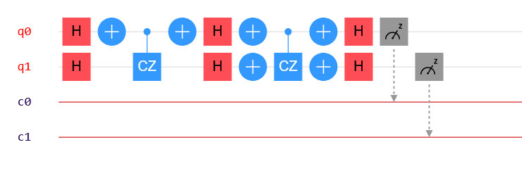

ALGORITHM:

Algorithm: Hybrid Classical–Quantum Route Optimization (HCQRO)

Step 1: Classical Route Generation
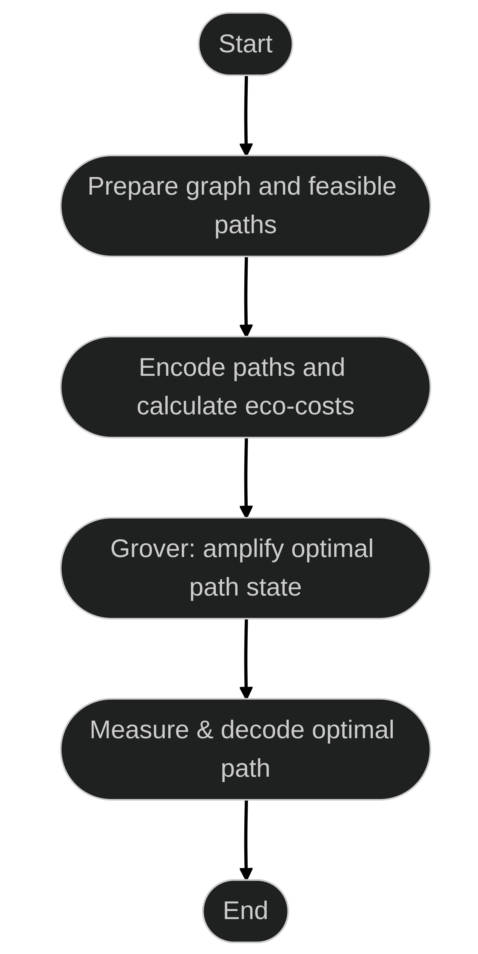
- Utilize real-time data on traffic, elevation, and energy consumption to construct the feasible route set R.

Step 2: Eco-Cost Evaluation
- Compute the eco-cost for each route rᵢ as:
Cᵢ = αDᵢ + βEᵢ + γTᵢ + δGᵢ
where Dᵢ, Eᵢ, Tᵢ, and Gᵢ represent distance, energy usage, traffic intensity, and gradient, respectively.

Step 3: Quantum Encoding
- Represent each route index i as a quantum state:
|ψ₀⟩ = (1/√N) Σᵢ |i⟩,
where N denotes the total number of feasible routes.

Step 4: Grover-Based Quantum Search
- Apply the oracle O_f to mark routes satisfying Cᵢ ≤ C_threshold:
O_f |i⟩ = (−1)^{f(i)} |i⟩.
- Employ the diffusion operator D = 2|ψ₀⟩⟨ψ₀| − I to amplify marked routes.
- Repeat for r ≈ (π/4)√N iterations to enhance the probability of the optimal solution.

Step 5: Measurement and Selection
- Measure the final quantum state to obtain the route r* corresponding to the minimum eco-cost.
- Output the optimal path and its associated eco-cost for implementation in real-time navigation systems.
- This algorithm ensures environmentally sustainable routing with improved computational efficiency.

PSEUDOCODE
Algorithm HCQRO(G, source, destination, α, β, γ, D_max, K):
// Classical Phase: Route Generation and Pruning
1. routes ← all_simple_paths(G, source, destination)
2. feasible ← ∅
3. For each route in routes:
eco_cost ← 0
For each segment in route:
distance ← segment.distance
energy ← distance * segment.energy_factor
traffic ← segment.traffic_level
eco_cost += α*distance + β*energy + γ*traffic
If total_distance(route) ≤ D_max:
feasible.add((route, eco_cost))
4. Sort feasible by eco_cost
5. TopK ← first K routes from feasible

// Quantum Phase: Optimal Route Search using Grover's Algorithm
6. Define f(x) such that f(x)=1 for route with minimum eco-cost
7. Initialize n qubits → |0⟩ⁿ and apply Hadamard transform
8. Iterate r ≈ (π/4)*√N times:
a. Apply Oracle U_f to mark optimal route
b. Apply Diffusion Operator to amplify it
9. Measure qubits → result
10. Return route corresponding to result
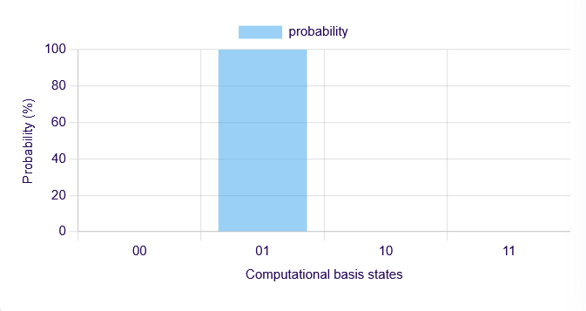
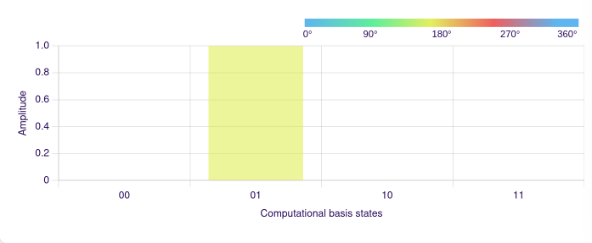

APPLICATIONS

• Logistics and Supply Chain Management
• Urban Mobility and Ride-Sharing
• Electric Vehicle (EV) Navigation
• Public Transportation Planning
• Drone Delivery and Aerial Navigation
• Environmental Conservation and Green Logistics
• Disaster Response and Emergency Services
• Tourism and Recreational Navigation
• Smart City Infrastructure
• Research and Development

REFERENCES
- https://inspirehep.net/files/e20b9f455ef4d44a6dcc381d62b4220a
- https://quantumzeitgeist.com/quantum-computing-in-transportation-quantum-route-optimization/
- https://1qbit.com/blog/optimization/optimizing-logistics-using-quantum-computing/

