Employee Attrition & Workforce Analytics
Machine Learning Thesis Proposal
Student Name: Sirisha Chinni
Program: MS in Computer Science (AI)

Abstract
This proposal presents a machine learning-based analysis of employee attrition, salary, and performance. The dataset shows a strong class imbalance (91% non-attrition, 9% attrition), which significantly impacts model performance. The study aims to identify key drivers of attrition and provide actionable HR insights.

Introduction and Background
Employee attrition affects organizational productivity and cost. Machine learning enables predictive analytics to identify high-risk employees and improve workforce planning.

Problem Statement
The dataset is highly imbalanced, making it difficult for models to correctly predict attrition cases. Additionally, weak correlations between features and attrition create challenges in building strong predictive models.

Research Questions
RQ1: Factors influencing attrition
RQ2: Salary fairness
RQ3: Feature importance
RQ4: Salary prediction accuracy
RQ5: Work-life balance impact
RQ6: Performance vs compensation
RQ7: Employee segmentation

Exploratory Data Analysis
Key findings from dataset visualizations:
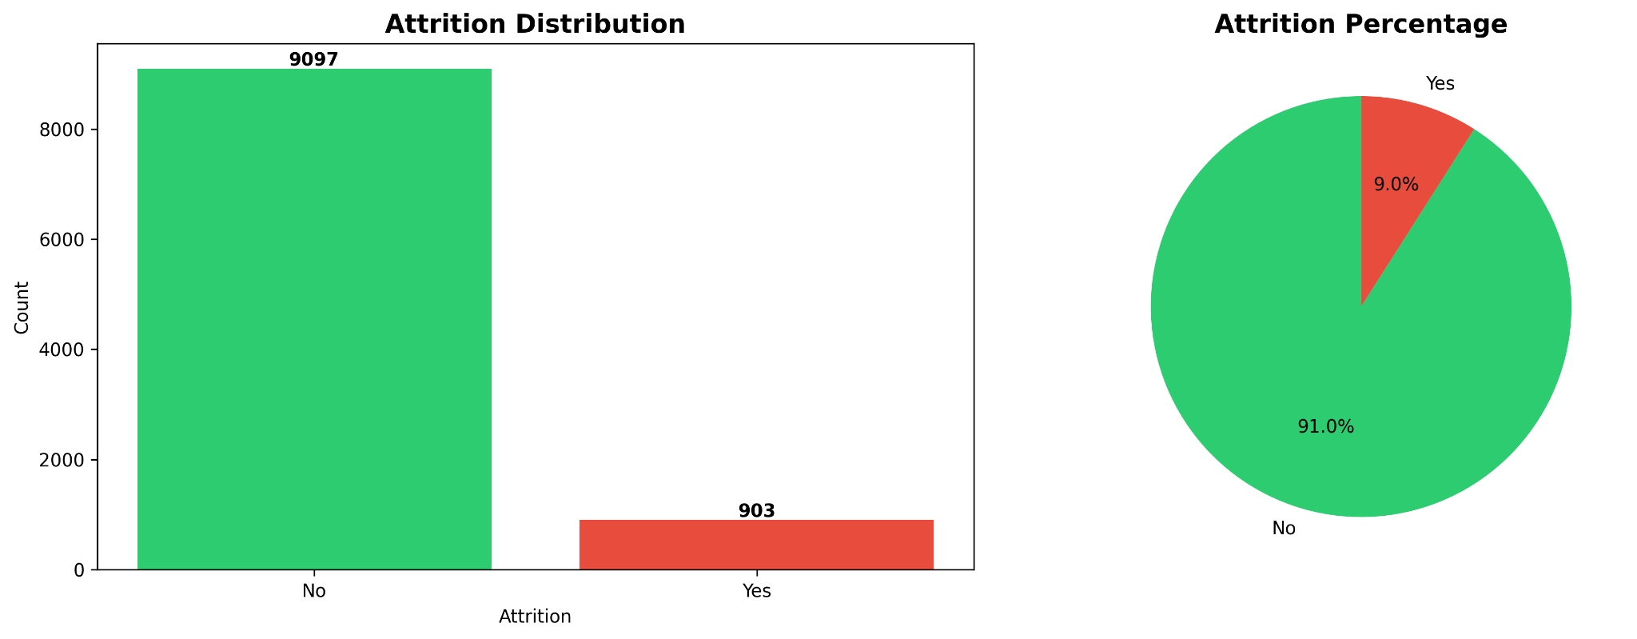
Attrition Distribution: 91% employees retained, 9% left → severe imbalance.
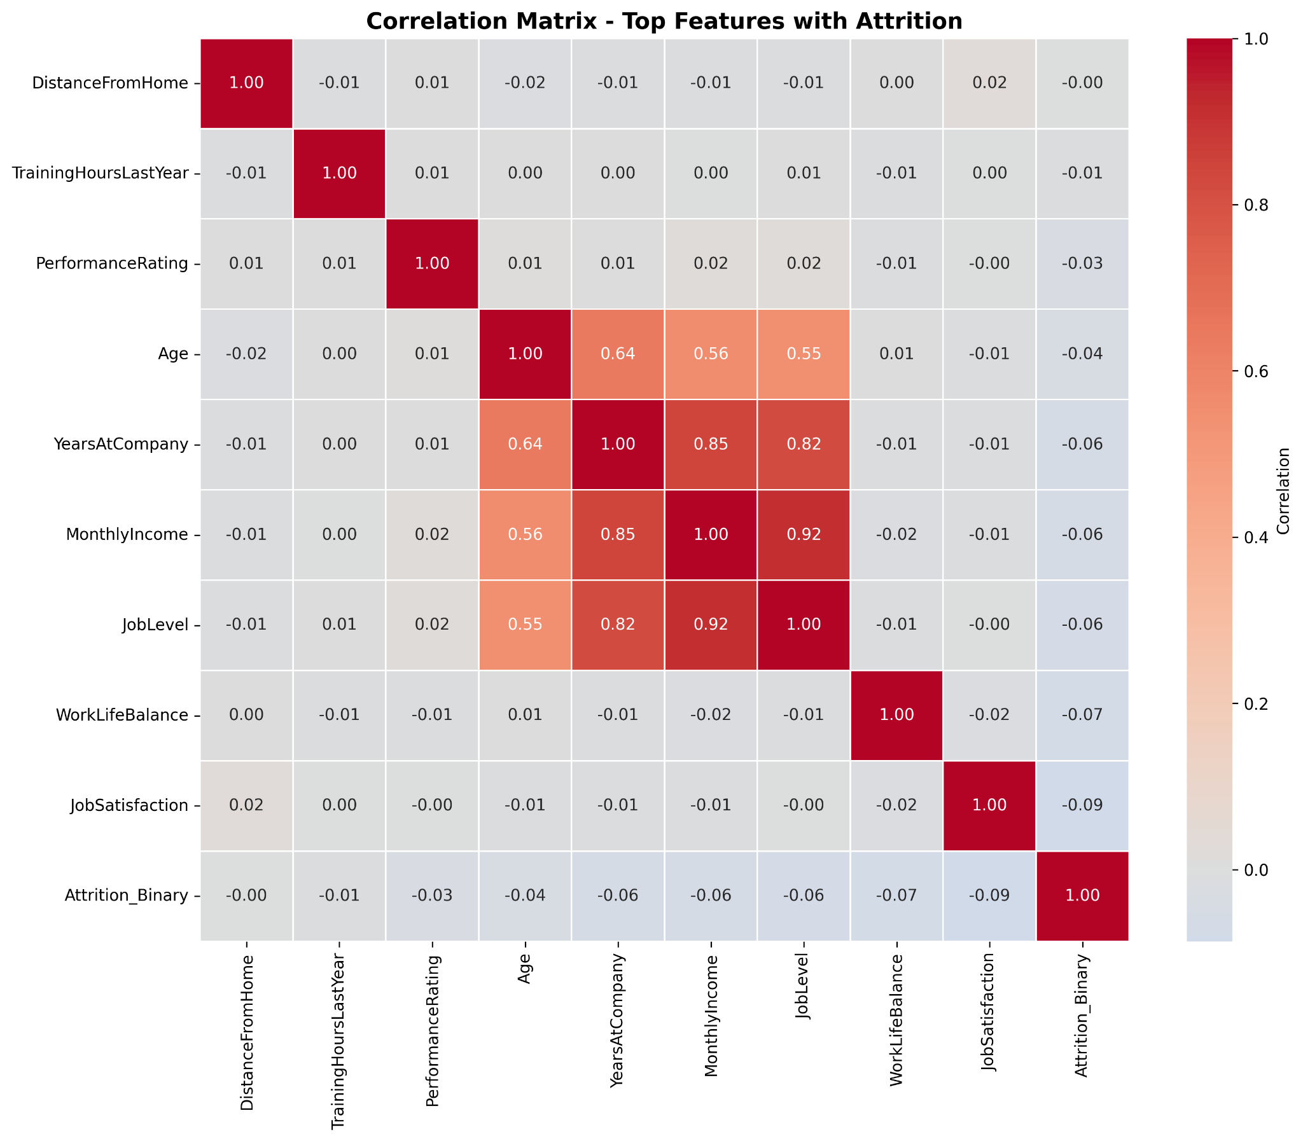
Correlation Matrix: Weak correlation with attrition; strongest factors are Job Satisfaction and Work-Life Balance.
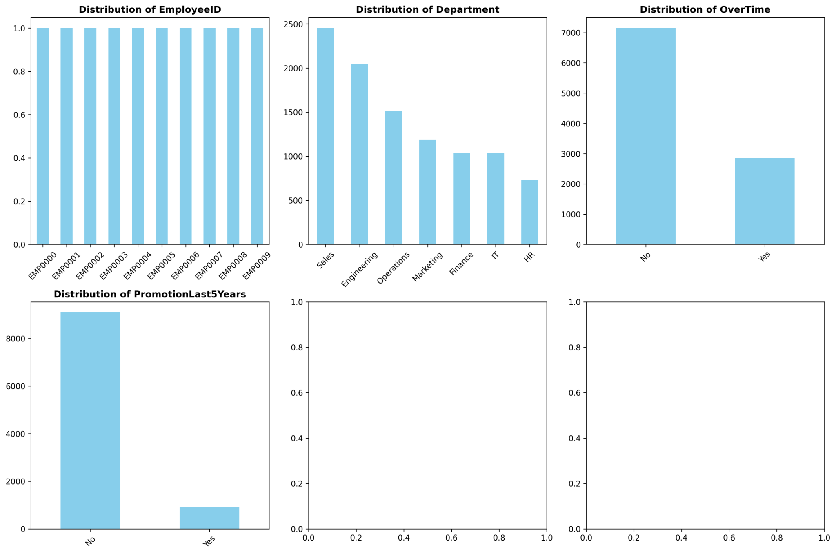
Categorical Distribution: Sales dominates; promotions are rare; overtime impacts attrition.

Model Evaluation
Comparison of models using ROC and confusion matrices:
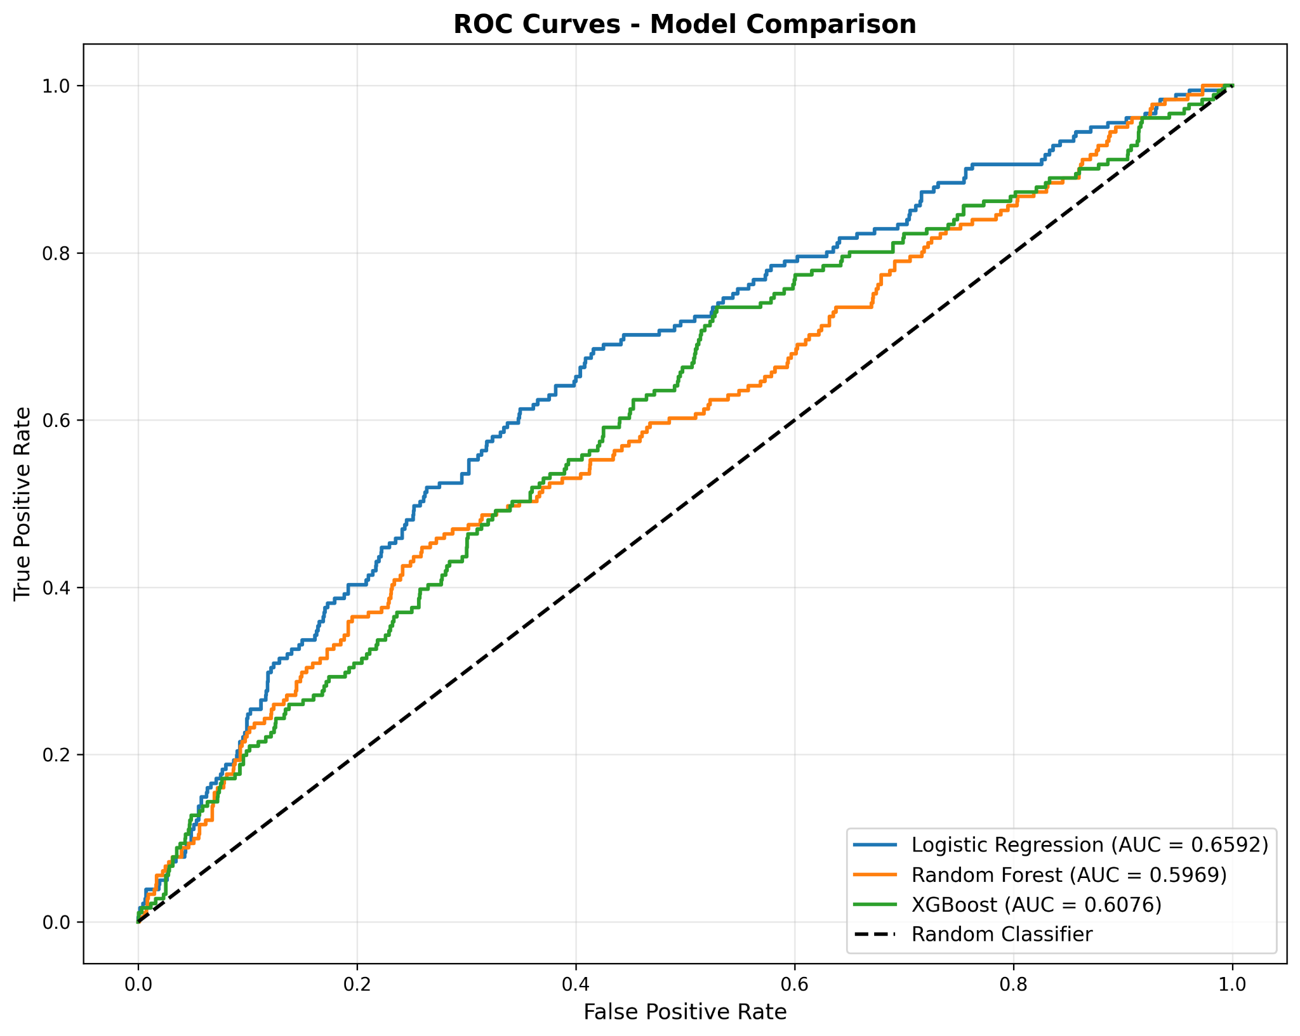
ROC Curve: Logistic Regression performs best (AUC ~0.66).
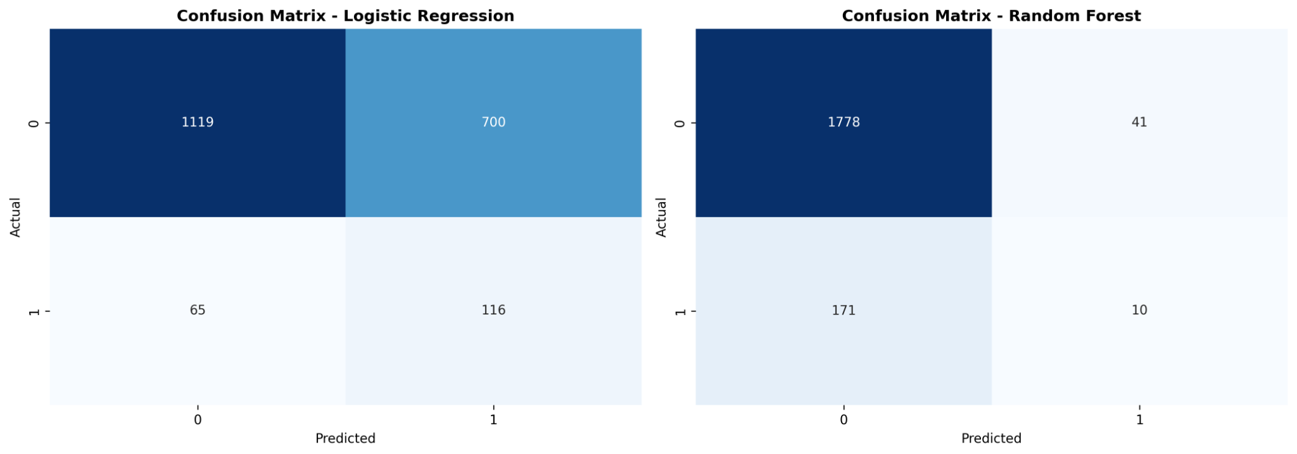
Confusion Matrix: Models struggle with minority class detection.

Feature Importance Analysis
Top contributing features identified using Random Forest:
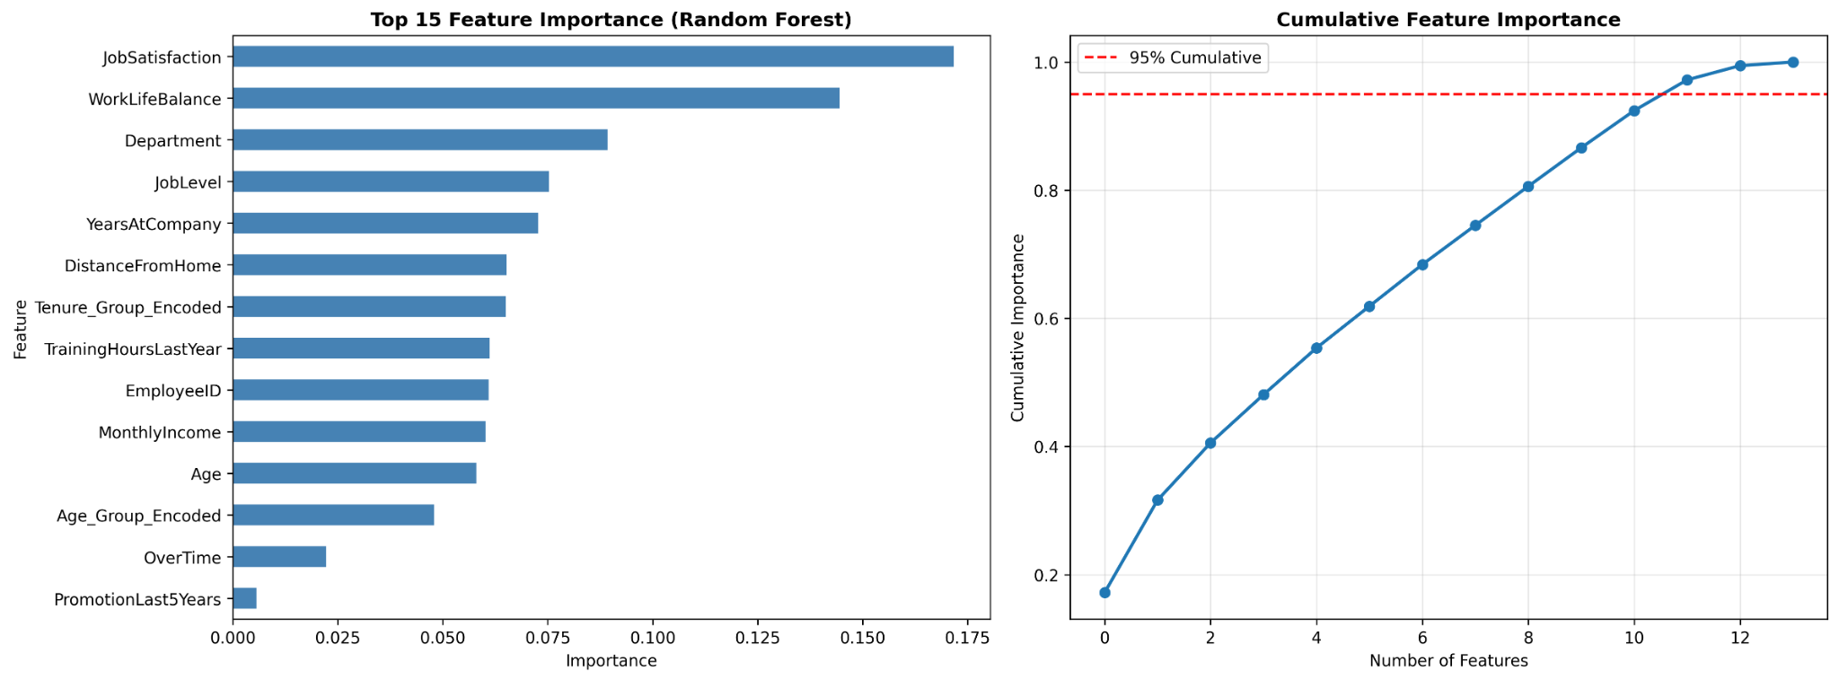
Top Features: Job Satisfaction, Work-Life Balance, Department.

Key Findings
- Behavioral features are more important than demographic ones
- Logistic Regression outperforms complex models
- Class imbalance reduces recall significantly
- Weak feature correlation limits model accuracy

Conclusion
The study demonstrates challenges in attrition prediction due to imbalance and weak feature relationships. Future improvements include SMOTE, feature engineering, and advanced ensemble methods.

