**ENSC 280**

**PHASE 1**

**GROUP 04 PROJECT**

**SUMMER 2018**

**Sirpreet Kaur Dhillon 301318486**

**Ece Eskikurt 301269853**

**Tatendaishe Jakaza 301278282**

**Reem Mustafa 301245064**

**ABSTRACT**

**INTRODUCTION**

The objective of this project is to collect data on the mode of transport that students use to get to Simon Fraser University, and how it is related to the distance they live from the university. In short, we are conducting a commuter survey to understand how people commute to campus.

Understanding how students commute to school can help policy makers understand how students get to school, future transportation trends, and the environmental footprint created from commuter travel. This data can be used to analyse whether better public transportation routes need to be devised, and provide information for whether a student ride sharing service would be feasible and beneficial for students who live far from campus.

**DATA COLLECTION**

For the data collection, we created a survey displayed in **Figure 1.** below through Google Forms. Each of us posted the survey on a social media platform that we are active on and ensured that at least 24 samples were collected. We used a public social media platform to randomize the data we would get rather than sending the survey to one group of people e.g. people who live near campus that we know.

We also made use of Google Maps to collect information on how far the compass card users/ drivers live from school.

|  |  |
| --- | --- |
| **Variables** |  |
| *Dependent* | * Mode of transportation used to get to school |
| *Independent* | * Distance from school (here SFU) * Availability of resources such as:   + U-pass   + Car |

**Table 1. Experiment Variables**

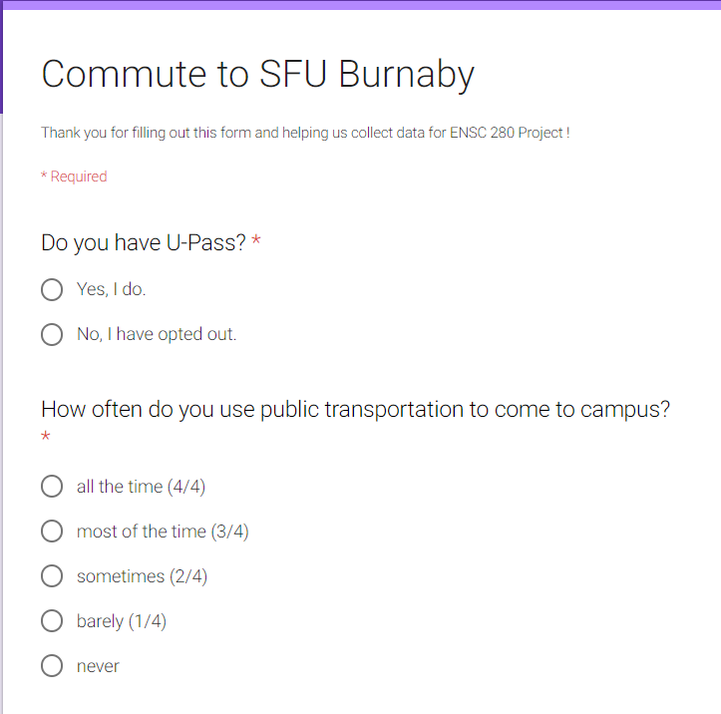

**Figure 1. Survey or Google form used to collet Data**

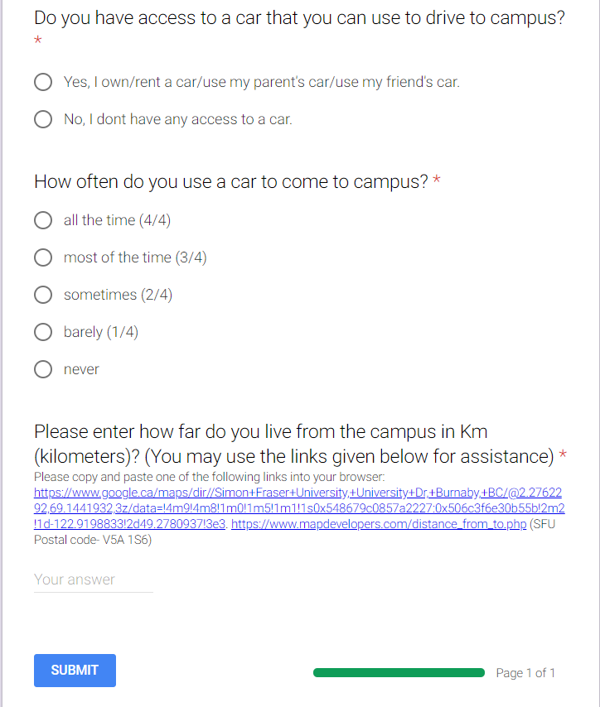

**RAW DATA**

|  |  |  |  |  |  |
| --- | --- | --- | --- | --- | --- |
| **Data Sample**  **No.** | **Compass Card and U-pass?** | **Probability of using U-pass or Transit to get to campus** | **Access to a Car?** | **Probability of using a Car to get to campus** | **Distance from school in km** |
| **1** | **Yes** | **0** | **Yes** | **0** | **7.9** |
| **2** | **Yes** | **0** | **No** | **0** | **5** |
| **3** | **Yes** | **0** | **No** | **0** | **0** |
| **4** | **Yes** | **1/4** | **Yes** | **1/4** | **5** |
| **5** | **Yes** | **3/4** | **Yes** | **3/4** | **15** |
| **6** | **Yes** | **2/4** | **No** | **2/4** | **22.3** |
| **7** | **Yes** | **1/4** | **Yes** | **1/4** | **22** |
| **8** | **Yes** | **2/4** | **Yes** | **2/4** | **17.2** |
| **9** | **Yes** | **2/4** | **Yes** | **2/4** | **29** |
| **10** | **Yes** | **3/4** | **Yes** | **3/4** | **9.6** |
| **11** | **Yes** | **1/4** | **Yes** | **1/4** | **2** |
| **12** | **Yes** | **0** | **No** | **0** | **35** |
| **13** | **No** | **0** | **Yes** | **0** | **0.7** |
| **14** | **Yes** | **0** | **No** | **0** | **4.4** |
| **15** | **Yes** | **1/4** | **No** | **1/4** | **0** |
| **16** | **Yes** | **0** | **No** | **0** | **5** |
| **17** | **Yes** | **0** | **No** | **0** | **1.4** |
| **18** | **Yes** | **0** | **No** | **0** | **1.2** |
| **19** | **Yes** | **1** | **Yes** | **1** | **25** |
| **20** | **Yes** | **0** | **Yes** | **0** | **3** |
| **21** | **Yes** | **1/4** | **No** | **1/4** | **6** |
| **22** | **Yes** | **1/4** | **Yes** | **1/4** | **18** |
| **23** | **Yes** | **2/4** | **Yes** | **2/4** | **40** |
| **24** | **Yes** | **0** | **No** | **0** | **8.3** |
| **25** | **Yes** | **0** | **No** | **0** | **50** |
| **26** | **Yes** | **0** | **No** | **0** | **26** |
| **27** | **Yes** | **0** | **No** | **0** | **5.7** |
| **28** | **Yes** | **0** | **No** | **0** | **0.7** |
| **29** | **Yes** | **1** | **Yes** | **1** | **29.1** |
| **30** | **Yes** | **1/4** | **Yes** | **1/4** | **18** |
| **31** | **Yes** | **1/4** | **Yes** | **1/4** | **35** |
| **32** | **Yes** | **0** | **No** | **0** | **29** |
| **33** | **Yes** | **0** | **No** | **0** | **0.6** |
| **34** | **Yes** | **1** | **No** | **1** | **10** |
| **35** | **Yes** | **0** | **No** | **0** | **21.7** |
| **36** | **Yes** | **0** | **No** | **0** | **35.8** |
| **37** | **Yes** | **1/4** | **Yes** | **1/4** | **12.9** |
| **38** | **Yes** | **1** | **Yes** | **1** | **20** |
| **39** | **Yes** | **0** | **No** | **0** | **12.9** |
| **40** | **Yes** | **0** | **No** | **0** | **23.64** |
| **41** | **Yes** | **1** | **Yes** | **1** | **26.9** |
| **42** | **Yes** | **1** | **Yes** | **1** | **15** |

**Table 2. Raw Data**

**MEMBERS’ INVOLVEMENT**

**\*Note: The member involvement is indicated in a bracket in front of each student’s name\***

Sirpreet Kaur Dhillon (1)

* Helped to shape the idea
* Edited the report
* Edited the survey

Ece Eskikurt (1)

* Come up with the raw idea
* Created the draft of the survey
* Shared survey on social media for data collection

Tatendaishe Jakaza (1)

* Helped to shape the idea
* Created the draft of the report
* Edited the survey

Reem Mustafa (1)

* Helped to shape the idea
* Edited the survey
* Shared survey on social media for data collection