1)When <http://localhost:8080/pactera/CityWeather> is launched from the browser after the war is deployed on the server.

It will show a drop down where in you can select a state.

Weather API used iss <http://openweathermap.org/current>

Query used : http://api.openweathermap.org/data/2.5/weather?q=$selectedCity&APPID=032c41e2d7d559a0dbe1d05fd8808b80

For Sydney:

http://api.openweathermap.org/data/2.5/weather?q=Sydney&APPID=032c41e2d7d559a0dbe1d05fd8808b80

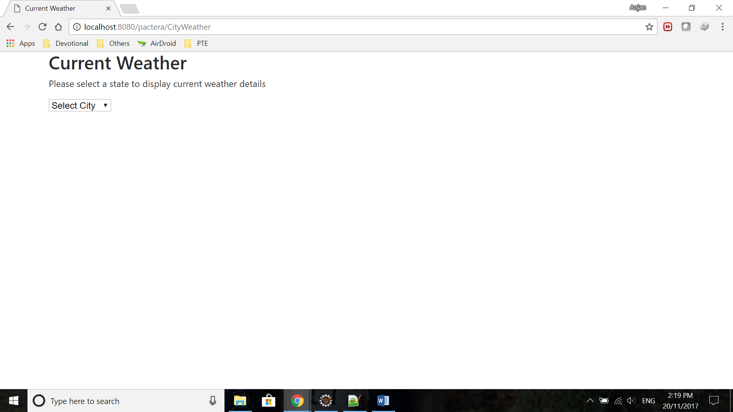

2) Below are the weather details when sydney is selected:

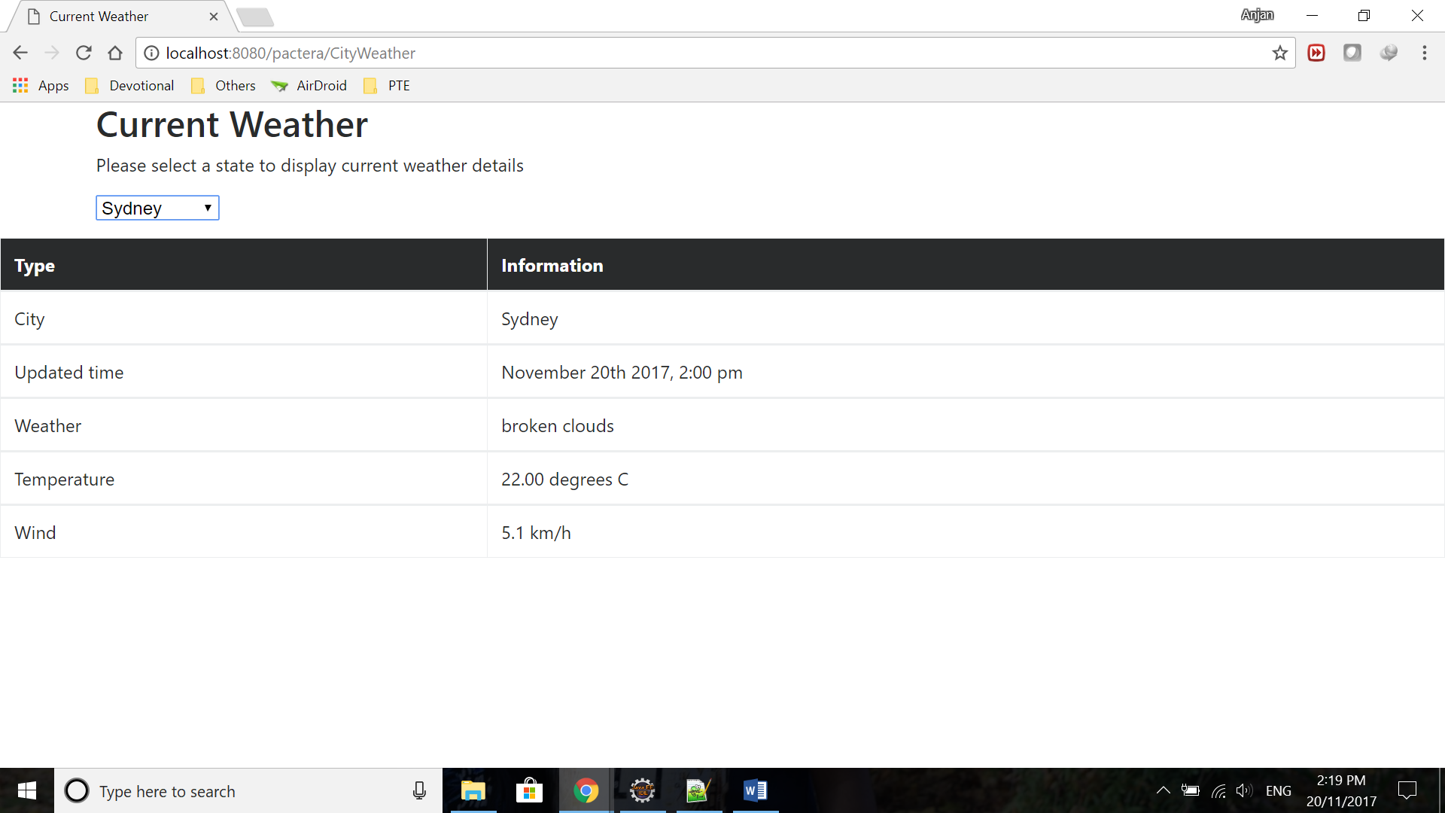

3)Below are the weather details when Melbourne is selected:

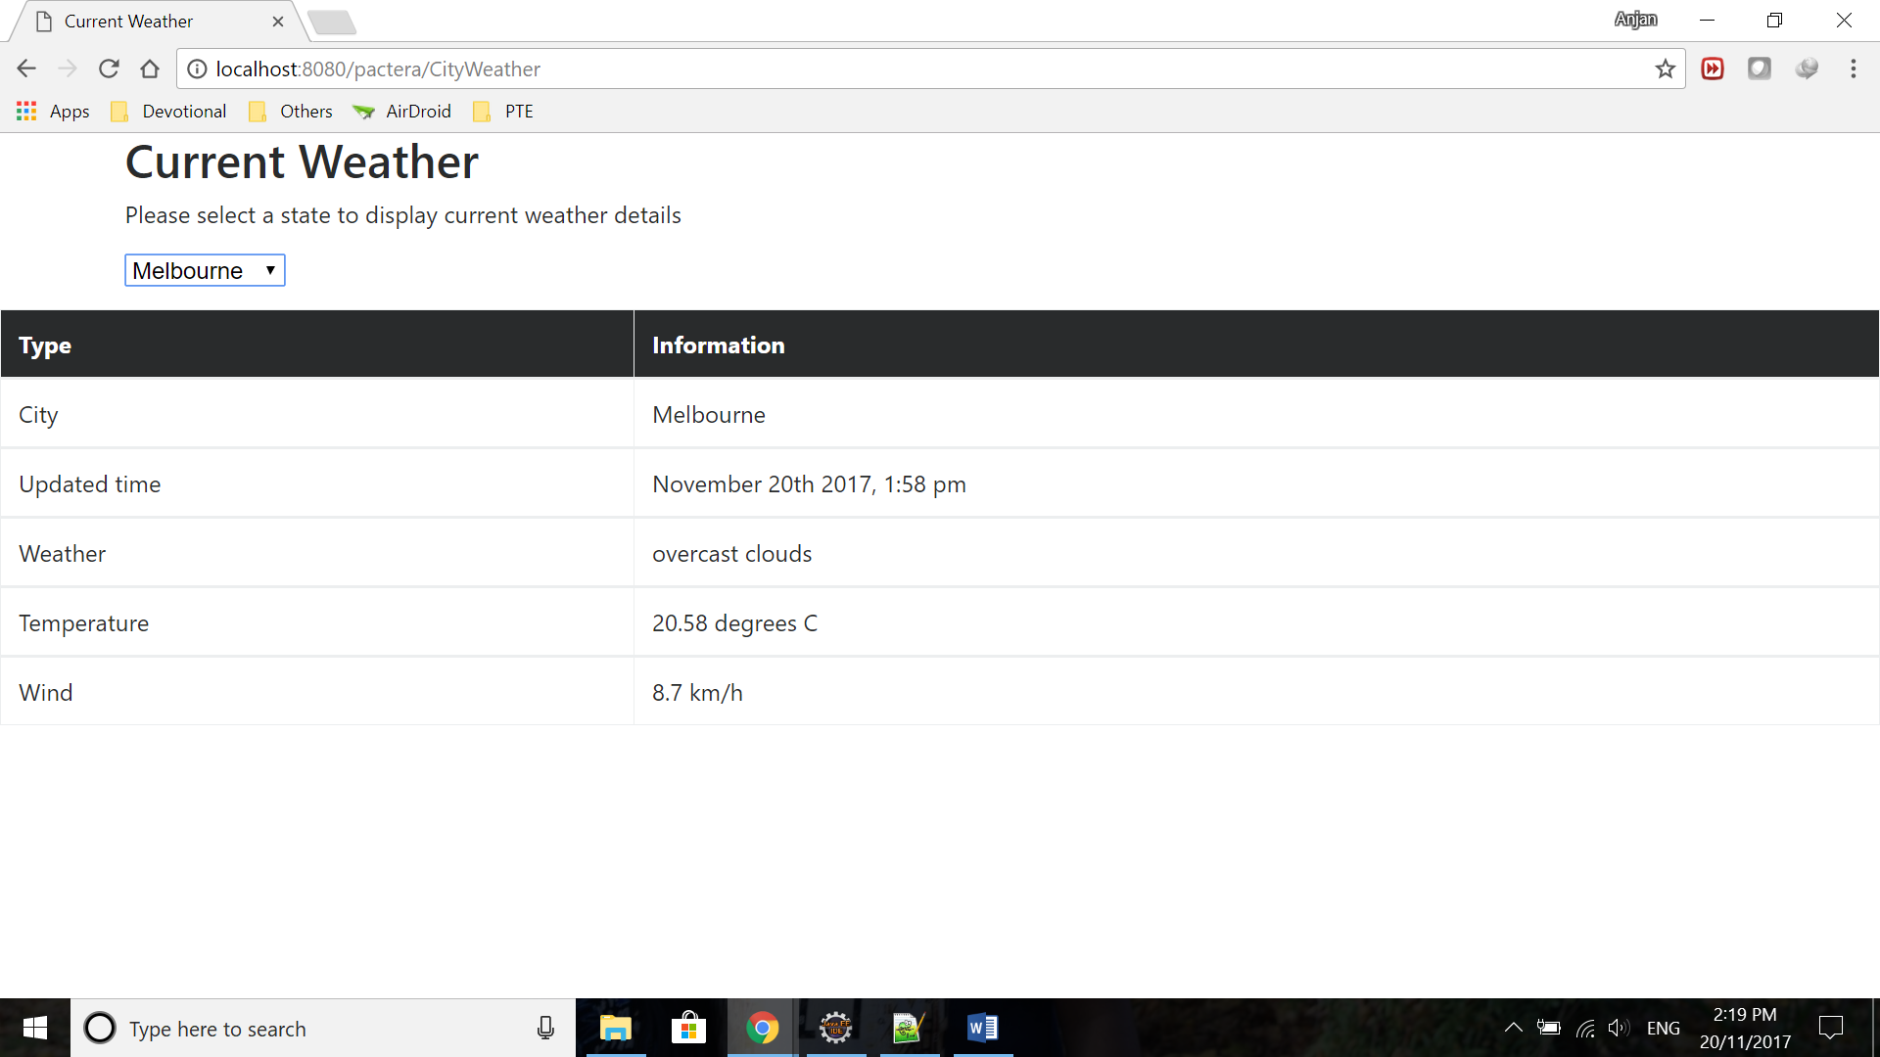

4)Below are the weather details when Wollongong is selected:

