**VISVESVARAYA TECHNOLOGICAL UNIVERSITY**

**“JnanaSangama”, Belgaum -590014, Karnataka.**



## LAB REPORT

**on**

BIG DATA ANALYTICS (20CS6PEBDA)

***Submitted by***

## Siri Chandan Sai K (1BM19CS212)

***in partial fulfillment for the award of the degree of***

**BACHELOR OF ENGINEERING**

***in***

## COMPUTER SCIENCE AND ENGINEERING



**B.M.S. COLLEGE OF ENGINEERING**

**(Autonomous Institution under VTU)**

## BENGALURU-560019

**May-2022 to July-2022**

**B. M. S. College of Engineering,**

**Bull Temple Road, Bangalore 560019**

(Affiliated To Visvesvaraya Technological University, Belgaum)

**Department of Computer Science and Engineering**



**CERTIFICATE**

This is to certify that the Lab work entitled “**BIG DATA ANALYTICS**” carried out by **Siri Chandan Sai K(1BM19CS212),** who is bonafide student of **B. M. S. College of Engineering.** It is in partial fulfillment for the award of **Bachelor of Engineering in Computer Science and Engineering** of the Visvesvaraya Technological University, Belgaum during the year 2022. The Lab report has been approved as it satisfies the academic requirements in respect of a BIG DATA ANALYTICS **- (20CS6PEBDA)** work prescribed for the said degree.

Dr.Pallavi G B **Dr. Jyothi S Nayak**

Assistant Professor Professor and Head

Department of CSE Department of CSE

BMSCE, Bengaluru BMSCE, Bengaluru

`

# Index Sheet

|  |  |  |
| --- | --- | --- |
| **Sl.**  **No.** | **Experiment Title** | **Page No.** |
| **1** | **MongoDB CRUD Demonstration** | **4-6** |
| **2** | **Cassandra Employee Database** | **7-8** |
| **3** | **Cassandra Library Database** | **9-10** |
| **4** | **Hadoop installation** | **11** |
| **5** | **HDFS Commands** | **12** |
| **6** | **Create a Map Reduce program to**   1. **find average temperature for each year from NCDC data set.** 2. **find the mean max temperature for every**   **month** | **13-19** |
| **7** | **For a given Text file, Create a Map Reduce program to sort the content in an alphabetic order**  **listing only top 10 maximum occurrences of**  **words.** | **20-25** |
| **8** | **Create a Map Reduce program to**  **demonstrating join operation** | **26-37** |
| **9** | **Program to print word count on scala shell**  **and print “Hello world” on scala IDE** | **38-39** |
| **10** | **Using RDD and FlatMap count how many times each word appears in a file and write out a list of**  **words whose count is strictly greater than 4**  **using Spark** | **40** |

|  |  |  |
| --- | --- | --- |
|  |  |  |
|  |  |  |
|  |  |  |
|  |  |  |
|  |  |  |

**Course Outcome**

|  |  |
| --- | --- |
| CO1 | Apply the concept of NoSQL, Hadoop or Spark for a given task |
| CO2 | Analyze the Big Data and obtain insight using data analytics mechanisms. |
| CO3 | Design and implement Big data applications by applying NoSQL, Hadoop or Spark |

# MongoDB- CRUD Demonstration

# CRUD (CREATE, READ, UPDATE, DELETE) OPERATIONS

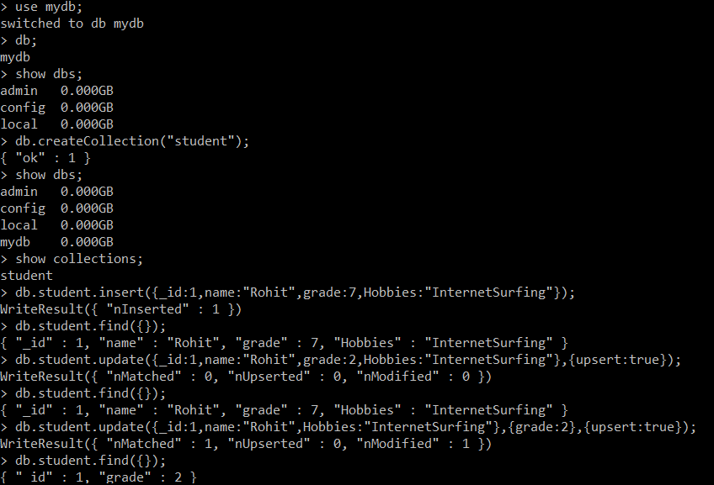

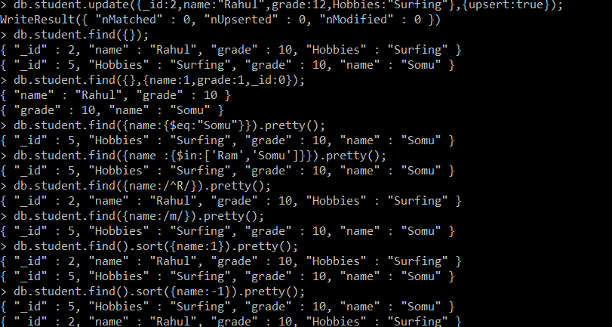

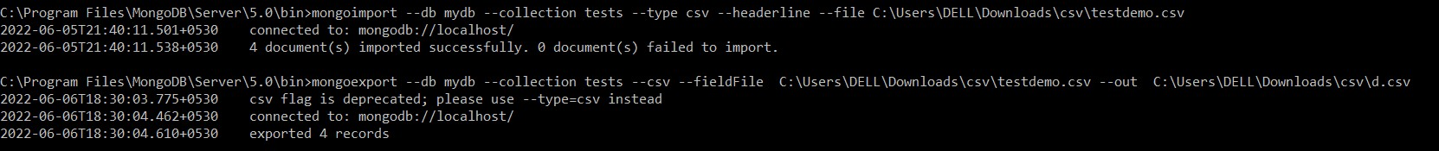

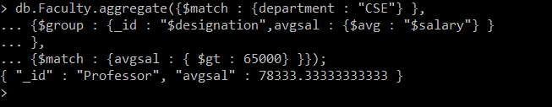

# Perform the following DB operations using Cassandra.

1. Create a key space by name Employee

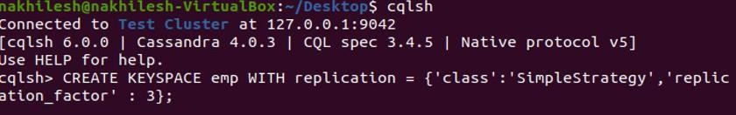

1. Create a column family by name Employee-Info with attributes Emp_Id Primary Key, Emp_Name, Designation, Date_of_Joining, Salary, Dept_Name

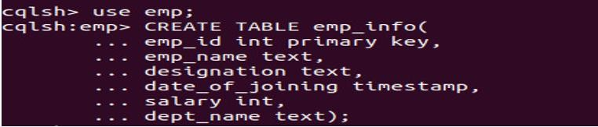

1. Insert the values into the table in batch

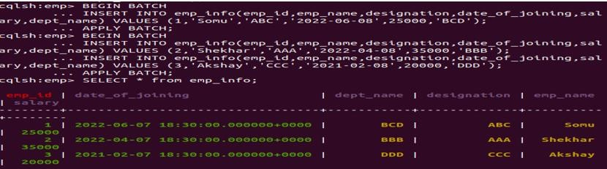

1. Update Employee name and Department of Emp-Id 2

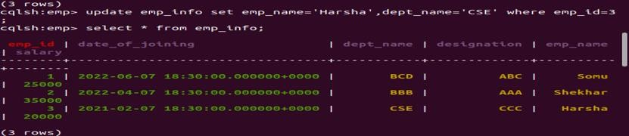

1. Sort the details of Employee records based on salary

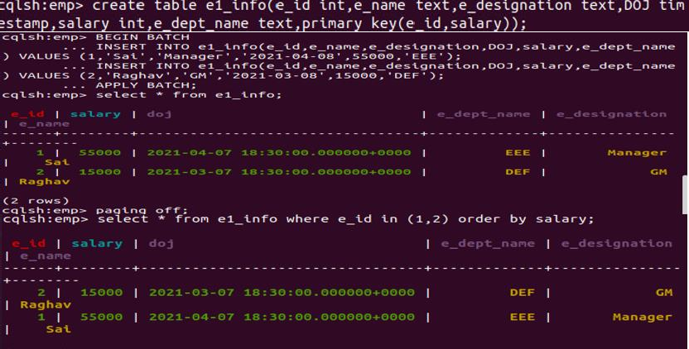

1. Alter the schema of the table Employee_Info to add a column Projects which stores a set of Projects done by the corresponding Employee



1. Update the altered table to add project names

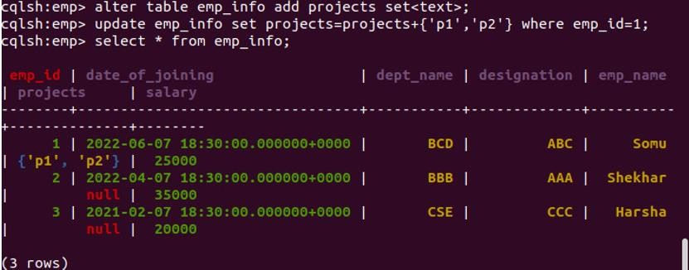

# 3. Perform the following DB operations using Cassandra.

1. Create a key space by name Library

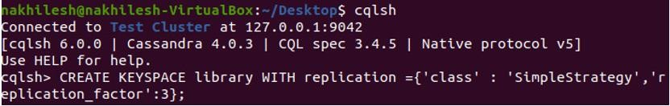

1. Create a column family by name Library-Info with attributes Stud_Id Primary Key, Counter_value of type Counter,

Stud_Name, Book-Name, Book-Id, Date_of_issue

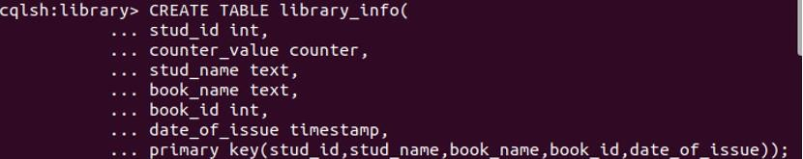

1. Insert the values into the table in batch

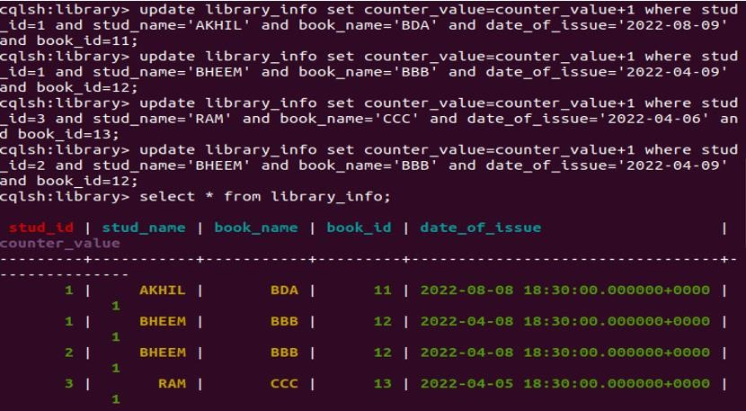

1. Display the details of the table created and increase the value of the counter

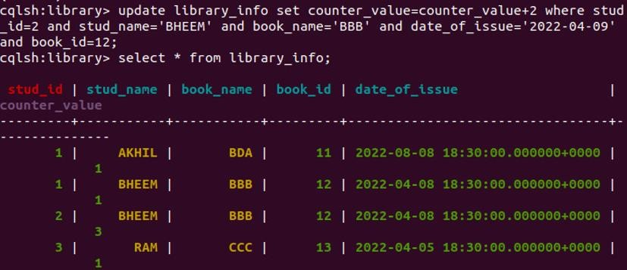

1. Write a query to show that a student with id 112 has taken a book “BDA” 2 times.

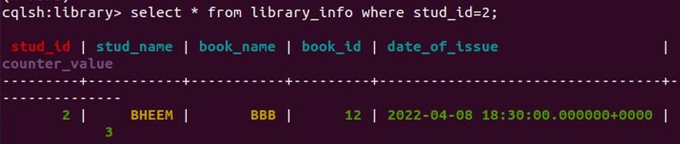

1. Export the created column to a csv file

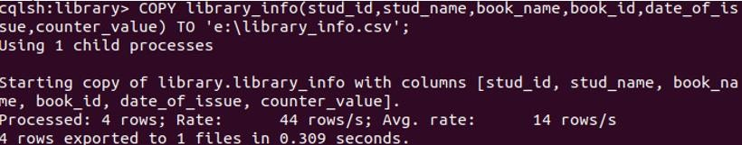

1. Import a given csv dataset from local file system into Cassandra column family

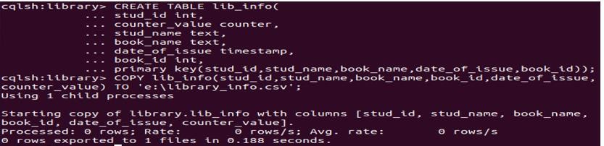

# Hadoop Installation

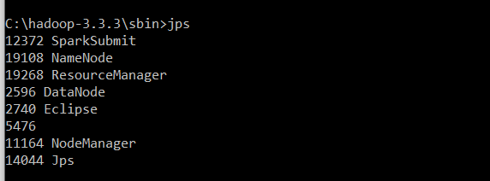

## Execution of HDFS Commands for interaction with Hadoop Environment.

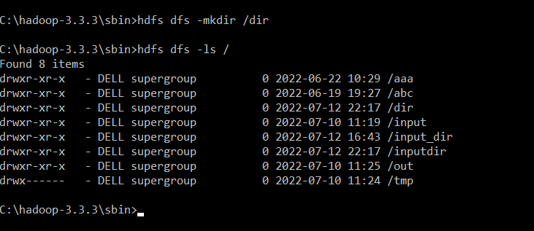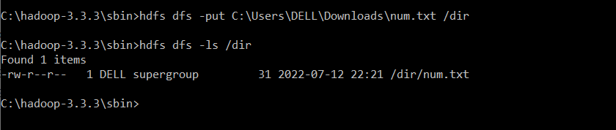

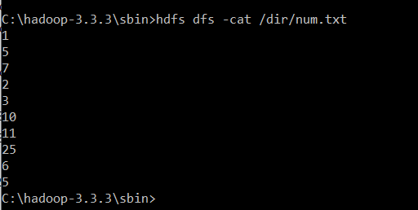

* 1. **For the given file, Create a Map Reduce program to**

## Find the average temperature for each year from the NCDC data set.

**Average Driver Class**

package temp;

import org.apache.hadoop.fs.Path; import org.apache.hadoop.io.IntWritable; import org.apache.hadoop.io.Text;

import org.apache.hadoop.mapreduce.Job;

import org.apache.hadoop.mapreduce.lib.input.FileInputFormat; import org.apache.hadoop.mapreduce.lib.output.FileOutputFormat;

public class AverageDriver {

public static void main(String[] args) throws Exception { if (args.length != 2) {

System.err.println("Please Enter the input and output parameters"); System.exit(-1);

}

Job job = new Job(); job.setJarByClass(AverageDriver.class); job.setJobName("Max temperature"); FileInputFormat.addInputPath(job, new Path(args[0])); FileOutputFormat.setOutputPath(job, new Path(args[1])); job.setMapperClass(AverageMapper.class); job.setReducerClass(AverageReducer.class); job.setOutputKeyClass(Text.class); job.setOutputValueClass(IntWritable.class); System.exit(job.waitForCompletion(true) ? 0 : 1);

}

}

job.setOutputKeyClass(Text.class); job.setOutputValueClass(IntWritable.class); System.exit(job.waitForCompletion(true) ? 0 : 1);

}

## Average Mapper Class

package temp;

import java.io.IOException;

import org.apache.hadoop.io.IntWritable; import org.apache.hadoop.io.LongWritable; import org.apache.hadoop.io.Text;

import org.apache.hadoop.mapreduce.Mapper;

public class AverageMapper extends Mapper<LongWritable, Text, Text, IntWritable> {

public static final int MISSING = 9999;

public void map(LongWritable key, Text value, Mapper<LongWritable, Text, Text, IntWritable>.Context context) throws IOException, InterruptedException {

int temperature;

String line = value.toString(); String year = line.substring(15, 19); if (line.charAt(87) == '+') {

temperature = Integer.parseInt(line.substring(88, 92));

} else {

temperature = Integer.parseInt(line.substring(87, 92));

}

String quality = line.substring(92, 93);

if (temperature != 9999 && quality.matches("[01459]")) context.write(new Text(year), new IntWritable(temperature));

}

}

## Average Reducer class

package temp;

import java.io.IOException;

import org.apache.hadoop.io.IntWritable; import org.apache.hadoop.io.Text;

import org.apache.hadoop.mapreduce.Reducer;

public class AverageReducer extends Reducer<Text, IntWritable, Text, IntWritable> {

public void reduce(Text key, Iterable<IntWritable> values, Reducer<Text, IntWritable, Text, IntWritable>.Context context) throws IOException, InterruptedException {

int max_temp = 0; int count = 0;

for (IntWritable value : values) { max_temp += value.get(); count++;

}

context.write(key, new IntWritable(max_temp / count));

}

}

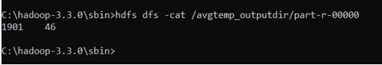

# find the mean max temperature for every month

## MeanMax driver class

package meanmax;

import org.apache.hadoop.fs.Path; import org.apache.hadoop.io.IntWritable; import org.apache.hadoop.io.Text;

import org.apache.hadoop.mapreduce.Job;

import org.apache.hadoop.mapreduce.lib.input.FileInputFormat; import org.apache.hadoop.mapreduce.lib.output.FileOutputFormat;

public class MeanMaxDriver {

public static void main(String[] args) throws Exception { if (args.length != 2) {

System.err.println("Please Enter the input and output parameters"); System.exit(-1);

}

Job job = new Job(); job.setJarByClass(MeanMaxDriver.class); job.setJobName("Max temperature"); FileInputFormat.addInputPath(job, new Path(args[0])); FileOutputFormat.setOutputPath(job, new Path(args[1])); job.setMapperClass(MeanMaxMapper.class); job.setReducerClass(MeanMaxReducer.class); job.setOutputKeyClass(Text.class); job.setOutputValueClass(IntWritable.class); System.exit(job.waitForCompletion(true) ? 0 : 1);

}

}

## MeanMax Mapper class

package meanmax;

import java.io.IOException;

import org.apache.hadoop.io.IntWritable; import org.apache.hadoop.io.LongWritable; import org.apache.hadoop.io.Text;

import org.apache.hadoop.mapreduce.Mapper;

public class MeanMaxMapper extends Mapper<LongWritable, Text, Text, IntWritable> {

public static final int MISSING = 9999;

public void map(LongWritable key, Text value, Mapper<LongWritable, Text, Text, IntWritable>.Context context) throws IOException, InterruptedException {

int temperature;

String line = value.toString();

String month = line.substring(19, 21); if (line.charAt(87) == '+') {

temperature = Integer.parseInt(line.substring(88, 92));

} else {

temperature = Integer.parseInt(line.substring(87, 92));

}

String quality = line.substring(92, 93);

if (temperature != 9999 && quality.matches("[01459]")) context.write(new Text(month), new IntWritable(temperature));

}

}

## MeanMax Reducer Class

package meanmax;

import java.io.IOException;

import org.apache.hadoop.io.IntWritable; import org.apache.hadoop.io.Text;

import org.apache.hadoop.mapreduce.Reducer;

public class MeanMaxReducer extends Reducer<Text, IntWritable, Text, IntWritable> {

public void reduce(Text key, Iterable<IntWritable> values, Reducer<Text, IntWritable, Text, IntWritable>.Context context) throws IOException, InterruptedException {

int max_temp = 0; int total_temp = 0; int count = 0;

int days = 0;

for (IntWritable value : values) { int temp = value.get();

if (temp > max_temp) max_temp = temp; count++;

if (count == 3) { total_temp += max_temp; max_temp = 0;

count = 0; days++;

}

}

context.write(key, new IntWritable(total_temp / days));

}

}

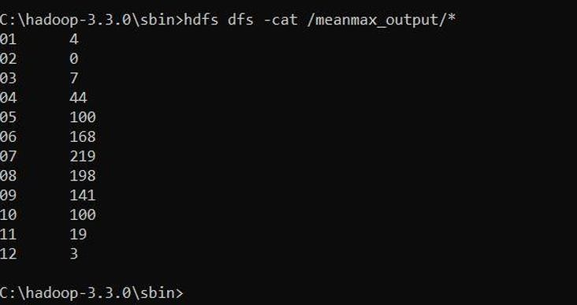

## For a given Text file, create a Map Reduce program to sort the content in an alphabetic order listing only top ‘n’ maximum occurrence of words.

**TopN Driver Class**

package samples.topn;

import java.io.IOException; import java.util.StringTokenizer;

import org.apache.hadoop.conf.Configuration; import org.apache.hadoop.fs.Path;

import org.apache.hadoop.io.IntWritable; import org.apache.hadoop.io.Text;

import org.apache.hadoop.mapreduce.Job; import org.apache.hadoop.mapreduce.Mapper;

import org.apache.hadoop.mapreduce.lib.input.FileInputFormat; import org.apache.hadoop.mapreduce.lib.output.FileOutputFormat; import org.apache.hadoop.util.GenericOptionsParser;

public class TopN {

public static void main(String[] args) throws Exception { Configuration conf = new Configuration();

String[] otherArgs = (new GenericOptionsParser(conf, args)).getRemainingArgs();

if (otherArgs.length != 2) { System.err.println("Usage: TopN <in> <out>"); System.exit(2);

}

Job job = Job.getInstance(conf); job.setJobName("Top N"); job.setJarByClass(TopN.class); job.setMapperClass(TopNMapper.class); job.setReducerClass(TopNReducer.class); job.setOutputKeyClass(Text.class); job.setOutputValueClass(IntWritable.class);

FileInputFormat.addInputPath(job, new Path(otherArgs[0])); FileOutputFormat.setOutputPath(job, new Path(otherArgs[1])); System.exit(job.waitForCompletion(true) ? 0 : 1);

}

public static class TopNMapper extends Mapper<Object, Text, Text, IntWritable> {

private static final IntWritable one = new IntWritable(1); private Text word = new Text();

private String tokens = "[_|$#<>\\^=\\[\\]\\*/\\\\,;,.\\-:()?!\"']";

public void map(Object key, Text value, Mapper<Object, Text, Text, IntWritable>.Context context) throws IOException, InterruptedException {

String cleanLine = value.toString().toLowerCase().replaceAll(this.tokens, " "); StringTokenizer itr = new StringTokenizer(cleanLine);

while (itr.hasMoreTokens()) { this.word.set(itr.nextToken().trim()); context.write(this.word, one);

}

}

}

}

## TopN Combiner Class

package samples.topn;

import java.io.IOException;

import org.apache.hadoop.io.IntWritable; import org.apache.hadoop.io.Text;

import org.apache.hadoop.mapreduce.Reducer;

public class TopNCombiner extends Reducer<Text, IntWritable, Text, IntWritable> {

public void reduce(Text key, Iterable<IntWritable> values, Reducer<Text, IntWritable, Text, IntWritable>.Context context) throws IOException, InterruptedException {

int sum = 0;

for (IntWritable val : values) sum += val.get();

context.write(key, new IntWritable(sum));

}

}

## TopN Mapper Class

package samples.topn;

import java.io.IOException; import java.util.StringTokenizer;

import org.apache.hadoop.io.IntWritable; import org.apache.hadoop.io.Text;

import org.apache.hadoop.mapreduce.Mapper;

public class TopNMapper extends Mapper<Object, Text, Text, IntWritable> { private static final IntWritable one = new IntWritable(1);

private Text word = new Text();

private String tokens = "[_|$#<>\\^=\\[\\]\\*/\\\\,;,.\\-:()?!\"']";

public vo```\\id map(Object key, Text value, Mapper<Object, Text, Text, IntWritable>.Context context) throws IOException, InterruptedException {

String cleanLine = value.toString().toLowerCase().replaceAll(this.tokens, " "); StringTokenizer itr = new StringTokenizer(cleanLine);

while (itr.hasMoreTokens()) { this.word.set(itr.nextToken().trim()); context.write(this.word, one);

}

}

}

## TopN Reducer Class

package samples.topn;

import java.io.IOException; import java.util.HashMap; import java.util.Map;

import org.apache.hadoop.io.IntWritable; import org.apache.hadoop.io.Text;

import org.apache.hadoop.mapreduce.Reducer; import utils.MiscUtils;

public class TopNReducer extends Reducer<Text, IntWritable, Text, IntWritable>

{

private Map<Text, IntWritable> countMap = new HashMap<>();

public void reduce(Text key, Iterable<IntWritable> values, Reducer<Text, IntWritable, Text, IntWritable>.Context context) throws IOException, InterruptedException {

int sum = 0;

for (IntWritable val : values) sum += val.get();

this.countMap.put(new Text(key), new IntWritable(sum));

}

protected void cleanup(Reducer<Text, IntWritable, Text, IntWritable>.Context context) throws IOException, InterruptedException {

Map<Text, IntWritable> sortedMap = MiscUtils.sortByValues(this.countMap); int counter = 0;

for (Text key : sortedMap.keySet()) { if (counter++ == 20)

break;

context.write(key, sortedMap.get(key));

}

}

}

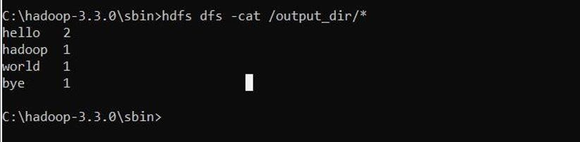

## Create a Map Reduce program to demonstrating join operation.

// JoinDriver.java

import org.apache.hadoop.conf.Configured; import org.apache.hadoop.fs.Path;

import org.apache.hadoop.io.Text; import org.apache.hadoop.mapred.*;

import org.apache.hadoop.mapred.lib.MultipleInputs; import org.apache.hadoop.util.*;

public class JoinDriver extends Configured implements Tool {

public static class KeyPartitioner implements Partitioner<TextPair, Text> { @Override

public void configure(JobConf job) {}

@Override

public int getPartition(TextPair key, Text value, int numPartitions) { return (key.getFirst().hashCode() & Integer.MAX_VALUE) % numPartitions;

}

}

@Override

public int run(String[] args) throws Exception {

if (args.length != 3) {

System.out.println("Usage: <Department Emp Strength input>

<Department Name input> <output>"); return -1;

}

JobConf conf = new JobConf(getConf(), getClass());

conf.setJobName("Join 'Department Emp Strength input' with 'Department Name input'");

Path AInputPath = new Path(args[0]); Path BInputPath = new Path(args[1]); Path outputPath = new Path(args[2]);

MultipleInputs.addInputPath(conf, AInputPath, TextInputFormat.class,

Posts.class);

MultipleInputs.addInputPath(conf, BInputPath, TextInputFormat.class,

User.class);

FileOutputFormat.setOutputPath(conf, outputPath);

conf.setPartitionerClass(KeyPartitioner.class);

conf.setOutputValueGroupingComparator(TextPair.FirstComparator.class);

conf.setMapOutputKeyClass(TextPair.class);

conf.setReducerClass(JoinReducer.class);

conf.setOutputKeyClass(Text.class);

JobClient.runJob(conf);

return 0;

}

public static void main(String[] args) throws Exception {

int exitCode = ToolRunner.run(new JoinDriver(), args); System.exit(exitCode);

}

}

// JoinReducer.java

import java.io.IOException; import java.util.Iterator;

import org.apache.hadoop.io.Text; import org.apache.hadoop.mapred.*;

public class JoinReducer extends MapReduceBase implements Reducer<TextPair, Text, Text,

Text> {

@Override

public void reduce (TextPair key, Iterator<Text> values, OutputCollector<Text, Text>

output, Reporter reporter)

throws IOException

{

Text nodeId = new Text(values.next()); while (values.hasNext()) {

Text node = values.next();

Text outValue = new Text(nodeId.toString() + "\t\t" + node.toString()); output.collect(key.getFirst(), outValue);

}

}

}

// User.java

import java.io.IOException; import java.util.Iterator;

import org.apache.hadoop.conf.Configuration; import org.apache.hadoop.fs.FSDataInputStream; import org.apache.hadoop.fs.FSDataOutputStream; import org.apache.hadoop.fs.FileSystem;

import org.apache.hadoop.fs.Path;

import org.apache.hadoop.io.LongWritable; import org.apache.hadoop.io.Text;

import org.apache.hadoop.mapred.*;

import org.apache.hadoop.io.IntWritable;

public class User extends MapReduceBase implements Mapper<LongWritable, Text, TextPair,

Text> {

@Override

public void map(LongWritable key, Text value, OutputCollector<TextPair, Text> output,

Reporter reporter)

throws IOException

{

String valueString = value.toString();

String[] SingleNodeData = valueString.split("\t"); output.collect(new TextPair(SingleNodeData[0], "1"), new

Text(SingleNodeData[1]));

}

}

//Posts.java

import java.io.IOException;

import org.apache.hadoop.io.*; import org.apache.hadoop.mapred.*;

public class Posts extends MapReduceBase implements Mapper<LongWritable, Text, TextPair,

Text> {

@Override

public void map(LongWritable key, Text value, OutputCollector<TextPair, Text> output,

Reporter reporter) throws IOException

{

String valueString = value.toString();

String[] SingleNodeData = valueString.split("\t"); output.collect(new TextPair(SingleNodeData[3], "0"), new

Text(SingleNodeData[9]));

}

}

// TextPair.java import java.io.*;

import org.apache.hadoop.io.*;

public class TextPair implements WritableComparable<TextPair> {

private Text first; private Text second;

public TextPair() {

set(new Text(), new Text());

}

public TextPair(String first, String second) { set(new Text(first), new Text(second));

}

public TextPair(Text first, Text second) { set(first, second);

}

public void set(Text first, Text second) { this.first = first;

this.second = second;

}

public Text getFirst() { return first;

}

public Text getSecond() { return second;

}

@Override

public void write(DataOutput out) throws IOException { first.write(out);

second.write(out);

}

@Override

public void readFields(DataInput in) throws IOException { first.readFields(in);

second.readFields(in);

}

@Override

public int hashCode() {

return first.hashCode() * 163 + second.hashCode();

}

@Override

public boolean equals(Object o) { if (o instanceof TextPair) { TextPair tp = (TextPair) o;

return first.equals(tp.first) && second.equals(tp.second);

}

return false;

}

@Override

public String toString() { return first + "\t" + second;

}

@Override

public int compareTo(TextPair tp) { int cmp = first.compareTo(tp.first); if (cmp != 0) {

return cmp;

}

return second.compareTo(tp.second);

}

// ^^ TextPair

// vv TextPairComparator

public static class Comparator extends WritableComparator {

private static final Text.Comparator TEXT_COMPARATOR = new Text.Comparator();

public Comparator() { super(TextPair.class);

}

@Override

public int compare(byte[] b1, int s1, int l1, byte[] b2, int s2, int l2) {

try {

int firstL1 = WritableUtils.decodeVIntSize(b1[s1]) + readVInt(b1, s1); int firstL2 = WritableUtils.decodeVIntSize(b2[s2]) + readVInt(b2, s2);

int cmp = TEXT_COMPARATOR.compare(b1, s1, firstL1, b2, s2, firstL2); if (cmp != 0) {

return cmp;

}

return TEXT_COMPARATOR.compare(b1, s1 + firstL1, l1 - firstL1,

b2, s2 + firstL2, l2 - firstL2);

} catch (IOException e) {

throw new IllegalArgumentException(e);

}

}

}

static {

WritableComparator.define(TextPair.class, new Comparator());

}

public static class FirstComparator extends WritableComparator {

private static final Text.Comparator TEXT_COMPARATOR = new Text.Comparator();

public FirstComparator() { super(TextPair.class);

}

@Override

public int compare(byte[] b1, int s1, int l1, byte[] b2, int s2, int l2) {

try {

int firstL1 = WritableUtils.decodeVIntSize(b1[s1]) + readVInt(b1, s1); int firstL2 = WritableUtils.decodeVIntSize(b2[s2]) + readVInt(b2, s2); return TEXT_COMPARATOR.compare(b1, s1, firstL1, b2, s2, firstL2);

} catch (IOException e) {

throw new IllegalArgumentException(e);

}

}

@Override

public int compare(WritableComparable a, WritableComparable b) { if (a instanceof TextPair && b instanceof TextPair) {

return ((TextPair) a).first.compareTo(((TextPair) b).first);

}

return super.compare(a, b);

}

} }

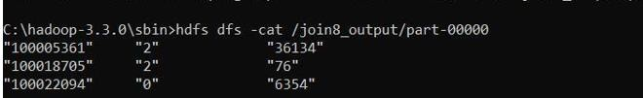

## Program to print word count on scala shell and print “Hello world” on scala IDE

scala> println("Hello World!"); Hello World!

val data=sc.textFile("C:\Users\DELL\Downloads\new.txt ") data.collect;

val splitdata = data.flatMap(line =**>** line.split(" ")); splitdata.collect;

val mapdata = splitdata.map(word =**>** (word,1)); mapdata.collect;

val reducedata = mapdata.reduceByKey(_+_); reducedata.collect;

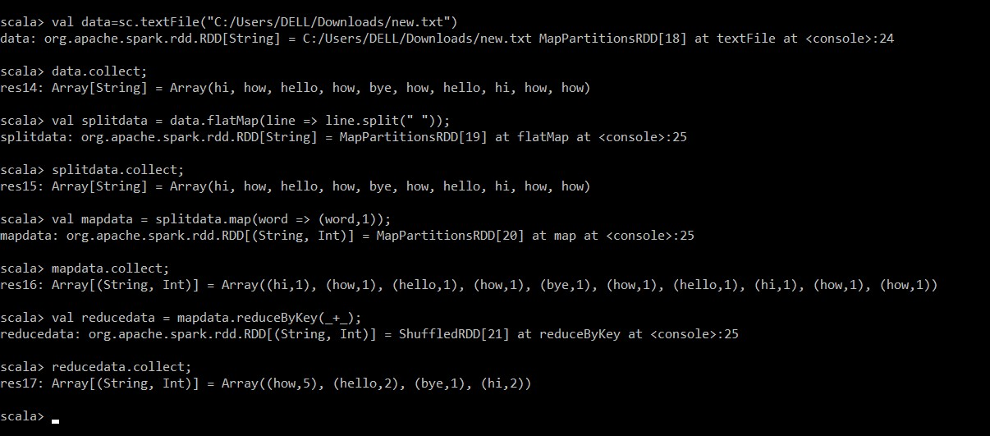

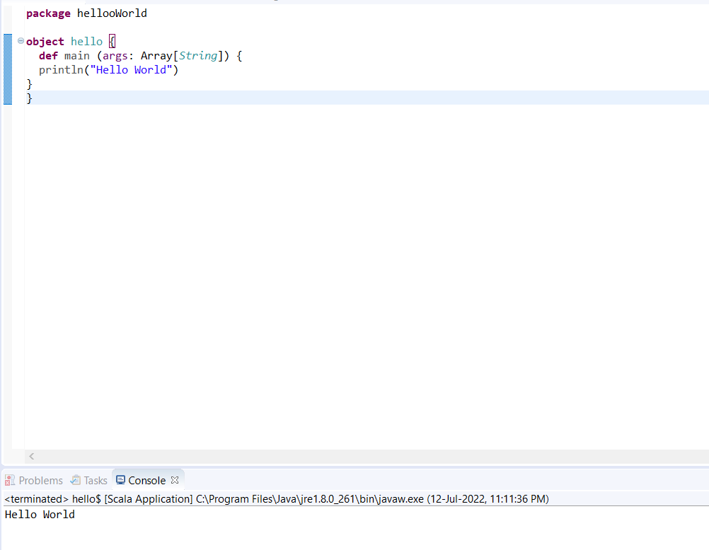

## Using RDD and Flat Map count how many times each word appears in a file and write out a list of words whose count is strictly greater than 4 using Spark

val textFile = sc.textFile("C:\Users\DELL\Downloads\new.txt ")

val counts = textFile.flatMap(line => line.split(" ")).map(word => (word, 1)).reduceByKey(_ + _)

import scala.collection.immutable.ListMap

val sorted=ListMap(counts.collect.sortWith(_._2 > _._2) println(sorted)

for((k,v)<-sorted)

{

if(v>4)

{

print(k+",") print(v) println()

}

}

