1.Create a key space by name Employee

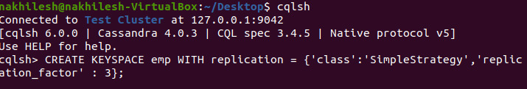
2.Create a column family by name Employee-Info with attributes Emp_Id Primary Key, Emp_Name, Designation, Date_of_Joining, Salary, Dept_Name
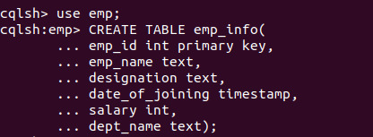
3.Insert the values into the table in batch
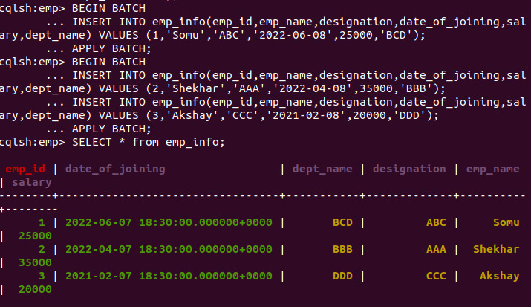

4. Update Employee name and Department of Emp-Id 2

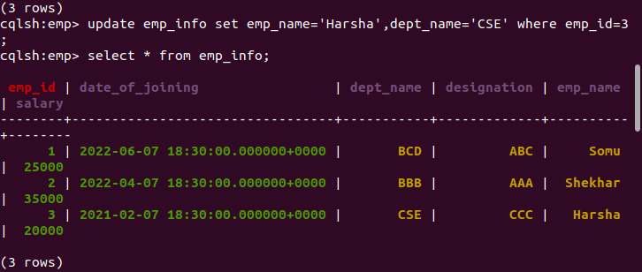
5. Sort the details of Employee records based on salary

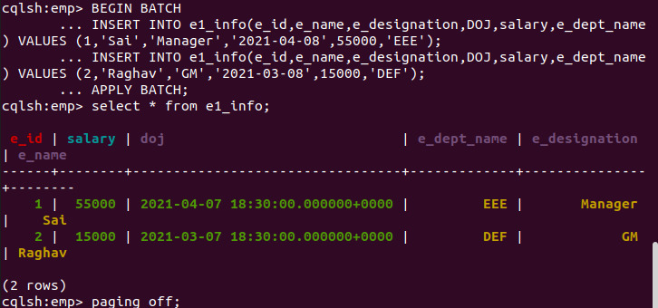
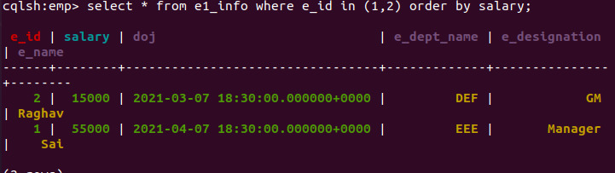
6. Alter the schema of the table Employee_Info to add a column Projects which stores a set of Projects done by the corresponding Employee.

7. Update the altered table to add project names.

