

PYTHON PROJECT

Project

on

**FACE RECOGNITION**

Submitted by: Siri Chandhana

Roll No: 23

Reg.no : 12310028

Course Code: CSM216

Term Id: 224251

Section: K23UP

**Acknowledgment**

I would like to express my sincere gratitude to my instructor, Mr. Aman Kumar Sir, for his invaluable guidance throughout this project. His expertise and advice on both the technical and conceptual aspects of the Face Recognition have been crucial in shaping its development.

I also extend my thanks to my peers for their constructive feedback, which helped refine the system and improve its functionality, accuracy, and user experience. Their insights have been vital in making the more practical and user-friendly.

This project would not have reached its current state without the collective effort and support of everyone involved, and I am truly grateful for the encouragement and feedback provided at every stage.

**Table of Contents**

1. Introduction
2. Objectives and Scope of the Project
3. Application Tools
4. Project Design
5. Flowchart
6. Data Flow Diagram

**Introduction**

Face recognition is a sophisticated technology that identifies or verifies individuals by analyzing and comparing facial features from images or video frames. As one of the most prevalent applications of artificial intelligence and computer vision, face recognition plays a crucial role in security, surveillance, authentication, and personal identification systems. It has evolved significantly in recent years, driven by advances in machine learning, deep learning, and the availability of large datasets.

Face recognition systems operate in two primary stages: **face detection** and **face matching**. In the detection phase, the system locates human faces within an image or video. This process isolates the facial region from the background and other objects. Next, during the matching phase, unique features such as the distance between eyes, the shape of the nose, or the contour of the jawline are extracted to create a digital signature known as a "face encoding." These encodings are then compared against a database of known faces to identify or authenticate individuals.

Despite its potential, face recognition faces technical and ethical challenges. Variations in lighting, pose, facial expressions, and occlusions like masks can reduce accuracy. Bias in training datasets can lead to lower performance for certain demographics, raising fairness concerns. Additionally, the technology raises privacy issues, as unauthorized surveillance or misuse can compromise individual freedoms

The field is rapidly advancing, with research focusing on improving accuracy, speed, and fairness. Innovations like 3D facial recognition, multimodal biometric systems, and edge AI are expected to expand its capabilities. Regulatory frameworks are also being developed globally to ensure ethical and transparent use of this technology.

**Objectives and Scope of the Project**

**Objectives:**

The objective of this face recognition project is to develop a real-time, accurate system for detecting and recognizing faces. It aims to enhance security through user authentication, optimize data processing for efficiency, and ensure privacy by implementing robust data protection measures while evaluating performance under diverse conditions.

1. **Develop a Functional Face Recognition System**: Implement a real-time face recognition system that can detect and identify individuals from video frames or images.
2. **Accuracy Improvement**: Enhance the accuracy of face detection and matching by optimizing face encodings and using advanced machine learning techniques.
3. **User Authentication**: Integrate the system for secure user authentication, such as login or access control in real-time.
4. **Efficient Data Processing**: Build an efficient system capable of processing large amounts of visual data with minimal computational resources.
5. **Privacy Considerations**: Address potential privacy concerns by ensuring that personal data (e.g., face images) is handled responsibly and securely.
6. **Evaluation of Performance**: Test the system under various conditions (lighting, facial expressions, and occlusions) to evaluate robustness and accuracy.

**Scope of the Project**

The scope of this project includes face detection and recognition from images or video streams, real-time performance, and integration into security applications. It covers handling environmental variations, scalability for moderate-sized user databases, and addressing privacy concerns. The system will be designed for practical use cases, ensuring high adaptability and reliability.

1. **Face Detection and Recognition**: The system will detect human faces from images or video streams and match them with a pre-trained database of known faces for identification.
2. **Integration with Security Systems**: The project will integrate face recognition with security applications, such as user authentication for devices or access control systems.
3. **Real-Time Operation**: The system will function in real-time, with video capture from a webcam or other video sources to detect and identify faces immediately.
4. **Environment Variability**: The system will account for variations in lighting, face orientation, and facial expressions, aiming for high performance even in challenging conditions.
5. **Scalability**: The project will aim to scale for handling a moderate number of users (i.e., recognition from a database of known faces).
6. **Ethical and Legal Constraints**: The scope includes considering the ethical implications of face recognition technology, such as user consent and data privacy laws.

**Application Tools for Face Recognition**

The successful development of a face recognition system requires a variety of tools, libraries, and software to ensure efficient processing, high accuracy, and user-friendly interaction. The tools utilized in this project are as follows:

**1.** **Programming Language:**

- Python: Chosen for its simplicity, flexibility, and rich ecosystem of libraries, Python is the primary programming language for developing the face recognition system. Its extensive support for machine learning and computer vision tools makes it ideal for such projects.

**2.** **IDE (Integrated Development Environment):**

- Jupyter Notebook: Used during the development phase for quick prototyping and testing, allowing for an interactive coding experience and easy debugging of smaller code segments.

- PyCharm: Utilized for integrated development and debugging of the complete face recognition system. It provides a robust environment for managing large codebases and debugging efficiently.

**3**. **Libraries/Packages:**

- face_recognition: The core library for face recognition, used for detecting and recognizing faces. It provides pre-built functions for extracting face encodings and matching them to known faces.

- OpenCV: Used for image processing, face detection, and real-time video capture. OpenCV helps in managing video streams and processing frames for face detection.

- Dlib: Provides additional support for face detection and alignment, improving the accuracy and robustness of the system.

- NumPy: Handles array manipulations and mathematical operations required for processing images and face encodings.

- Matplotlib: Used for visualizing data and testing the results during development (optional for data visualization).

**4. Version Control:**

- Git: Employed for version control, allowing the team to track changes, manage collaboration, and revert to previous versions of the codebase when needed.

**5. Additional Tools:**

- Notepad++: Used for drafting code snippets, writing pseudo-code, and taking notes during development.

- Microsoft Edge or Google Chrome: Browsers used to test and validate web-based implementations or applications utilizing face recognition for login or access control.

These tools work in tandem to build an efficient, accurate, and scalable face recognition system. By leveraging Python’s powerful libraries, the project aims to deliver a robust solution that meets real-time requirements and addresses both technical and privacy challenges.

**Project Design**

The Face Recognition project is structured into several functional modules, each performing specific tasks to ensure seamless operation and accurate face recognition. These modules work together to capture, process, and identify faces efficiently.

1. Face Detection Module:
   * Purpose: Detects faces in images or video streams.
   * Tools: Uses OpenCV for detecting faces in real-time from webcam input or static images.
   * Functionality: Captures frames from a video feed, identifies the facial region, and isolates faces for further processing.
2. Face Encoding and Recognition Module:
   * Purpose: Extracts unique features (encodings) from detected faces and compares them to a database of known faces.
   * Tools: Utilizes the face_recognition library to generate and match face encodings.
   * Functionality: Extracts key facial features such as eye distance, nose shape, and jawline to create a unique digital signature (face encoding). Matches these encodings with known faces stored in a database.
3. Database Management Module:
   * Purpose: Stores and manages face encodings of known individuals.
   * Tools: Stores data in a simple file format (e.g., JSON, SQLite) for easy retrieval and management.
   * Functionality: Allows for the addition, update, or removal of user data (faces) and ensures that recognized faces are accurately matched to the correct user.
4. User Authentication Module:
   * Purpose: Uses face recognition to authenticate users and grant access.
   * Tools: Integrates with the face recognition module to verify the identity of detected individuals.
   * Functionality: After detecting and recognizing a face, the system authenticates the user and provides access or performs actions (e.g., unlock devices, login to applications).
5. Real-Time Processing Module:
   * Purpose: Processes face detection and recognition in real-time.
   * Tools: Uses OpenCV for capturing video streams and face_recognition for processing each frame.
   * Functionality: Continuously captures and processes video frames, detects faces, and attempts to recognize them in real time for seamless interaction.
6. Privacy and Security Module:
   * Purpose: Ensures that personal data (face images and encodings) are stored securely and responsibly.
   * Tools: Implements data encryption techniques and ensures compliance with privacy regulations.
   * Functionality: Protects user data through encryption and anonymization, ensuring that facial information is not misused or accessed without consent.
7. Performance Evaluation Module:
   * Purpose: Evaluates the accuracy and robustness of the face recognition system.
   * Tools: Implements performance metrics such as accuracy, false positive rate, and processing speed.
   * Functionality: Tests the system under various conditions (lighting, facial expressions, occlusions) to evaluate the performance and make necessary improvements.
8. User Interface (Optional):
   * Purpose: Provides a graphical interface for easier interaction with the system.
   * Tools: Uses Tkinter or PyQt for designing a simple GUI.
   * Functionality: Allows users to manage face enrollment, view recognition results, and monitor system performance through a visual interface, providing additional functionality alongside the core face recognition features.

These modules collaborate to build a robust, real-time face recognition system, ensuring accurate identification, smooth user interaction, and compliance with privacy standards. Each module serves a specific function but works cohesively to deliver a seamless face recognition experience.

**Role of Modularity**

The modular design of the face recognition system ensures scalability, maintainability, and flexibility. Each module can be developed, tested, and updated independently, allowing easy integration of new features or improvements. This approach facilitates smoother updates, efficient collaboration, and enhanced user experience, ensuring the system remains adaptable and user-friendly while meeting evolving needs.

**Flowchart**

The flowchart below outlines the workflow within the Face Recognition project, highlighting the key processes and decision points:

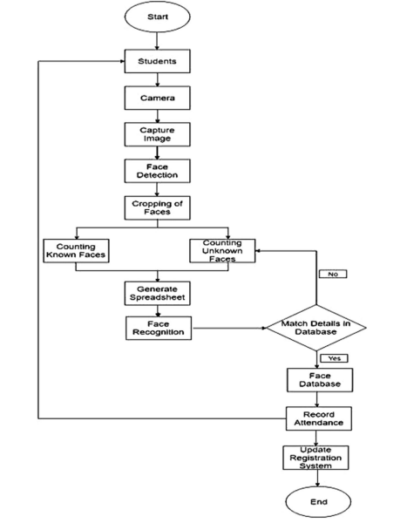

**Data Flow Diagram**

The Data Flow Diagram (DFD) for the Face Recognition project is structured as follows:

**Level 0 DFD**

At this level, the system is represented as a single process interacting with external entities.

* **External Entity**: User
* **Process**: Face Recognition System
* **Data Flow**:
  + User provides a face image (e.g., via webcam or uploaded photo) to the Face Recognition System.
  + The system processes the image and returns an authentication result (e.g., access granted or denied).
  + 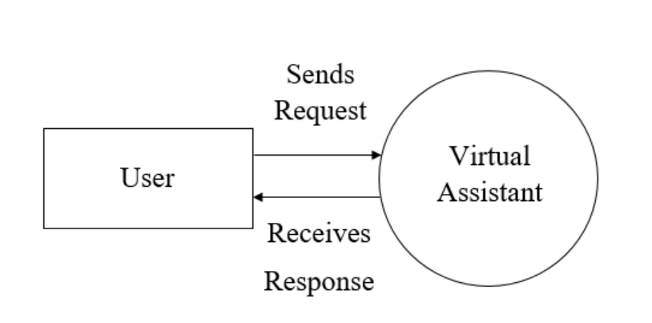

**Level 1 DFD (Detailed Processes)**

This level breaks the system into key internal modules and their data flows.

**Processes:**

1. **Face Detection:**
   * Input: Raw image from the user.
   * Output: Detected face region sent to the Face Encoding process.
2. **Face Encoding:**
   * Input: Detected face from the Face Detection process.
   * Output: Encoded facial features (face encoding) sent to Recognition and Matching.
3. **Recognition and Matching:**
   * Input: Face encoding from the Face Encoding process and known encodings from the database.
   * Decision: Matches input encoding with known encodings in the database.
   * Output: Matched identity or no match found, sent to User Authentication.
4. **User Authentication:**
   * Input: Matched identity (or no match) from Recognition and Matching.
   * Output: Authentication result (e.g., access granted or denied) sent back to the User.
5. **Database Management:**
   * Input: Requests to add, update, or delete face encodings.
   * Output: Updates to the database of known face encodings

**Data Stores**

1. **Database of Encodings:**

Stores face encodings of known users, used for recognition and matching processes.

**Data Flows**

1. **Raw Image**: Flows from User to Face Detection.
2. **Detected Face Region**: Sent from Face Detection to Face Encoding.
3. **Face Encoding**: Flows from Face Encoding to Recognition and Matching.
4. **Matched Identity**: Sent from Recognition and Matching to User Authentication.
5. **Authentication Result**: Sent from User Authentication back to the User.
6. **Database Requests**: Flows from Recognition and Matching or external commands to Database Management.

**BLOCK DIAGRAM:**

