AUTO SHOP CART
A report submitted in partial fulfillment of the Academic requirements for the award of the degree of
Bachelor of Technology

SOCIAL INNOVATION IN PRACTICE


J.NIKITHA 22H51A0485
B. SIRI CHOWDARY 23H51A0410
M. PUSHPA LATHA 23H51A0434
K. SAHASRA 23H51A04E2
T. VARUN KUMAR 23H51A04H4
G. SRUJAN REDDY 23H51A04Q6

UNDER THE COURSE

CENTRE FOR ENGINEERING EDUCATION RESEARCH

CMR COLLEGE OF ENGINEERING & TECHNOLOGY
(Autonomous)
(NAAC Accredited with ‘A⁺’ Grade & NBA Accredited)
(Approved by AICTE, Permanently Affiliated to JNTU Hyderabad)
KANDLAKOYA, MEDCHAL ROAD, HYDERABAD-501401
2024-25

CENTRE FOR ENGINEERING EDUCATION RESEARCH

CMR COLLEGE OF ENGINEERING & TECHNOLOGY
(Autonomous)
(NAAC Accredited with ‘A⁺’ Grade & NBA Accredited)
(Approved by AICTE, Permanently Affiliated to JNTU Hyderabad)
KANDLAKOYA, MEDCHAL ROAD, HYDERABAD-501401


CERTIFICATE
This is to certify that the report entitled “AUTO SHOP CART” is a bonafide work done by J.Nikitha (22H51A0485), B.Siri Chowdary (23H51A0410), M.Pushpa Latha (23H51A0434), K.Sahasra(23H51A04E2),T.VarunKumar (23H51A04H4), G. Srujan Reddy (23H51A04Q6) of II B.Tech II Semester, in partial fulfillment of the requirements for the award of the degree of Bachelor of Technology, submitted to Centre for Engineering Education Research, CMR College of Engineering & Technology, Hyderabad during the Academic Year 2024-25.

(Names of the project coordinators) (Mr.B. Suresh ram)
- Mr. K. Raju, Assistant Professor, CEER/ECE HOD-CEER
- Mr. S. Suresh, Assistant Professor, CEER/IT
- Mr. P. Senthil, Assistant Professor, CEER/CSM

DECLARATION

We, the students of II B.Tech II Semester of Centre for Engineering Education Research , CMR COLLEGE OF ENGINEERING & TECHNOLOGY, Kandlakoya, Hyderabad, hereby declare, that under the supervision of our course coordinators, we have independently carried out the project titled “Auto Shop Cart” and submitted the report in partial fulfillment of the requirement for the award of Bachelor of Technology in by the Jawaharlal Nehru Technological University, Hyderabad (JNTUH) during the academic year 2024-2025.

STUDENT NAME | ROLL NUMBER | SIGNATURE
J.NIKITHA | 22H51A0485
B.SIRI CHOWDARY | 23H51A0410
M.PUSHPA LATHA | 23H51A0434
K.SAHASRA | 23H51A04E2
T.VARUN KUMAR | 23H51A04H4
G.SRUJAN REDDY | 23H51A04Q6

ACKNOWLEDGEMENT
We are obliged and grateful to thank Mr.B.Suresh Ram, Head(CEER), CMRCET, for his cooperation in all respects during the course.
We would like to thank the Principal of CMRCET, Dr.A.Seshu Kumar, for his support in the course of this project work.
We would like to thank the Director of CMRCET, Major. Dr.V.A.Narayana, for his support in the course of this project work.
Finally, we thank all our faculty members and Lab Assistants for their valid support.
We own all our success to our beloved parents, whose vision, love and inspiration has made us reach out for these glories.

ABSTRACT
The "Auto Shop Cart" is a smart, automated shopping assistant designed to enhance the customer experience in retail and grocery stores. This innovative system integrates various components such as RFID sensors, microcontrollers, and digital displays to streamline the shopping process. As items are placed into the cart, RFID tags are scanned, and the product details along with their prices are automatically added to a digital bill displayed on an LCD or mobile interface. The system reduces the need for manual billing, minimizes human error, and speeds up the checkout process. Additionally, the Auto Shop Cart can include features such as item tracking, theft prevention, and inventory management. By combining automation with ease of use, this project contributes to smarter and more efficient retail operations.

CHAPTERS |  | DESCRIPTION | PAGE NO
 |  | Abstract
1 |  | Introduction | 1
2 |  | Literature Review  Literature Review | 2-8
3 |  | Problem Definition | 9
 | 3.1 | Problem Statement | 9
 | 3.2 | Objective | 9
 | 3.3 | Requirement Analysis | 10-15
4 |  | Methodology | 15
 | 4.1 | Conceptual Design | 16
 | 4.2 | Block Diagram | 17
 | 4.3 | Design Description | 18-19
5 |  | Implementation | 20
 | 5.1 | Results and Discussions | 20
 | 5.2 | Conclusions | 21
6 | 6.1 | Appendix | 22
 | 6.2 | References | 22
 | 6.3 | Source Code | 23-30
7 |  | Team Details | 31-32
TABLE OF CONTENT

CHAPTER-1
INTRODUCTION
In today’s fast-paced world, automation and smart systems are transforming the way we interact with everyday tasks, including shopping. Traditional shopping methods often involve long queues at billing counters, manual price checking, and customer dissatisfaction due to delays and inefficiencies. To overcome these challenges, the concept of an Auto Shop Cart emerges as a modern solution that enhances the shopping experience through technology and automation.
The Auto Shop Cart is an intelligent system designed to automate the billing process in supermarkets and retail stores. By using technologies such as RFID (Radio Frequency Identification), microcontrollers (like Arduino or Raspberry Pi), weight sensors, and LCD displays, the cart is capable of identifying and recording products as they are placed inside. This eliminates the need for manual scanning by store personnel, thereby saving time and reducing the chances of human error.
The main goal of this project is to simplify shopping by making the cart itself a self-service billing unit. As the customer moves through the store, each product added to the cart is automatically detected and displayed with its price and quantity. At the end of shopping, the total bill is readily available, allowing customers to pay directly through a kiosk or mobile app, avoiding long checkout lines altogether.
This system also benefits store management by enabling real-time inventory tracking and reducing losses due to item theft or mismanagement. Integration with a central database can help maintain up-to-date stock information and streamline warehouse operations. Moreover, the cart can be enhanced with features such as smart navigation, product suggestions, and voice assistance for added convenience.

CHAPTER-2
LITERATURE REVIEW
2.1. Existing Solutions:
1.Foldable & Compact Trolleys:-
- Smart human following shopping trolleys are designed to follow customers automatically, eliminating the need for them to push the cart manually. This technology offers convenience and ease for shoppers, allowing them to focus on shopping and enjoying their experience. The smart trolley is equipped with various sensors and cameras that can detect the customer's location and follow them while they shop.
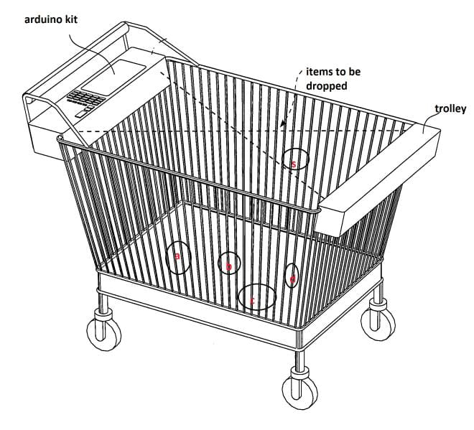
Figure.2.1.1: Compact Trolleys

FEATURES:
1. Autonomous Following:
- Computer Vision and Sensors: Follows the owner at a walking pace, avoiding obstacles and maintaining a safe distance.
2. Smart Navigation:
- Obstacle Avoidance: Efficiently navigates crowded environments.
3. Additional Smart Features:
- Removable Power Bank: Charges devices on the go.
- TSA-Approved Lock: Easy airport security checks.
- Location Tracking: Real-time tracking via smartphone app.
DISADVANTAGES:
1. Limited Speed: Follows only at walking pace.
2. Smartphone Dependency: Requires a smartphone for full functionality.
3. Battery Life: Limited usage time; needs frequent recharging.
4. Navigation Accuracy: May occasionally struggle with small or fast-moving obstacles.
5. Weight: Technology and battery add extra weight.
6. Cost: Higher price compared to traditional luggage.
7. Data Security: Potential privacy concerns and risk of unauthorized tracking.
2.COWAROBOT R1 by COWAROBOT:-
- The COWAROBOT R1 is a self-driving suitcase designed to autonomously follow its owner using AI-based tracking technology.
- It utilizes visual recognition algorithms and sensors to detect and follow the user while navigating through crowded environments such as airports, train stations, and sidewalks.
- The suitcase is equipped with a built-in power bank for device charging and a smartphone app for remote control and monitoring.
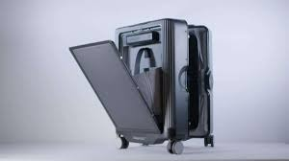
Figure. 2.1.2: COWAROBOT R1 by COWAROBOT
FEATURES:
1. Self-Driving Capability: Utilizes AI-based tracking and visual recognition algorithms to autonomously follow its owner.
2. Navigation in Crowded Environments: Designed to navigate through crowded places like airports, train stations, and sidewalks.
3. Built-in Power Bank: Includes a built-in power bank for charging devices on the go.
4.Smartphone App: Offers a smartphone app for remote control and monitoring of the suitcase.
5. Stylish Design: Typically features a modern and sleek design.
DISADVANTAGES:
1. Cost:Self-driving: technology can make the suitcase expensive compared to traditional options.
2. Complexity: The technology involved may require occasional updates or maintenance.
3. Security Concerns: Autonomous tracking and connectivity could raise security and privacy issues if not properly secured.
4. Limited Terrain Adaptability: May struggle with irregular terrains or unexpected obstacles despite its advanced navigation capabilities.
5. Battery Life: Dependency on battery power, especially with the added load of charging devices, could affect usage time.
3. Travelmate Robotics:-
- Travelmate Robotics offers a range of autonomous robotic suitcases designed to follow their owners seamlessly.
- These suitcases feature omnidirectional wheels, intelligent sensors, and obstacle avoidance technology to navigate through various terrains and environments.
- They also come with smart features such as USB charging ports, GPS tracking, and app-controlled settings for customization.
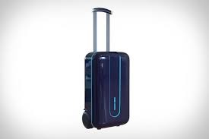
Figure.2.1.3: TRAVELMATE ROBOTICS

FEATURES:
1. Omnidirectional Wheels: Allows for easy maneuverability in any direction.
2. Intelligent Sensors: Detect obstacles and navigate around them autonomously.
3. Obstacle Avoidance Technology: Enhances safety by avoiding collisions in various terrains and environments.
4. Smart Features:
- USB Charging Ports: Enables convenient charging of electronic devices while on the move.
- GPS Tracking: Helps owners locate their suitcase at all times.
- App-Controlled Settings:Provides customization options through a smartphone app for personalized user experience.
DISADVANTAGES:
1. Cost:Autonomous technology and advanced features may make these suitcases more expensive than traditional options.
2. Complexity: Requires understanding and occasional maintenance of the robotic and electronic systems.
3. Security Concerns: Connectivity features such as GPS tracking and app control may raise privacy and security considerations if not properly secured.
4. Battery Life: Like any electronic device, battery life and dependency on power could affect usage time, especially with charging ports in use.
5. Weight and Size: The additional components for autonomy and features may add to the overall weight and size of the suitcase.

GAPS IN EXISTING SOLUTIONS:
All the existing solutions have many disadvantages. The following are the gaps we found in those existing solutions:
- Potentially fewer additional features like GPS tracking or extensive app control.
- Availability and distribution may be limited compared to more established brands.
- Higher cost due to advanced technology.
- Maintenance and updates may require technical support.
- Potentially higher cost and weight due to advanced robotic systems.
- Requires understanding and occasional maintenance of electronic components.
- Battery life considerations, especially with active use of charging ports.
4. Proposed Solution:
As we have gone with the need statement, we gone through a literature review so that we can know what exactly our prototype must contain, what kind of updates it should have. While going through this process we came across constraints like:

- Advanced obstacle detection for safe navigation.
- Intuitive user interfaces and controls.
- GPS tracking and smartphone integration for security.
- Ergonomic design with adjustable features.
- Robust construction and durability.
- Continuous feedback and improvement mechanisms.

CHAPTER-3
PROBLEM DEFINITION
3.1 Problem Statement:
Many travelers find maneuvering luggage a hassle, particularly in crowded spaces . Current suitcases require manual handling, causing fatigue and limiting mobility . While following suitcases offer hands-free travel, there are oncerns about their ability to safely navigate obstacles, respond intuitively to user control, and ensure security . To gain wider acceptance, there's a need for a user-centered following suitcase system that prioritizes safe navigation and user control.
3.2 Objective:
- Develop a User-centered Design
- Enhance Safe Navigation
- Improve User Control and Responsiveness
- Ensure Security and Reliability
- Increase Mobility and Reduce Fatigue
3.3 Requirement Analysis:
1. ARDUINO UNO:
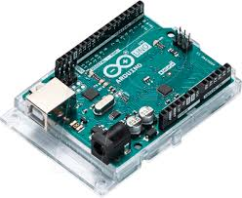
Figure.3.3.1: ARDUINO UNO
A microcontroller board based on the ATmega328P, used for controlling the various sensors, motors, and communication modules. It has 14 digital I/O pins, 6 analog inputs, a 16 MHz quartz crystal, a USB connection, a power jack, and a reset button.
2. 12V BATTERY:
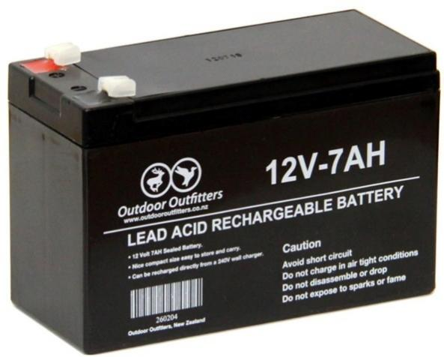
Figure.3.3.2: 12V BATTERY
A power source that provides 12 volts of electrical energy to power the Arduino Uno and other components such as the motor driver and motors.
4. DC MOTORS:
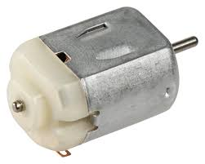
Figure.3.3.4 : DC MOTORS
Four DC motors that convert electrical energy into mechanical energy to drive the wheels of the suitcase.
5. WHEELS:
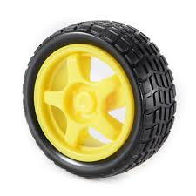
Figure.3.3.5 : WHEELS
Four wheels attached to the DC motors to provide mobility to the suitcase.
6. BREADBOARD:
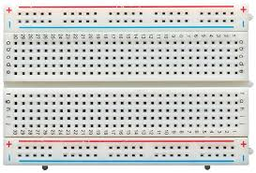
Figure.3.3.6: BREADBOARD
A construction base used for prototyping and testing circuits without soldering. It allows easy connections of components using jumper wires.
7. ULTRASONIC SENSOR:
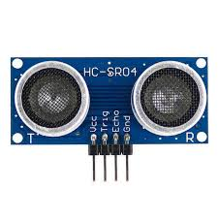
FIG.3.3.7: ULTRASONIC SENSOR
- A sensor that measures the distance to an object by using ultrasonic sound waves. It can be used to detect obstacles and avoid collisions.
10.SUITCASE:
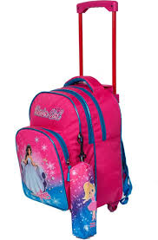
Figure.3.3.10: SUITCASE
The physical casing that will house all the components and serve as the luggage being maneuvered.
11. JUMPER WIRES:
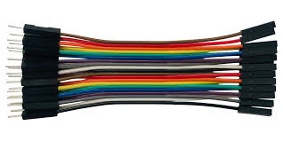-
Figure. 3.3.11: JUMPER WIRES:
Wires used to make connections between different components on the breadboard and the Arduino Uno

CHAPTER-4
METHODOLOGY
Our problem is to design an automatic moving suitcase which offer hands-free travel. We designed an automatic moving suitcase that safely navigate obstacles, respond intuitively to user control, and ensure security. With the help of this suitcase people can travel easily without any need for carrying their own luggage. Travel is made easy with the help of auto luggage.
4.1 CONCEPTUAL DESIGN
Our design includes very simple mechanism. The design of the prototype is as shown below in the figure
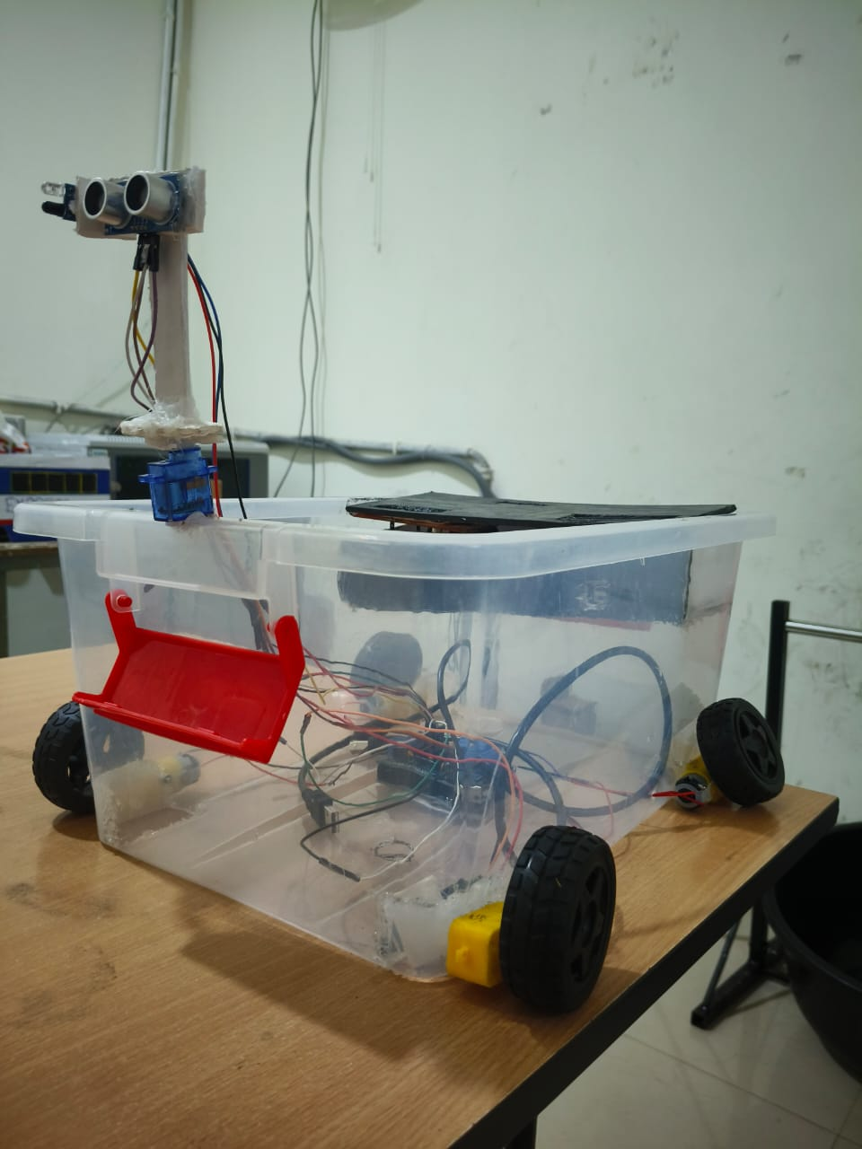
Figure.4.1.1 : PROTOTYPE
The mechanism of the solution is simple. First the ultrasonic sensors detect the obstacles and calculate the distance and send the distance to the microcontroller. The L298n motor driver adjusts the speed of wheels and the suitcase will move forward and follow the user in a straight line.The GPS acquires the real time location coordinates of the suitcase and sends the data to Arduino.
The GSM module will sends a message to user’s phone with location coordinates and also initiates a call to notify the user about suitcase location.

4.2 BLOCK DIAGRAM:
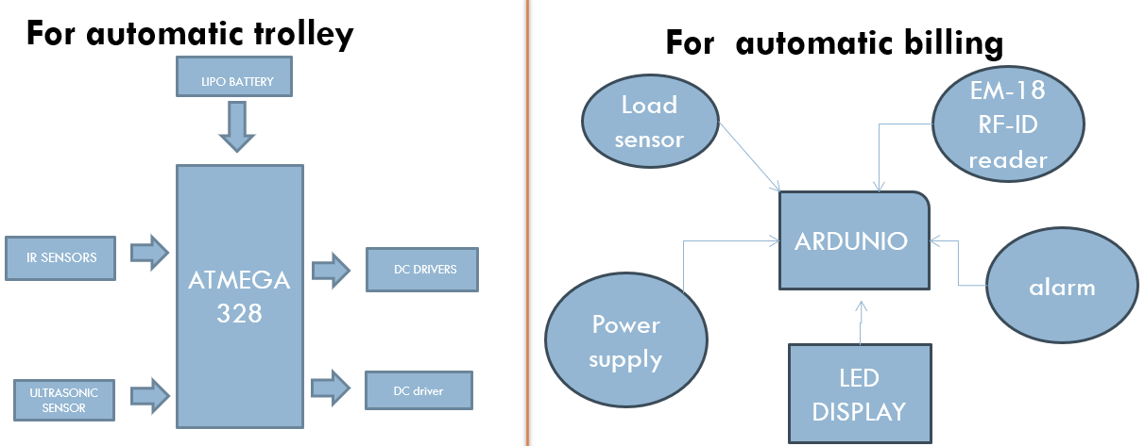
Figure. 4.2.1: BLOCK DIAGRAM

4.3 DESIGN DESCRIPTION


Figure.4.3.1: DESIGN AND INTEGRATION
Central to its design are ultrasonic sensors, strategically mounted on the front and sides, which detect obstacles and navigate around them by emitting ultrasonic waves and measuring the time taken for the echoes to return. This allows the suitcase to maintain a safe distance from obstacles and follow the user seamlessly. The GPS module, integrated into the suitcase, communicates with satellites to provide real-time location tracking, enabling users to monitor the suitcase's position via a mobile app. By communicating with satellites, the GPS module can determine the precise location of the suitcase at any given timeAdditionally, the GSM module facilitates remote communication, sending data over cellular networks to allow users to issue commands and receive updates about their luggage’s status. The GSM module ensures continuous connectivity, making it possible to manage the suitcase from virtually anywhere.A microcontroller serves as the system's brain, processing data from the sensors, GPS, and GSM modules, and controlling the suitcase's motorized wheels, which are mounted at the base. The microcontroller coordinates all the components, ensuring smooth and efficient operation.
These wheels ensure smooth and reliable movement, enabling the suitcase to autonomously

CHAPTER-5
IMPLEMENTATION
5.1 RESULTS AND DISSCUSSION:
• Obstacle Detection and Navigation:
- The ultrasonic sensors effectively detected obstacles within a range of 0.5 to 2 meters, allowing the suitcase to navigate around them without collision.
- The follow-me functionality was tested in various environments, such as airports and crowded spaces, and the suitcase maintained a consistent distance from the user, avoiding obstacles smoothly.
• Battery Performance:
- The suitcase's battery life was sufficient for a full day of typical travel activities, including continuous operation of sensors, GPS tracking, and GSM communication.
5.2 CONCLUSION:
The automatic suitcase equipped with ultrasonic sensors, GPS, and GSM technology represents a significant leap in travel convenience and security. Ultrasonic sensors enable the suitcase to autonomously follow the user by detecting and navigating around obstacles, ensuring a smooth and hands-free travel experience. GPS technology allows for real-time tracking, providing peace of mind by allowing users to locate their suitcase at any time. GSM technology further enhances security by enabling remote communication with the suitcase, such as sending alerts or updates to the user's mobile device. This combination of technologies not only alleviates the physical burden of carrying luggage but also offers enhanced security and connectivity, making it an ideal solution for modern travellers seeking a seamless and worry-free journey.

CHAPTER-6

6.1.REFERENCES
- https://images.app.goo.gl/mZUEQEtpYcYrAw8E7
- https://www.irjet.net/archives/V6/i2/IRJET-V6I2435.pdf
- http://repository.psa.edu.my/bitstream/123456789/3123/1/AUTOMATIC%20LUGGAGE%20CARRIER.pdf
- https://www.slideshare.net/slideshow/smart-travel-bag-by-team-spark/104908246
- https://images.app.goo.gl/hhgZEkX3wyqcroUaA
- https://www.designnest.com/mobile/Project/4842/Auto-Follow-Suitcase
- https://encrypted-tbn3.gstatic.com/shopping?q=tbn:ANd9GcSrYvynn9iUEWydE-zWWg7E2nz4k47tjObcA1m8n4uUTbpyXip3rUwdBnL2-WbHzyRyVbX4ZuptUvBBKpahj_TdfdhExRRxES79rkytqqCwcmt_vE3gOZeXYXUuh3n0BBLVNRVlKyuCJw&usqp=CAc
6.3.SOURCE CODE
Code For Automatic Moving
#include<NewPing.h>
#include<Servo.h>
#include<AFMotor.h>
#define RIGHT A2
#define LEFT A3
#define TRIGGER_PIN A1
#define ECHO_PIN A0
#define MAX_DISTANCE 100
NewPing sonar(TRIGGER_PIN, ECHO_PIN, MAX_DISTANCE);
AF_DCMotor Motor1(1,MOTOR12_1KHZ);
AF_DCMotor Motor2(2,MOTOR12_1KHZ);
AF_DCMotor Motor3(3,MOTOR34_1KHZ);
AF_DCMotor Motor4(4,MOTOR34_1KHZ);
Servo myservo;
int pos =0;
void setup() {
// put your setup code here, to run once:
Serial.begin(9600);
myservo.attach(10);
{
for(pos = 90; pos <= 180; pos += 1){
myservo.write(pos);
delay(15);
} for(pos = 180; pos >= 0; pos-= 1) {
myservo.write(pos);
delay(15);
}for(pos = 0; pos<=90; pos += 1) {
myservo.write(pos);
delay(15);
}
}
pinMode(RIGHT, INPUT);
pinMode(LEFT, INPUT);
}
void loop() {
// put your main code here, to run repeatedly:
delay(50);
unsigned int distance = sonar.ping_cm();
Serial.print("distance");
Serial.println(distance);
int Right_Value = digitalRead(RIGHT);
int Left_Value = digitalRead(LEFT);
Serial.print("RIGHT");
Serial.println(Right_Value);
Serial.print("LEFT");
Serial.println(Left_Value);
if((Right_Value==1) && (distance>=10 && distance<=30)&&(Left_Value==1)){
Motor1.setSpeed(160);
Motor1.run(FORWARD);
Motor2.setSpeed(160);
Motor2.run(FORWARD);
Motor3.setSpeed(160);
Motor3.run(FORWARD);
Motor4.setSpeed(160);
Motor4.run(FORWARD);
}else if((Right_Value==0) && (Left_Value==1)) {
Motor1.setSpeed(250);
Motor1.run(FORWARD);
Motor2.setSpeed(250);
Motor2.run(FORWARD);
Motor3.setSpeed(150);
Motor3.run(BACKWARD);
Motor4.setSpeed(150);
Motor4.run(BACKWARD);
}else if((Right_Value==1)&&(Left_Value==0)) {
Motor1.setSpeed(150);
Motor1.run(BACKWARD);
Motor2.setSpeed(150);
Motor2.run(BACKWARD);
Motor3.setSpeed(250);
Motor3.run(FORWARD);
Motor4.setSpeed(250);
Motor4.run(FORWARD);
}else if((Right_Value==1)&&(Left_Value==1)) {
Motor1.setSpeed(0);
Motor1.run(RELEASE);
Motor2.setSpeed(0);
Motor2.run(RELEASE);
Motor3.setSpeed(0);
Motor3.run(RELEASE);
Motor4.setSpeed(0);
Motor4.run(RELEASE);
}else if(distance > 1 && distance < 10) {
Motor1.setSpeed(0);
Motor1.run(RELEASE);
Motor2.setSpeed(0);
Motor2.run(RELEASE);
Motor3.setSpeed(0);
Motor3.run(RELEASE);
Motor4.setSpeed(0);
Motor4.run(RELEASE);
}
}

Code For Automatic Billing
#include <SPI.h>
#include <MFRC522.h>
#include <LiquidCrystal_I2C.h>
LiquidCrystal_I2C lcd(0x27, 16, 2);
const int remove_button = 2;
const int add_button = 3;
const int reset_button = 4;
const int buzzer_Pin = 5;
#define SS_PIN 10
#define RST_PIN 9
MFRC522 mfrc522(SS_PIN, RST_PIN); // Create MFRC522 instance.
struct item
{
String item_name;
String item_number;
int item_price;
};
const int number_of_item = 4;
const item item_list[number_of_item]=
{
//Item Name Item RFID Number Item Price
{"Tata salt", "B3 23 E4 11", 100},
{"Milk Powder", "A3 51 A0 0D", 50},
{"Bournvita", "13 1F A3 0D", 20},
{"Ball_Pen", "E3 68 DC 12", 10},
};
int bill_amount = 0;
int remove_buttonState = 0;
int add_buttonState = 0;
int reset_buttonState = 0;
int add_item_flag = 1;
int remove_item_flag = 0;
void setup()
{
pinMode(remove_button, INPUT);
pinMode(reset_button, INPUT);
pinMode(add_button, INPUT);
pinMode(buzzer_Pin, OUTPUT);
Serial.begin(9600); // Initiate a serial communication
SPI.begin(); // Initiate SPI bus
mfrc522.PCD_Init(); // Initiate MFRC522
Serial.println("Approximate your card to the reader...");
Serial.println();
digitalWrite(buzzer_Pin, LOW);
lcd.init();
// Turn on the Backlight
lcd.backlight();
lcd.clear();
// Set cursor (Column, Row)
lcd.setCursor(0, 0);
lcd.print("Smart Trolley");
lcd.setCursor(0,1);
lcd.print("Billing System");
delay(2000);
lcd.clear();
// Set cursor (Column, Row)
lcd.setCursor(0, 0);
lcd.print("Start purchasing");
lcd.setCursor(0,1);
lcd.print("your item");
delay(100);
}
void loop()
{
remove_buttonState = digitalRead(remove_button);
add_buttonState = digitalRead(add_button);
reset_buttonState = digitalRead(reset_button);
if(remove_buttonState)
{
add_item_flag = 0;
remove_item_flag = 1;
lcd.clear();
// Set cursor (Column, Row)
lcd.setCursor(0, 0);
lcd.print("You Can now");
lcd.setCursor(0,1);
lcd.print("Remove your item");
delay(2000);
}
else if(add_buttonState)
{
add_item_flag = 1;
remove_item_flag = 0;
lcd.clear();
// Set cursor (Column, Row)
lcd.setCursor(0, 0);
lcd.print("You Can now");
lcd.setCursor(0,1);
lcd.print("add your item");
delay(2000);
}
else if(reset_buttonState)
{
lcd.clear();
// Set cursor (Column, Row)
lcd.setCursor(0, 0);
lcd.print("Resetting");
lcd.setCursor(0,1);
lcd.print("Trolley data");
delay(2000);
lcd.clear();
// Set cursor (Column, Row)
lcd.setCursor(0, 0);
lcd.print("Start Purchasing");
lcd.setCursor(0,1);
lcd.print("Your item");
delay(2000);
bill_amount = 0;
}
// Look for new cards
if ( ! mfrc522.PICC_IsNewCardPresent())
{
return;
}
// Select one of the cards
if ( ! mfrc522.PICC_ReadCardSerial())
{
return;
}
//Show UID on serial monitor
Serial.print("UID tag :");
String content= "";
byte letter;
for (byte i = 0; i < mfrc522.uid.size; i++)
{
Serial.print(mfrc522.uid.uidByte[i] < 0x10 ? " 0" : " ");
Serial.print(mfrc522.uid.uidByte[i], HEX);
content.concat(String(mfrc522.uid.uidByte[i] < 0x10 ? " 0" : " "));
content.concat(String(mfrc522.uid.uidByte[i], HEX));
}
Serial.println();
Serial.print("Message : ");
content.toUpperCase();
for(int i = 0 ;i < sizeof(item_list) ; i++)
{
if (content.substring(1) == item_list[i].item_number) //change here the UID of the card/cards that you want to give access
{
if(add_item_flag == 1)
{
bill_amount = bill_amount + item_list[i].item_price;
// Serial.println("you have purchased = " + item_list[i].item_name);
// Serial.print("Purchased item price");
// Serial.println(item_list[i].item_price);
// Serial.print("Total billing amount");
// Serial.println(bill_amount);
// delay(1000);
digitalWrite(buzzer_Pin, HIGH);
delay(500);
digitalWrite(buzzer_Pin, LOW);
lcd.clear();
// Set cursor (Column, Row)
lcd.setCursor(0, 0);
lcd.print(item_list[i].item_name );
lcd.setCursor(0,1);
lcd.print(String(item_list[i].item_price)+" Rs");
delay(2000);
}
else if(remove_item_flag == 1)
{
if(bill_amount > 0)
{
bill_amount = bill_amount - item_list[i].item_price;
// Serial.println("you have purchased = " + item_list[i].item_name);
// Serial.print("Purchased item price");
// Serial.println(item_list[i].item_price);
// Serial.print("Total billing amount");
// Serial.println(bill_amount);
// delay(1000);
digitalWrite(buzzer_Pin, HIGH);
delay(500);
digitalWrite(buzzer_Pin, LOW);
lcd.clear();
// Set cursor (Column, Row)
lcd.setCursor(0, 0);
lcd.print(item_list[i].item_name );
lcd.setCursor(0,1);
lcd.print("removed");
delay(2000);
}
else
{
lcd.clear();
// Set cursor (Column, Row)
lcd.setCursor(0, 0);
lcd.print("Your trolley is" );
lcd.setCursor(0,1);
lcd.print("empty now");
delay(2000);
}
}
}
}
lcd.clear();
// Set cursor (Column, Row)
lcd.setCursor(0, 0);
lcd.print("Total Billing");
lcd.setCursor(0,1);
lcd.print(String(bill_amount)+" Rs");
delay(2000);
}

PHOTO | NAME | ROLL NO | PHONE  NUMBER | EMAIL ID
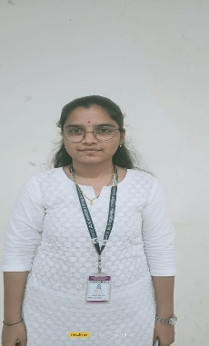 | J.NIKITHA | 22H51A0485 | 9550540801 | 22h51a0485@cmrcet.ac.in
 | B.SIRI  CHOWDARY | 23H51A0410 | 8885438063 | 23h51a0410@cmrcet.ac.in
 | M.PUSHPA  LATHA | 23H51A0434 | 7396117126 | 23h51a0434@cmrcet.ac.in
 | K.SAHASRA | 23H51A04E2 | 8125666559 | 23h51a04e2@cmrcet.ac.in
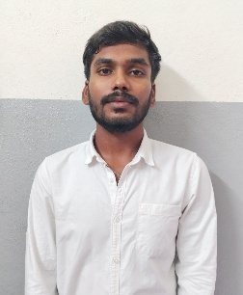 | T.VARUN  KUMAR | 23H51A04H4 | 9390643258 | 23h51a04h4@cmrcet.ac.in
 | G.SRUJAN  REDDY | 23H51A04Q6 | 7013115372 | 23h51a04q6@cmrcet.ac.in

