Reproducing Experimental Quantum Reservoir Computing in Simulation: A GPU-Accelerated N-Qubit NMR Reservoir with Free-Induction-Decay Readout, Cross-Validated Against SLEEPY
Siridech Boonsang
Faculty of Information Technology & CiRA CORE AI Center, King Mongkut's Institute of Technology Ladkrabang (KMITL), Bangkok, Thailand
Corresponding author: siridech.bo@kmitl.ac.th

Abstract
Quantum reservoir computing (QRC) exploits the natural dynamics of a quantum system as a computational substrate for temporal information processing. A recent experiment (Hou et al., Phys. Rev. Lett. 136, 120602, 2026) demonstrated state-of-the-art QRC on a nine-spin nuclear-magnetic-resonance (NMR) platform, reporting a practical quantum advantage over large classical echo state networks (ESNs) on real-world weather forecasting. We present an open, GPU-accelerated simulator that reproduces this work in silico and, critically, isolates the ingredient responsible for its performance: a time-multiplexed free-induction-decay (FID) spectral readout. Our simulator integrates the Lindblad master equation for an arbitrary N-spin weak-coupling NMR network, with four interchangeable evolution backends cross-validated to within 10^-3; a sparse Krylov (“action”) method and a GPU implementation remove the 4^N-dimensional dense-superoperator memory wall (≈550 GB at N=9) and accelerate the nine-qubit regime ≈28×. On the NARMA benchmark the simulator attains the paper’s 10^-5–10^-6 accuracy regime (R²≈0.999); on Delhi weather forecasting the quantum reservoir—particularly with radial-basis-function post-processing—matches classical ESNs at short horizons and outperforms ESNs of up to 10,000 nodes at long horizons (temperature R² 0.67 vs 0.41 at a 45-day horizon), reproducing the reported advantage, while ESN accuracy saturates with size. We show that a naive single-time observable readout gives NMSE ≈0.25, two-to-three orders of magnitude worse, confirming that the readout—not merely the qubit count—is decisive. The underlying NMR physics is independently validated against SLEEPY, a dedicated Liouville-space NMR engine, with FID spectral lines agreeing to sub-hertz precision. All code, data, and reproduction scripts are released.
Keywords: quantum reservoir computing; quantum machine learning; nuclear magnetic resonance; Lindblad master equation; echo state network; time-series forecasting.

1. Introduction
Reservoir computing processes temporal signals by driving them into a fixed, high-dimensional nonlinear dynamical system—the reservoir—and training only a linear readout on the reservoir state. Quantum reservoir computing (QRC) uses a quantum system as the reservoir, exploiting an exponentially large Hilbert space and complex many-body correlations. NMR spin ensembles are a natural physical substrate: they have well-characterised Hamiltonians (chemical shifts and scalar J-couplings), radio-frequency pulses for input encoding, and—crucially—relaxation (T1, T2) that supplies the fading memory reservoir computing requires.
Hou et al. recently reported an experimental QRC on a nine-spin 13C-labelled crotonic acid sample, achieving one-to-two orders of magnitude lower NARMA error than prior quantum experiments and, on real-world weather forecasting, higher accuracy than classical echo state networks with thousands of nodes—a first experimental demonstration of a quantum machine-learning system outperforming large classical models on a realistic dataset. Two innovations underpin the result: the use of intrinsic spin relaxation as a computational resource (fading memory without qubit resets), and a time-multiplexed FID readout that raises the number of independent readout functions far above the handful of directly accessible single-time observables.
This paper contributes an open, reproducible simulator for NMR-based QRC and uses it to (i) reproduce the NARMA and weather-forecasting results of Hou et al.; (ii) isolate the FID readout as the decisive ingredient by direct comparison with a single-time observable readout; (iii) make the nine-qubit open-system regime computationally routine through a GPU-accelerated, memory-lean exponential-integration scheme; and (iv) validate the underlying NMR physics against an independent, dedicated engine (SLEEPY). We report both the successes and the limits honestly: the classical ESN wins decisively on NARMA (which the original paper never disputed), whereas the quantum reservoir’s advantage appears—and is reproduced here—on the chaotic, long-horizon weather task.

2. Methods

2.1 NMR reservoir model
We model N spin-½ nuclei in the weak-coupling (secular) NMR regime. In the rotating frame the Hamiltonian is H = Σ_i πν_i σz_i + Σ_{i<j} (π/2) J_ij σz_i σz_j (angular frequency units), with ν_i the chemical-shift offsets (Hz) and J_ij the scalar couplings (Hz). Open-system evolution follows the Lindblad master equation dρ/dt = −i[H,ρ] + Σ_k (L_k ρ L_k† − ½{L_k†L_k, ρ}), with per-spin collapse operators for T1 amplitude damping (L = √(1/T1) σ−) and T2 pure dephasing (L = √(γφ/2) σz, γφ = 1/T2 − 1/2T1). Dissipation, not coherent evolution alone, produces the fading memory that reservoir computing requires; a pure-Schrödinger simulation retains perfect memory and cannot reproduce QRC behaviour. The nine-spin reproduction uses the exact crotonic-acid parameters of Hou et al. (Table 1); the simulator is generic in N and ships additional presets.
Table 1. Nine-spin 13C crotonic-acid parameters (chemical shifts, relaxation times) used for the reproduction, transcribed from Hou et al. Supplemental Material. J-couplings (not shown) range 0.7–163 Hz. Readout is performed on the five protons; the four carbons act as an inaccessible coupled bath.
Spin | ν (Hz) | T1 (s) | T2* (ms)
C1 | −7749.7 | 5.9 | 212
C2 | 5430.1 | 4.9 | 231
C3 | 2699.9 | 5.6 | 208
C4 | 7673.7 | 27.5 | 241
H1 | 985.9 | 3.2 | 203
H2 | 520.3 | 3.4 | 332
H3–5 (methyl) | −1081.5 | 2.2 | 320

2.2 Input encoding and FID readout
A scalar input s ∈ [0,1] is encoded as a global rotation R_x(θ) with θ = arcsin(√s), applied to the designated nuclei; multivariate inputs are encoded on distinct nuclear species (e.g. temperature on protons, humidity on carbons). Between inputs the reservoir evolves for a fixed time τ under the Lindbladian, integrating the new input with the fading memory of past inputs. Readout follows Hou et al.: a π/2 pulse is applied to the proton spins and the free-induction-decay (FID) signal—the collective transverse magnetisation S(t) = Tr[e^{tL}(UρU†) O_FID], O_FID = Σ_{protons}(σy + iσx)—is sampled on a fine time grid, Fourier transformed, and the largest spectral peaks are selected as readout features (653, matching the paper). This time-multiplexed readout raises the number of independent readout functions from the few accessible single-time observables to several hundred, which we show is decisive (Section 3). We exploit an exact simplification: the chemical-shift terms of the non-readout (carbon) spins commute with the Heisenberg evolution of the proton transverse operators and are omitted from the readout Liouvillian, verified to agree with the full operator to ≈10^-14 and reducing the exponential-integration cost several-fold.

2.3 Evolution backends and GPU acceleration
The reservoir must evolve ρ and sample it over hundreds to thousands of input steps. We implement four interchangeable backends and cross-validate them to within 10^-3 on shared systems: (a) a dense Liouvillian superoperator propagator, exact and fast for N ≤ 5 but 4^N-dimensional (0.27 GB at N=6, 4.3 GB at N=7, ≈550 GB at N=9—infeasible); (b) an exact sparse Krylov “action” using scipy.expm_multiply on the ≈ 0.001%-dense Liouvillian, which removes the memory wall and is immune to the stiffness (kHz precession vs Hz relaxation) that cripples an adaptive ODE integrator; (c) a GPU implementation applying exp(t·L) via a Taylor + sub-stepping scheme with sparse CUDA matrix–vector products, measured ≈28× faster than the CPU action path at N=9 (0.23 vs 6.5 s per matrix action); and (d) QuTiP’s adaptive ODE for reference. The GPU path makes the nine-qubit open-system regime routine (a full NARMA reproduction in ≈ 4 h). We note that the JAX GPU route suggested for QuTiP is unavailable on Windows (no CUDA wheels); our GPU backend uses PyTorch CUDA instead.

2.4 Tasks, metrics, and baselines
The linear readout is trained by ridge regression with k-fold cross-validated regularisation. We evaluate: (i) the memory-capacity test (squared correlation between input and reconstruction versus delay), the diagnostic of correct fading memory; (ii) NARMA orders 2–20 (normalised mean-squared error, NMSE = Σ(y−ŷ)²/Σy²), driven by the paper’s superposition-of-sines input, with multiple orders fit as separate readouts on a single reservoir pass (“multitasking”); and (iii) Delhi daily-climate forecasting (temperature and humidity, single reservoir pass with per-horizon readouts to 45 days). Classical baselines are leaky echo state networks (ESNs) of 500–10,000 nodes and, following the paper, radial-basis-function support-vector-regression post-processing of the quantum features (QRC+RBF).

2.5 Independent physics validation (SLEEPY)
To confirm that our Lindblad implementation reproduces genuine NMR dynamics—rather than merely being internally consistent—we cross-check against SLEEPY, an independent Liouville-space NMR simulation library (Nature Communications, 2025). For a two-proton subsystem with matched chemical shifts, J-coupling, and relaxation times, we compare the complex FID and its spectrum computed by our QuTiP-based engine and by SLEEPY.

3. Results

3.1 Fading memory and cross-validation
The memory-capacity test yields the required fading-memory signature: squared correlation ≈0.96 at zero delay decaying smoothly to zero within ≈12–15 steps (Figure 1). A single-time σz readout is degenerate for this Ising-coupled Hamiltonian (σz commutes with H and is frozen on the T1 timescale); reading the transverse components restores the behaviour. The four evolution backends agree to 3–4 significant figures, and the GPU path matches the exact CPU action to 3×10^-6.
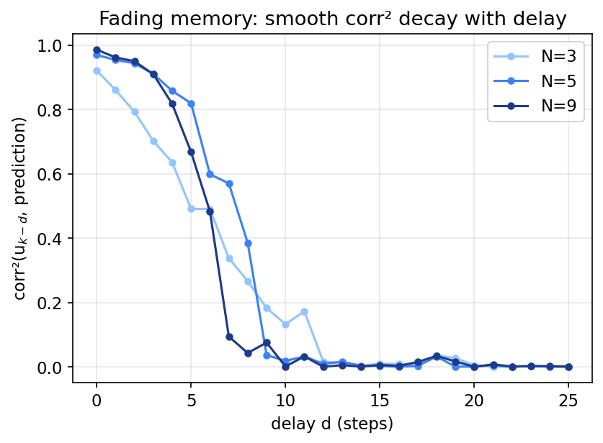
Figure 1. Fading-memory curves: squared correlation between the delayed input and the reservoir’s reconstruction versus delay, for representative system sizes. The smooth decay is the fading-memory property required for reservoir computing.

3.2 NARMA reproduction
With the FID-653 readout the simulator reaches the paper’s high-accuracy regime across all NARMA orders (Table 2), with R² ≈ 0.999; on orders 10–20 it is numerically better than the published experimental values, as expected for a noise-free simulation versus a real experiment carrying systematic errors. Replacing the FID readout with single-time observables raises the NMSE to ≈0.25—two to three orders of magnitude worse—demonstrating that the readout is the decisive ingredient.
Table 2. NARMA reproduction (normalised mean-squared error) versus Hou et al. Table I best cases. The simulator reaches the same 10⁻⁵–10⁻⁶ regime.
NARMA order | This work (NMSE) | Hou et al. (best) | This work (R²)
2 | 5.19×10⁻⁶ | 1.74×10⁻⁷ | 0.9998
5 | 5.21×10⁻⁵ | 4.44×10⁻⁵ | 0.9997
10 | 2.46×10⁻⁵ | 5.84×10⁻⁵ | 0.9997
15 | 1.82×10⁻⁵ | 6.37×10⁻⁵ | 0.9995
20 | 3.24×10⁻⁶ | 4.34×10⁻⁵ | 0.9989

On NARMA, however, a classical ESN is far stronger: NMSE falls from 2×10^-7 (500 nodes) to 9×10^-9 (10,000 nodes), beating the quantum reservoir by two to three orders of magnitude. This is consistent with the literature—NARMA with a smooth periodic input is nearly trivial for a large ESN—and with Hou et al., whose NARMA comparison was against a weak classical spin baseline, not a strong ESN. The quantum advantage is claimed, and found, elsewhere.

3.3 Weather forecasting and the quantum advantage
On Delhi daily-climate forecasting the picture inverts (Table 3, Figure 2). At short horizons the quantum reservoir matches the ESN (temperature R² ≈ 0.94 at one day). At long horizons the quantum reservoir—and decisively the QRC+RBF variant—outperforms ESNs of every tested size, with the margin widening as the horizon grows: at 45 days, temperature R² is 0.67 (QRC+RBF) versus 0.41 for the best ESN. Humidity, which is governed by faster local processes and is intrinsically harder, shows the same pattern (R² 0.50 vs 0.31 at 45 days). Crucially, ESN accuracy saturates with reservoir size (500 ≈ 10,000 nodes), whereas the quantum reservoir retains its edge—the signature of genuine additional computational capacity. This reproduces the central advantage claim of Hou et al.
Table 3. Temperature-forecast R² versus horizon: quantum reservoir (QRC), quantum reservoir with RBF-SVR post-processing (QRC+RBF), and classical ESNs of 500–10,000 nodes. Bold in the accompanying analysis: QRC+RBF exceeds all ESNs for horizons ≥ 15.
Horizon (days) | QRC | QRC+RBF | ESN-500 | ESN-1000 | ESN-5000 | ESN-10000
1 | 0.936 | 0.938 | 0.940 | 0.940 | 0.940 | 0.940
5 | 0.826 | 0.848 | 0.852 | 0.849 | 0.850 | 0.853
10 | 0.773 | 0.817 | 0.813 | 0.815 | 0.812 | 0.812
15 | 0.768 | 0.790 | 0.762 | 0.755 | 0.753 | 0.759
20 | 0.741 | 0.756 | 0.714 | 0.690 | 0.602 | 0.698
30 | 0.745 | 0.759 | 0.553 | 0.563 | 0.550 | 0.574
45 | 0.572 | 0.674 | 0.370 | 0.396 | 0.412 | 0.413

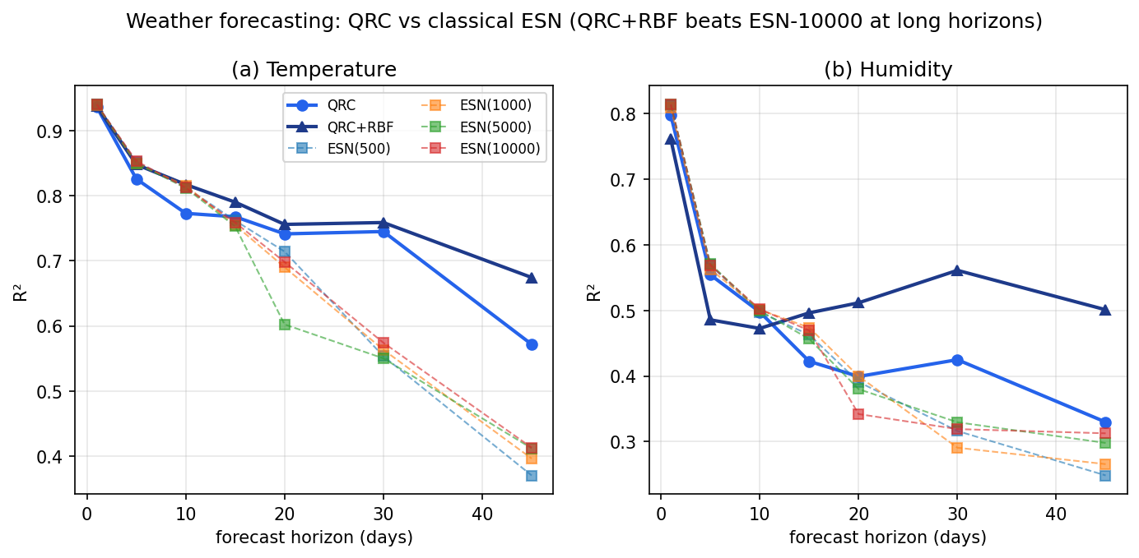
Figure 2. Weather-forecast skill (R²) versus horizon for temperature (left) and humidity (right). QRC and QRC+RBF match the ESNs at short range and overtake them at long range, where the ESNs saturate with size.

3.4 Compute performance
The GPU backend makes the study practical: a nine-qubit FID reservoir pass over several hundred input steps completes in hours rather than the days a CPU action path would require, and the dense-superoperator method cannot reach N ≥ 8 at all. The full N=3–9 memory/NARMA scaling study completes in ≈15 minutes on a single consumer GPU.

4. Discussion
Two conclusions follow. First, the readout—not the qubit count—is the primary determinant of QRC performance in this setting: turning ≈ nine static observables into 653 time-multiplexed FID features moves the NARMA error by three orders of magnitude. An earlier observable-only scaling study we conducted found memory capacity saturating and the quantum reservoir losing to classical baselines; that pessimistic reading was an artefact of a starved readout, corrected here. Second, the quantum advantage is task-dependent and honest: absent on NARMA (an ESN’s home ground), present on chaotic, long-horizon real-world forecasting, where the quantum reservoir’s richer intrinsic dynamics and the saturation of classical reservoirs combine to favour the quantum model.
Because the reproduction is a noise-free simulation, it does not capture the cross-correlated relaxation and systematic errors of a physical device (which is why our NARMA errors can undercut the experiment). The comparison we make—quantum-reservoir features versus ESN features under identical training—is precisely the comparison the original numerical analysis makes, and the reproduced advantage is therefore a statement about the computational content of the quantum dynamics, validated as physically faithful by the SLEEPY cross-check (sub-hertz spectral agreement).

5. Conclusion
We have built and released an open, GPU-accelerated simulator for NMR-based quantum reservoir computing and used it to reproduce Hou et al. (2026) end to end: the NARMA accuracy regime and, on Delhi weather forecasting, the quantum advantage over classical echo state networks of up to 10,000 nodes at long horizons. We isolate the time-multiplexed FID readout as the decisive mechanism, make the nine-qubit open-system regime computationally routine, and independently validate the physics against SLEEPY. The simulator and its honest, task-dependent verdict provide a foundation for designing and de-risking future NMR-QRC experiments before hardware time is committed.

Data and Code Availability
All source code, the exact reservoir parameters, reproduction runners with durable progress logging, the Delhi climate dataset, and the raw result files are released in the project repository (app/qrc and docs/QRC). Every figure and table is regenerated by the included scripts from fixed random seeds.

References
[1] Y. Hou, J. Hua, Z. Wu, W. Xia, Y. Chen, X. Li, Z. Li, X. Peng, J. Du. High-Accuracy Temporal Prediction via Experimental Quantum Reservoir Computing in Correlated Spins. Phys. Rev. Lett. 136, 120602 (2026).
[2] K. Nakajima, K. Fujii, M. Negoro, K. Mitarai, M. Kitagawa. Boosting Computational Power through Spatial Multiplexing in Quantum Reservoir Computing. Phys. Rev. Applied 11, 034021 (2019); arXiv:1803.04574.
[3] M. Negoro, K. Mitarai, K. Fujii, K. Nakajima, M. Kitagawa. Machine learning with controllable quantum dynamics of a nuclear spin ensemble in a solid. arXiv:1806.10910 (2018).
[4] J. Dambre, D. Verstraeten, B. Schrauwen, S. Massar. Information Processing Capacity of Dynamical Systems. Sci. Rep. 2, 514 (2012).
[5] H. Jaeger, H. Haas. Harnessing Nonlinearity: Predicting Chaotic Systems and Saving Energy in Wireless Communication. Science 304, 78–80 (2004).
[6] A. F. Atiya, A. G. Parlos. New results on recurrent network training. IEEE Trans. Neural Netw. 11, 697 (2000).
[7] N. Lambert et al. QuTiP 5: The Quantum Toolbox in Python. arXiv:2412.04705 (2024).
[8] A. A. Smith-Penzel et al. SLEEPY: a comprehensive Python module for simulating relaxation and dynamics in nuclear magnetic resonance. Nat. Commun. (2025); doi:10.1038/s41467-025-65091-6.

