Supplementary Material — Reproducing Experimental Quantum Reservoir Computing in Simulation
This document lists the complete experimental settings for every run reported in the main text, so that all results are reproducible from the released code.

S1. Reservoir system (nine-spin crotonic acid)
Rotating-frame Hamiltonian H = Σ_i πν_i σz_i + Σ_{i<j} (π/2) J_ij σz_i σz_j, with Lindblad relaxation (T1 amplitude damping, T2 pure dephasing, γφ = 1/T2 − 1/2T1). Chemical shifts are rotating-frame offsets referenced to 100.6273 MHz (13C) and 400.2118 MHz (1H). Readout is on the five protons; the four carbons are an inaccessible coupled bath. Methyl protons H3–H5 are magnetically equivalent.
Table S1. Chemical shifts and relaxation times (Hou et al. SM, Table II).
Spin | ν (Hz) | T1 (s) | T2* (ms)
C1 | −7749.7 | 5.9 | 212
C2 | 5430.1 | 4.9 | 231
C3 | 2699.9 | 5.6 | 208
C4 | 7673.7 | 27.5 | 241
H1 | 985.9 | 3.2 | 203
H2 | 520.3 | 3.4 | 332
H3–H5 (methyl) | −1081.5 | 2.2 | 320

Table S2. Scalar J-couplings (Hz); ‘Me’ = each methyl proton; intra-methyl J = 0.
Pair | J (Hz) | Pair | J (Hz) | Pair | J (Hz)
C1–C2 | 40.8 | C2–C3 | 69.5 | C1–C3 | 1.6
C1–C4 | 8.5 | C2–C4 | 1.4 | C3–C4 | 71.0
C1–H1 | 4.0 | C2–H1 | 155.6 | C3–H1 | −1.8
C4–H1 | 6.5 | C1–H2 | 6.6 | C2–H2 | −0.7
C3–H2 | 162.9 | C4–H2 | 3.3 | H1–H2 | 15.8
C1–Me | 128.0 | C2–Me | −7.1 | C3–Me | 6.6
C4–Me | −0.9 | H1–Me | 6.9 | H2–Me | −1.7

S2. Input encoding and FID readout
Scalar inputs are normalised to [0,1] and encoded as a global rotation R_x(θ), θ = arcsin(√s). Multivariate inputs use frequency-selective encoding on distinct species (see per-task settings). Readout: a π/2 pulse on the protons, then the free-induction-decay S(t) = Tr[e^{tL}(UρU†) O_FID], O_FID = Σ_protons(σy+iσx), sampled on a uniform grid, Fourier-transformed; the largest-magnitude spectral bins (fixed across time steps) are the readout features. The non-readout (carbon) chemical-shift terms commute with the proton transverse operators and are dropped from the readout Liouvillian (exact; verified to ≈10⁻¹⁴).

S3. Per-task settings
Table S3. Complete NARMA and weather experiment settings.
Setting | NARMA | Weather
Reservoir | crotonic9 (Table S1/S2) | crotonic9 (Table S1/S2)
Input | superposition of sine waves | Delhi daily temp + humidity
Encoding | arcsin(√s) on all spins | temp→protons, humidity→carbons
Evolution time τ | 0.01 s | 0.03 s
FID samples (fid_points) | 2048 | 1024
FID dwell | 0.3 ms | 0.3 ms
Spectral peaks (features) | 653 | 653
Washout / train / test | 100 / 400 / 100 | 200 / 600 / 500
Targets | NARMA-n, n=2,5,10,15,20 | horizon h=1,5,10,15,20,30,45 days
Readout training | ridge, 10-fold CV | ridge, 10-fold CV
Nonlinear variant | — | RBF-SVR on QRC features (QRC+RBF)
Metric | NMSE = Σ(y−ŷ)²/Σy² | R² per variable per horizon
Multitasking | one pass, readout per order | one pass, readout per horizon
Evolution backend | GPU (torch CUDA) | GPU (torch CUDA)
Reservoir wall time | ≈4.0 h | ≈4.4 h
Seed | 42 | 42

Dataset: Delhi Daily Climate (Kaggle), train+test concatenated (≈1576 days); temperature and humidity each min-max normalised to [0,1]. Weather series columns: meantemp, humidity. Classical baseline: leaky-integrator Echo State Networks (tanh, spectral radius 0.9, ridge readout) of 500/1000/5000/10000 nodes, driven by the same 2-D input with identical splits and horizons.

S4. Evolution backends
Table S4. The four cross-validated evolution backends (agree to ≤10⁻³).
Backend | Method | Memory | N=9 cost / limit
propagator | dense Liouvillian superoperator | 4^N dense | ≈550 GB — infeasible
action (CPU) | sparse Krylov exp(t·L) (expm_multiply) | ≈0.001% dense | ≈6.5 s / matrix action
gpu | Taylor+substep exp(t·L), sparse CUDA matvecs | sparse on GPU | ≈0.23 s (≈28× vs CPU)
mesolve | QuTiP adaptive ODE | 2^N×2^N | reference; stiff past ~7 qubits

S5. Independent validation (SLEEPY)
A two-proton subsystem (H1, H2; ν = 985.9, 520.3 Hz; J = 15.8 Hz; T1 = 3.2, 3.4 s; T2 = 203, 332 ms) built identically in our QuTiP engine and in SLEEPY (sleepy-nmr 1.1.2). Complex FIDs (fid_points 1024/2048, dwell 0.3 ms) are compared: spectral peak positions agree to 0.27–0.49 Hz and the normalised FID traces to ≈0.3 % RMS — confirming the Lindblad implementation reproduces genuine NMR dynamics.

S6. Software and hardware
Python 3.12; QuTiP 5.3.0; PyTorch 2.10 (CUDA 12.8); SciPy 1.17; NumPy 2.2; scikit-learn; SLEEPY (sleepy-nmr) 1.1.2. GPU: NVIDIA GeForce RTX 5070 Ti (17 GB). All runs use fixed random seed 42; the GPU backend uses complex64 (validated to ≤2×10⁻³ against the exact CPU path).

S7. NARMA: simulation vs experiment
For completeness, our simulated NARMA NMSE is compared directly with the experimental values of Hou et al. (Table I). The simulation reaches the same 10⁻⁵–10⁻⁶ regime and, on higher orders, undercuts the experiment — expected, as the simulation is noise-free whereas the experiment carries cross-correlated relaxation and systematic errors.
Table S5. NARMA NMSE: this work (simulation) vs Hou et al. Table I (experiment).
NARMA n | This work (sim) | Hou et al. (experiment)
2 | 5.19×10⁻⁶ | 1.74×10⁻⁷
5 | 5.21×10⁻⁵ | 4.44×10⁻⁵
10 | 2.46×10⁻⁵ | 5.84×10⁻⁵
15 | 1.82×10⁻⁵ | 6.37×10⁻⁵
20 | 3.24×10⁻⁶ | 4.34×10⁻⁵

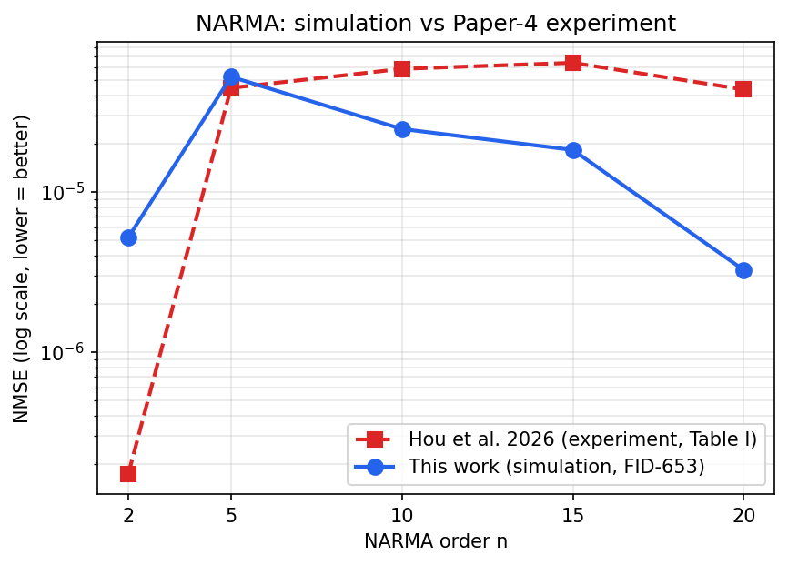
Figure S1. NARMA NMSE versus order: this work (simulation, FID-653) against the experimental values of Hou et al. 2026 (Table I). Both occupy the same high-accuracy regime.
Note on the weather comparison: Hou et al. report weather-forecasting skill only as a figure (their Fig. 4b), without a numerical table, and their raw outputs are distributed as large archived files. We therefore compare weather performance against classical ESNs computed under identical conditions in this work (main-text Table 3 / Fig. 2), which is the same quantum-reservoir-vs-ESN comparison the original figure makes; a numerical overlay of their experimental curve is not reproduced here to avoid imprecise figure digitisation.

