Input-Encoding Optimization for NMR Quantum Reservoir Computing
Manuscript addendum — systematic comparison of input-encoding functions on a 9-spin ¹³C crotonic-acid reservoir, judged by intrinsic reservoir-capacity metrics. Companion to the main reproduction manuscript (Hou et al. 2026, PRL 136, 120602) and to §5.2 (FID feature representations, Fig. 8).

1. Motivation
Input encoding — the map from a classical scalar s ∈ [0,1] to an RF-pulse rotation angle θ(s) — is a foundational but under-studied design choice in QRC. Existing experiments each fix an encoding (arcsin√s in Hou 2026; arccos(2s−1) in Negoro 2018; s·π in linear schemes) and none compares them systematically. Yet the encoding is the only nonlinearity applied at the input stage: the reservoir Hamiltonian is fixed, so the curvature of θ(s) directly shapes how much of the input range is used and how much nonlinearity is injected. We compare seven encoding functions on the same reservoir and rank them by a panel of intrinsic reservoir-quality metrics rather than a single downstream forecast.

2. Encoding functions tested
name | formula | range | origin
arcsin_sqrt | θ = arcsin(√s) | [0, π/2] | Hou 2026 (Paper 4)
arccos | θ = arccos(2s − 1) | [0, π] | Negoro 2018 (Paper 3)
linear | θ = s·π | [0, π] | baseline
sinusoidal | θ = π·sin²(s) | [0, π·sin²1] | emphasizes mid-range
logarithmic | θ = π·log(1+s) | [0, π·log2] | compresses range
polynomial | θ = π·s³ | [0, π] | emphasizes extremes
exponential | θ = π·(1 − e^−s) | [0, π(1−1/e)] | smooth saturation

3. Methodology

3.1 Reservoir and per-encoding evolution
The reservoir is the exact 9-spin ¹³C crotonic-acid system used in the main reproduction (rotating-frame H = Σ π νᵢ σᶻᵢ + Σ (π/2) Jᵢⱼ σᶻᵢσᶻⱼ, Lindblad T₁/T₂ dissipation providing fading memory), read out through the time-multiplexed FID signal. Because changing the encoding changes the reservoir dynamics, each encoding requires its own reservoir evolution (unlike the feature study of §5.2, which re-scores one cached trace). Fidelity ('quick'): fid_points=512, n_virtual=10, split (30,110,70)=210 steps, GPU evolution, seed 42. All settings other than the encoding are held identical, so metric differences are attributable to the encoding alone.

3.2 Why not a downstream forecast (weather R²)?
Ranking encodings by weather-forecast R² failed: at any affordable fidelity the metric was noise-dominated (mostly negative cross-validated R², error bars larger than the differences). The cause is a fidelity wall — a temperature forecast is a demanding long-memory task that is only well-conditioned near full fidelity (~14–18 h GPU per encoding), infeasible across seven. This is itself a finding: downstream task R² is the wrong tool for screening encodings, conflating encoding quality with the task's sample/fidelity budget.

3.3 The judging panel — intrinsic, fidelity-robust metrics
Each encoding is judged by intrinsic metrics well-defined at modest fidelity. The reservoir is driven by uniform i.i.d. random input u ∈ [0,1] and its FID readout matrix X is scored on: (i) linear memory capacity (MC) — held-out squared correlation reconstructing u[t−k] over delays k=1…30; (ii) nonlinear information-processing capacity (IPC) — as MC but with degree-2 and degree-3 Legendre-polynomial targets P_d(u[t−k]), the orthogonal basis; (iii) NARMA-10 NMSE — a standard nonlinear task computed on the same random drive (rescaled to 0.5·u for recurrence stability); (iv) effective dimensionality — participation ratio of the state covariance. Rigor: train/test split, readout fit on train and scored on test, PCA-50 conditioning so p<n (in-sample capacity would be overfit-inflated). The MC estimator was validated on a synthetic 8-tap delay line (returns linear MC = 8.00 exactly, nonlinear ≈ 0).

3.4 Data provenance and reproducibility
Every reservoir evolution is expensive; every metric is cheap. Each encoding's raw per-step FID waveform is persisted to disk (memcap_<fn>_<hash>.npz, including the exact random input) BEFORE any metric is computed. Thus all metrics are computed offline from the saved waveforms; any future metric or alternate-readout re-analysis is free with no re-evolution; and every FID/spectrum in the control-plane UI names the exact saved waveform it was drawn from, so figures are independently verifiable against on-disk data.

3.5 Readout-robustness control
Because each metric is computed through a readout representation, the panel is computed under two readouts: the Paper-4 magnitude653 spectral-peak set (primary verdict) and the richer multimodal set (§5.2). Identical rankings under both imply readout-independence.

4. Results
Multi-metric panel, magnitude653 readout (Fig. 9):
encoding | total capacity | linear MC | nonlinear IPC | NARMA-10 NMSE ↓
arcsin_sqrt | 5.51 | 3.66 | 1.86 | 0.595
exponential | 3.66 | 2.49 | 1.17 | 0.680
logarithmic | 3.12 | 2.15 | 0.97 | 0.720
sinusoidal | 2.68 | 1.83 | 0.85 | 0.744
arccos | 2.67 | 1.58 | 1.09 | 0.950
linear | 1.83 | 0.99 | 0.84 | 1.012
polynomial | 1.55 | 0.73 | 0.83 | 1.084
(Effective dimensionality was ≈ 1.1 for all encodings and did not discriminate — see §5.)
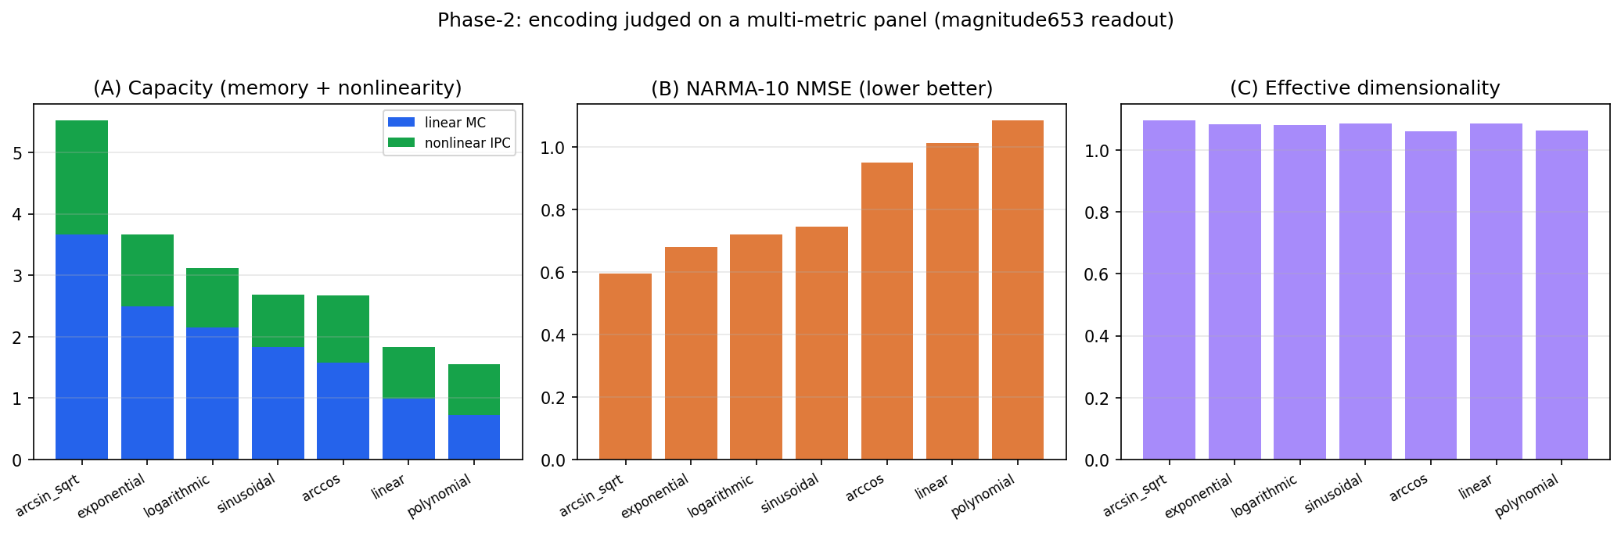
Figure 9: encoding functions judged on (A) total capacity (linear MC + nonlinear IPC, stacked), (B) NARMA-10 NMSE (lower better), (C) effective dimensionality, magnitude653 readout. arcsin_sqrt leads every panel.
- arcsin_sqrt wins on every discriminating metric: the most linear memory (3.66), the most nonlinearity (IPC 1.86, ≈1.6× the runner-up), the highest total capacity (5.51 vs 3.66 for #2), and the best task performance (NARMA NMSE 0.595 — the only encoding clearly below 1; linear and polynomial are ≥1.0, no better than the mean).
- The ranking is well-separated, decreasing monotonically 5.51 → 1.55 (a factor ~3.5), far larger than plausible estimator noise — in sharp contrast to the weather-R² attempt, where encodings were statistically indistinguishable.
- The ranking is readout-independent: recomputing total capacity under the multimodal readout yields the identical order.

5. Discussion
Mechanism — why arcsin_sqrt wins. With the Hamiltonian fixed, θ(s) is the sole input nonlinearity, and two properties govern quality: how uniformly it spreads inputs across the rotation range (memory), and how much curvature it injects (nonlinearity). arcsin(√s) is the angle whose excitation probability sin²θ = s is linear in the input — it spreads inputs evenly over the Bloch polar angle, using the full readout range. The losers fail here: θ = π·s³ (polynomial) compresses almost all inputs toward θ ≈ 0 (near-identity pulses), giving the lowest memory AND nonlinearity; linear similarly underuses the range. That the losers are worst on both memory and nonlinearity indicates the dominant effect is input-range utilization, with arcsin√'s curvature adding a nonlinearity bonus (its IPC lead exceeds its MC lead).
Validation of the literature choice. Paper 4's θ = arcsin(√s) is confirmed as the best of the seven — for the first time with a mechanistic and quantitative justification rather than as an unexplained convention.
Decoupling of encoding and readout. Readout-independence, together with the §5.2 finding that feature representations are low-headroom, indicates encoding and readout are largely separable design axes: the encoding governs intrinsic reservoir quality, the readout contributes little once the reservoir is fixed. Optimize the encoding first, the readout second.
Methodological contribution. The fidelity-wall failure of weather-R² and the success of the intrinsic-capacity panel argue a general point: use intrinsic capacity metrics (MC/IPC), not a demanding downstream task, to screen QRC design choices.
Limitations. (i) Single seed, quick fidelity — the large monotonic gaps make the ranking robust to noise, but multiple seeds and higher fidelity would attach formal error bars. (ii) Effective dimensionality did not discriminate (≈1.1 for all), expected to become informative only at larger n_virtual/system size. (iii) Absolute capacities are modest and should be read as relative comparisons.
Future work. (i) Phase-amplitude encoding R_z(2πs)·R_x(θ) — the judging harness scores it automatically. (ii) Learned encoding (GRAPE / gradient optimization): this fixed-function comparison is the empirical baseline for optimizing a parametrized encoding pulse directly; the GPU stepper is autodiff-capable (torch), so an end-to-end differentiable-QRC optimizer is buildable here with the MC metric as objective — a planned dedicated study. (iii) Encoding×feature interaction. (iv) Higher-fidelity, multi-seed confirmation.

6. Reproducibility
- Per-encoding evolution + waveform persistence: scripts/qrc_memcap.py (--experiment all --fidelity quick).
- Memory-capacity / IPC estimator + delay-line self-test: scripts/qrc_memcap.py (memory_capacity), --selftest.
- Multi-metric judging + readout-robustness + Fig. 9: scripts/qrc_judge.py --glob 'artifacts/traces/memcap_*.npz'.
- Saved waveforms: artifacts/traces/memcap_<fn>_<hash>.npz (7 files), each with its exact random input, split, and configuration metadata.

