Woxsen University
School of Technology

B.Tech - Computer Science and Engineering (Artificial Intelligence and Machine Learning)
PROJECT BASED LEARNING REPORT

Title: Design and Implementation of a DBMS for
Recruitment and Applicant Tracking
Course: Database Management Systems (DBMS)
Course Code: 25TU03MJM0

Student Name: Sirigiri Sruti
Roll No: 25WU0102266
Section: AIML WHALES
Faculty: Dr. Kiran Mayee Adavala
Academic Year: 2026–2027

Table of Contents
- Abstract
- Introduction and Problem Statement
- Objectives and Scope
- Software and Hardware Requirements
- ER Diagram
- Relational Schema and Normalization
- Data Dictionary
- SQL Commands Used
- Queries and Outputs
- UI Design and Screenshots
- Implementation Details
- Testing and Results
- Conclusion and Future Enhancements
- References
- Appendix – GitHub Repository
Submission note: The official project instructions require the report PDF, UI source code and screenshots to be uploaded to the specified GitHub repository structure.

1. Abstract
Recruitment involves managing information about applicants, job vacancies, applications, interviews and selection results. The project develops a centralized relational database for recruitment and applicant tracking and connects it to a simple graphical user interface. The database is implemented in MySQL as recruitmentdb, while Python with Tkinter provides the user interface and mysql.connector provides database connectivity. The final interface supports applicant insertion, deletion, viewing and clearing of input fields. The project was developed through the problem-definition, relational-database design and user-interface stages represented by Presentation-I, Presentation-II and Presentation-III.

2. Introduction and Problem Statement

2.1 Background
The project is based on the recruitment lifecycle: job vacancy, application, shortlisting, interview and selection. Presentation-I identified the difficulty of managing these stages through scattered lists, loose files and spreadsheets. The proposed solution is a centralized relational database that stores recruitment information once and supports clear tracking and retrieval.

2.2 Problem Statement
The initial problem statement identifies recruitment as a data-intensive process involving job vacancies, applicants, applications, interviews and selection results. Manual or file-based management makes applicant information difficult to organize, causes duplication and inconsistency, makes status tracking difficult, slows retrieval and complicates interview scheduling and recruitment reporting. A centralized database is therefore required to store, organize, retrieve and track recruitment information throughout the hiring process.

2.3 Recruitment Process
Stage | Current problem identified in Presentation-I
Job Vacancy | Openings are posted across scattered lists.
Application | Resumes are collected as loose files.
Shortlisting | Manual comparison is error-prone.
Interview | Schedules are tracked in spreadsheets.
Selection | Results are difficult to consolidate and report.

3. Objectives and Scope

3.1 Objectives
- Design a centralized relational database for recruitment and applicant tracking.
- Represent departments, recruiters, jobs, applicants, applications, interviews and selections.
- Apply primary keys, foreign keys and integrity constraints to maintain consistent data.
- Create SQL DDL and DML commands for database and table creation and sample data.
- Execute JOIN, GROUP BY and HAVING queries for recruitment information retrieval.
- Build a Python/Tkinter graphical interface connected to MySQL.
- Demonstrate applicant INSERT, VIEW and DELETE operations through the UI.
- Verify the working connection between the interface and the MySQL database.

3.2 Scope
- Applicant information management.
- Job and department related data modeling.
- Application tracking and status storage.
- Interview and selection record management.
- SQL-based retrieval and reporting queries.
- A lightweight desktop UI for applicant CRUD operations.
- The current implementation does not provide authentication, automated email, resume parsing or advanced analytics.

4. Software and Hardware Requirements

4.1 Software Requirements
Component | Used in the project
Operating system | Windows
Programming language | Python 3.14
GUI toolkit | Tkinter / ttk
Database | MySQL
Python database driver | mysql.connector
Development environment | Python IDLE
Database name | recruitmentdb
Version control / submission | GitHub (required repository structure)

4.2 Hardware Requirements
Requirement | Recommended / used
Computer | Laptop or desktop computer
Processor | Modern x64 processor
Memory | 4 GB RAM or higher
Storage | Sufficient free space for Python, MySQL and project files
Display | Standard monitor/laptop display
Network | Internet connection for GitHub submission

5. Entity–Relationship (ER) Diagram
The ER model connects DEPARTMENT, JOB, RECRUITER, APPLICANT, APPLICATION, INTERVIEW and SELECTION. The model uses one-to-many relationships for department-to-job, recruiter-to-job and applicant-to-application, and connects application records to interview and selection records.
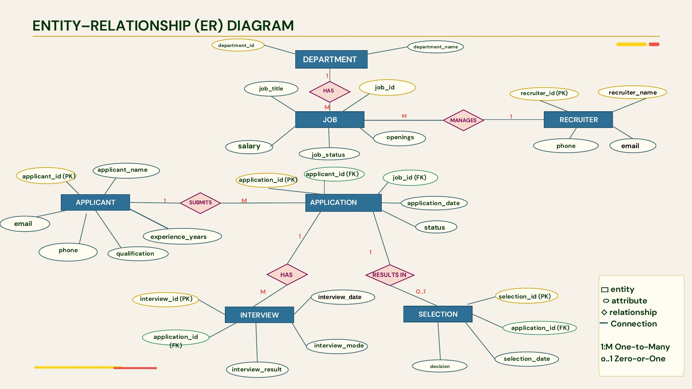
Figure 1. ER diagram from Presentation-II.

6. Relational Schema and Normalization

6.1 Relational Schema
Table | Primary key | Important foreign keys / purpose
DEPARTMENT | department_id | Stores department names.
RECRUITER | recruiter_id | Stores recruiter contact details.
APPLICANT | applicant_id | Stores applicant personal/professional details.
JOB | job_id | department_id → DEPARTMENT; recruiter_id → RECRUITER
APPLICATION | application_id | applicant_id → APPLICANT; job_id → JOB
INTERVIEW | interview_id | application_id → APPLICATION
SELECTION | selection_id | application_id → APPLICATION
APPLICATION_TRACKING | — | Denormalized tracking/reporting table used in the working database.

6.2 Normalization
The following normalization discussion is an analysis of the relational design presented in Presentation-II and the SQL implementation. The tables separate major entities so that applicant, job, recruiter, department, application, interview and selection facts are stored in their appropriate relations.
Normal form | Application to this project
1NF | Attributes are represented as atomic columns; repeated recruitment details are not stored as a repeating group inside a single applicant r
2NF | Entity-specific attributes depend on the key of their own relation; application-specific details are separated from applicant and job details.
3NF | Non-key facts are separated by entity. For example, department_name is stored in DEPARTMENT rather than repeated in every JOB rec
Design note: application_tracking is a reporting/tracking table containing copied applicant/job/status fields, so it is intentionally less normalized than the core entity tables. It is useful for direct tracking output but should not be treated as the canonical source of entity data.

7. Data Dictionary
The following dictionary is derived from the SQL implementation used for the recruitmentdb database.
Table | Column | Type | Constraint / role
department | department_id | INT | PRIMARY KEY
department | department_name | VARCHAR(100) | NOT NULL
recruiter | recruiter_id | INT | PRIMARY KEY
recruiter | recruiter_name | VARCHAR(100) | NOT NULL
recruiter | email | VARCHAR(120) | UNIQUE
recruiter | phone | VARCHAR(20) | Contact field
applicant | applicant_id | INT | PRIMARY KEY
applicant | applicant_name | VARCHAR(80) | NOT NULL
applicant | email | VARCHAR(120) | UNIQUE
applicant | phone | VARCHAR(20) | Contact field
applicant | qualification | VARCHAR(50) | Qualification
applicant | experience_years | INT | CHECK (experience_years >= 0)
job | job_id | INT | PRIMARY KEY
job | job_title | VARCHAR(100) | NOT NULL
job | department_id | INT | FOREIGN KEY → department
job | recruiter_id | INT | FOREIGN KEY → recruiter
job | openings | INT | Number of openings
job | salary | DECIMAL(10,2) | Salary
job | job_status | VARCHAR(20) | Job status
application | application_id | INT | PRIMARY KEY
application | applicant_id | INT | FOREIGN KEY → applicant
application | job_id | INT | FOREIGN KEY → job
application | application_date | DATE | Application date
application | application_status | VARCHAR(20) | DEFAULT 'Pending'
interview | interview_id | INT | PRIMARY KEY
interview | application_id | INT | FOREIGN KEY → application
interview | interview_date | DATE | Interview date
interview | interview_mode | VARCHAR(20) | Online/Offline
interview | interview_result | VARCHAR(20) | Interview outcome
selection | selection_id | INT | PRIMARY KEY
selection | application_id | INT | FOREIGN KEY → application
selection | selection_date | DATE | Selection date
selection | decision | VARCHAR(20) | Selection decision
application_tracking | application_id | INT | Tracking record identifier
application_tracking | applicant_name | VARCHAR(80) | Reporting field
application_tracking | job_title | VARCHAR(100) | Reporting field
application_tracking | application_date | DATE | Tracking date
application_tracking | application_status | VARCHAR(20) | Tracking status

8. SQL Commands Used

8.1 DDL – Database and Table Creation
DDL commands create the recruitmentdb database and the relational tables. Primary keys, foreign keys, UNIQUE, NOT NULL, CHECK and DEFAULT constraints are used in the implementation.
CREATE DATABASE IF NOT EXISTS recruitmentdb;
USE recruitmentdb;
CREATE TABLE IF NOT EXISTS applicant ( applicant_id INT PRIMARY KEY, applicant_name VARCHAR(80) NOT NULL, email VARCHAR(120) UNIQUE, phone VARCHAR(20), qualification VARCHAR(50), experience_years INT CHECK (experience_years >= 0) );
CREATE TABLE IF NOT EXISTS application ( application_id INT PRIMARY KEY, applicant_id INT, job_id INT, application_date DATE,
application_status VARCHAR(20) DEFAULT 'Pending', FOREIGN KEY (applicant_id) REFERENCES applicant(applicant_id),
FOREIGN KEY (job_id) REFERENCES job(job_id)
);

8.2 DML – Sample Insertion and Retrieval
INSERT INTO applicant
(applicant_id, applicant_name, email, phone, qualification, experience_years)
VALUES
(306, 'Kavya Singh', 'kavya@gmail.com',
'9000000006', 'B.Tech', 0);
SELECT * FROM applicant;
The working database was also populated with departments, recruiters, jobs, applications, interviews, selection data and application-tracking records.

8.3 Constraints Used
Constraint | Example / purpose
PRIMARY KEY | Uniquely identifies each entity record.
FOREIGN KEY | Links JOB to DEPARTMENT/RECRUITER and APPLICATION to APPLICANT/JOB.
NOT NULL | Ensures required fields such as applicant_name are provided.
UNIQUE | Prevents duplicate applicant/recruiter email values.
CHECK | Restricts experience_years to values greater than or equal to zero.
DEFAULT | Sets application_status to Pending when no status is supplied.

9. Queries and Outputs

9.1 JOIN – Applicants with Applied Job Titles
SELECT a.applicant_name, j.job_title
FROM applicant a
JOIN application ap ON a.applicant_id = ap.applicant_id
JOIN job j ON ap.job_id = j.job_id;
Sample output:
Aarav Kumar — AI Engineer
Aarav Kumar — Software Developer
Diya Sharma — AI Engineer
Rohan Verma — Software Developer
Sneha Reddy — HR Executive
Sneha Reddy — Marketing Executive Arjun Patel — Financial Analyst

9.2 GROUP BY – Count Applications by Status
SELECT application_status, COUNT(*) AS total
FROM application
GROUP BY application_status;
Sample output:
Pending — 4
Shortlisted — 2 Selected — 1

9.3 HAVING – Jobs with More Than One Applicant
SELECT j.job_title, COUNT(ap.applicant_id) AS total
FROM job j
JOIN application ap ON j.job_id = ap.job_id
GROUP BY j.job_id, j.job_title
HAVING COUNT(ap.applicant_id) > 1;
Sample output:
AI Engineer — 2
Software Developer — 2

9.4 Presentation-II Query Given During Evaluation
The query solution file checks Rohan Verma's application and job details.
SELECT
a.applicant_name, ap.application_id, ap.application_date, ap.application_status,
j.job_id,
j.job_title,
j.openings,
j.salary,
j.job_status FROM applicant a
JOIN application ap
ON a.applicant_id = ap.applicant_id
JOIN job j
ON ap.job_id = j.job_id
WHERE a.applicant_name = 'Rohan Verma';
Expected result: Rohan Verma | 403 | 2026-09-03 | Pending | 202 | Software Developer | 5 | 700000.00 | Open

10. UI Design and Screenshots
Presentation-III implements a desktop graphical interface titled “Recruitment Database Management System”. The
UI contains Applicant ID, Name, Email, Phone, Qualification and Department ID-labelled input fields, along with
INSERT, DELETE, VIEW and CLEAR buttons. A ttk.Treeview displays applicant records returned from MySQL. 10.1 Initial / Before-Insert UI
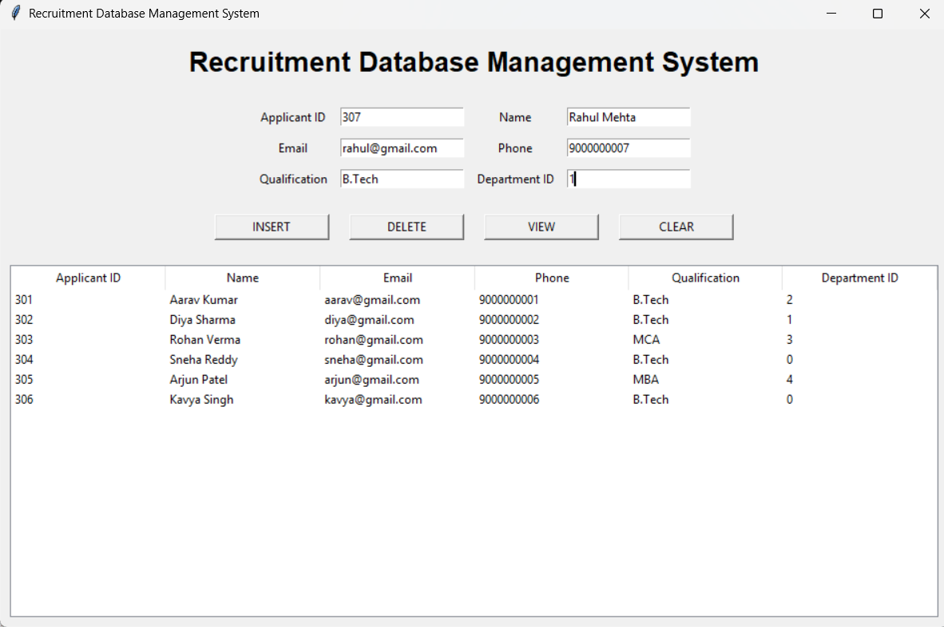
Figure 2. UI showing the initial applicant list before adding applicant 306.

10.2 Final Working UI
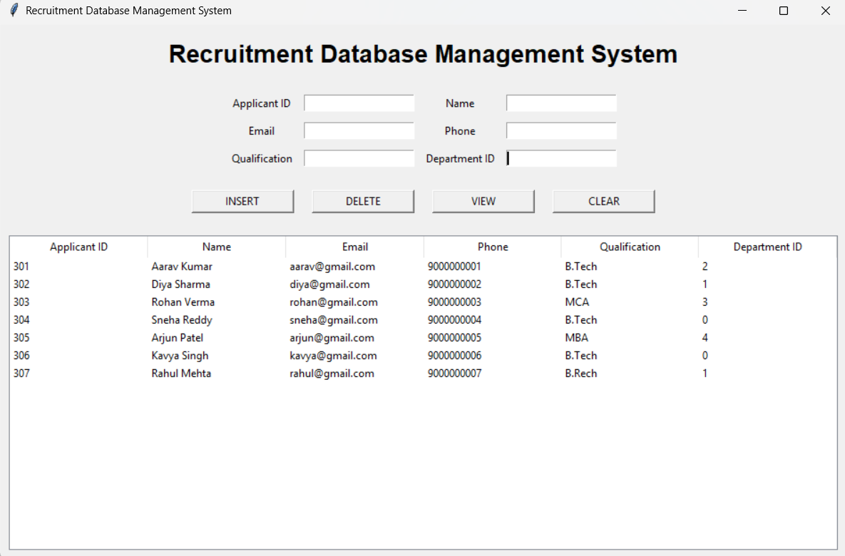
Figure 3. Final UI showing applicants 301–307, including Rahul Mehta (307).

10.3 Database Connectivity Evidence
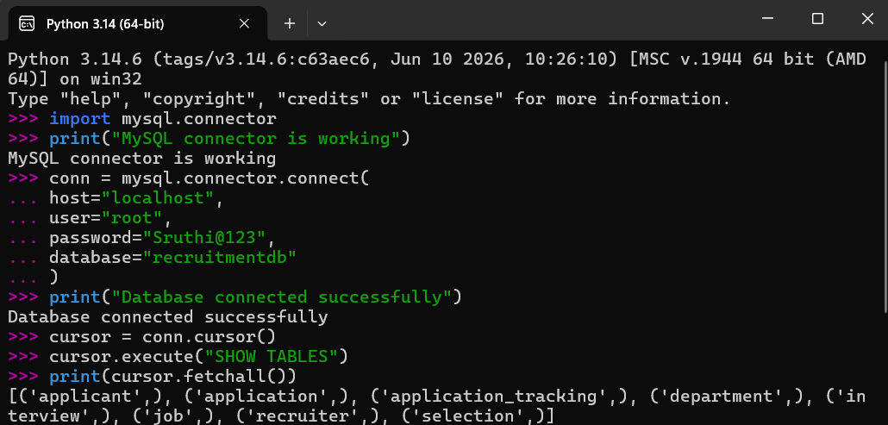
Figure 4. Python/MySQL console showing successful connection and accessible tables. Sensitive credentials are intentionally excluded from the report.

10.4 UI Operation Summary
Operation | UI action | Expected database effect
INSERT | Enter applicant details and click INSERT | New applicant record is stored and the view is refreshed.
VIEW | Click VIEW | Records from the applicant table are retrieved and displayed.
DELETE | Enter Applicant ID and click DELETE | Selected applicant record is removed and the view is refreshed.
CLEAR | Click CLEAR | All input fields are emptied.
The official Presentation-III instructions require screenshots of insert, delete, view, before and after states. The final GitHub screenshot set should therefore include the successful delete-before/delete-after and clear-state screenshots if they are not already captured.

11. Implementation Details

11.1 Technology Stack
- Python 3.14 – application programming language.
- Tkinter/ttk – graphical user interface.
- MySQL – relational database backend.
- mysql.connector – Python-to-MySQL connectivity.
- Python IDLE – development/testing environment.

11.2 Database Connectivity
def connect_db():
return mysql.connector.connect( host="localhost", user="root", password="***", database="recruitmentdb" )
The live console test showed “Database connected successfully” and the SHOW TABLES command returned the recruitmentdb tables.

11.3 Applicant Insertion
query = """ INSERT INTO applicant
(applicant_id, applicant_name, email, phone, qualification, experience_years)
VALUES (%s, %s, %s, %s, %s, %s) """ cursor.execute(query, values) conn.commit() clear_fields() view_applicants()

11.4 Deletion and View Refresh
def delete_applicant():
applicant_id = id_entry.get() # validate ID, execute DELETE, commit,
# then refresh the applicant table

11.5 UI Construction
The UI uses Tkinter widgets for labels and entry fields, ttk.Treeview for tabular display, and buttons connected to Python callback functions. The VIEW operation fetches applicant rows and inserts them into the Treeview. The CLEAR operation resets the entry widgets.

11.6 Implementation Consistency Note
The SQL APPLICANT table contains the column experience_years; the final UI labels its last field and table column as Department ID. The observed values (2, 1, 3, 0, 4, etc.) correspond to the experience_years values in the SQL data. In the current relational model, department_id is a foreign key of JOB, not APPLICANT. For a future cleanup, the UI label should be renamed to Experience Years, or a deliberate applicant-to-department relationship should be added to the schema.

12. Testing and Results
Testing was performed at the database-console level and through the Tkinter UI. During development, a database error was encountered when the UI attempted to use a field name that did not exist in the applicant table. The schema was inspected with DESCRIBE applicant, the insert statement was aligned with the actual column names, and subsequent insertion was successful.
Test | Action | Observed result
T1 | Connect to recruitmentdb | Connection succeeded; database tables were accessible.
T2 | VIEW applicant records | Applicant rows displayed in the Tkinter table.
T3 | INSERT applicant 306 | Kavya Singh was inserted successfully and appeared in VIEW.
T4 | INSERT applicant 307 | Rahul Mehta was entered during UI testing; final table displayed 307.
T5 | CLEAR fields | CLEAR control is implemented to empty all input fields.
T6 | Invalid insert / schema mismatch
T7 | DELETE by Applicant ID
Initial 1054 unknown-column error was diagnosed and the insert path was aligned with the actual applicant schema.
DELETE control is implemented to remove a selected applicant and refresh the view; final live verification should be

12.1 Debugging Evidence
An early test produced MySQL error 1054 (unknown column). This was a useful schema-to-UI validation step. The final UI screenshots show that applicant records can be displayed after the insert path was corrected.

13. Conclusion and Future Enhancements

13.1 Conclusion
The project progressed from identifying recruitment-management problems to designing a relational database and implementing a connected graphical interface. The final system demonstrates a working Python/Tkinter front end connected to the MySQL recruitmentdb database. Applicant data can be entered through the interface, stored in MySQL and retrieved into the UI. The database design also supports job, application, interview and selection information beyond the applicant screen.

13.2 Future Enhancements
- Rename the final UI field labelled “Department ID” to “Experience Years” unless a department_id column is intentionally added to APPLICANT. In the current SQL schema, department_id belongs to JOB.
- Add form validation for numeric IDs, phone numbers, email format and experience values.
- Add search/filter functionality and richer recruitment dashboards.
- Add user authentication and role-based access.
- Add resume/document storage or links and application-status workflow.
- Add automated reporting and export to CSV/PDF.

14. References
- DBMS Course Project – Final Presentation Instructions, AIML Whales and AIML Panthers, 2026.
- Presentation-I: Problem Statement – Design and Implementation of a DBMS for Recruitment and Applicant Tracking.
- Presentation-II: Database design, ER model, relational schema, constraints and SQL implementation.
- Presentation-III: User Interface – Recruitment Database Management System.
- Project SQL file: recruitmentdb_Presentation-II.sql.
- Presentation-II Query Solution: Rohan Verma application and job details.
- MySQL Documentation, MySQL Reference Manual.
- Python Documentation, tkinter and database programming references.
- MySQL Connector/Python documentation.

15. Appendix – GitHub Repository
The course instructions specify a public repository named DBMS-Course-Project with four folders: Presentation-I, Presentation-II, Presentation-III and Project-Report. The report PDF, UI source code and required screenshots should be placed in the appropriate folders.
GitHub repository link: To be inserted after the final repository URL is confirmed.
Recommended final repository contents:
- Presentation-I: problem-description PPT/PDF.
- Presentation-II: PPT/PDF, ER diagram image, complete SQL file and Presentation-II query solution.
- Presentation-III: PPT/PDF, Python UI source code and screenshots of insert/delete/view/before/after states.
- Project-Report: this final report PDF.

