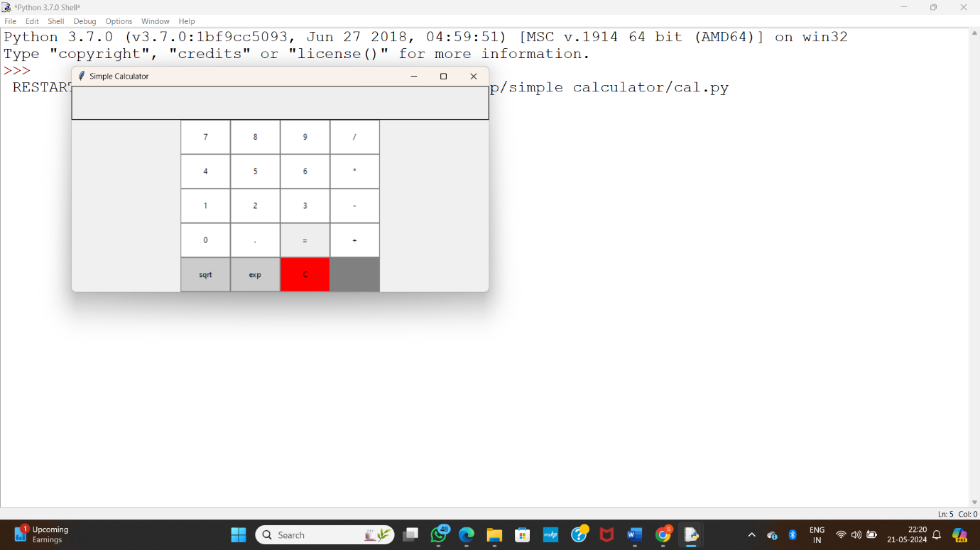

**Fig (i)**

Here we are observing the calculator

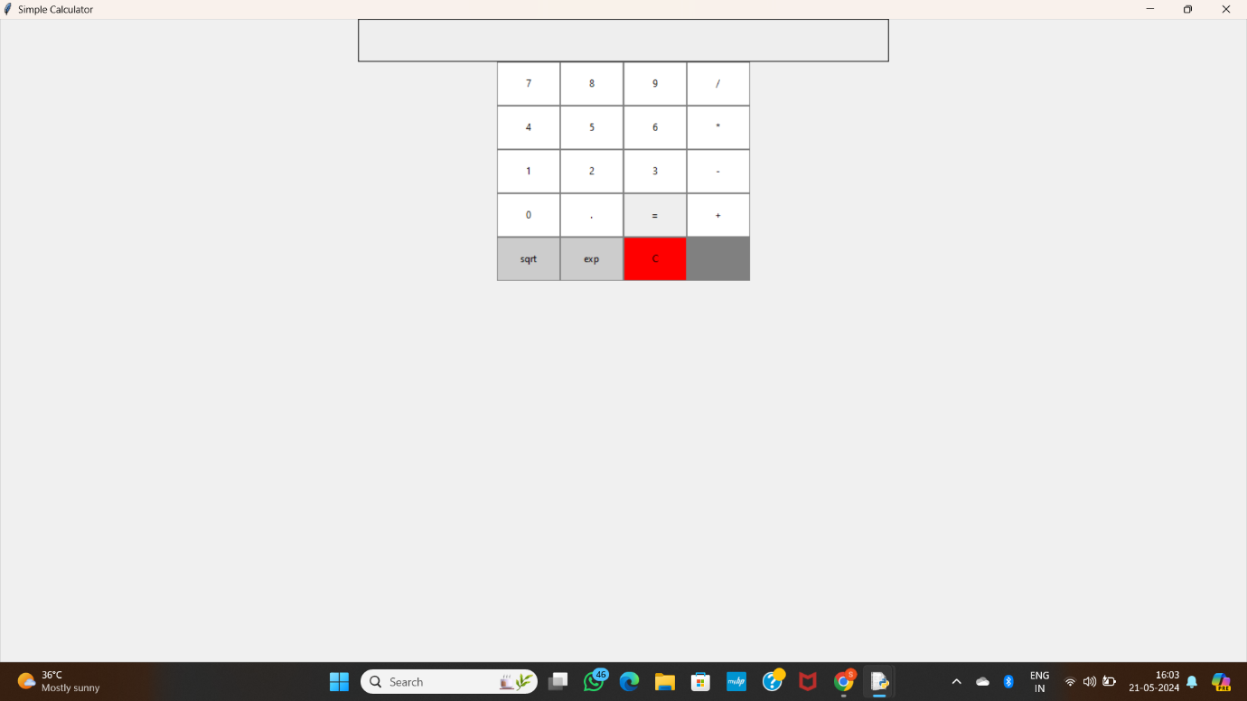

**Fig(ii)**

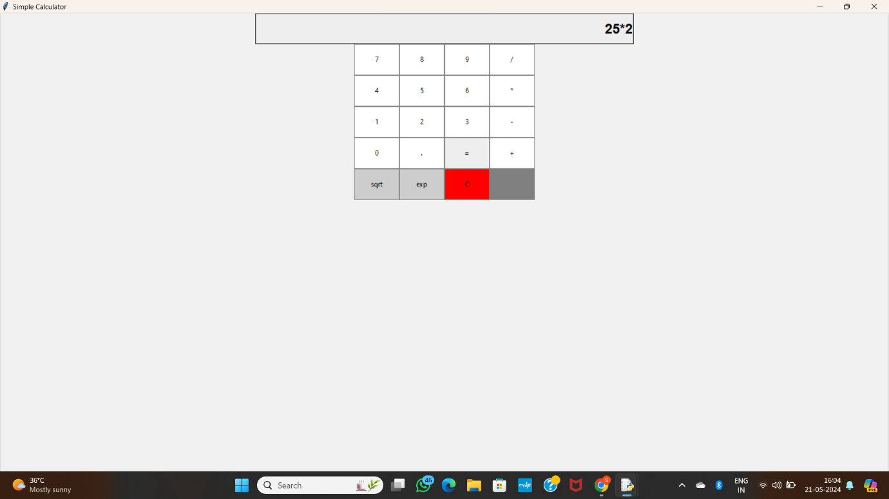

**Fig(iii)**

**Here we are using multiplication operation between 25 and 2**

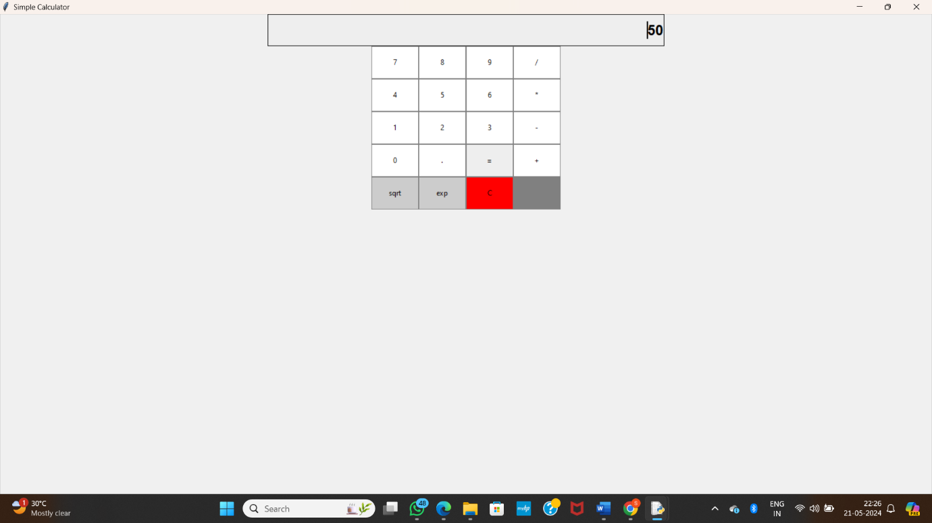

Fig(iv)

We are getting output of multiplication operation 50