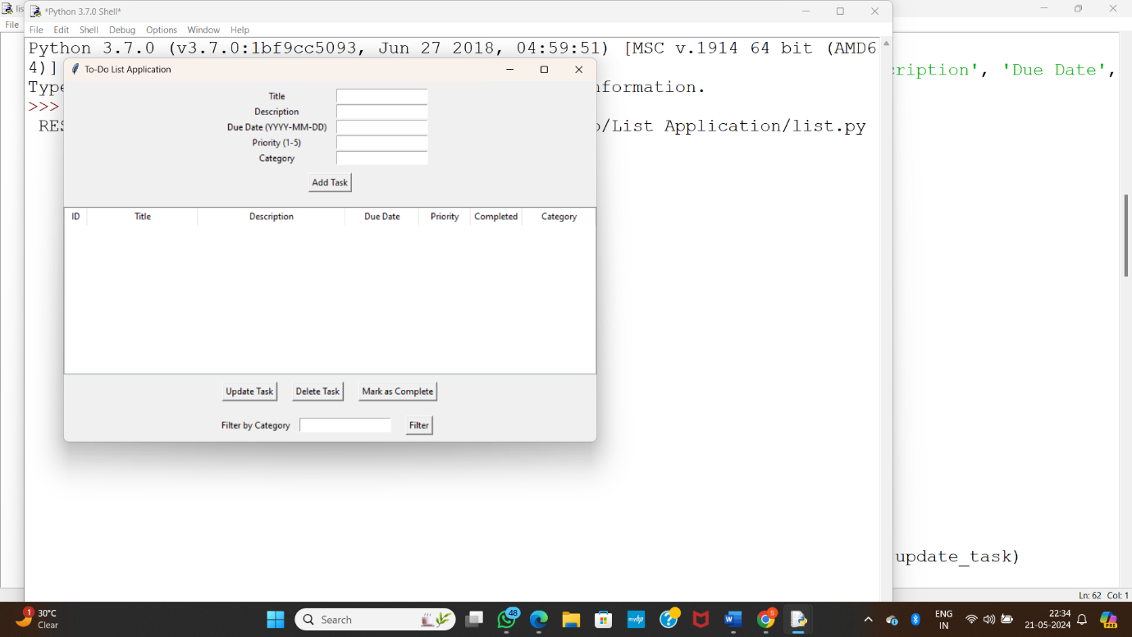

**Fig(i)**

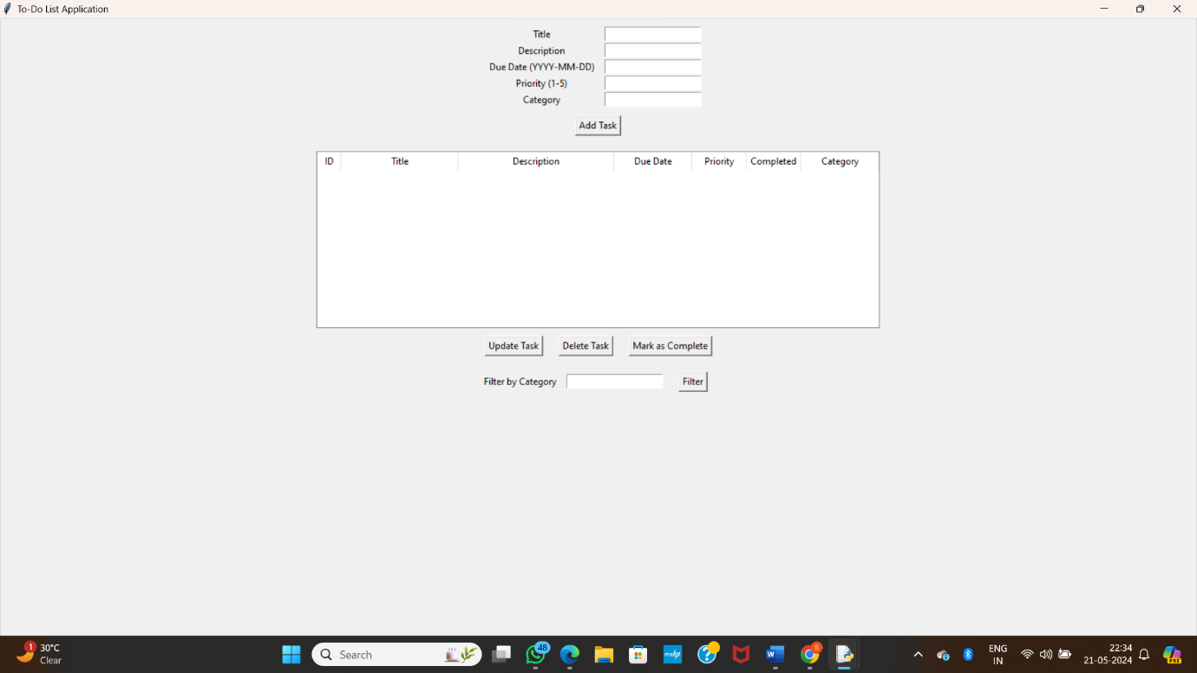

**Fig(ii)**

**Here you can observe the title, description ,due date,priority and category**

**After filling above details you can add task**

**And you can perform below tasks like update task,delete task,filter**

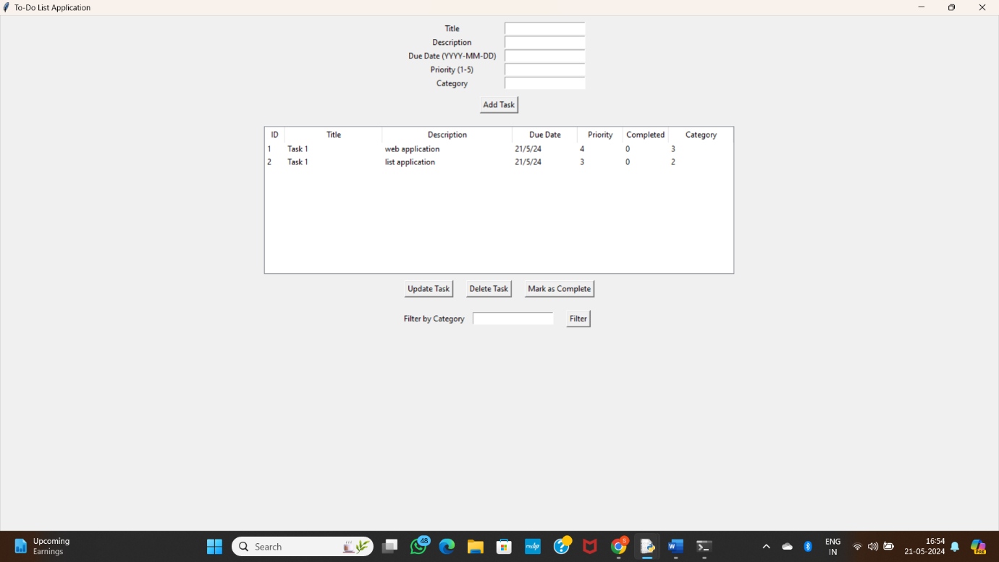

Fig(iii)