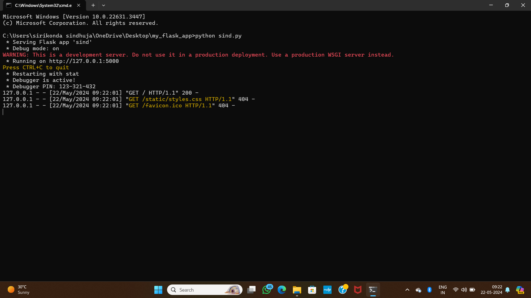

After executing in cmd u can open chrome or googgle and type the link

Then you are able to see the output

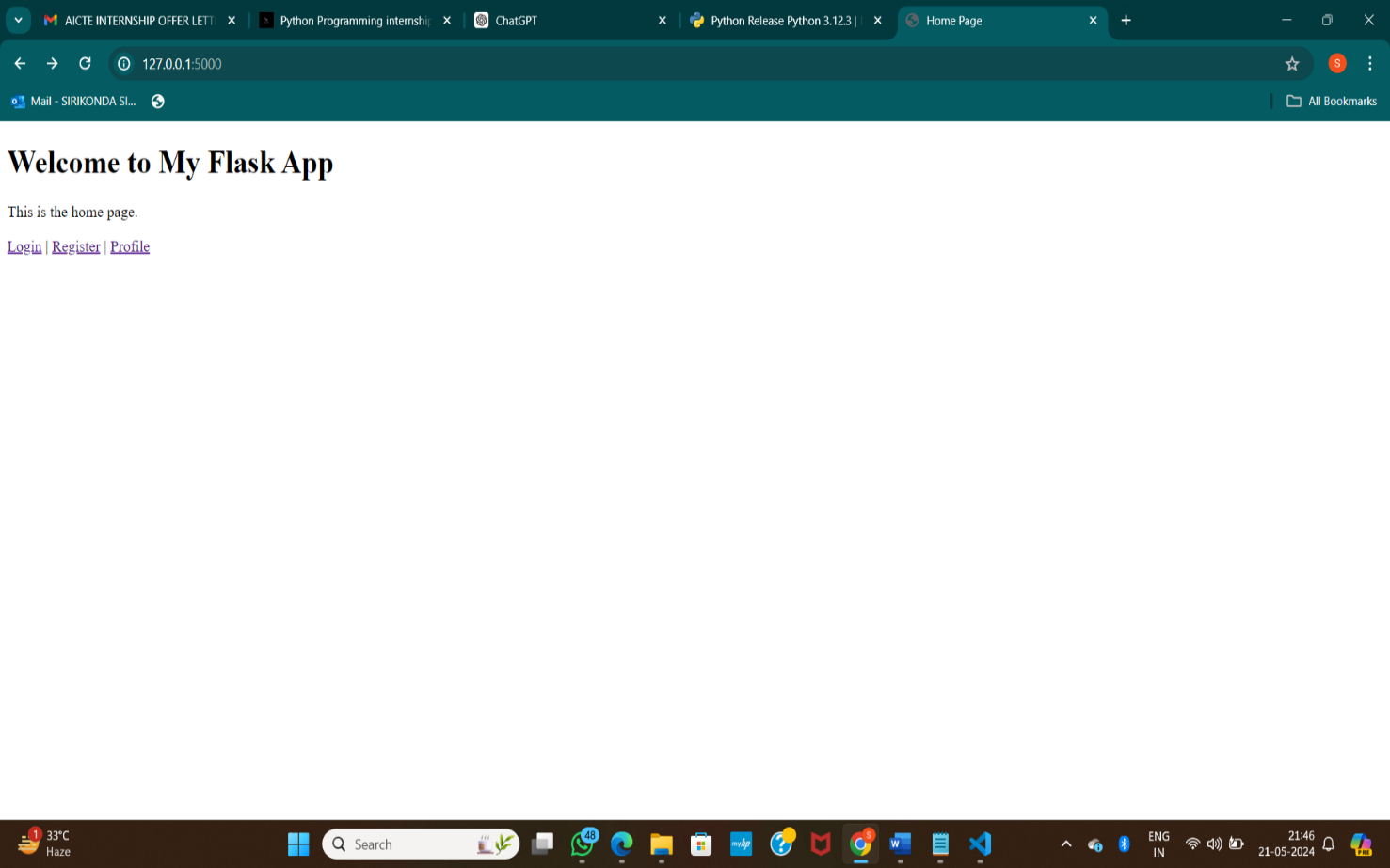

Fig(i)we can observe the web page and welcome to my flask app

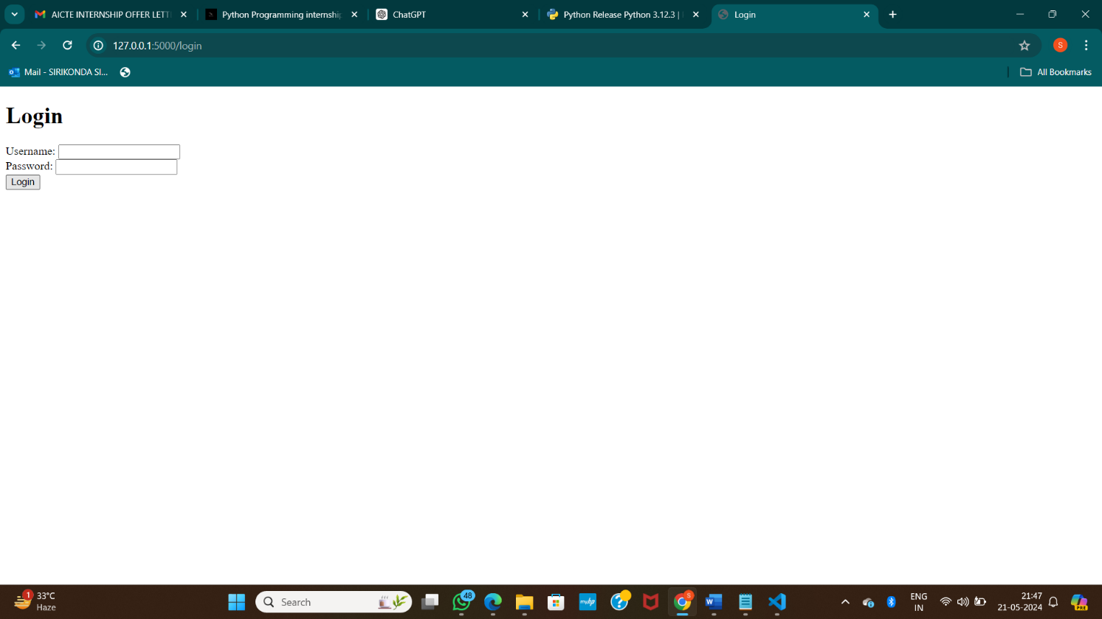

Fig(ii) we can observe the login details

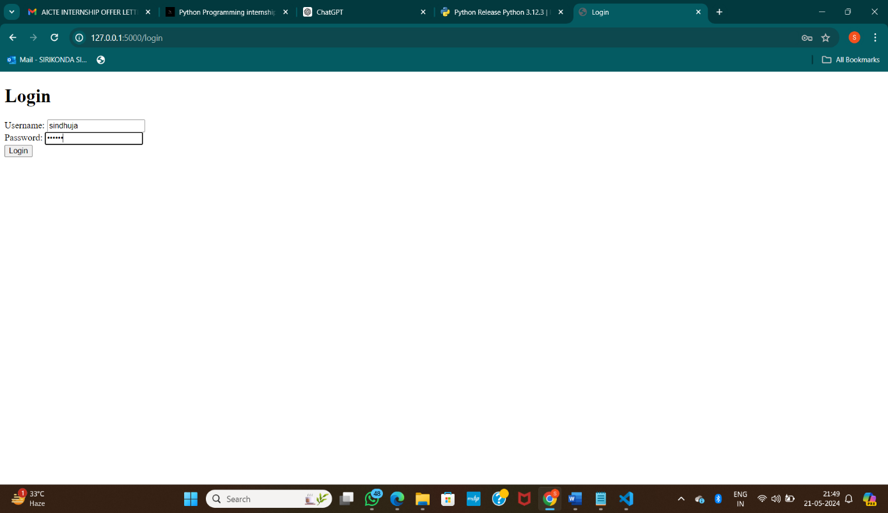

Fig(iii)we can enter the login details

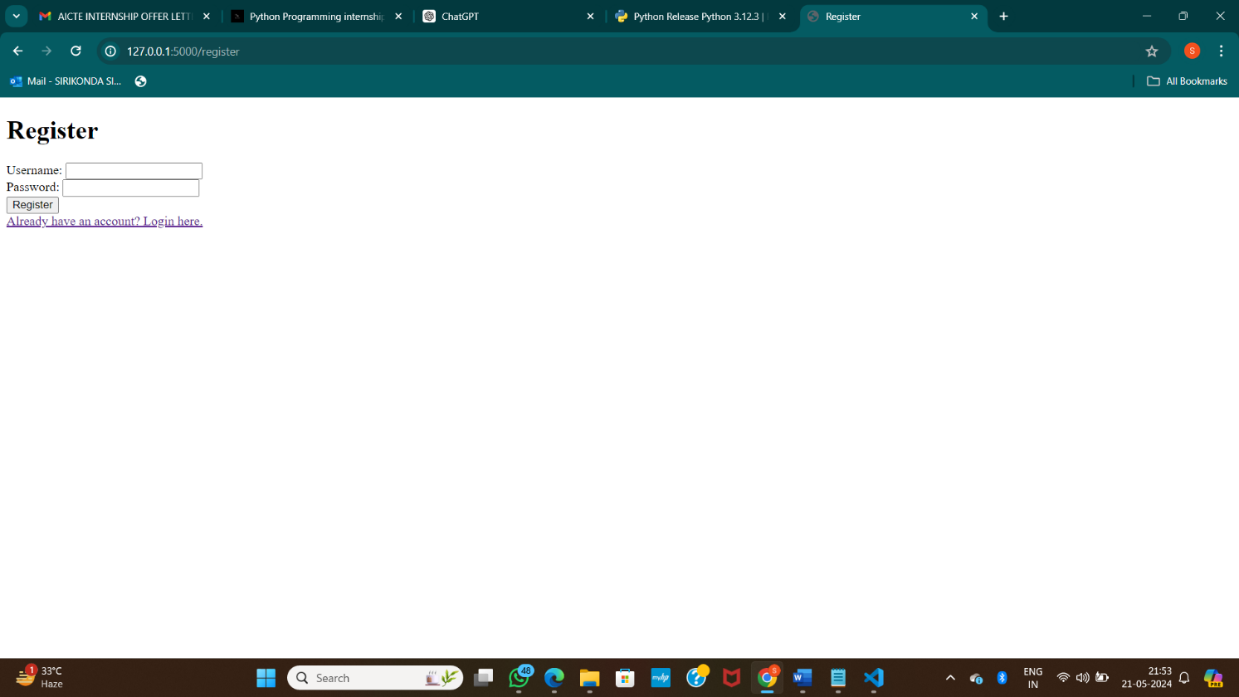

Fig(iv) we can observe the register details

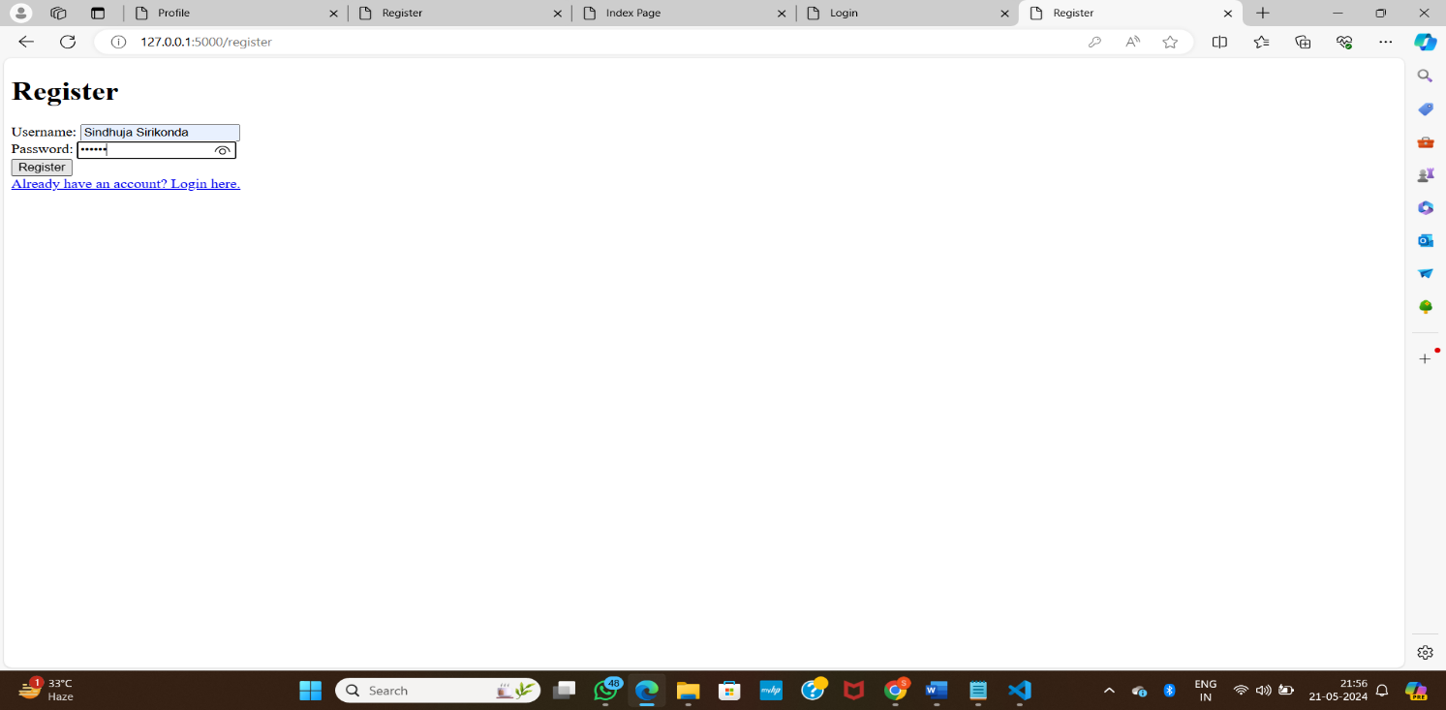

Fig(v)

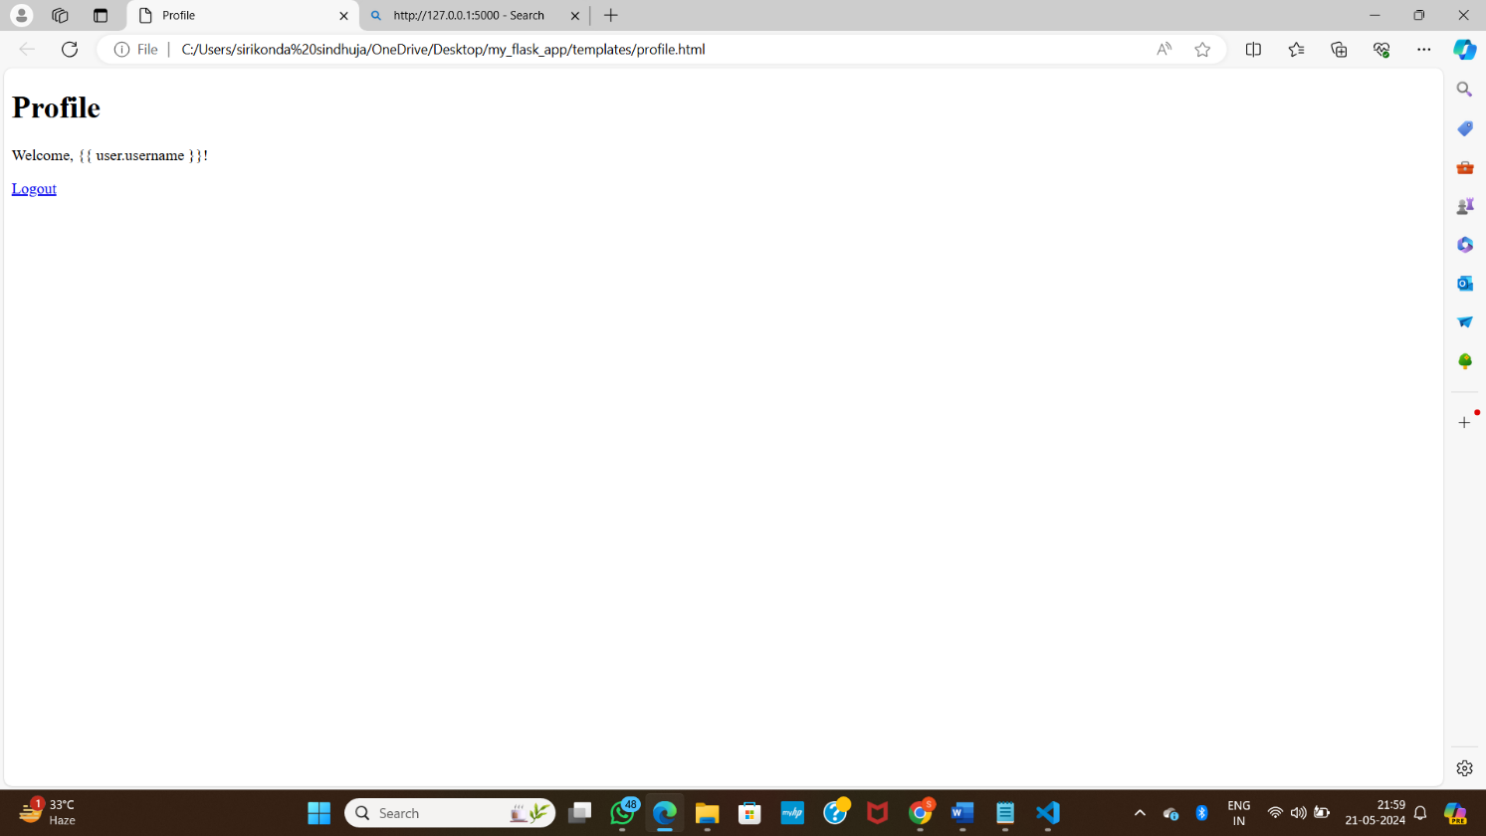

From Fig(v) and fig(vi)

We can observe after registering you login and profile is created.