# 🌤️ Offline Weather App — Project Procedure

🔹 Step-by-Step Procedure

• Step 1: Project Planning  
 - Decide to create a weather app without using external APIs.  
 - Plan to use HTML, CSS, and JavaScript.  
 - Choose to store static weather data for 50+ cities manually.

• Step 2: HTML Structure  
 - Create a basic HTML page with:  
 • A title and heading.  
 • An input box for city name.  
 • A button to fetch weather.  
 • A weather info box to show results.  
 • A container for side-by-side layout.

• Step 3: CSS Styling  
 - Add styling for:  
 • Responsive layout using Flexbox.  
 • Beautiful gradient background.  
 • Weather info box and buttons.  
 • A weather image with rounded corners and shadows.

• Step 4: Add Weather Image  
 - Insert a weather-themed image from a free image source (Pexels).  
 - Place it beside the form using a flex container.  
 - Ensure image resizes properly for small screens.

• Step 5: JavaScript Logic  
 - Create a JavaScript object named 'fakeWeatherData' with weather data for 50+ cities.  
 - Add a function to:  
 • Read the user’s input.  
 • Convert the city name to lowercase.  
 • Check if the city exists in the data object.  
 • If found, display temperature, weather condition, and humidity.  
 • If not found, show an alert message.

• Step 6: Testing  
 - Test with valid cities (like 'London', 'Delhi', 'Tokyo') to confirm data shows correctly.  
 - Test with invalid cities to confirm error alert appears.  
 - Test on mobile and desktop for layout responsiveness.

• Step 7: Final Integration  
 - Combine HTML, CSS, JavaScript, and image into one .html file.  
 - Ensure clean layout with input section and image shown side-by-side.

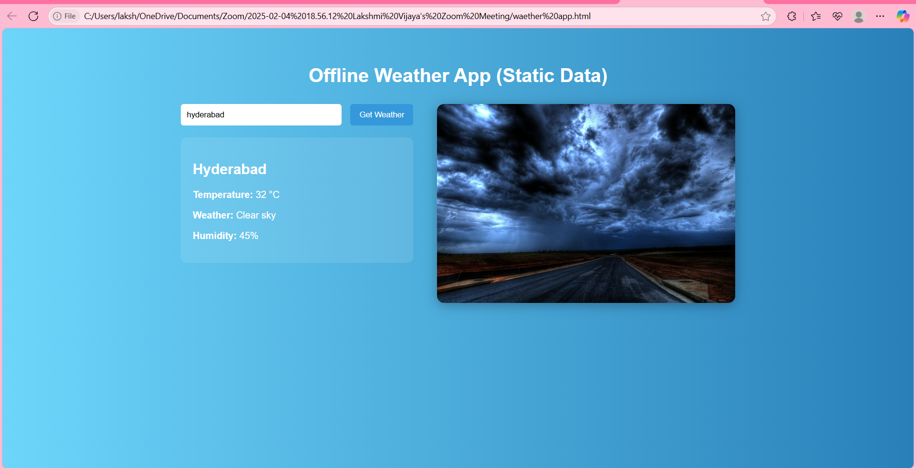Offline Weather App