1_ryu_version.png
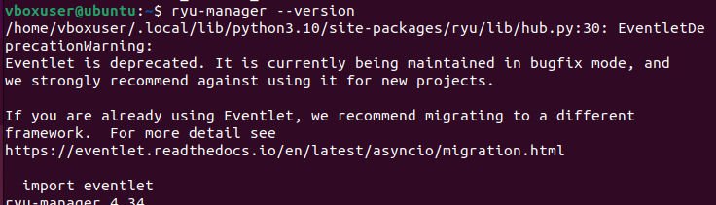
2_ryu_running_traffic_report.png
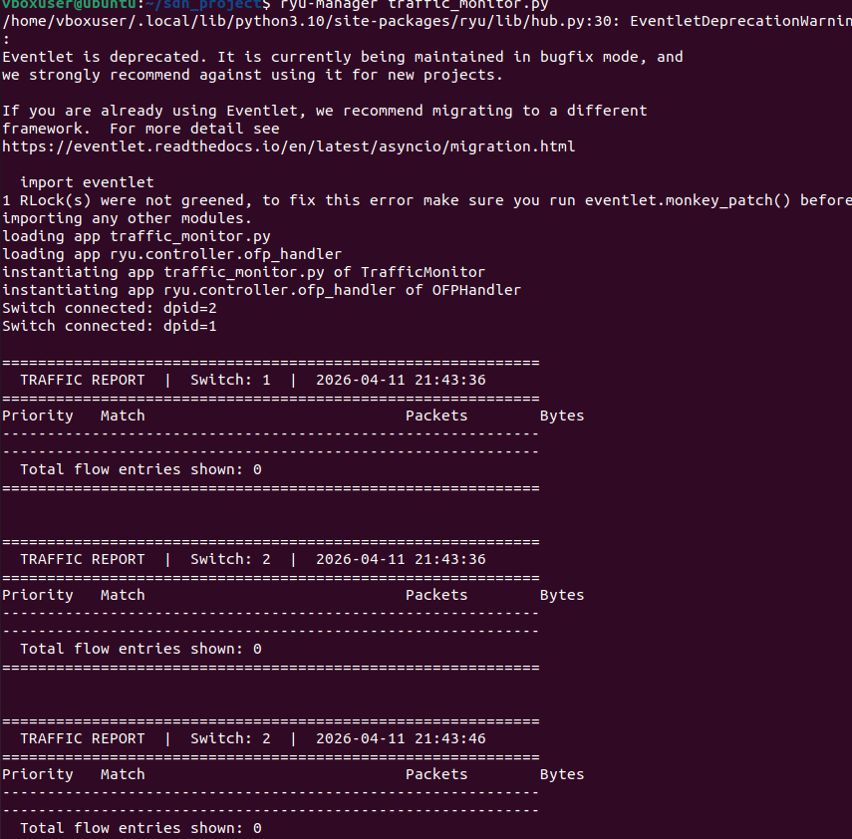
3_flow_stats_18_entries.png

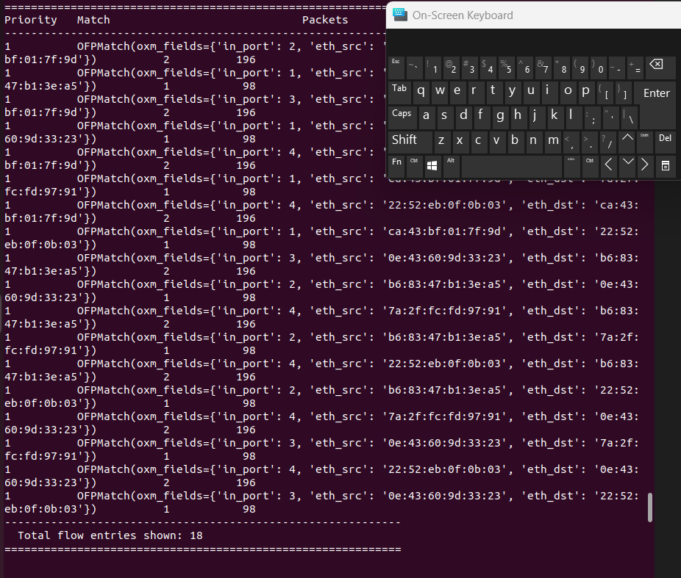
4_mininet_topology_started.png
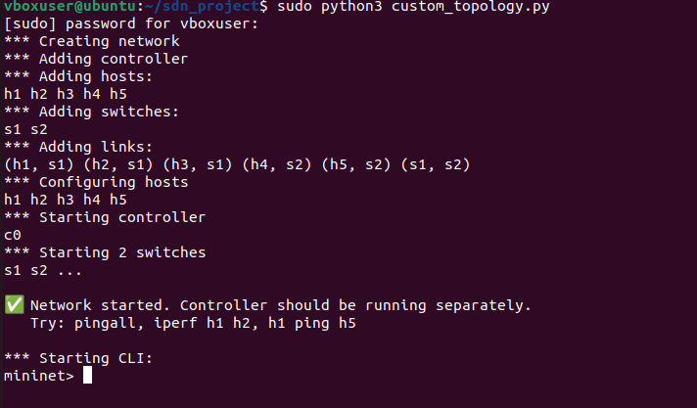
5_pingall_0percent_loss.png

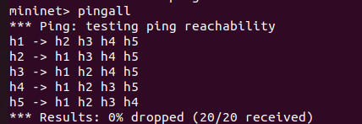
6_periodic_traffic_reports.png
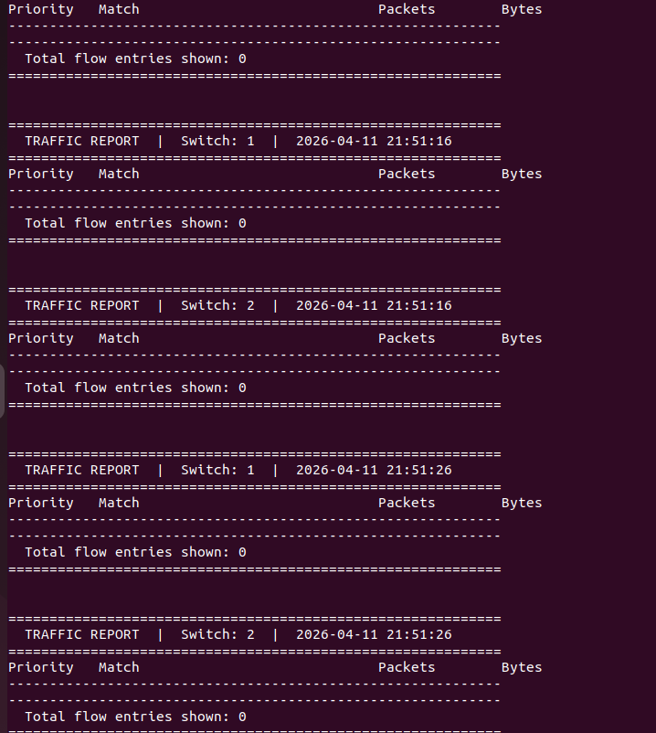

7_iperf_results.png
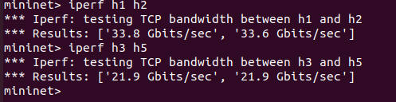
8_dump_flows_before_traffic.png
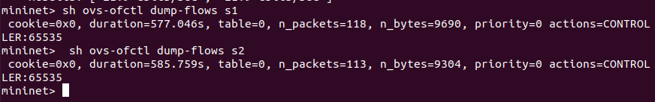
9_pingall_scenario2.png
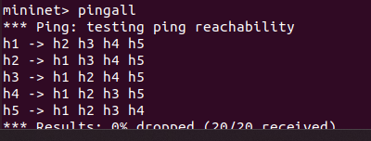
10_ping_latency_h1_h2.png
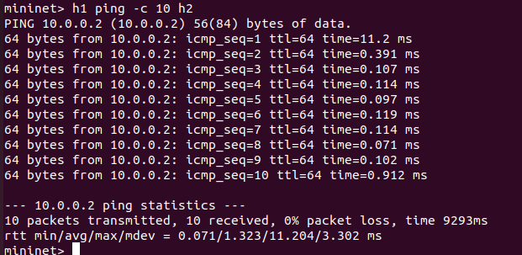\
11_dump_flows_after_traffic.png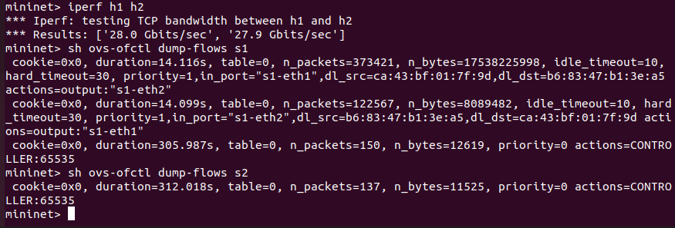
12_concurrent_ping_traffic_report.png
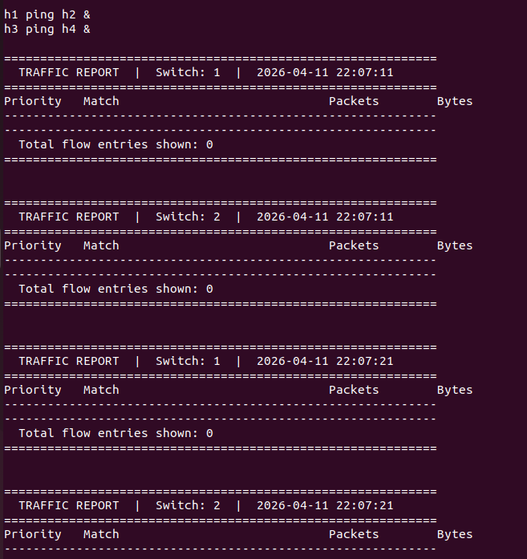

Wireshark
