Gold Price Research Assistant
AI Agent with Live Web Search
n8n project | Google Gemini + Tavily Search + Simple Memory

1. Project Goal
Build an AI agent in n8n that answers questions about gold prices using live web search. The agent splits a question into sub-questions (city and karat), searches the web for each one, compares the results and returns a table with the date, unit and source link for every price.
Example question: Compare today's 22K and 24K gold price per 10 grams in Hyderabad, Chennai and Mumbai.

2. Workflow Architecture
The workflow has three nodes in a line. The AI Agent has three connected sub-nodes: the model, the memory and the search tool.
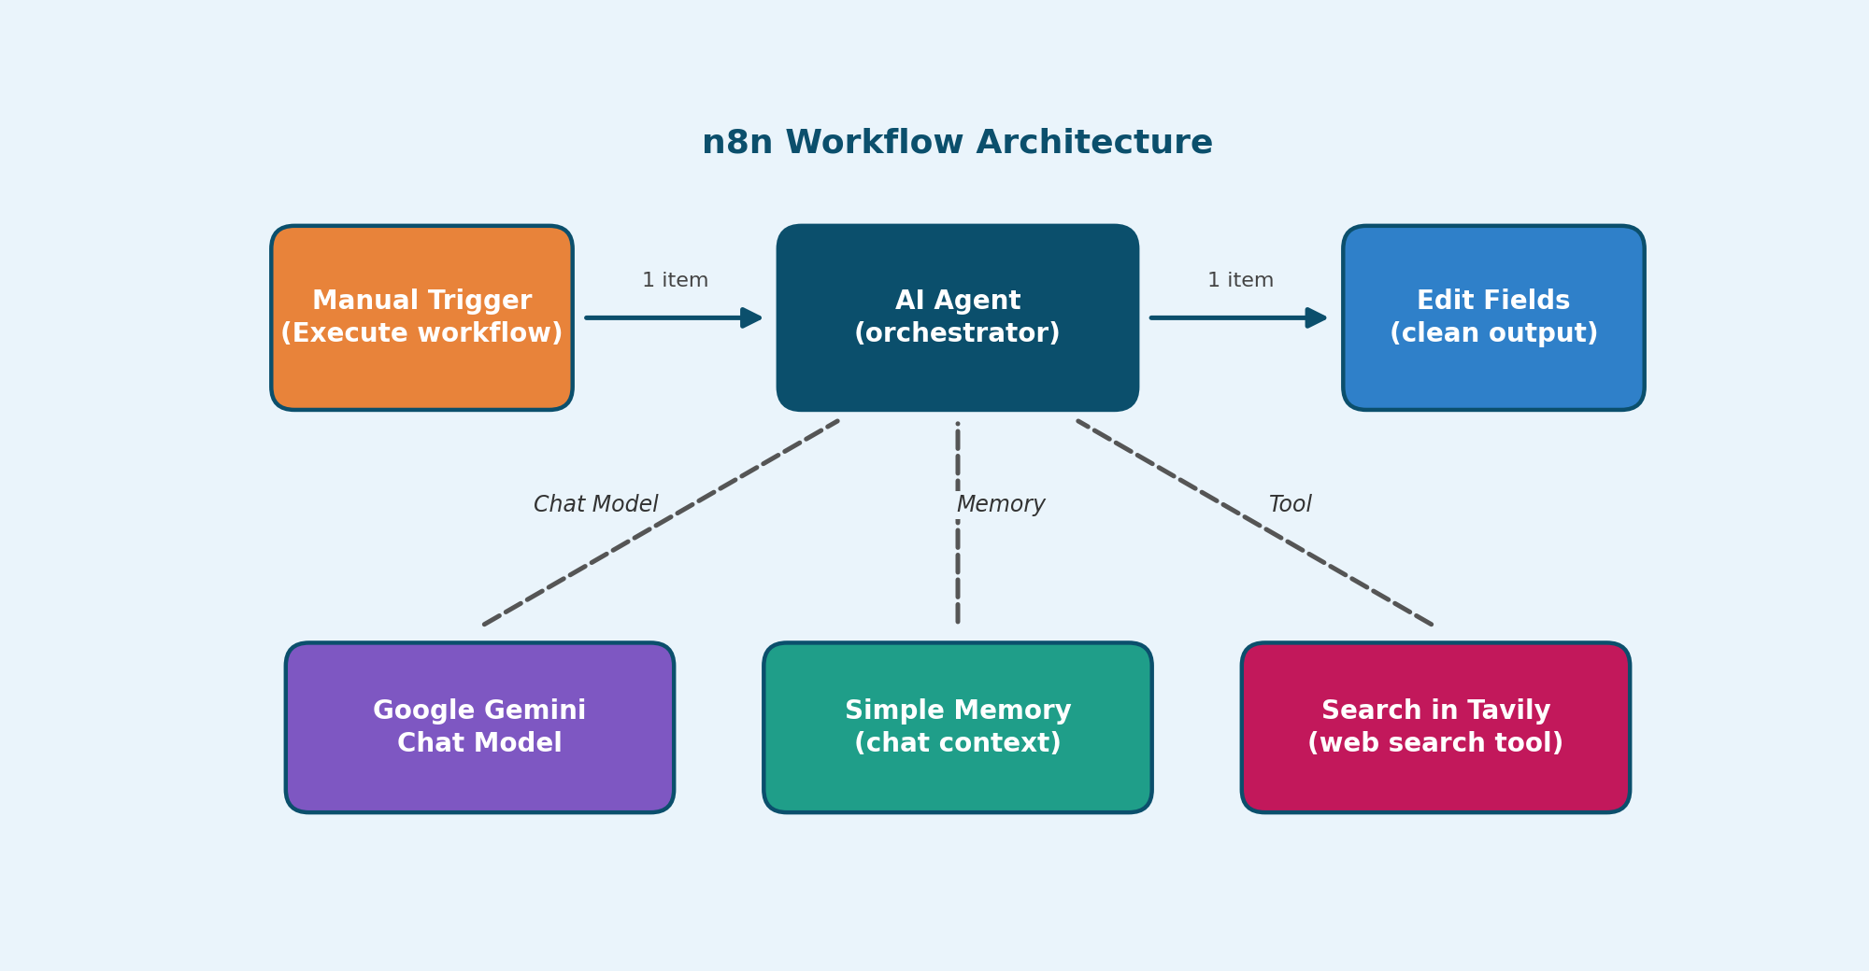
Figure 1: n8n workflow architecture
Node | Type | Role
Manual Trigger | Trigger | Starts a test run and sends 1 item to the agent.
AI Agent | Agent | Plans the research, calls the search tool and writes the answer.
Google Gemini Chat Model | Chat Model | The language model for reasoning and writing.
Simple Memory | Memory | Keeps recent messages as context.
Search in Tavily | Tool | Web search. The model writes the query for each sub-question.
Edit Fields | Set (manual) | Saves the final text in a field named answer.

3. Research Pipeline
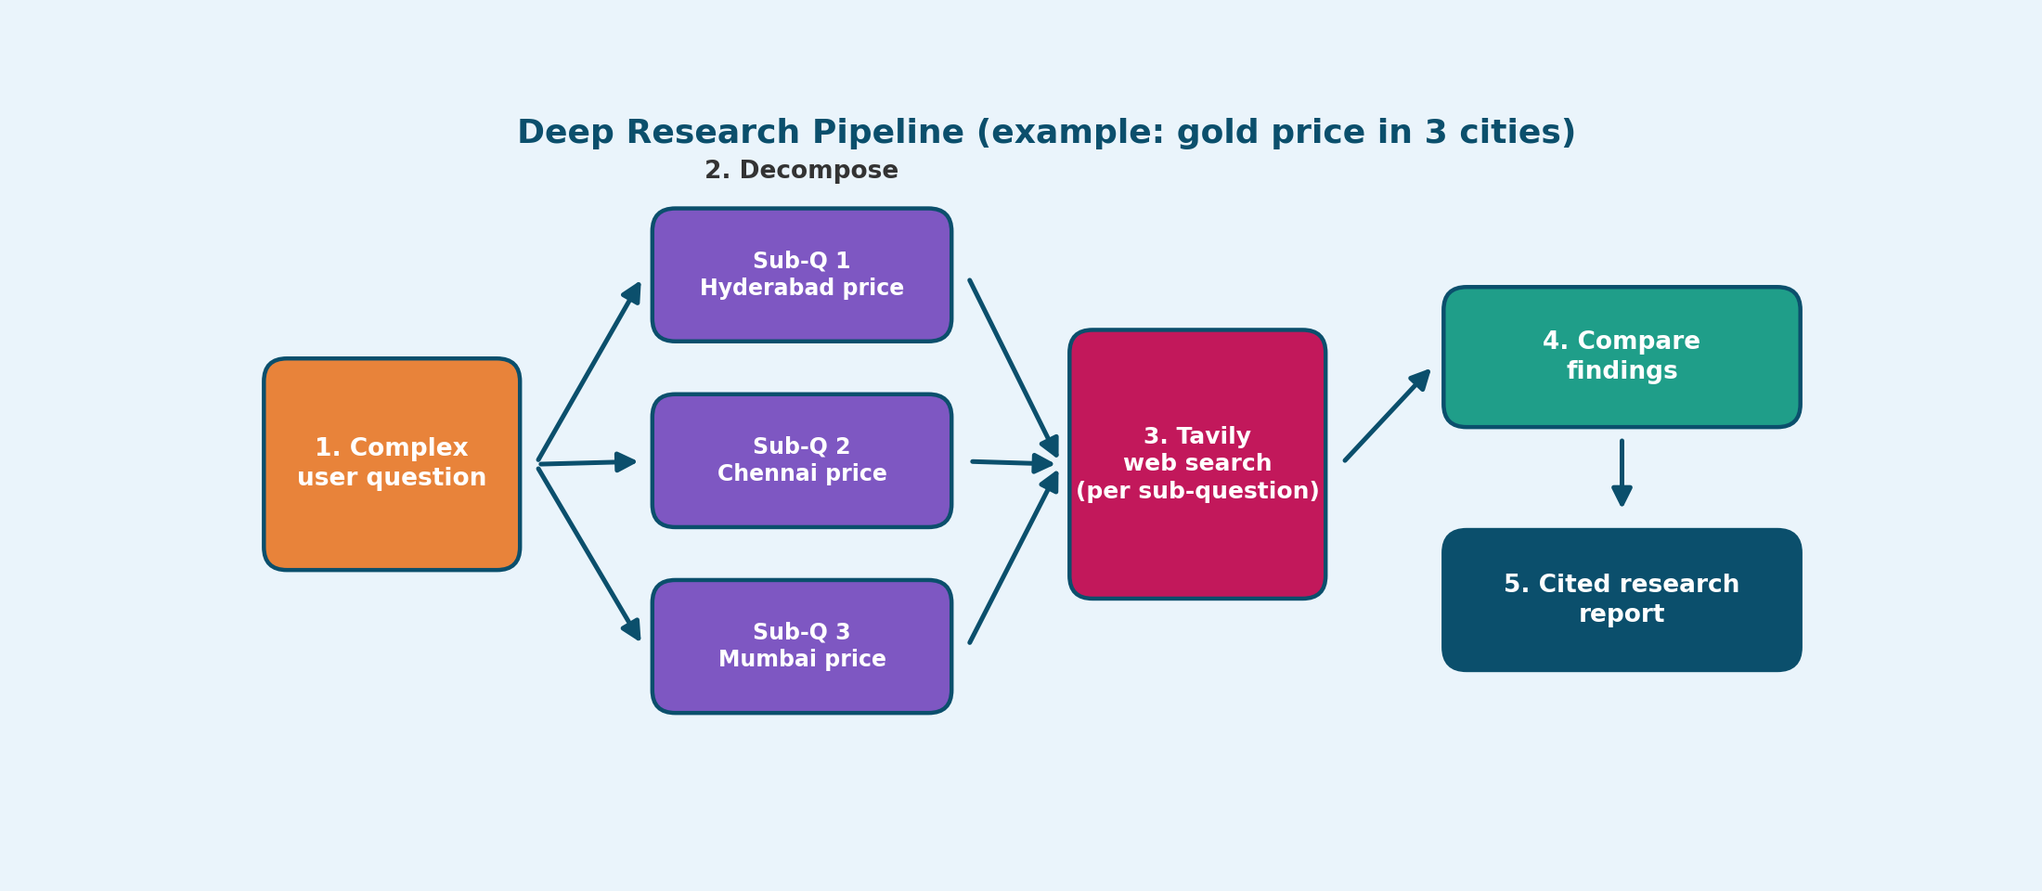
Figure 2: from gold price question to sourced table
- Ask: the question enters through the trigger, with today's date added in the prompt.
- Decompose: the agent splits it into city and karat sub-questions.
- Search: Tavily is called for each sub-question (3 searches in our test).
- Compare: results are checked for date and source.
- Report: Gemini writes a table with prices and source links.

4. Build Steps in n8n
- Trigger: add Trigger manually.
- AI Agent: set Prompt Source to Define below, add the date expression and the question, then paste the System Message (section 6).
- Gemini: add Google Gemini Chat Model with your API key and a Flash model.
- Memory: add Simple Memory and set a session key such as gold-test-1.
- Tavily: add Search in Tavily with your API key. Let the model define the query.
- Edit Fields: add a field named answer with the agent's output.
- Test: Save, then click Execute workflow.

5. Settings That Matter
Where | Setting | Why
AI Agent prompt | Add today's date using {{ $now.format('dd MMM yyyy') }} | The agent knows the real date.
AI Agent options | Max Iterations = 5 | Stops endless search loops.
Tavily options | Time range day or week, 3 to 5 results | Avoids old articles.
Gemini options | Temperature 0.2 | Keeps facts steady.
Simple Memory | New session key for each test | Old answers do not mix in.

6. System Message
Paste this in AI Agent, Options, System Message (Fixed mode):
You are a Deep Research Assistant for gold prices in India.
1. Break the question into sub-questions (city, 22K, 24K).
2. You MUST call the Tavily search tool. Never answer from memory.
3. Use at most 4 searches, then write the final answer.
4. Use only results from the last 7 days. Ignore older dates.
5. Show date, unit and source URL for every price.

7. Test Run and Result
The test ran with green ticks on every node: Gemini 4 times, Memory 4 times and Tavily 3 times.
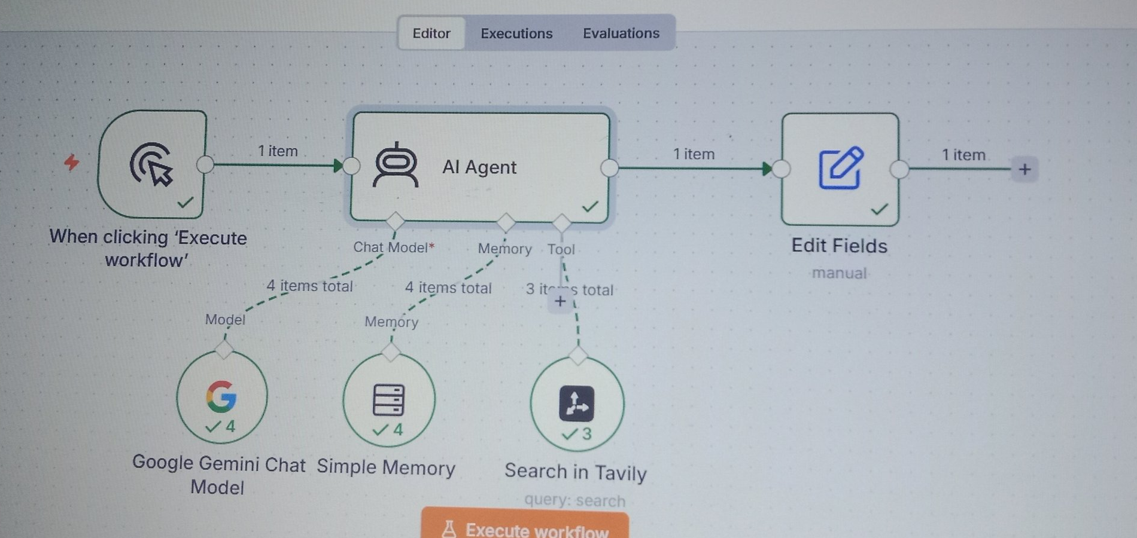
Figure 3: successful run in the n8n editor
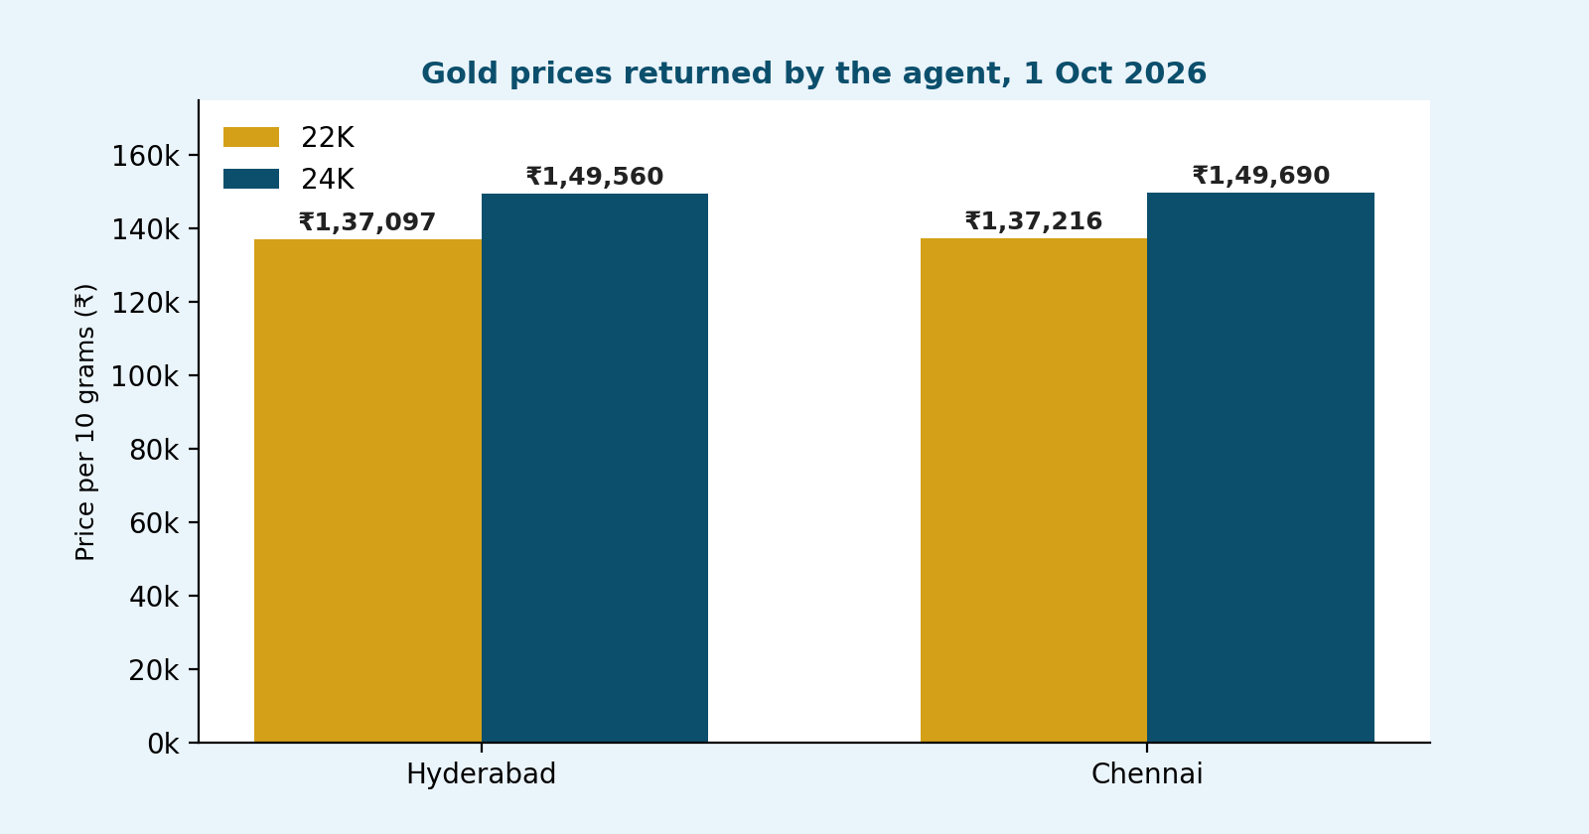
Figure 4: prices returned by the agent (per 10 grams)
City | 22K gold | 24K gold | Source
Hyderabad | Rs 1,37,097 | Rs 1,49,560 | LiveMint
Chennai | Rs 1,37,216 | Rs 1,49,690 | LiveMint
Note: these are the cities visible in the run output. Prices change during the day, so check a jeweller or bank site before buying.

8. Problems We Hit and Fixes
Problem | What happened | Fix
Endless loop | Tavily ran 13 times and used 47,820 tokens. | Max Iterations 5, at most 4 searches, 3 to 5 results per search.
Old date | The answer said May 22, 2024. | Date in the prompt, Tavily time range day or week, ignore old dates.
No sources | Prices had no links to check. | Rule: must call Tavily and list the source URL for every price.

9. Best Practices and Next Steps

Best practices
- Always show the date and source for every price.
- Open one source link and match a price before trusting the table.
- Keep Max Iterations and search limits low to save tokens.

Next improvements
- Add a Schedule Trigger to run every morning.
- Send the table to Gmail or Telegram.
- Ask for the answer in Telugu, and add more cities or silver prices.

