Sabaragamuwa University of Sri Lanka



Graph Theory– Research-Based Assignment

Title | A Graph-Theoretic Budgeted Route-Selection Model for Colombo’s Bus-Train Network under Fuel Shortage
Course Title | Graph Theory
Course Code | DS5106
Student Name | VKMN Sirimanna

DEPARTMENT OF DATA SCIENCE
FACULTY OF COMPUTING

31.10.2026

Abstract
Sri Lanka’s public bus services have repeatedly been cut back during fuel shortages. In March 2022 private operators reported running only about a quarter of their fleet, and in March 2026 operators again warned of cuts of up to 50% under the QR fuel quota. Railways, by contrast, kept running. When only a fraction of bus routes can operate, planners must decide which routes to keep. This report formulates that decision as a budgeted route-selection problem on a graph: given a bus–train network in which trains always operate, choose at most k of the N bus routes so that the number of pairs of stops that can still reach each other is as large as possible.
A network of 64 stops (towns and junctions), 31 bus routes and 3 train lines in the Colombo metropolitan area was assembled from public sources. Five selection strategies were compared: random, longest-routes-first, centrality-first, a greedy algorithm and greedy with swap-based local search, and greedy was checked against exhaustive search for small budgets. With half of the bus routes running, the greedy selection keeps 79.2% of all stop pairs connected, against 63.2% for centrality-first, 58.3% for longest-routes-first and 51.5% for random selection. Full connectivity is preserved with 23 of the 31 routes, so eight routes are redundant for reachability. For every budget of up to seven routes the greedy selection equals the exhaustive optimum. Routes 138 and 212/341 are the most critical single routes, and Nugegoda and Maharagama are the most central stops. The conclusions remain stable when the endpoint-only Metro Bus routes are removed. Limitations include route status that could be only partly verified, the absence of demand data, and the use of reachability rather than travel time.
Keywords: graph theory, public transport network, route reduction, network robustness, connectivity, fuel shortage, Colombo.

Table of Contents
Abstract 1
Table of Contents 2
List of Figures 3
List of Tables 3
1. Introduction 4
1.1 Background and motivation 4
1.2 Connection to Graph Theory 4
1.3 Objectives and structure of the report 4
2. Literature Review 5
2.1 Robustness of public transport networks 5
2.2 Network downsizing and route reduction 6
2.3 Studies in the Sri Lankan context 6
2.4 Summary of reviewed work 6
3. Research Gap and Proposed Problem 7
3.1 Identified gaps 7
3.2 Research questions 8
3.3 Formal problem statement 8
4. Methodology 9
4.1 Graph model 9
4.2 Data collection 9
4.3 Algorithms 10
4.4 Evaluation 11
4.5 Implementation 11
5. Findings / Results 11
5.1 Connectivity as the budget shrinks 11
5.2 Which routes are kept at a 50% budget 13
5.3 Critical routes and central stops 14
5.4 Robustness to the endpoint-only routes 15
5.5 Optimality check for small budgets 16
6. Discussion 17
6.1 Interpretation of the findings 17
6.2 Significance 17
6.3 Limitations 17
7. Conclusion and Future Work 18
References 19
Appendix A. Route data used in the analysis 21
Appendix B. Algorithm summary 22

List of Figures
Figure 1. Connectivity C(S) against the percentage of bus routes kept running (N = 31) 12
Figure 2. Network at a 50% bus budget. Red: kept bus routes; blue: train lines; dashed grey: stopped bus routes. Stop positions are approximate 13
Figure 3. Loss in connectivity when each bus route is removed on its own (twelve most critical routes) 14
Figure 4. The ten stops with the highest betweenness centrality in the full network 15
Figure 5. Robustness check: greedy + swap with and without the Metro Bus (CM) routes 16

List of Tables
Table 1. Summary of the reviewed studies and their limitations for the present problem 6
Table 2. Summary of the dataset 10
Table 3. Connectivity at selected budgets (full data, N = 31) 12
Table 4. Most critical single routes 14
Table 5. Betweenness centrality and degree of the ten most central stops 15
Table 6. Connectivity without the CM routes (N = 25) 15
Table 7. Greedy versus exhaustive optimum for small budgets (connectivity C) 16

1. Introduction

1.1 Background and motivation
Public buses are the backbone of daily travel in the Colombo metropolitan region, but their operation depends directly on diesel supply. During the 2022 foreign-exchange crisis, private bus owners reported that they could operate only about a quarter of their 20,000-vehicle fleet because of diesel shortages [8]. On 8 June 2022 the president of the Lanka Private Bus Owners’ Association said that private bus services would be limited to 50% of capacity for that day, while the Sri Lanka Transport Board and Sri Lanka Railways stated that their services would continue [9]. The problem has not disappeared: in March 2026 the same association warned that services could fall by as much as 50% because the fuel quota for buses had not been properly regulated, noting an allocation of only 60 litres per bus under the QR system [10].
Fuel shortages are not the only pressure on the bus network. In 2024 the association’s president estimated that about 35% of bus routes in the Western Province had ceased to exist, and the Sri Lanka Transport Board reported running a single bus twice a day on several routes [11]. A 2022 newspaper review likewise listed many once-popular Colombo routes that had disappeared [12]. Service reductions are therefore a recurring reality, and the way routes are chosen for reduction determines how many people lose access to the network.
When service must be cut, operators tend to protect profitable routes or cut proportionally. Neither approach looks at the structure of the network: a route that earns little revenue may still be the only link joining a suburb to the rest of the system. A graph-theoretic view makes this structure explicit and allows the effect of every possible reduction to be measured.

1.2 Connection to Graph Theory
A public transport network can be represented as a graph G = (V, E). In the widely used L-space representation, each node is a stop or station and two nodes are joined by an edge if they are consecutive stops on at least one route [1]. A route is then a path in G, and removing a route removes the edges that only that route provides. Whether two places can still be reached by public transport is a question about the connected components of the remaining graph. The problem studied here is therefore a selection problem on a graph: choosing a set of paths (routes) under a budget so that the connectivity of the resulting graph is maximised.

1.3 Objectives and structure of the report
The objectives are: (i) to review how graph theory has been used to study route removal and network downsizing; (ii) to identify a research gap, particularly for Sri Lanka; (iii) to formulate a new problem, the budgeted route-selection problem, and develop algorithms for it; (iv) to analyse a real bus–train network of the Colombo area; and (v) to discuss findings, limitations and future work. Section 2 reviews the literature, Section 3 states the gap and the problem, Section 4 describes the methodology, Section 5 presents the results, Section 6 discusses them, and Section 7 concludes.

2. Literature Review

2.1 Robustness of public transport networks
The study of how networks respond to the loss of components goes back to the error-and-attack tolerance work of Albert, Jeong and Barabási [7], which showed that networks can behave very differently under random failures and targeted attacks. Applied to public transport, this idea has produced many studies of node and link removal. Cicchini, Caridi and Ermann [1] argue that removing individual stops or links does not match how services actually fail, because a bus line is operated as a single unit by one organisation; a failure, a management decision or a strike removes the whole route. They therefore remove entire routes from the Buenos Aires metropolitan bus network (489 lines) using strategies based on degree, closeness, PageRank and betweenness centrality of routes, plus random removal and one-step ‘most harmful’ and ‘least harmful’ strategies. Damage is measured by the size of the largest connected component and related measures. Betweenness-based attacks and the one-step maximal strategy were the most damaging, and betweenness attacks tended to detach peripheral parts of the network from its core [1].
Shao, Zhang and Li [3] model the bus network of Jinan, China, as a stop network and a line network, test random and deliberate attacks, and then improve robustness by adding edges. They find that deliberate attacks are more damaging than random ones, that attacking the node with maximum betweenness causes the most damage, and that different edge-addition strategies work best under different attack types [3]. Both studies use attacks, that is, an adversary choosing what to remove, and the optimisation in [3] works by adding links rather than by deciding which existing services to keep.
Earlier network-science work treated transit systems as complex networks. Latora and Marchiori [18] used efficiency measures to analyse the Boston subway; Sen et al. [19] showed that the Indian railway network has small-world properties; von Ferber et al. [20] analysed the public transport networks of fourteen large cities, including the relation between routes and stations; and Derrible and Kennedy [21] studied the structure and robustness of 33 metro systems. These studies describe the topology and robustness of existing networks, but they do not address which services a planner should keep when supply has to be reduced.

2.2 Network downsizing and route reduction
A smaller body of work asks which parts of a transit network to keep when supply must shrink. Guillot, Furno, Aghezzaf and El Faouzi [2] study downsizing after the drop in demand caused by COVID-19. They formulate a mixed-integer linear program that selects an optimal sub-network of bus stops such that access time and itinerary delay do not increase excessively, and then convert the selected stops into a decision tool that proposes which bus lines to close. Their model requires a known origin–destination demand matrix and was applied to 1,144 bus stops in Lyon. The authors note that choosing lines indirectly through stops gives no guarantee of the quality of the resulting set of lines, and that a formulation in which a solution is directly a subset of lines to keep could increase computational complexity drastically but is being studied [2].
Li, Yang and Zhou [6] examine progressive bus route cutbacks in Beijing’s Huairou District with an agent-based model calibrated by a large language model. Their results show that the structural configuration of the network influences stability more than capacity, that removing high-connectivity routes causes dissatisfaction to rise sharply (especially for older and disabled passengers), and that dissatisfaction passes through stable, transitional and critical phases [6]. This supports the idea that routes should not be cut on cost-effectiveness alone, but the study is simulation-based, covers a single district, and does not search for the best set of routes to keep.

2.3 Studies in the Sri Lankan context
Sri Lankan work on transport networks as graphs is limited. Kalpana, Jayasinghe and Abenayake [5] use betweenness and closeness centrality to assess the resilience of the Greater Colombo road network to the floods of May 2010, May 2016 and May 2017, reporting that the relative impact on accessibility (above 60%) is much larger than the direct physical impact (up to 7%). Their network is the road network, not the bus or train services that run on it. Rajapaksha, Lanel, Athapattu and Sanjeewa [4] propose a weighted multiplex centrality measure and apply it to a Sri Lankan transport network of 542 locations across bus, railway and domestic flight layers, identifying Colombo as the most influential node followed by hubs such as Polgahawela, Ragama, Maho, Peradeniya and Maradana. Their analysis is based on node importance and sequential node removal [4].

2.4 Summary of reviewed work
Table 1. Summary of the reviewed studies and their limitations for the present problem.
Study | Network | Method | Limitation for this problem
Cicchini et al. [1] | Buenos Aires buses (489 lines) | Route removal by centrality; largest component | Adversarial attack, not a decision of which routes to keep; bus only
Shao et al. [3] | Jinan buses | Random/deliberate attack; edge addition | Adds links; no budget on which services to keep; China
Guillot et al. [2] | Lyon buses (1,144 stops) | MILP optimal sub-network of stops | Stop-based; needs OD demand; demand drop, not fuel; bus only
Li et al. [6] | Beijing, Huairou (79 routes) | Agent-based route deletion | Simulation of given deletions; no optimal selection; one district
Kalpana et al. [5] | Greater Colombo roads | Centrality under flood scenarios | Road network, flood hazard; no bus/train services
Rajapaksha et al. [4] | Sri Lanka bus/rail/air (542 nodes) | Multiplex centrality; node removal | Node importance; no route budget; no fuel scenario
Latora & Marchiori [18]; Sen et al. [19]; von Ferber et al. [20]; Derrible & Kennedy [21] | Subway, railway, mixed public transport and metro networks | Efficiency, small-world and robustness analysis | Describe topology and robustness; do not choose which services to keep

3. Research Gap and Proposed Problem

3.1 Identified gaps
Based on the targeted literature search carried out for this study, the following gaps were identified:
- G1 – Attacker versus planner. Route-removal studies such as [1] and [3] ask how much damage the worst removals cause. A planner facing a fuel quota asks the opposite question: given that only k routes can run, which set should be kept?
- G2 – Stops versus lines. The closest optimisation model [2] selects stops and only afterwards infers lines, and its authors state that a direct line-based formulation is an open direction. In practice, fuel and fleet are allocated to routes, so the decision variable should be the route.
- G3 – Cause of reduction and mode mix. Existing downsizing work responds to falling demand. A fuel shortage is a supply shock, and in Sri Lanka it affects buses much more than trains [9]. Treating trains as a fixed backbone and buses as the adjustable layer has not, to my knowledge, been analysed.
- G4 – Sri Lankan evidence. Available Sri Lankan studies concentrate on road networks under floods [5] or on node importance in a national multiplex network [4]. No study of budgeted bus-route selection for the Colombo bus–train network was found.

3.2 Research questions
- RQ1. If trains always run and only k of N bus routes can run, which set of routes maximises network connectivity?
- RQ2. How much better is an optimised selection than random selection and than a simple heuristic that keeps the longest routes?
- RQ3. Which routes and stops are most critical, and which routes are redundant for reachability?
- RQ4. Are the conclusions robust to uncertainty in the route data?

3.3 Formal problem statement
Let B be the set of bus routes with |B| = N and T the set of train lines. For a subset S ⊆ B, let G(S) be the graph on the full stop set V (|V| = n) whose edges are the consecutive-stop links of all routes in T ∪ S. Let the connected components of G(S) be c₁, …, c_m. The connectivity of S is
C(S) = Σᵢ |cᵢ| (|cᵢ| − 1) / ( n (n − 1) )
which is the fraction of ordered pairs of distinct stops that are joined by a path. The Budgeted Route-Selection problem (BRS) is:
maximise C(S) subject to S ⊆ B, |S| ≤ k
C(S) is non-decreasing in S, because adding a route can only add edges, and 0 ≤ C(S) ≤ 1, with C(B) giving the connectivity when no cuts are needed. The budget k represents the number of bus routes that the available fuel and fleet can support.
Proposition 1 (monotonicity). If S ⊆ S′ ⊆ B then C(S) ≤ C(S′). Proof. Adding a route adds edges to the graph. An edge either joins two stops that are already in the same component, which changes nothing, or merges two components of sizes a and b. Because (a + b)(a + b − 1) − a(a − 1) − b(b − 1) = 2ab ≥ 0, the numerator of C never decreases. Adding the routes of S′ \ S one at a time therefore gives C(S) ≤ C(S′).
Proposition 2 (C is not submodular). A set function f is submodular if the gain from adding an element never increases as the set grows. C does not have this property. Example. Let there be n = 3 stops x₁, x₂, x₃, a route R₁ joining x₁ and x₂, and a route R₂ joining x₂ and x₃. Then C(∅) = 0, C({R₁}) = 2/6, C({R₂}) = 2/6 and C({R₁, R₂}) = 6/6. Adding R₂ gains 2/6 when starting from ∅ but 4/6 when starting from {R₁}, so the gain grows with the set. The same happens in the Colombo data: adding route 171 to S = {CM04, 119, 308, 992} raises C by 0.0506, whereas adding it to S ∪ {Mhg-Ratmalana} raises C by 0.0526.
Proposition 1 shows that using the whole budget never hurts, and Proposition 2 shows why the usual (1 − 1/e) guarantee for greedy maximisation of monotone submodular functions cannot be applied here. The quality of the greedy solution is therefore examined empirically, including an exhaustive comparison for small budgets (Section 5.5).

4. Methodology

4.1 Graph model
The network is modelled in L-space [1]. Nodes are stops at the level of towns and junctions (for example Nugegoda, Maharagama, Fort), not individual bus stops, because the available public sources list routes by the towns they serve. Two nodes are joined by an undirected edge if they are consecutive on at least one bus or train route. All train lines are placed in the base graph and are never removed, following the reports that railway services continued during fuel crises [9]. Transfers are assumed to be possible at no cost wherever two routes share a town, so two stops can be joined by public transport whenever they lie in the same connected component. Waiting time, walking between stops of the same town and timetables are not modelled.

4.2 Data collection
No complete stop-by-stop dataset for Sri Lanka was available, so the data were assembled from public sources: the route lists on the Wikipedia pages of Nugegoda, Maharagama, Homagama, Rukmale, Godagama and Battaramulla [14]; the directions page of the Department of Immigration and Emigration for routes serving Battaramulla [15]; a 2017 parliamentary question listing routes 103, 117, 144 and 192 [16]; and the Lanka Metro Transit announcement of seven new Metro Bus routes in August 2026 [13]. Train lines were taken from the stations named in [14] together with the Coastal, Kelani Valley and Main line stations.
The following rules were applied. (a) Only routes whose towns could be listed in order were included, giving 31 bus routes. (b) Routes reported as discontinued or almost discontinued (112, 115, 118, 123, 131, 152, 155, 156, 168, 173, 186) were excluded [11], [12]. (c) The Metro Bus (CM) routes are express services for which only endpoints (and, for CM01, Pettah) are published, so they were entered as direct links and treated separately in the robustness analysis. CM06 (Kollupitiya Circular) was left out because no stop list is published [13]. (d) Route variants such as 138/2 and 138/3 were not modelled separately. (e) Some intermediate towns (for example Rajagiriya on route 171) were placed by geography, and the train-line stations beyond those named in [14] come from general knowledge of the Coastal, Kelani Valley and Main lines. (f) Whether each included route is running today could be checked only against the 2022 and 2024 newspaper reports [11], [12], which do not cover every route; the data should be treated as a snapshot to be updated. The full list of routes is given in Appendix A.
Table 2. Summary of the dataset.
Quantity | Value
Stops (nodes) | 64
Bus routes (adjustable) | 31 (25 conventional + 6 Metro Bus CM routes)
Train lines (always running) | 3 (Coastal, Kelani Valley, Main)
Edges in the full graph | 90
Average degree | 2.81
Stops served by trains | 17
Connectivity with trains only, C(∅) | 0.0675

4.3 Algorithms
The exact optimum could be found by evaluating all subsets, but with N = 31 there are 2³¹ = 2,147,483,648 subsets, which is impractical, and the structure of C does not make the problem easy: adding a route that joins two large components increases C more than adding it when the components are small, so C is not submodular (Proposition 2) and the usual (1 − 1/e) greedy guarantee does not apply. Five strategies were therefore compared, and greedy was checked against exhaustive search where this is feasible.
- Random. k routes chosen uniformly at random; the mean and the 10th–90th percentile band over 300 trials are reported.
- Longest-first. The k routes covering the most distinct stops. This is a proxy for demand, since no passenger data are available.
- Centrality-first. The k routes whose stops have the largest total betweenness centrality in the full network. This follows the centrality-based route rankings used in [1] and gives a structure-aware baseline that needs no demand data.
- Greedy. Starting from the empty set, repeatedly add the route that gives the largest increase in C(S) until k routes are chosen. One run produces a nested sequence of solutions for every k. Each step evaluates at most N candidates, and each evaluation costs O(n + m), so the complete curve costs O(N²(n + m)).
- Greedy + swap. Starting from the greedy set, repeatedly exchange one kept route with one dropped route whenever this increases C(S), until no single swap helps (a local optimum under the swap neighbourhood).
- Exhaustive search (small budgets only). For k ≤ 7 all C(N, k) subsets were evaluated (up to 2,629,575 subsets for k = 7), which gives the true optimum to compare with greedy.

4.4 Evaluation
Each strategy is evaluated for every budget k = 0, 1, …, N and also summarised by the normalised area under its curve, AUC = (1/100) ∫ C d(percentage of routes kept), computed by the trapezoidal rule. Three further analyses are carried out. (i) Route criticality: the loss in C when a single route is removed from the full set of bus routes. (ii) Stop centrality: betweenness centrality of stops in the full graph. (iii) Robustness: all strategies are repeated after removing the six CM routes, to test whether conclusions depend on the endpoint-only data. Finally, for k ≤ 7 the greedy value is compared with the exhaustive optimum (Section 5.5).

4.5 Implementation
All computations were implemented in Python using NetworkX [17] for graph construction, connected components and betweenness centrality, and Matplotlib for the figures. The map positions in Figure 2 are approximate and are used only for drawing; they play no part in the analysis. The script `final_analysis.py` reproduces every number and figure in this report.

5. Findings / Results

5.1 Connectivity as the budget shrinks
Trains alone connect only 6.7% of stop pairs, because they serve 17 of the 64 stops. Bus routes are therefore essential to reachability, and the choice of which ones to run matters a great deal. Figure 1 shows the connectivity achieved by each strategy as the share of bus routes kept running increases.
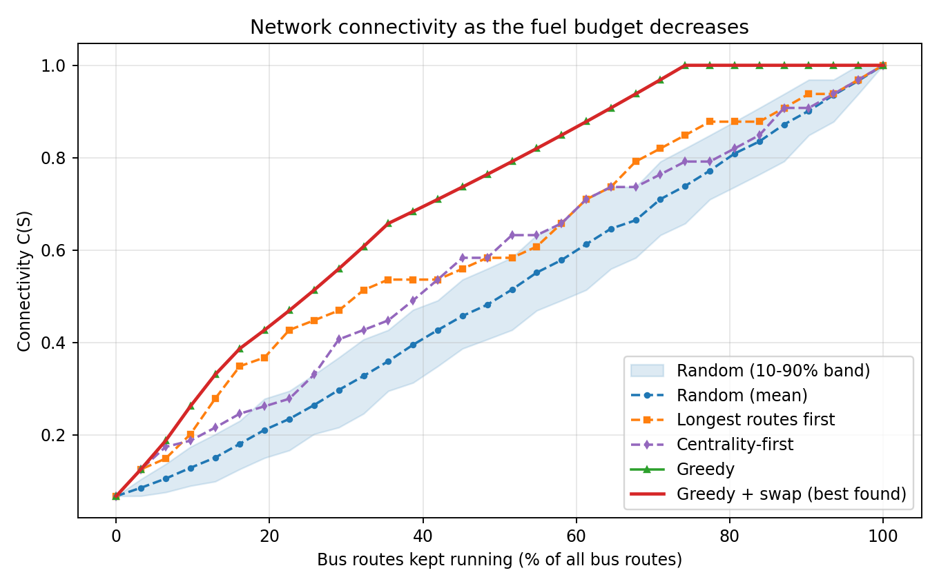
Figure 1. Connectivity C(S) against the percentage of bus routes kept running (N = 31).
The greedy curve lies on or above all baselines at every budget (all strategies coincide at k = 0 and k = 1). The swap search found no improvement over greedy at any budget, so the greedy sets are locally optimal with respect to single swaps (this does not prove global optimality). Table 3 gives the values at 25%, 50% and 75% of routes.
Table 3. Connectivity at selected budgets (full data, N = 31).
Budget (routes kept) | Random (mean) | Longest-first | Centrality-first | Greedy | Greedy + swap
25% (k = 8) | 0.265 | 0.448 | 0.330 | 0.513 | 0.513
50% (k = 16) | 0.515 | 0.583 | 0.632 | 0.792 | 0.792
75% (k = 23) | 0.739 | 0.849 | 0.792 | 1.000 | 1.000
AUC (0–1) | 0.508 | 0.605 | 0.570 | 0.713 | 0.713

At a 50% budget, greedy selection keeps 79.2% of stop pairs connected, which is 27.7 percentage points above random selection and 20.9 points above longest-first. Greedy reaches full connectivity (C = 1) with 23 of the 31 routes, about 74%. The remaining eight routes add no new reachability once those 23 are running.
Centrality-first selection, which keeps the routes whose stops have the highest total betweenness centrality, reaches 0.632 at a 50% budget. That is better than longest-first (0.583) and random (0.515) but far below greedy (0.792). At 25% and 75% of routes it is weaker than longest-first (0.330 against 0.448, and 0.792 against 0.849), and its AUC is 0.570 compared with 0.713 for greedy. Choosing routes one by one by importance ignores the fact that several important routes overlap, because they pass through the same hubs, Nugegoda and Maharagama. Greedy avoids this by always asking what a route adds to the routes already chosen.

5.2 Which routes are kept at a 50% budget
Figure 2 shows the network when 16 of the 31 bus routes run, with the train lines always on. The kept routes are 117, 124, 128/1, 138, 163, 171, 177, 190, 212/341, 308, 313, 376, 689, 690, 992 and Mhg-Dehiwala. The routes stopped are 103, 119, 144, 17, 170, 174, 183, 192, Mhg-Ratmalana and all six CM routes. The selection prefers routes that serve outlying towns reachable in no other way, and drops routes whose links are already provided by other routes or by trains.
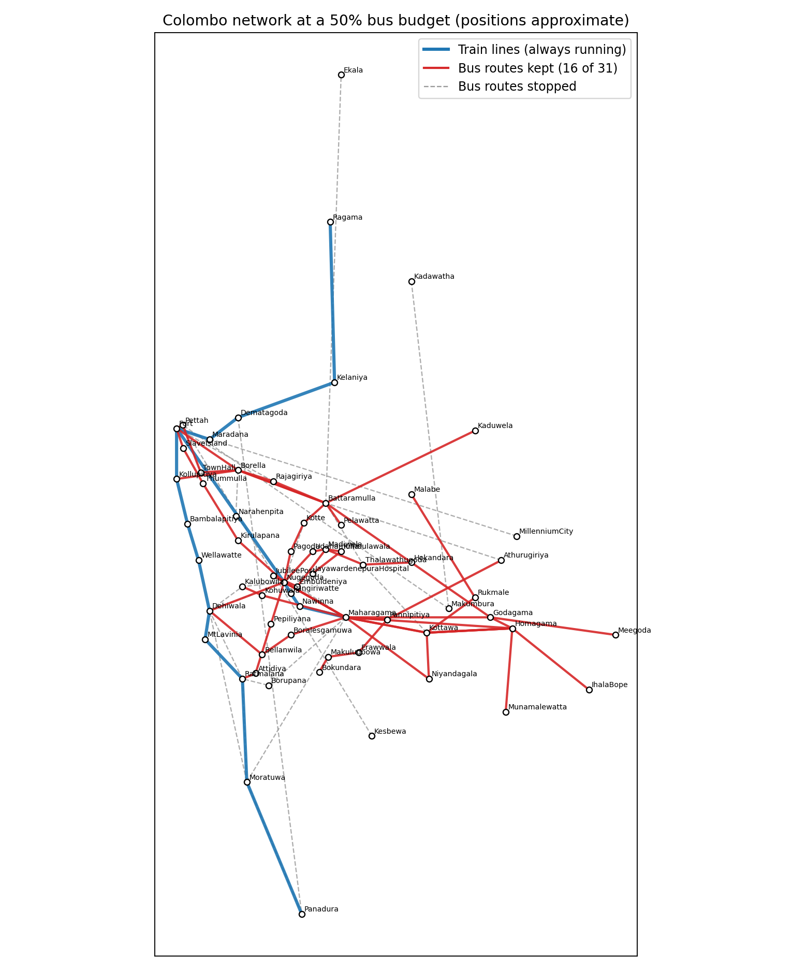
Figure 2. Network at a 50% bus budget. Red: kept bus routes; blue: train lines; dashed grey: stopped bus routes. Stop positions are approximate.

5.3 Critical routes and central stops
Removing a single route from the full set shows how much each route contributes uniquely (Figure 3 and Table 4). Routes 138 and 212/341 are the most critical: each is the only service reaching several stops, and removing either lowers connectivity by 0.092. Routes 689, 690, 376, 117 and Mhg-Dehiwala each cost 0.062, and CM01 costs 0.062 because it is the only link joining Makumbura (and Kadawatha, via CM03) to the rest of the network.
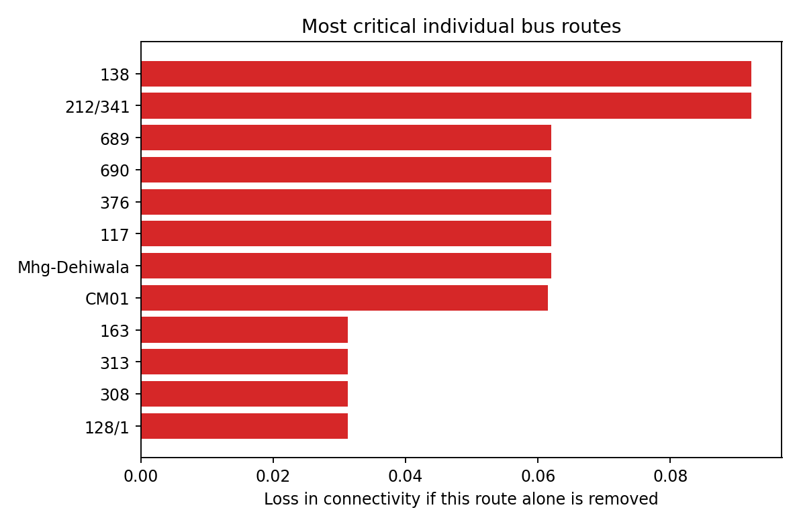
Figure 3. Loss in connectivity when each bus route is removed on its own (twelve most critical routes).
Table 4. Most critical single routes.
Route | Loss in C if removed | Interpretation
138 | 0.092 | Only link to Kirulapana, Thummulla and Slave Island
212/341 | 0.092 | Only link to Bokundara, Makuludoowa and Erawwala
689, 690, 376, 117, Mhg-Dehiwala | 0.062 each | Each is the only service for two outlying stops
CM01 | 0.062 | Only link joining Makumbura (and Kadawatha, via CM03) to the rest
163, 313, 308, 128/1 | 0.031 each | Each is the only service for one outlying stop (for 163, Pagoda)

Betweenness centrality identifies the stops that lie on the largest share of shortest paths (Figure 4 and Table 5). Nugegoda (0.388) and Maharagama (0.386) are by far the most central, followed by Fort and Battaramulla. Both critical routes, 138 and 212/341, pass through Nugegoda and Maharagama, which explains why they matter so much.
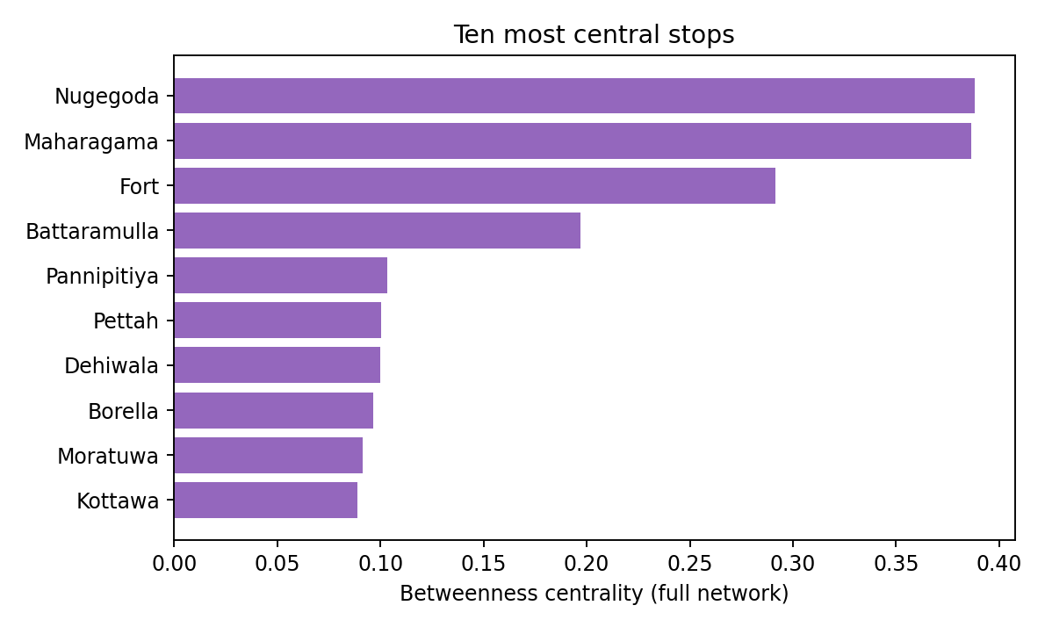
Figure 4. The ten stops with the highest betweenness centrality in the full network.
Table 5. Betweenness centrality and degree of the ten most central stops.
Stop | Betweenness | Degree
Nugegoda | 0.388 | 11
Maharagama | 0.386 | 12
Fort | 0.292 | 8
Battaramulla | 0.197 | 9
Pannipitiya | 0.103 | 3
Pettah | 0.100 | 4
Dehiwala | 0.100 | 7
Borella | 0.097 | 6
Moratuwa | 0.091 | 4
Kottawa | 0.089 | 5

5.4 Robustness to the endpoint-only routes
Removing the six CM routes leaves N = 25 bus routes. Table 6 and Figure 5 show that the ranking of strategies is unchanged: greedy still reaches 0.805 at a 50% budget, against 0.632 for longest-first, 0.579 for centrality-first and 0.518 for random, and full connectivity is again reached at about 72% of the routes (18 of 25).
Table 6. Connectivity without the CM routes (N = 25).
Budget (routes kept) | Random (mean) | Longest-first | Centrality-first | Greedy | Greedy + swap
25% (k = 6) | 0.272 | 0.433 | 0.309 | 0.503 | 0.503
50% (k = 12) | 0.518 | 0.632 | 0.579 | 0.805 | 0.805
75% (k = 19) | 0.779 | 0.836 | 0.805 | 1.000 | 1.000
AUC (0–1) | 0.531 | 0.619 | 0.575 | 0.727 | 0.727
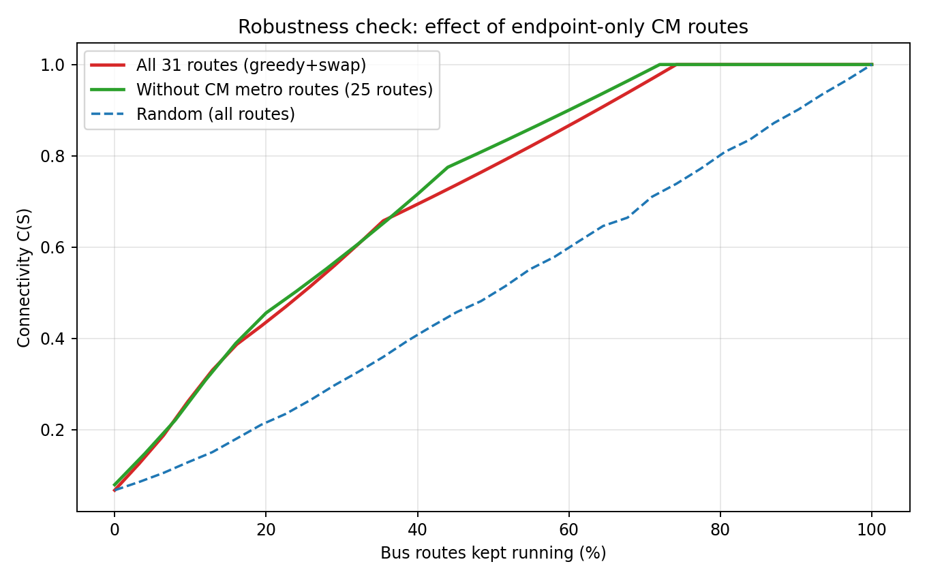
Figure 5. Robustness check: greedy + swap with and without the Metro Bus (CM) routes.

5.5 Optimality check for small budgets
To check how close greedy is to the optimum, all subsets of k routes were evaluated exhaustively for k = 1, …, 7 (up to 2,629,575 subsets for k = 7), for the full data and for the data without the CM routes. In every case the greedy value equals the exhaustive optimum (Table 7), so greedy is optimal for budgets of up to seven routes, about 23% of the 31 routes. For larger budgets exhaustive search is infeasible, and no optimality claim is made.
Table 7. Greedy versus exhaustive optimum for small budgets (connectivity C).
Budget k | Full data: greedy | Full data: exhaustive | No CM: greedy | No CM: exhaustive
1 | 0.1255 | 0.1255 | 0.1479 | 0.1479
2 | 0.1875 | 0.1875 | 0.2209 | 0.2209
3 | 0.2619 | 0.2619 | 0.3086 | 0.3086
4 | 0.3304 | 0.3304 | 0.3892 | 0.3892
5 | 0.3869 | 0.3869 | 0.4559 | 0.4559
6 | 0.4271 | 0.4271 | 0.5032 | 0.5032
7 | 0.4692 | 0.4692 | 0.5529 | 0.5529

6. Discussion

6.1 Interpretation of the findings
The results answer the research questions. For RQ1 and RQ2, selecting routes by their contribution to connectivity preserves substantially more of the network than selecting them at random or by length: the gap is largest at moderate budgets (25–70% of routes), which is exactly the range reported during the 2022 and 2026 shortages [9], [10]. For RQ3, a small number of routes carry disproportionate structural importance, and they pass through two hubs, Nugegoda and Maharagama. This matches the finding of Li et al. [6] that structural, high-connectivity routes should be protected, and the observation of Cicchini et al. [1] that high-betweenness routes bridge the core and the periphery. For RQ4, the conclusions do not depend on the endpoint-only CM routes.
Roughly a quarter of the bus routes (8 of 31) are redundant for reachability once the others and the trains are running. This does not mean they are useless, since they may add capacity, frequency and shorter journeys, but it shows where fuel can be saved with no loss of reachability, and it identifies routes whose suspension would hurt most. A planner could use the greedy order as a priority list: protect the first routes selected and suspend the last ones first.
Two further checks support greedy as a method. For budgets of up to seven routes, exhaustive search found no better set than greedy in either dataset (Section 5.5). And the centrality-first baseline, which follows the ranking logic of route-attack studies [1], preserves less connectivity than greedy at every intermediate budget, so knowing which routes are central is useful but not sufficient: the planner must also account for the overlap between routes.

6.2 Significance
The study turns a recurring Sri Lankan problem into a precise graph problem with a transparent measure of success. It differs from attack studies [1], [3] by taking the planner’s viewpoint, from the downsizing model of [2] by selecting routes directly and by using a supply shock with a fixed train backbone, and from earlier Sri Lankan work [4], [5] by addressing service reduction in a bus–train network. The method needs only route sequences, which are far easier to obtain than origin–destination matrices.

6.3 Limitations
- Data quality. Routes were compiled from public web pages at the town level, some listings are incomplete, and whether each route is currently running was not verified. The Metro Bus routes are endpoints-only, some intermediate towns and train stations were placed from general geography, and the 2017 parliamentary data for routes 117 and 192 are old. Results show the method working on real structure, not an operational plan.
- Measure. Connectivity counts whether two stops can reach each other, with no weight for demand, travel time, frequency, transfers or capacity. A route that serves a handful of people but links an isolated stop scores as much as one serving thousands.
- Budget definition. The budget is a number of routes. Fuel use actually depends on bus-kilometres and frequency, so long routes use more fuel than short ones.
- Heuristic. Greedy and swap search give good solutions, and exhaustive search confirms that greedy is optimal for budgets of up to seven routes, but there is no optimality proof for larger budgets; C is not submodular (Proposition 2), so no approximation guarantee is available.
- Scope. The network covers part of the Colombo region and does not include the whole Western Province or long-distance services.

7. Conclusion and Future Work
This report formulated the budgeted route-selection problem for a bus–train network in which trains keep running, and studied it on a 64-stop, 31-route network of the Colombo area. Greedy selection preserved 79.2% of stop-pair connectivity with half of the bus routes running, compared with 58.3% for a length heuristic and 51.5% for random choice, and preserved full connectivity with 23 of 31 routes. Routes 138 and 212/341 and the hubs Nugegoda and Maharagama were identified as structurally critical, and the findings were robust to removing the endpoint-only routes. Exhaustive search confirmed that greedy is optimal for every budget of up to seven routes.
Future work can improve the model in several directions:
- Demand-weighted objective. Replace pair counts by origin–destination demand, or by the number of people who can still reach the Fort/Pettah centre.
- Fuel-based budget. Use route length and frequency to define fuel use, giving a knapsack-type integer linear programme with route variables yᵣ ∈ {0, 1} and a budget Σ fuelᵣ yᵣ ≤ F.
- Travel time and transfers. Measure average shortest travel time or the number of transfers instead of reachability, in the spirit of [2] and [6].
- Exact methods and bounds. Develop an ILP or branch-and-bound formulation to certify how close greedy is to optimal beyond the seven-route budgets checked here, and test whether BRS is NP-hard.
- Better data. Verify which routes run today with the National Transport Commission or operator timetables, include stop-level data and frequencies, and add the Metro Bus routes’ intermediate stops.
- Equity. Add population or vulnerable-group weights so that cuts do not isolate poorer or peripheral areas, as emphasised in [6].

References
[1] Cicchini, T., Caridi, I., & Ermann, L. (2024). Robustness of the public transport network against attacks on its routes. arXiv:2409.12460.
[2] Guillot, M., Furno, A., Aghezzaf, E.-H., & El Faouzi, N.-E. (2022). Transport network downsizing based on optimal sub-network. Communications in Transportation Research, 2, 100079. https://doi.org/10.1016/j.commtr.2022.100079
[3] Shao, Z., Zhang, Y., & Li, K. (2026). Robustness analysis and optimization strategy of urban bus network based on complex network. Sustainability, 18(12), 6320. https://doi.org/10.3390/su18126320
[4] Rajapaksha, R. W. K. T., Lanel, G. J., Athapattu, A. M. C. U. M., & Sanjeewa, R. (2026). Multiplex centrality-driven analysis for enhancing urban transport resilience and infrastructure planning. Ceylon Journal of Science, 55(4), 1224–1237. https://doi.org/10.4038/cjs.v55i4.9482
[5] Kalpana, L. D. C. H. N., Jayasinghe, A. B., & Abenayake, C. C. (2020). Network centrality assessment (NCA): Assessing the transport networks’ resilience for urban flooding [Abstract]. In Proceedings of the 5th International Conference on Research for Transport and Logistics Industry (p. 4). Sri Lanka Society of Transport and Logistics.
[6] Li, Q., Yang, X., & Zhou, S. (2025). Exploring dissatisfaction in bus route reduction through LLM-calibrated agent-based modeling. arXiv:2510.26163.
[7] Albert, R., Jeong, H., & Barabási, A.-L. (2000). Error and attack tolerance of complex networks. Nature, 406, 378–382.
[8] AFP. (2022, March 2). Sri Lanka runs out of fuel as dollar crisis worsens. Aaj News. https://english.aaj.tv/news/30280051/
[9] Marian, T. (2022, June 8). Passenger transport worst affected by fuel crisis. News 1st. https://www.newsfirst.lk/2022/06/08/passenger-transport-worst-affected-by-fuel-crisis/
[10] LPBOA warns of up to 50% reduction in bus services over fuel shortages. (2026, March 21). Ada Derana. https://www.adaderana.lk/news.php?nid=120050
[11] Waravita, P. (2024, August 4). Disappearing bus routes in Colombo. The Sunday Morning. https://www.themorning.lk/articles/1KDwxHdxbv0gXLKF8GfM
[12] Popular bus routes extinct. (2022, November 6). Sunday Observer. https://archives1.sundayobserver.lk/node/60817
[13] Farzan, Z. (2026, August 5). 7 new Metro Bus routes for Colombo travel. News 1st. https://newsfirst.lk/2026/08/05/7-new-metro-bus-routes-set-to-transform-colombo-transport
[14] Wikipedia contributors. Nugegoda; Maharagama; Homagama; Rukmale; Godagama; Battaramulla; Fort railway station. Wikipedia, The Free Encyclopedia. https://en.wikipedia.org (accessed October 2026).
[15] Department of Immigration and Emigration, Sri Lanka. Location: directions by road to Battaramulla. https://www.immigration.gov.lk/pages_e.php?id=29 (accessed October 2026).
[16] Parliament of Sri Lanka. (2017, August 11). Question 1122/2017 (1122/’16), asked by C. Wijesiri to the Minister of Transport and Civil Aviation: Route Nos. 103, 144, 117 and 192: Plying of SLTB buses. https://www.parliament.lk/en/business-of-parliament/parliamentary-questions/details/7687/1122 https://www.parliament.lk/en/business-of-parliament/parliamentary-questions/details/7687/1122
[17] Hagberg, A. A., Schult, D. A., & Swart, P. J. (2008). Exploring network structure, dynamics, and function using NetworkX. In Proceedings of the 7th Python in Science Conference (SciPy 2008), 11–15.
[18] Latora, V., & Marchiori, M. (2002). Is the Boston subway a small-world network? Physica A: Statistical Mechanics and its Applications, 314(1–4), 109–113. https://doi.org/10.1016/S0378-4371(02)01089-0
[19] Sen, P., Dasgupta, S., Chatterjee, A., Sreeram, P. A., Mukherjee, G., & Manna, S. S. (2003). Small-world properties of the Indian railway network. Physical Review E, 67(3), 036106. https://doi.org/10.1103/PhysRevE.67.036106
[20] von Ferber, C., Holovatch, T., Holovatch, Yu., & Palchykov, V. (2009). Public transport networks: Empirical analysis and modeling. The European Physical Journal B, 68(2), 261–275. https://doi.org/10.1140/epjb/e2009-00090-x
[21] Derrible, S., & Kennedy, C. (2010). The complexity and robustness of metro networks. Physica A: Statistical Mechanics and its Applications, 389(17), 3678–3691. https://doi.org/10.1016/j.physa.2010.04.008

Appendix A. Route data used in the analysis
Stops are towns or junctions listed in the order served. Train lines (T) are always running. CM routes are express services with published endpoints only (CM06 omitted).
Type | Route | Stops in order
Train | Coastal | Fort – Kollupitiya – Bambalapitiya – Wellawatte – Dehiwala – MtLavinia – Ratmalana – Moratuwa – Panadura
Train | KV | Fort – Nugegoda – Pangiriwatte – Nawinna – Maharagama
Train | Main | Fort – Maradana – Dematagoda – Kelaniya – Ragama
Bus | 17 | Panadura – Moratuwa – Ratmalana – Dehiwala – Nugegoda – Kotte – Battaramulla
Bus | 103 | Borella – Narahenpita
Bus | 117 | Nugegoda – Pepiliyana – Attidiya – Ratmalana
Bus | 119 | Nugegoda – JubileePost – Embuldeniya – Maharagama
Bus | 124 | Maharagama – Godagama – Homagama – IhalaBope
Bus | 138 | Homagama – Kottawa – Maharagama – Nugegoda – Kirulapana – Thummulla – SlaveIsland – Fort – Pettah
Bus | 144 | Rajagiriya – Fort
Bus | 163 | Dehiwala – Nugegoda – Pagoda – Kotte – Battaramulla
Bus | 170 | Athurugiriya – Battaramulla – Borella – TownHall – Pettah
Bus | 171 | Pelawatta – Battaramulla – Rajagiriya – Borella – Fort
Bus | 174 | Kottawa – Thalawathugoda – Battaramulla – Borella
Bus | 177 | Kaduwela – Battaramulla – Borella – Kollupitiya
Bus | 183 | Nugegoda – Kalubowila – Dehiwala – Moratuwa – Panadura
Bus | 190 | Meegoda – Godagama – Battaramulla – Borella – TownHall – Pettah
Bus | 192 | Moratuwa – Maharagama
Bus | 308 | Maharagama – Niyandagala – Kottawa – Homagama
Bus | 313 | Homagama – Kottawa – Maharagama – Kohuwala – Kalubowila
Bus | 376 | Kottawa – Rukmale – Malabe
Bus | 689 | Nugegoda – Udahamulla – Madiwela – Thalawathugoda – Hokandara
Bus | 690 | Nugegoda – JubileePost – Embuldeniya – Madiwela – Kimbulawala – JayawardenepuraHospital
Bus | 992 | Nugegoda – Maharagama – Pannipitiya – Athurugiriya
Bus | 212/341 | Nugegoda – Maharagama – Pannipitiya – Erawwala – Makuludoowa – Bokundara
Bus | 128/1 | Maharagama – Homagama – Munamalewatta
Bus | Mhg-Dehiwala | Maharagama – Boralesgamuwa – Bellanwila – Dehiwala
Bus | Mhg-Ratmalana | Maharagama – Borupana – Ratmalana
Metro Bus | CM01 | Makumbura – Pettah – Fort
Metro Bus | CM02 | MillenniumCity – Fort
Metro Bus | CM03 | Kadawatha – Makumbura
Metro Bus | CM04 | Dematagoda – Panadura
Metro Bus | CM05 | Battaramulla – Ekala
Metro Bus | CM08 | Kesbewa – Pettah

Appendix B. Algorithm summary
Greedy selection. Input: set B of bus routes, train set T, budget k. Output: S with |S| ≤ k.
- Set S ← ∅.
- While |S| < k: for each route r in B \ S compute C(S ∪ {r}); choose r with the largest value; set S ← S ∪ {r}.
- Return S.
Swap improvement. Starting from S: while there exist a ∈ S and b ∈ B \ S with C((S \ {a}) ∪ {b}) > C(S), replace a by b. Stop when no improving swap exists.

