Micro Project: 3-DOF Robotic Manipulator
Kinematic Modeling, Forward Kinematics Formulation & 3D Simulation
Project Title: | 3-DOF Revolute Robotic Manipulator (RRR)
Group Members: | 1. [Student Name 1] - [Roll Number / ID]  2. [Student Name 2] - [Roll Number / ID]  3. [Student Name 3] - [Roll Number / ID]
Department: | [Department Name, e.g., Mechanical / Robotics / Mechatronics]
Institution: | [College / University Name]
Academic Year: | 2025 - 2026

1. Algorithm (Pseudo-code)

The following step-by-step logic defines the geometric initialization, kinematic transformation pipeline, and 3D simulation of the 3-DOF articulated manipulator:
Step 1: Link Parameter Definition
Define the physical link dimensions: Base height L1, Upper arm length L2, and Forearm length L3 in meters.
Step 2: DH Parameter Formulation
Assign Standard Denavit-Hartenberg parameters for each link:
• Link 1: d = L1, a = 0, alpha = +pi/2
• Link 2: d = 0, a = L2, alpha = 0
• Link 3: d = 0, a = L3, alpha = 0
Step 3: Robot Assembly
Instantiate RevoluteDH joint objects and assemble the serial-link DHRobot model.
Step 4: Input Joint Angles
Acquire joint variables q1, q2, and q3 in degrees and convert them into radians.
Step 5: Homogeneous Transformation Calculation
Compute the individual link transformation matrices A1, A2, and A3, and evaluate the composite end-effector transformation matrix:
T_0_3 = A1 * A2 * A3
Step 6: End-Effector Position Extraction
Extract the translational coordinates (X, Y, Z) from the fourth column of matrix T_0_3:
X = cos(q1) * [L2 * cos(q2) + L3 * cos(q2 + q3)]
Y = sin(q1) * [L2 * cos(q2) + L3 * cos(q2 + q3)]
Z = L1 + L2 * sin(q2) + L3 * sin(q2 + q3)
Step 7: 3D Kinematic Plotting
Pass the joint angles to the robotics visualization environment to render the links, joint axes, and coordinate frames in 3D Euclidean space, and save the resulting graphical plot to file.
2. Program

Core Python implementation utilizing Peter Corke's Robotics Toolbox for forward kinematics calculation and 3D simulation:
import numpy as np
import roboticstoolbox as rtb
import matplotlib.pyplot as plt
class Manipulator3DOF:
def __init__(self, l1=0.5, l2=0.4, l3=0.3):
self.l1 = l1
self.l2 = l2
self.l3 = l3
self.link1 = rtb.RevoluteDH(d=self.l1, a=0.0, alpha=np.pi/2)
self.link2 = rtb.RevoluteDH(d=0.0, a=self.l2, alpha=0.0)
self.link3 = rtb.RevoluteDH(d=0.0, a=self.l3, alpha=0.0)
self.robot = rtb.DHRobot([self.link1, self.link2, self.link3], name="3DOF_Manipulator")
def forward_kinematics(self, q):
return self.robot.fkine(q)
def plot_arm(self, q, save_path=None):
self.robot.plot(q, backend="pyplot", block=False)
if save_path:
plt.savefig(save_path, dpi=300)
plt.close()
if __name__ == "__main__":
arm = Manipulator3DOF(l1=0.5, l2=0.4, l3=0.3)
test_angles = [
[0.0, 0.0, 0.0],
[30.0, 45.0, 30.0],
[-45.0, 60.0, -30.0]
]
for i, angles in enumerate(test_angles, 1):
q_rad = np.deg2rad(angles)
T = arm.forward_kinematics(q_rad)
pos = T.t
print(f"Test Configuration {i}:")
print(f"Joint Angles (deg): q1 = {angles[0]}, q2 = {angles[1]}, q3 = {angles[2]}")
print("Homogeneous Transformation Matrix:")
print(np.round(T.A, 4))
print(f"End-Effector Coordinates (m): X = {pos[0]:.4f}, Y = {pos[1]:.4f}, Z = {pos[2]:.4f}\n")
arm.plot_arm(np.deg2rad([30.0, 45.0, 30.0]), save_path="manipulator_3d_pose.png")
3. Result

The script was executed for three distinct joint angle test configurations to evaluate the spatial displacement of the end-effector:
Test Configuration 1:
Joint Angles (deg): q1 = 0.0, q2 = 0.0, q3 = 0.0
Homogeneous Transformation Matrix:
[[ 1. 0. 0. 0.7]
[ 0. 0. -1. 0. ]
[ 0. 1. 0. 0.5]
[ 0. 0. 0. 1. ]]
End-Effector Coordinates (m): X = 0.7000, Y = 0.0000, Z = 0.5000
Test Configuration 2:
Joint Angles (deg): q1 = 30.0, q2 = 45.0, q3 = 30.0
Homogeneous Transformation Matrix:
[[ 0.2241 -0.8365 0.5 0.3122]
[ 0.1294 -0.483 -0.866 0.1802]
[ 0.9659 0.2588 0. 1.0726]
[ 0. 0. 0. 1. ]]
End-Effector Coordinates (m): X = 0.3122, Y = 0.1802, Z = 1.0726
Test Configuration 3:
Joint Angles (deg): q1 = -45.0, q2 = 60.0, q3 = -30.0
Homogeneous Transformation Matrix:
[[ 0.6124 -0.3536 -0.7071 0.3251]
[-0.6124 0.3536 -0.7071 -0.3251]
[ 0.5 0.866 0. 0.9964]
[ 0. 0. 0. 1. ]]
End-Effector Coordinates (m): X = 0.3251, Y = -0.3251, Z = 0.9964

Table 1: Kinematic Comparison Across Configurations
Config | Joint Angles (q1, q2, q3) | X (m) | Y (m) | Z (m)
1 (Home) | [0.0°, 0.0°, 0.0°] | 0.7000 | 0.0000 | 0.5000
2 (Reach) | [30.0°, 45.0°, 30.0°] | 0.3122 | 0.1802 | 1.0726
3 (Pick) | [-45.0°, 60.0°, -30.0°] | 0.3251 | -0.3251 | 0.9964

3D Simulation Plot of the Manipulator (Configuration 2):

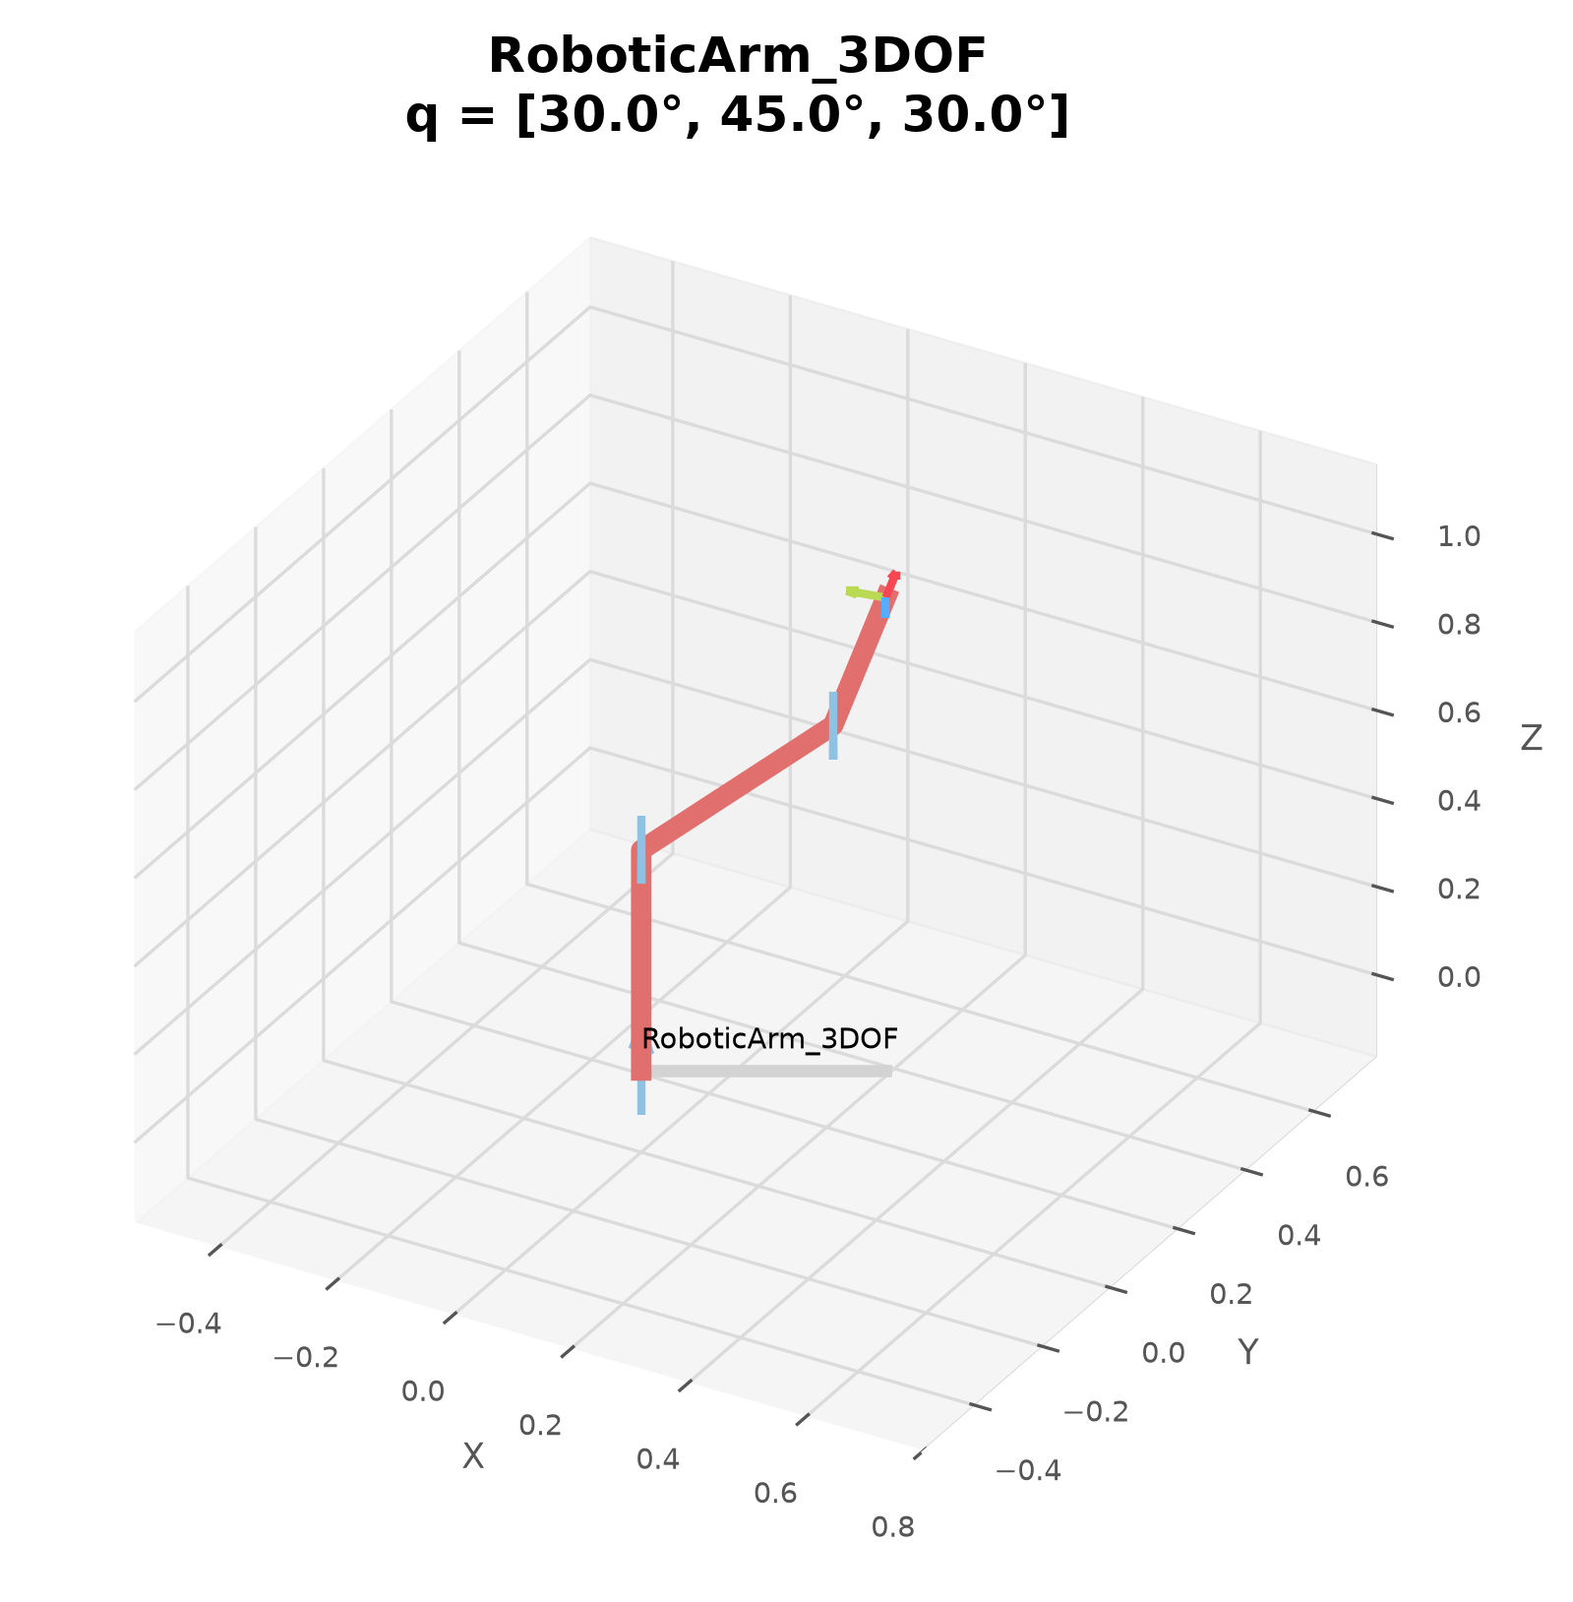
Figure 1: Generated 3D Robotic Manipulator Model at Joint Angles q = [30.0°, 45.0°, 30.0°]

