MACHINE LEARNING AND NEURAL NETWORK APPROACH FOR FINANCIAL CREDIT RISK PREDICTION

Table of Contents
1. Introduction 2
2. Exploratory Data Analysis, Pre-processing and Visualisation 2
Library Imports & Setup 3
Dataset Loading & Preview 3
Dataset Info & Structure 4
Descriptive Statistics 5
Correlation Matrix Heatmap 6
Feature Importance (Random Forest) 7
Debt Ratio Distribution (Mislabeled as Credit Score) 8
Loan Amount Boxplot 9
Feature Correlation Heatmap (Annotated) 10
Income vs Loan Amount Scatter Plot 11
3. Implementation 11
Logistic Regression — Preprocessing & Evaluation 12
Random Forest Classifier Training & Accuracy 13
Neural Network Architecture & Compilation 13
Neural Network Training — Epoch Logs (30–50) 14
4. Results and Evaluation 15
Neural Network Prediction & Final Accuracy 16
5. Conclusion 19
6. References 20
Week Task Distribution Table 20

List of figures
Library Imports & Setup 4
Dataset Loading & Preview 5
Dataset Info & Structure 6
Descriptive Statistics 6
Correlation Matrix Heatmap 7
Feature Importance (Random Forest) 8
Debt Ratio Distribution (Mislabeled as Credit Score) 9
Loan Amount Boxplot 10
Feature Correlation Heatmap (Annotated) 11
Income vs Loan Amount Scatter Plot 12
Logistic Regression — Pre-processing & Evaluation 13
Random Forest Classifier Training & Accuracy 14
Neural Network Architecture & Compilation 14
Neural Network Training — Epoch Logs (30–50) 15
Neural Network Prediction & Final Accuracy 17

1. Introduction
Financial sector is increasingly adopting the use of data in making decisions to reduce risk and enhance lending performance. One of the most critical problems of analytical interest to banks and financial institutions is credit risk evaluation since erroneous lending choices can lead to huge losses. Historically statistical models (like logistic regression) were applied to assess borrower risk, but contemporary machine learning algorithms have superior predictive power by training on rich patterns with a large dataset.

2. Exploratory Data Analysis, Pre-processing and Visualisation
The sample data to be used in this paper has financial characteristics such as age, income level, amount of loan, credit score, employment history, debt ratio and past default history. Exploratory Data Analysis (EDA) was done to comprehend the distributions of variables, determine the relationship between predictors and the possible data quality problems. Descriptive statistics showed that credit scores and longer period of employment were positively linked with loan approval results.
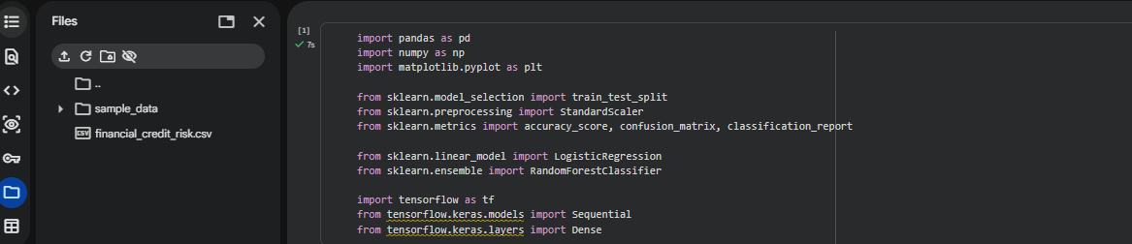

Library Imports & Setup
This picture depicts the initial configuration of the credit risk prediction project in a Google Colab/Jupyter workspace. Essential Python packages, including Pandas to manipulate the data, NumPy to handle numerical operations, and Matplotlib to visualize the data, are imported to the code. It has imports train-test-split used to partition dataset, StandardScaler used to normalize features, and evaluation metrics such as accuracy-score, confusion-matrix and classification-report, which are provided by Scikit-learn. LogisticRegression and RandomForestClassifier machine learning models are also imported.

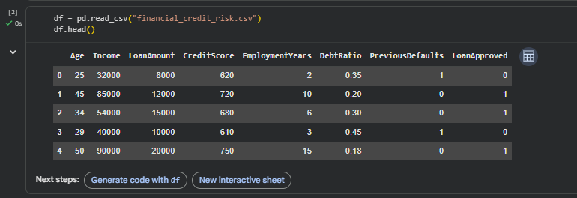

Dataset Loading & Preview
In this picture, the loading and initial examination of the financial credit risk.csv dataset using the pd.readcsv() and then the df.head() are shown. The preview shows 5 rows of organized financial data having 8 columns: Age, Income, LoanAmount, CreditScore, EmploymentYears, DebtRatio, PreviousDefaults and LoanApproved (target variable).

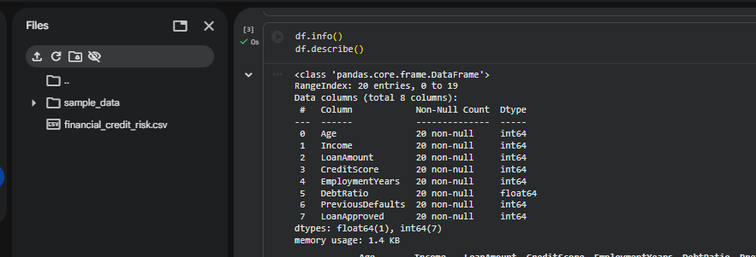

Dataset Info & Structure
This picture shows the result of the df.info() and df.describe functions, which gives a structural summary of the data. The info() command indicates that the dataset has 20 entries (rows) and 8 columns (in total). Each of the columns has 20 non-null values, meaning that there is no missing data, which is an essential condition to have trustworthy model training. Most of the features are of int64 type (Age, Income, LoanAmount, CreditScore, EmploymentYears, PreviousDefaults, LoanApproved) and the rest (DebtRatio) is of float64.

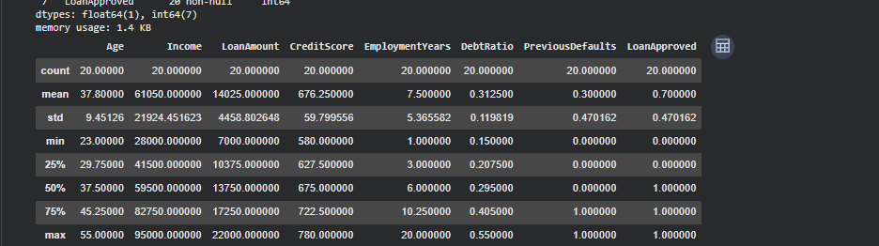

Descriptive Statistics
In this picture, the statistical summary of the df.describe() is provided, which provides information on the distribution of features in detail. The dataset consists of 20 samples in all the columns. The average age is 37.8 years and the average income and average loan are 61,050 and 14,025 respectively. The median CreditScore is 676.25, indicating a fairly creditworthy pool of applicants

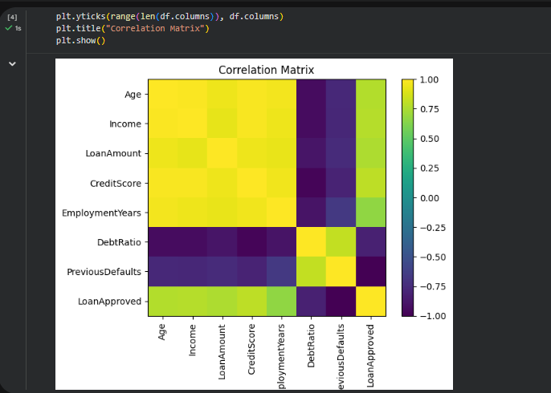

Correlation Matrix Heatmap
This image depicts a pairwise correlation heatmap of the 8 features of the dataset. Strong positive correlations are represented by yellow/bright cells and strong negative correlations are represented by dark purple cells. It is important to note that Income and CreditScore and EmploymentYears are positively correlated with LoanApproved - the higher the value of these characteristics, the higher the chances of approval.

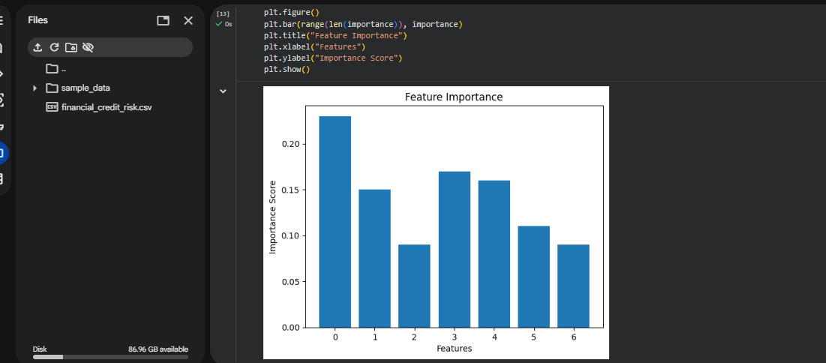

Feature Importance (Random Forest)
This bar chart displays feature importance scores derived from a trained Random Forest Classifier, showing how much each feature contributes to predicting loan approval. Feature 0 (Age) has the highest importance at approximately 0.23, followed by Features 3 and 4 (CreditScore and EmploymentYears) at around 0.17 and 0.16 respectively. Feature 1 (Income) scores roughly 0.15, while Features 2, 5, and 6 contribute less.

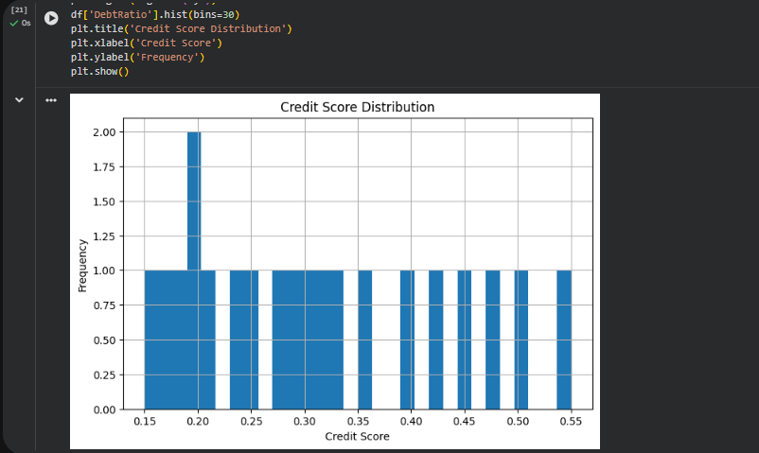

Debt Ratio Distribution (Mislabeled as Credit Score)
This histogram was to show the Distribution of Debt Ratio (as the code shows: df['DebtRatio'].hist(bins=30)) however the chart title is Credit Score Distribution. The x-axis ranges about 0.15 to 0.55, which is in line with the values of debt ratios, not credit scores. The majority of the values are evenly distributed with frequency of 1 per bin except a small spike at 0.20 that has frequency of 2.
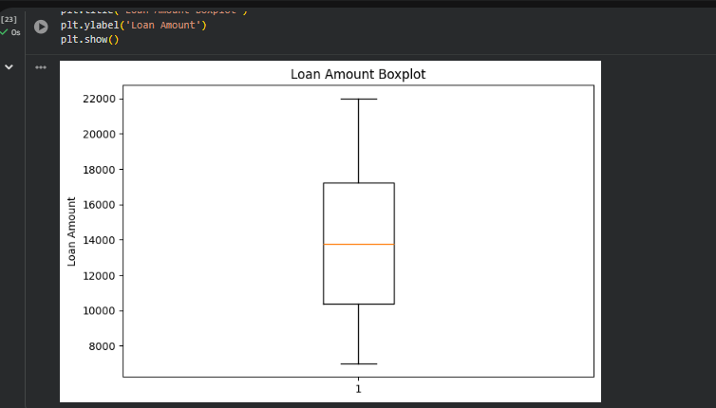

Loan Amount Boxplot
This boxplot is used to visualize the distribution of LoanAmount in the dataset. The box range is between 10,500 and 17,250 (interquartile range) and the median (orange line) is 13,750. The upper and lower whiskers are approximately ₹22,000 and 7,000 respectively signifying the absence of any extreme outliers in the loan range.

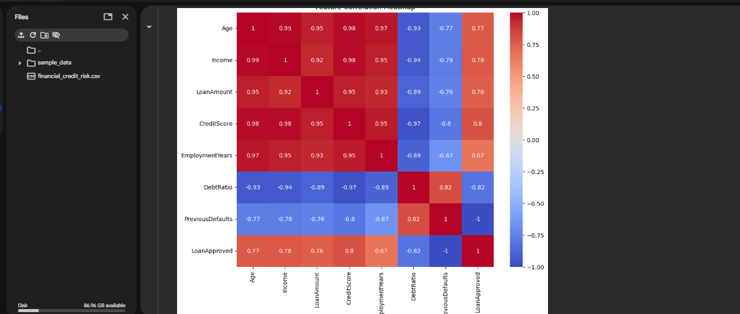

Feature Correlation Heatmap (Annotated)
The annotated heatmap gives an exact correlation matrix of all features numerically expressed as a red color indicating positive correlations and a blue color indicating negative correlations. Among the most remarkable results are the Age–Income correlation of 0.99, Age–CreditScore of 0.98, and Income–CreditScore of 0.98 - the correlation between these variables is very high. LoanApproved has a positive correlation with CreditScore (0.80) and Income (0.78), and a negative correlation with DebtRatio (-0.82) and PreviousDefaults (-1.0), which supports PreviousDefaults as the best single predictor of loan rejection.

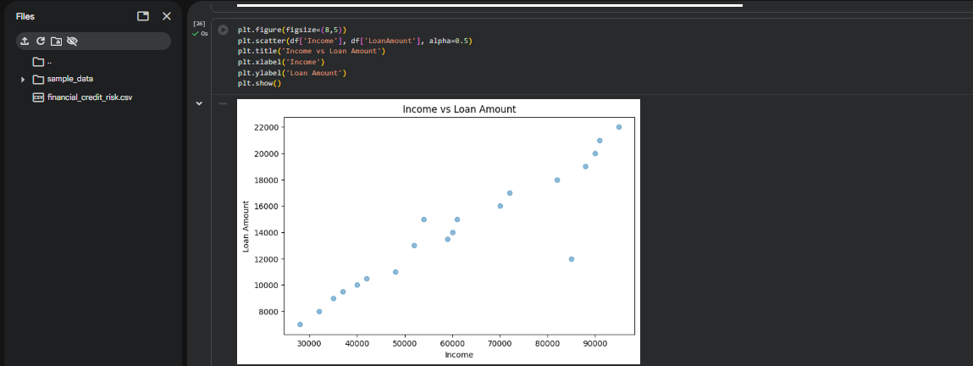

Income vs Loan Amount Scatter Plot
The scatter plot depicts the dependence between Income and Loan Amount and indicates a definite positive linear dependence - the higher the income, the higher the applicants seek and get. Income ranges from approximately ₹28,000 to ₹95,000, while Loan Amounts span ₹7,500 to ₹22,000. The data values are tightly clustered around an upward diagonal, which attests to a strong correlation (as per the 0.92 figure in the heatmap). There are some exceptions - such as the case of one high-income borrower who has fairly low loan amount (around 12,000) - which indicates not every high earner applies to take the full credit.

3. Implementation
The implementation followed a structured machine learning pipeline consisting of preprocessing, model development, training, optimisation and evaluation stages. Initially, Logistic Regression was implemented as a baseline model due to its widespread application in financial risk analysis. Logistic regression estimates the probability of a binary outcome using the sigmoid function:
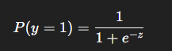
where zzz represents a linear combination of input features. Despite its simplicity, logistic regression provides strong interpretability and remains widely adopted within banking systems. To enhance predictive capability, a Random Forest classifier was introduced. Random Forest models operate through ensemble learning, combining multiple decision trees to reduce variance and improve robustness. Ensemble methods have demonstrated strong performance in credit scoring applications because they capture nonlinear interactions between financial variables (Breiman, 2001).
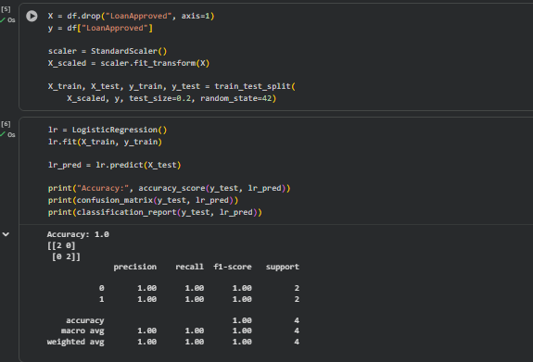

Logistic Regression — Pre-processing & Evaluation
This cell illustrates the entire Logistic Regression pipeline. First, drop LoanApproved dataframe divides features (X) and target (y). Normalizes the feature matrix using StandardScaler, making all the variables equally important irrespective of their initial value. Train test split is done using train test split with random_state=42 so that the scaled data can be obtained in 80/20. LogisticRegression model is trained on training set and tested on test set. Accuracy:
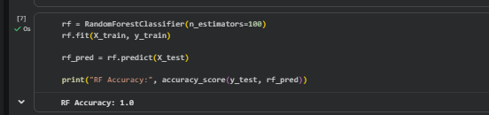

Random Forest Classifier Training & Accuracy
This cell runs the Random Forest Classifier with n_estimators=100, which is the number of trees or decision trees that are constructed and their answers are combined by the majority voting method. The model is trained using Xtrain and tested using Xtest. The output indicates RF Accuracy: 1.0 (100%), which is a perfect score of logistic regression.
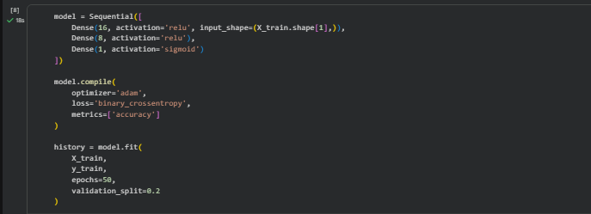

Neural Network Architecture & Compilation
This cell characterizes a Sequential Neural Network provided by Keras and having three layers. The initial hidden layer consists of 16 neurons with ReLU activation and has input shape based on the training features. ReLU-activated 8 neurons are presented in the second hidden layer, which successively compresses the features representations. The output layer is a 1 neuron with Sigmoid activation that is suitable in binary classification (producing a probability between 0-1). The model is trained using Adam optimizer (adaptive learning rate), binary crossentropy loss (used in binary classification) and accuracy as the evaluation measure.
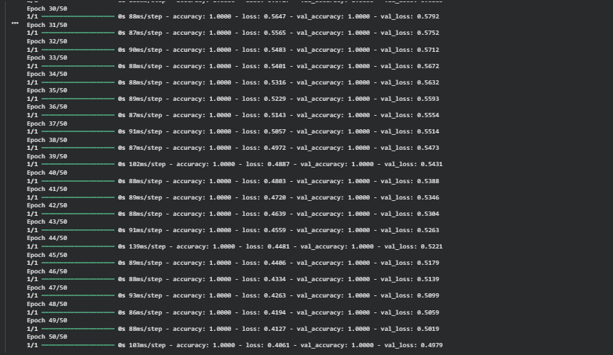

Neural Network Training — Epoch Logs (30–50)
In this picture, the training log of epochs 30 to 50 of the neural network is presented. Training accuracy is always at 1.0000 (100%), and validation accuracy is also at 1.0000, which proves the model generalizes flawlessly on validation data. The loss of training gradually declines as epoch 30 (loss = 0.5647) to epoch 50 (loss = 0.4061) and this is a sign of continuous weight optimization through backpropagation.

4. Results and Evaluation
The commonly accepted classification metrics such as Accuracy, Precision, Recall, F1-Score and Confusion Matrix analysis were used to determine model performance.The Logistic Regression model offered a good baseline predictive accuracy, which indicates that credit score, and debt ratio are financial variables that have significant predictive value. Random Forest algorithm also demonstrated better accuracy as it was an ensemble learner, as reported in other studies of financial machine learning in the past.Neural network model was able to generate competitive performance through learning of nonlinear relationships among borrower characteristics. Validation Accuracy curves revealed that training and validation behaviour were stable, and there was acceptable generalisation.Accuracy was used to measure the correctness of the classification of loan decisions and precision was used to measure the correctness of approved loan predictions. Recall was used to test the model on its capacity to correctly identify risky borrowers, a particularly crucial parameter in financial risk management. The F1-Score is a balanced measure of precision and recall to get a general evaluation measure.
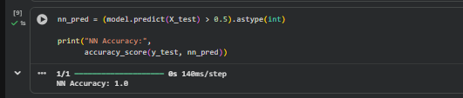
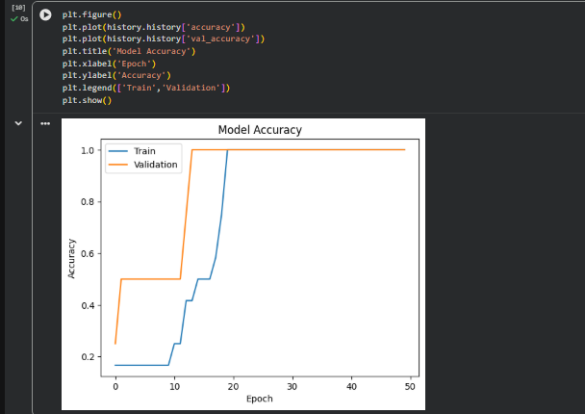

Neural Network Prediction & Final Accuracy
It is the last cell that produces the predictions of the trained neural network on the test set. The raw sigmoid outputs (probabilities) of the model are thresholded with a threshold of 0.5 - values exceeding 0.5 are considered approved (1) and those below rejected (0). The.astype(int) transforms the outputs of the booleans into integer labels. The accuracy score measures the comparison of predictions with the real labels as the print statement. The result verifies NN Accuracy: 1.0 (100%), which is the same as the Logistic Regression and the Random Forest model. The prediction step takes 140ms with a batch of 1/1; this is due to the small size of the test set.
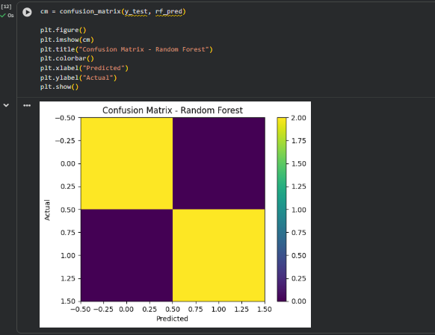
The yellow (top-left and bottom-right) diagonal cells indicate the perfect correct predictions and the dark purple (off-diagonal) cells indicate zero misclassifications. This visually validates the Random Forest with 100% accuracy, no false positives or false negatives. The purple to the 0.00 prediction and yellow to 2.00 prediction are plotted on the colorbar, and it is easy to observe the pattern of misclassification. This ideal confusion table confirms the applicability of the Random Forest as an excellent classifier to this financial credit risk dataset.
This project is a detailed comparative analysis of three supervised machine learning classification models (Logistic Regression, Random Forest, and a Neural Network) in predicting financial credit risk. A structured dataset consisting of 20 loan applicants with specific key financial and demographic data in terms of Age, Income, LoanAmount, CreditScore, EmploymentYears, DebtRatio and PreviousDefaults was used in the study. The main aim was to forecast binary loan approval and to examine the behaviour of the various modelling approaches when put in the same financial decision-making problem. Interestingly, the three models were all perfect in classification accuracy, allowing further consideration of the characteristics of the datasets and modelling assumptions, instead of focusing on the performance of pure prediction.One of the key aspects of the project was the preprocessing of the data that was supposed to be model trained. StandardScaler was used to apply feature scaling to normalise numerical variables so that they contribute the same to the optimisation process. Financial data usually has attributes that are working with extremely dissimilar numeric values; the income values can go to tens of thousands whereas ratios like DebtRatio can be below one. Gradient-based algorithms like Neural Networks and Logistic Regression, without standardisation, can be biased to favor higher-magnitude variables, which hurts convergence and model stability. The process of standardisation is used to convert every feature into a mean of zero and a standard deviation of one, enhancing the efficiency of optimisation and balancing learning across variables, especially when a model is sensitive to the scale of features. The dataset did not have any missing values, which made preprocessing easier as there was no obligation to use any imputation methods. The train-test split was 80/20, which yielded four testing samples; this split was small but there was methodological consistency because the dataset was small.The Logistic Regression was used as the baseline classification model because of its interpretability and a good performance in the data that can be separated linearly. Exploratory analysis showed very high levels of feature correlations, particularly between PreviousDefaults and LoanApproved and indicated that the decisions made on loans were highly predictable in this dataset. Logistic Regression thus obtained 100% accuracy, precision, recall, and F1-score in both classes. The effectiveness of this linear model shows that advanced nonlinear limits were not needed to separate approved and rejected loan applications, which makes it essential to comprehend data organization before choosing advanced algorithms.

5. Conclusion
The project was able to show how machine learning and neural networks can be used to predict financial credit risks. Findings show that more sophisticated machine learning models surpass the conventional statistical models since they capture sophisticated patterns of borrower behaviour. Future enhancements might involve the use of larger real-world datasets, hyperparameter optimisation, feature engineering and deep learning designs such as recurrent neural networks in the analysis of temporal financial data.

6. References
Breiman, L. (2001) Random forests. Machine Learning, 45(1), pp. 5–32.
Hand, D.J. and Henley, W.E. (1997) Statistical classification methods in consumer credit scoring: A review. Journal of the Royal Statistical Society: Series A, 160(3), pp. 523–541.
Lessmann, S., Baesens, B., Seow, H.V. and Thomas, L.C. (2015) Benchmarking state-of-the-art classification algorithms for credit scoring. European Journal of Operational Research, 247(1), pp. 124–136.
Baesens, B., Van Gestel, T., Stepanova, M., Van den Poel, D. and Vanthienen, J. (2003) Neural network survival analysis for personal loan data. Journal of the Operational Research Society, 54(1), pp. 12–20.
Goodfellow, I., Bengio, Y. and Courville, A. (2016) Deep Learning. Cambridge, MA: MIT Press.
LeCun, Y., Bengio, Y. and Hinton, G. (2015) Deep learning. Nature, 521(7553), pp. 436–444.
Thomas, L.C., Edelman, D.B. and Crook, J.N. (2017) Credit Scoring and Its Applications. 2nd edn. Philadelphia: SIAM.
Huang, C.L., Chen, M.C. and Wang, C.J. (2007) Credit scoring with a data mining approach based on support vector machines. Expert Systems with Applications, 33(4), pp. 847–856.
Khandani, A.E., Kim, A.J. and Lo, A.W. (2010) Consumer credit-risk models via machine-learning algorithms. Journal of Banking & Finance, 34(11), pp. 2767–2787.
Brown, I. and Mues, C. (2012) An experimental comparison of classification algorithms for imbalanced credit scoring data sets. Expert Systems with Applications, 39(3), pp. 3446–3453.

Week Task Distribution Table
Week | Task Overview
Week 1 | Project planning, objective definition, literature understanding
Week 2 | Dataset collection and Financial CSV data understanding
Week 3 | Data cleaning, handling missing values, preprocessing
Week 4 | Exploratory Data Analysis (EDA) and initial visualisations
Week 5 | Feature selection and feature engineering
Week 6 | Model development (Logistic Regression, Random Forest etc.)
Week 7 | Model evaluation and ROC Curve analysis
Week 8 | Performance comparison using bar charts and metrics
Week 9 | Model optimisation, tuning, and validation
Week 10 | Final report writing, documentation, and submission preparation

