AllowPush
1# Does the user allow push notifications? TRUE/FALSE
row = row + "," + str(len(install.access_data)>0)

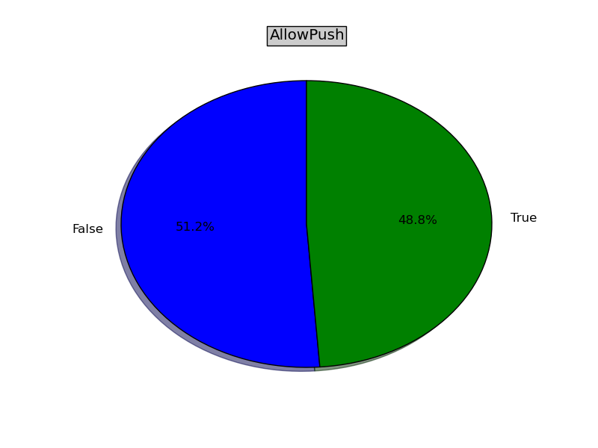
AdOptedIn
2 # Has the user opted in to Ad Targeting TRUE/FALSE
row = row + "," + str(len(install.advertising_identifier)>0)
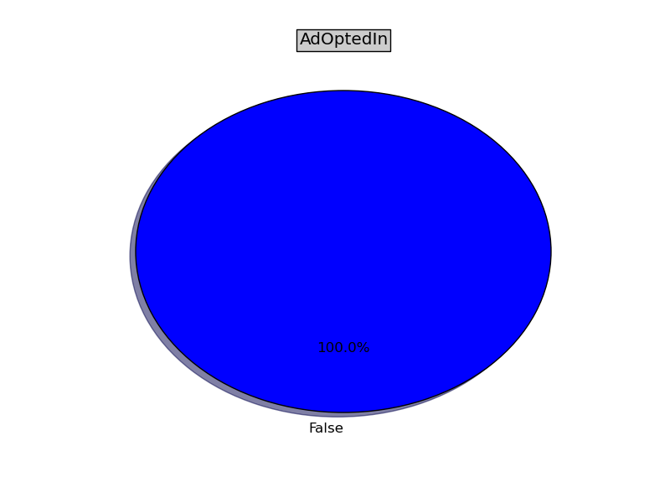
NumCampaignMatch
3# How many campaigns did this user match? INTEGER
row = row + "," + str(len(install.campaignmatch_set.all()))
Carrier
4# Name of Telco carrier for this user’s phone STRING
row = row + "," + str(install.carrier_name)
AppVersion
5# What version of the Customer App are they on? DOTTED NUMBER
row = row + "," + str(install.client_version)
StartDate
6# When did they start using the App DATETIME
row = row + "," + str(install.created)

AllowiBeacon
7# Do they allow iBeacons TRUE/FALSE
row = row + "," + str(install.feature_ibeacons)
AllowGeo
8# Do they allow Geolocation TRUE/FALSE
row = row + "," + str(install.feature_locations)
AllowFeaturePush
9# Do they allow push (different to access_data) TRUE/FALSE
row = row + "," + str(install.feature_push)
ScreenHeight
10# Screen Height INTEGER
row = row + "," + str(install.height)
AllowBT
11# Do they allow Bluetooth? TRUE/FALSE
row = row + "," + str(install.ibeacons)
HaveUniqueGlobalID
12# Do they have a unique GLOBAL identifier? TRUE/FALSE
row = row + "," + str(len(install.identifier_for_vendor)>0)
NumCrash
13# How many crashes did the user have? INTEGER
row = row + "," + str(len(install.installcrash_set.all()))
DailyUsage
14# Not sure this is useful. INTEGER
row = row + "," + str(len(install.installdailyusage_set.all()))
IP
15# IP Address. Probably useless. DOTTED NUMBER
row = row + "," + str(install.ipaddress)
LastUpdateDate
16# Date of Last Update by SDK (still operating) DATETIME
row = row + "," + str(install.last_seen)
# not included
# row = row + "," + str(install.latitude)
# row = row + "," + str(install.longitude)
17# Probably useless. We should be ignoring rows that <>’prod’ as they are developer tests TRUE/FALSE
row = row + "," + str(install.mode=='prod')
DeviceModel
18# User’s Device Model STRING
row = row + "," + str(install.model)
BlockPush
19# User has blocked push after initially accepting TRUE/FALSE (DATETIME)
row = row + "," + str(install.negative_feedback)
OS
20# Device Operating system STRING
row = row + "," + str(install.operating_system)
OSVersion
21# Device Operating system version DOTTED NUMBER
row = row + "," + str(install.os_version)
RevokePush
22# Push Token revoked TRUE/FALSE (DATETIME)
row = row + "," + str(install.revoked)
SignIn
23# User has signed in TRUE/FALSE
row = row + "," + str(len(install.sh_cuid)>0)
24# Ignore TRUE/FALSE
row = row + "," + str(install.smart)
Uninstalled
25# Did the user remove this App TRUE/FALSE
row = row + "," + str(install.uninstalled)
ScreenWidth
26# Screen Width INTEGER
row = row + "," + str(install.width)
email_exists = str(len(install.installtag_set.filter(key='sh_email')[0].string)>0)
EmailExist
27# did the user give us their email TRUE/FALSE
row = row + "," + email_exists
if email_exists:
freemails = ['gmail.com', 'hotmail.com', 'live.com', 'yahoo.com','yahoo.co.uk']
EmailAddress
28# is the email address a “free” email address TRUE/FALSE
row = row + "," + str(install.tags.get('sh_email').split('@')[1] in freemails)
else:
row = row + ",FALSE"
InstallDays
29# age in days of App launch from App installation INTEGER
row = row + "," + str((install.installtag_set.filter(key='sh_app_launch')[0].datetime - install.installtag_set.filter(key='sh_first_run')[0].datetime).days)
PushCount
30# How many push has this user received INTEGER
row = row + "," + str(install.tags.get('sh_push_count'))
Timezone
31# what timezone is the user in INTEGER
row = row + "," + str(install.tags.get('sh_utc_offset'))
SDK
32# what SDK version - probably irrelevant DOTTED NUMBER
row = row + "," + install.tags.get('sh_version')
UserType
33# is the user a “free” or “paid” user STRING
row = row + "," + install.tags.get('user_type',"Free")
Questions
34# How many question did the user answer? INTEGER
row = row + "," + str(int(install.tags.get('questions',0)))
CorrectQuestion
35# How many question did the user get correct? INTEGER
row = row + "," + str(int(install.tags.get('questions_correct',0)))

