**1. Which tool have you used for implement CI/CD?** Jenkins

**2. Any alternate tool do you know for CI/CD?** Bamboo/udeploy/teamcity/rfs

**3. What is continuos integration? What are the steps involved Jenkins?**

Git scm -- > compile -- > test -- > build -- > static code analysis -- > nexus -- > build failure send notification (CI)

**4. What type of jobs have you configured in jenkins?**

Free style,pipeline,maven project,multi branch pipe line,external job

**5. What are the types of jobs are available in Jenkins?**

Free style,pipeline,maven project,multi branch pipe line,external job

**6. What is the difference b/w freestyle and pipeline?**

Free style-🡪 everything through GUI

Pipeline --- > written in the syntax based

**7. What is pipeline? Purpose or why we are using pipeline?**

Pipeline is a user defined model of a CDCI/CD purpose

Using groovy script, parallel way ,sequential way we are using pipeline

**Stages**: pipeline project---software installations in another slaves,divide into the our work into pipeline,connecvting the remote server,software uninstallations.

**8. What is declarative pipeline?**

Starting with Pipeline syntax --- >

**9.what is the diff b/w declarative pipeline and script based pipeline?**

Declarative starts syntax with: pipeline

Script based pipeline starts syntax with : node

**10.what is pipeline syntax?**

Pipeline

Agent any

Stage

**11.what is master/slave architecture ? what is the use of master/slave?**

We don’t want to burden on master, so divide into the work to different slaves; we can run the same time like 2 or 3 job put in the crontab job parallelly…

**12. How many we can connect the slaves?**

Based on jenkins server

**13. How many ways to connect the slaves? 3 ways**

1.launch agent agents via ssh

2. launch agent via java Web start –Command On The Master(JNLP)

3.launch agent via execution of command on the master

**14. How to create a node?**

Manage Jenkins--- > manage nodes ---- > new node (node is nothing but slaves)

**15. How many ways we can provide security for your Jenkins server?**

**16.what is sonar qube? Have you configure? How you configure?**

Any unwanted variables declared, they did not used anywhere in project,

Unique connections is opened, it’s not closed properly,

Resources is taking more somewhere,

It’s Waste of Resources is going on..Those of the information it will gives to us, we can give the information on dash board to the developers

Fix the bug they will checking the code again once development is done

**Have you configure sonar qube tools? Yes**

1.sonar scanner --- > manage Jenkins--- > global tool configuaration

2.sonar server --- > sonar.properties (**In github-🡪 repository-🡪 sonar.properties)**

**17. what type of artifactory repository tool have you used?**

Nexus ,, jfrog,S3

Oss versions----free –not supporting tagging

S3---how much storage is used that much of amount paid

**18. Why we need the use artifcatory ? Purpose**

Create our own repository,

We can maintain multiple versions of delivery of our project, store all delivery projects stored into the backup

anybody wants deploy the previous build,bcoz current build is failure so take the backup of the **war** and deploy .

**war**: they want to used fixed versions of jar they will keep in one place these are the repository they will put into one place they will get the libraries into one place.every one use same type of libraries.

**18. How you declare a variable in pipeline?**

$mvnHome/bin/mvn

**19. What is DSL language?**

Domain specific language i.e groovy

They will use pipeline plug-in used the groovy in the pipeline what is the syntax used i.e called as a declarative way…

**Allow any type of scripts** ? Shell scripts,java code,declare variables ,shell,bash commands,shell commands any thing

**Q) What is upstream & downstream projects? What is the use of it? Which scenario you configure?**

Dependency for the one project with another project

Prev build result will depends on next project

Multiple projects build one by one …

**Q) if a have 10 repositories in github? How many jobs can configure ?**

10 jobs we can create

**Q)do you have experience to install Jenkins?**

Yes We can

**Q)have you configure jdk,maven,gradle-----etc?**

yes

manage Jenkins---- > configure sys --- > config all the servers config

Global tool configuration:--- > software’s are used in our application

**Q) In my environment I have different version for java implementation projects is there? How you configure multiple jdk’s?**

Add no.of multiple vesions of java like slave

Global tool config--- > JDK

Add JDK

Name & path of installation , add another jdk

**Q) how to take backup my Jenkins? complete server information( like configurations,plugins) which folder I want backup**

Plugin: thin backup plugin

**Q)what is Jenkins home directory?**

Var/lib/Jenkins

Usr..jenkins

**Q) How to deleted old builds automatically?**

Discard old builds

**Q) How to configure multiple environment deployment?**

General--- > This project is parameterized --- > add parameter

Q)What is the difference between Continuous Integration, Continuous Delivery, and Continuous Deployment?

**Continuous Integration:**

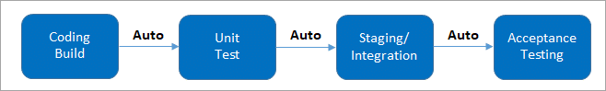

**Continuous Delivery:**

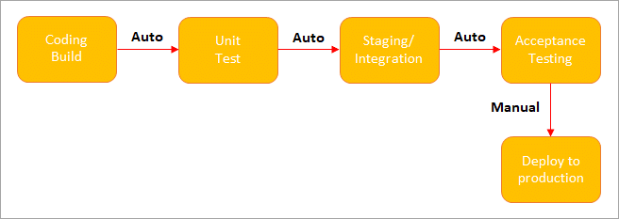

**(Manual Deployment to Production.**Does not involve every change to be deployed.**)**

**Continuous Deployment:**

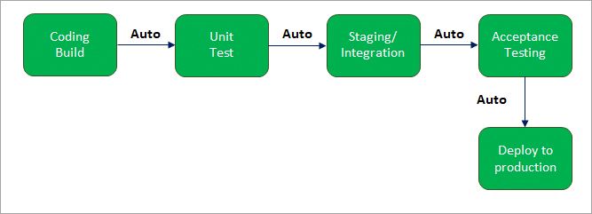

**(Automated Deployment to Production.**Involves every change to be deployed  
automatically.**)**

**Q ) What is Jenkins pipeline? What is a CI CD pipeline?**

**Answer:**The pipeline can be defined as the suite of **plugins which supports implementation** and integration of continuous delivery pipelines into Jenkins.

Continuous integration or continuous delivery **pipeline consists of build, deploy, test, release pipeline**. The pipeline **feature** saves a **lot of time and error in maintaining the builds**. Basically, a **pipeline is a group of build jobs** that are **chained and integrated in sequence.**

**Q ) What are Declarative Pipelines in Jenkins?**

pipeline {

agent any

stages {

stage(‘Build’) {

steps {

// Statements…

}

}

stage (‘Test’) {

steps {

// Statements…

}

}

}

}

**The above code has 3 major elements**

* **Pipeline:**The block of script contents.
* **Agent:** Defines where the pipeline will start running from.
* **Stage:** The pipelines contain several steps enclosed in the block called Stage.

**Q #33) How can you define a Continuous Delivery Workflow?**

