VISVESVARAYA TECHNOLOGICAL UNIVERSITY

“Jnana Sangama”, Machhe, Belagavi, Karnataka-590018

Lab Experiment Record
Project Management with Git [BCSL358C]
Submitted in partial fulfillment towards AEC of 3rd semester of

Bachelor of Engineering

in
Computer Science and Engineering
(Artificial Intelligence & Machine Learning)

Submitted by
SIRI PATEL M

4GW24CI047

DEPARTMENT OF CSE (Artificial Intelligence & Machine Learning)
GSSS INSTITUTE OF ENGINEERING & TECHNOLOGY FOR WOMEN

(Affiliated to VTU, Belagavi, Approved by AICTE, New Delhi & Govt. of Karnataka)
K.R.S ROAD, METAGALLI, MYSURU-570016, KARNATAKA
(Accredited by NAAC)
2025-2026

I
INDEX

SI No | Contents | Page No.
1. | Setting Up and Basic Commands | 1
2. | Creating and Managing Branches | 1-2
3. | Creating and Managing Branches | 3
4. | Collaboration and Remote Repositories | 4
5. | Collaboration and Remote Repositories | 4
6. | Collaboration and Remote Repositories | 5
7. | Git Tags and Releases | 6
8. | Advanced Git Operations | 7
9. | Analyzing and Changing Git History | 8
10. | Analyzing and Changing Git History | 9
11. | Analyzing and Changing Git History | 9
12. | Analyzing and Changing Git History | 9-10
 | Appendix | 11

BCSL358C Project management with Git
1.Setting Up and Basic commands
Initialize a new Git repository in a directory. Create a new file and add it to the staging area and commit the changes with an appropriate commit message.

-->First-Time Git Setup
git config --global user.name "username"
git config --global user.email "email"
git config --global init.defaultBranch main ->to set main as default branch

-->basic commands
1.initialize a new git repo -> git init
2.create a new file -> touch filename

-->To Open File
i.Using vim command
vim filename
i -> to insert line
esc
to save and exit to save without changes
type wq+enter q!+enter
Or :x+enter

ii.Using nano command
nano filename
ctrl+s -> to save
ctrl+x -> to exit

3.add it to the staging area -> git add filename Or git add.
4.commit changes --> git commit -m "message"

2.Creating and Managing branches
Create a new branch named "feature-branch." Switch to the "master" branch. Merge the "feature-branch" into "master."

git branch branchname -> creates branch
git checkout branchname Or git switch branchname -> switch btw branches
git branch -> list all the branches

-->merging branches ----------------------
if created along | branch -> new branch|
git checkout sourcebranch (same like main branch) ----------------------
git merge branch
if conflict -> open that file and resolve conflit
then merge again

if seperately created in same repo(created in Github and not present in local)
check if branch is there
try to merge, if not possible
git pull origin branch --allow-unrelated-histories
if conflict, resolve
git add .
git commit -m " " -> get message as "merged branch"
git push origin sourcebranch

Dept.of CSE(AI&ML), GSSSIETW, Mysuru Page 1

BCS358C Project Management with Git

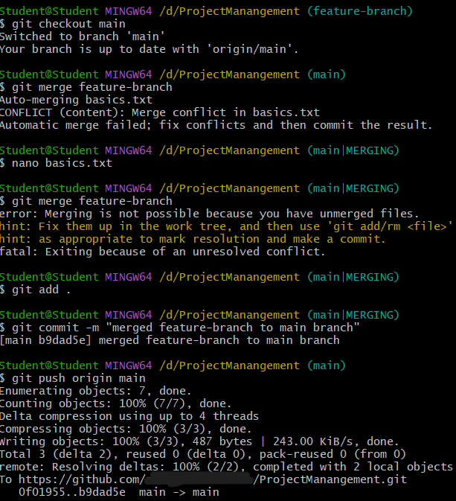

Dept.of CSE(AI&ML), GSSSIETW, Mysuru Page 2

BCS358C Project Management with Git
3.Creating and Managing Branches
Write the commands to stash your changes, switch branches, and then apply the stashed changes.

git stash list ->stash identifier/index, branch on which file is stashed, commit ID, commit message
git stash branch master stash{index} -> stores the changes into new branch master

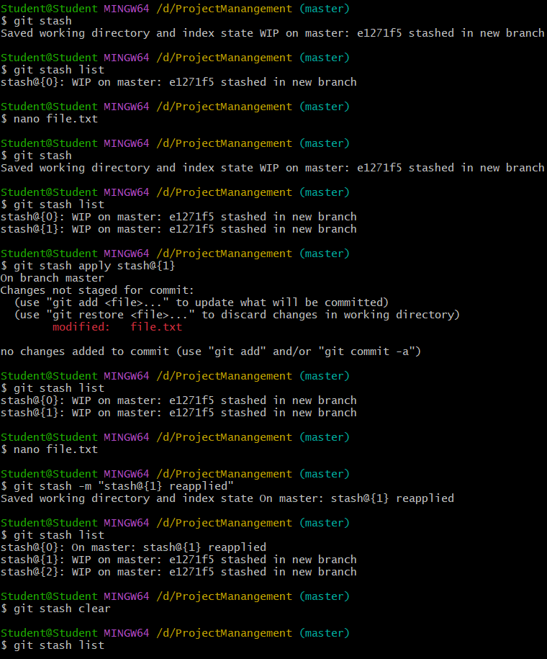

Dept.of CSE(AI&ML), GSSSIETW, Mysuru Page 3

BCS358C Project Management with Git
4.Collaboration and Remote repository
Clone a remote Git repository to your local machine
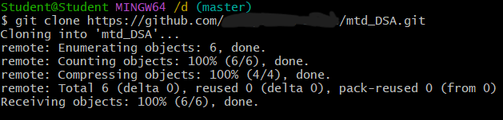
5.Collaboration and Remote repository
Fetch the latest changes from a remote repository and rebase your local branch onto the updated remote branch
To get the latest changes from default branch
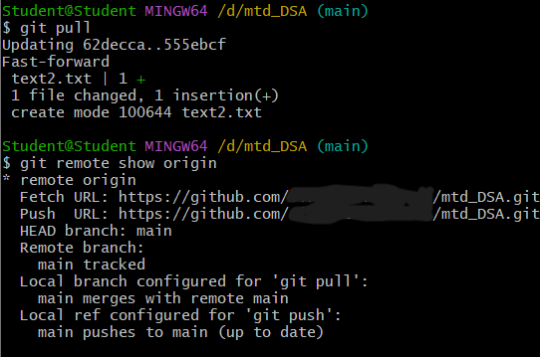
To get the changes from newly created branch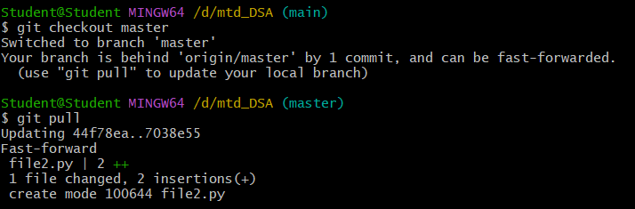
To do the same with fetch command
i. To get changes from default branch to local
git fetch origin (default branch)
git merge
Dept.of CSE(AI&ML), GSSSIETW, Mysuru Page 4

BCS358C Project Management with Git
ii. To get changes from different branch to local
git fetch origin-> downloads changes from git repo
git checkout (default branch)
git merge (different branch)
6.Collaboration and Remote repository
Write the command to merge “feature-branch” into “master” while providing a custom commit message for the merge.
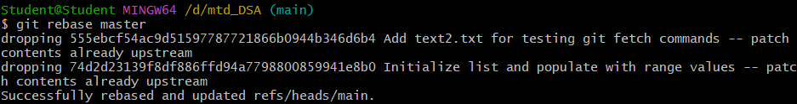
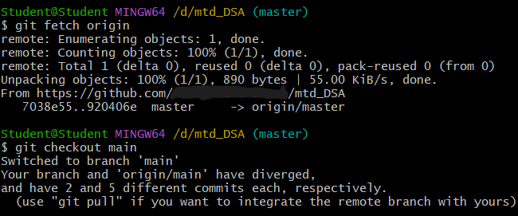

if conflict ->resolve conflict in the specified fil
if conflict -> resolve conflict in the specified file
git add <resolved-file>
git rebase –-continue

Dept.of CSE(AI&ML), GSSSIETW, Mysuru Page 5

BCS358C Project Management with Git
7.Git tags and releases
Write the command to create a lightweight Git tag named "v1.0" for a commit in your local repository.
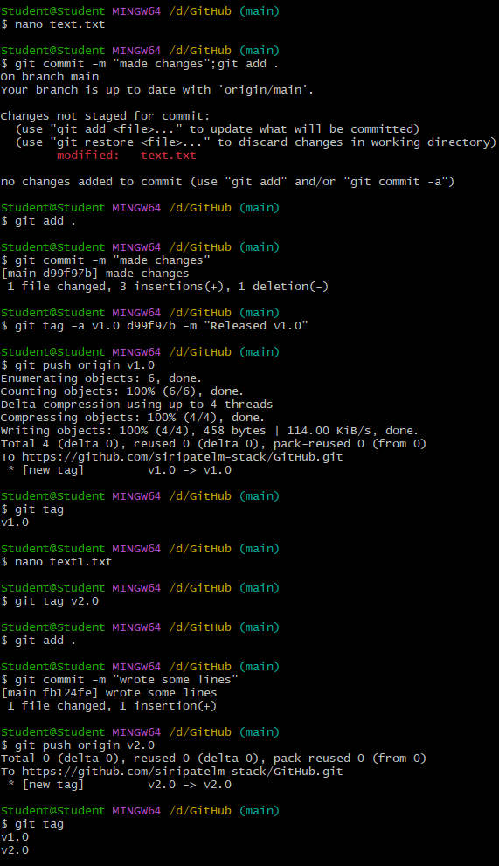
git tag v1.0 -> Create lightweight tag (current commit)
git tag v1.0 abc1234 -> Create lightweight tag (specific commit)
git tag -a v1.0 -m "Release version 1.0" -> Create annotated tag (with message)
git tag -a v1.0 abc1234 -m "Release v1.0"-> Create tag from specific commit with message
git tag -> lists existing tags

Dept.of CSE(AI&ML), GSSSIETW, Mysuru Page 6

BCS358C Project Management with Git
8.Advanced git operations
Write the command to cherry-pick a range of commits from "source-branch" to the current branch.

Git cherry-pick is a Git command that allows you to selectively apply individual commits from one branch to another branch. Unlike merge or rebase, which integrate entire branches, cherry-pick lets you hand-pick specific commits and replay them on top of your current branch.
git cherry-pick <commit-hash> -> Cherry-pick a single commit
git cherry-pick commit1 commit2 commit3 -> Cherry-pick multiple specific commits
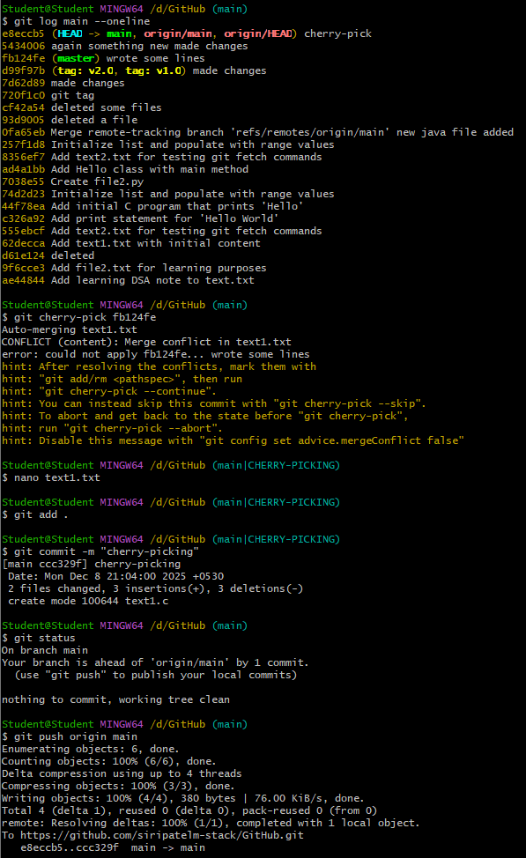

Dept.of CSE(AI&ML), GSSSIETW, Mysuru Page 7

BCS358C Project Management with Git
9.Analyzing and Changing Git History
Given a commit ID, how would you use Git to view the details of that specific commit, including the author, date, and commit message?

git log main –-oneline -> lists commit-hashes from latest to last
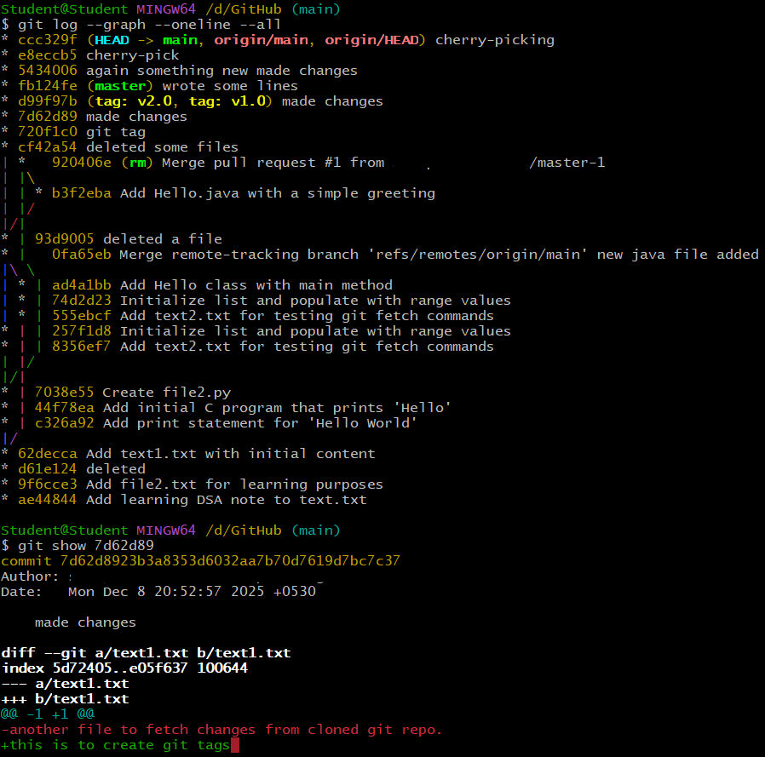
git cherry-pick<hash-commit> ->Pick any commit-hash and revisit the changes.

git log –-graph –-oneline --all -> shows the changes in graph
git show<commit-hash> -> List the changes made in specific commit-hash
git log -> to see commit history

Dept.of CSE(AI&ML), GSSSIETW, Mysuru Page 8

BCS358C Project Management with Git
10.Analysing and Changing Git History
Write the command to list all commits made by the author "JohnDoe" between "2023-01-01" and "2023-12-31."
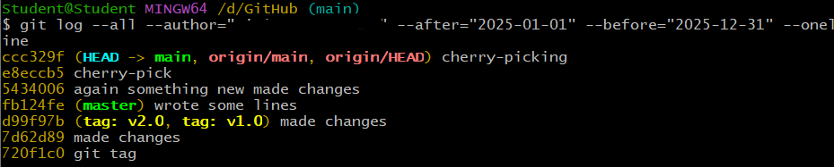
git log –-all -–author=”JohnDoe” –-after=”” –-before=”” –-oneline -> lists the history with commit-hash and commit message
git log --pretty=format:"%ad - %an: %s" --after="2023-01-01" --before="2023-12-31" --author="JohnDoe" -> lists the all the commit history in format
“day month date time year +timezone author :commit message”
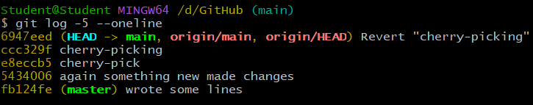
git log -5 -> to see last 5 commit history

11.Analysing and Changing Git History
Write the command to display the last five commits in the repository's history.
git log -5 -–oneline -> lists commit history in oneline

12.Analysing and Changing Git History
Write the command to undo the changes introduced by the commit with the ID "abc123".
git revert <commit hash> -> reverts changes from particular commit

Dept.of CSE(AI&ML), GSSSIETW, Mysuru Page 9

BCS358C Project Management with Git

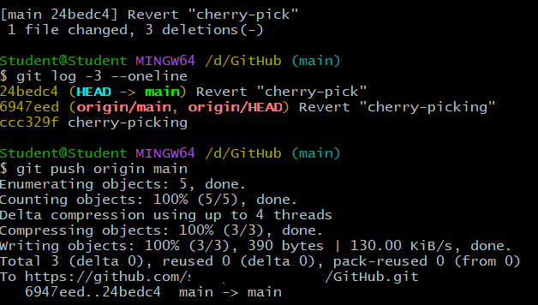

Dept.of CSE(AI&ML), GSSSIETW, Mysuru Page 10

BCS358C Project Management with Git
Repo link-
https://github.com/siripatelm-stack/4GW24CI047.git

Dept.of CSE(AI&ML), GSSSIETW, Mysuru Page 11

