ใบงานที่ 1
เรื่อง การทดลองวงจรมัลติเพลกเซอร์และวงจรดีมัลติเพลกเซอร์
(Multiplexer and Demultiplexer)

จัดทำโดย
นาย ศิริพงศ์ บุญประสิทธิ์
รหัส ENGCE200_SEC1

เสนอ
อาจารย์สมนึก สุระธง

ใบงานนี้เป็นส่วนหนึ่งของวิชา

ENGCE200
การออกแบบดิจิทัล
(Digital Systems Design)
หลักสูตร วศ.บ.วิศวกรรมคอมพิวเตอร์
สาขาวิศวกรรมไฟฟ้า คณะวิศวกรรมศาสตร์
มหาวิทยาลัยเทคโนโลยีราชมงคลล้านนา ภาคพายัพ เชียงใหม่
ภาคเรียนที่ 1 ปีการศึกษา 2568
ใบงานที่ 1
ชื่อบทเรียน การทดลองวงจรมัลติเพลกเซอร์และวงจรดีมัลติเพลกเซอร์
(Multiplexer and Demultiplexer)
จุดประสงค์การสอน
ปฏิบัติการทดลองสร้างวงจรคอมไบเนชันด้วยลอจิกเกตพื้นฐาน
ออกแบบและทดสอบวงจรมัลติเพล็กซ์
ออกแบบและทดสอบวงจรดีมัลติเพล็กซ์
1. ทฤษฎี
วิธีการออกแบบวงจรมัลติเพล็กซ์ (Multiplexer)
วิธีการออกแบบวงจรดีมัลติเพล็กซ์ (Demultiplexer)
2. จงออกแบบวงจรต่อไปนี้
1. วงจรมัลติเพล็กซ์ (16 : 1 Multiplexer)
2. วงจรดีมัลติเพล็กซ์ (1 : 16 Demultiplexer)
3. ผลการทดลอง
ทดลองโดยการนำ Output Multiplexer ต่อ เข้า Input Demultiplexer แล้วเลือก select อิสระ
4. สรุปผลการทดลอง
5. คำถามหลังการทดลอง
1. บอกหลักการทำงานวงจรมัลติเพล็กซ์
2. บอกหลักการทำงานวงจรดีมัลติเพล็กซ์
3. บอกวิธีการเชื่อมต่อทางไกลโดยสายส่งคู่เดียว

Multiplexer 16:1 logic
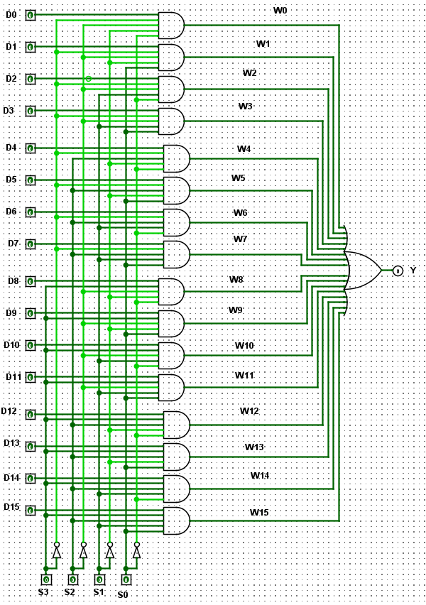
MUX16to1.vhdl
library IEEE;
use IEEE.STD_LOGIC_1164.all;

entity MUX16to1 is
port (
D : in std_logic_vector(15 downto 0);
S : in std_logic_vector(3 downto 0);
Y : out std_logic
);
end MUX16to1;

architecture GateLevel of MUX16to1 is

signal W : std_logic_vector(15 downto 0);

begin

W(0) <= D(0) and (not S(3)) and (not S(2)) and (not S(1)) and (not S(0));
W(1) <= D(1) and (not S(3)) and (not S(2)) and (not S(1)) and S(0);
W(2) <= D(2) and (not S(3)) and (not S(2)) and S(1) and (not S(0));
W(3) <= D(3) and (not S(3)) and (not S(2)) and S(1) and S(0);

W(4) <= D(4) and (not S(3)) and S(2) and (not S(1)) and (not S(0));
W(5) <= D(5) and (not S(3)) and S(2) and (not S(1)) and S(0);
W(6) <= D(6) and (not S(3)) and S(2) and S(1) and (not S(0));
W(7) <= D(7) and (not S(3)) and S(2) and S(1) and S(0);

W(8) <= D(8) and S(3) and (not S(2)) and (not S(1)) and (not S(0));
W(9) <= D(9) and S(3) and (not S(2)) and (not S(1)) and S(0);
W(10) <= D(10) and S(3) and (not S(2)) and S(1) and (not S(0));
W(11) <= D(11) and S(3) and (not S(2)) and S(1) and S(0);

W(12) <= D(12) and S(3) and S(2) and (not S(1)) and (not S(0));
W(13) <= D(13) and S(3) and S(2) and (not S(1)) and S(0);
W(14) <= D(14) and S(3) and S(2) and S(1) and (not S(0));
W(15) <= D(15) and S(3) and S(2) and S(1) and S(0);

Y <= W(0) or W(1) or W(2) or W(3) or
W(4) or W(5) or W(6) or W(7) or
W(8) or W(9) or W(10) or W(11) or
W(12) or W(13) or W(14) or W(15);

end GateLevel;

tb_MUX16to1.vhdl
library IEEE;
use IEEE.STD_LOGIC_1164.all;

entity tb_MUX16to1 is
end tb_MUX16to1;

architecture sim of tb_MUX16to1 is

signal D0 : std_logic := '0';
signal D1 : std_logic := '0';
signal D2 : std_logic := '0';
signal D3 : std_logic := '0';
signal D4 : std_logic := '0';
signal D5 : std_logic := '0';
signal D6 : std_logic := '0';
signal D7 : std_logic := '0';
signal D8 : std_logic := '0';
signal D9 : std_logic := '0';
signal D10 : std_logic := '0';
signal D11 : std_logic := '0';
signal D12 : std_logic := '0';
signal D13 : std_logic := '0';
signal D14 : std_logic := '0';
signal D15 : std_logic := '0';

signal D : std_logic_vector(15 downto 0);

signal S : std_logic_vector(3 downto 0);
signal Y : std_logic;

begin

D <= D15 & D14 & D13 & D12 &
D11 & D10 & D9 & D8 &
D7 & D6 & D5 & D4 &
D3 & D2 & D1 & D0;

uut : entity work.MUX16to1
port map
(
D => D,
S => S,
Y => Y
);

process
begin

D0 <= '1';
S <= "0000";
wait for 10 ns;
D0 <= '0';

D1 <= '1';
S <= "0001";
wait for 10 ns;
D1 <= '0';

D2 <= '1';
S <= "0010";
wait for 10 ns;
D2 <= '0';

D3 <= '1';
S <= "0011";
wait for 10 ns;
D3 <= '0';

D4 <= '1';
S <= "0100";
wait for 10 ns;
D4 <= '0';

D5 <= '1';
S <= "0101";
wait for 10 ns;
D5 <= '0';

D6 <= '1';
S <= "0110";
wait for 10 ns;
D6 <= '0';

D7 <= '1';
S <= "0111";
wait for 10 ns;
D7 <= '0';

D8 <= '1';
S <= "1000";
wait for 10 ns;
D8 <= '0';

D9 <= '1';
S <= "1001";
wait for 10 ns;
D9 <= '0';

D10 <= '1';
S <= "1010";
wait for 10 ns;
D10 <= '0';

D11 <= '1';
S <= "1011";
wait for 10 ns;
D11 <= '0';

D12 <= '1';
S <= "1100";
wait for 10 ns;
D12 <= '0';

D13 <= '1';
S <= "1101";
wait for 10 ns;
D13 <= '0';

D14 <= '1';
S <= "1110";
wait for 10 ns;
D14 <= '0';

D15 <= '1';
S <= "1111";
wait for 10 ns;
D15 <= '0';

wait;

end process;

end sim;

MUX16-1-wave.vcd
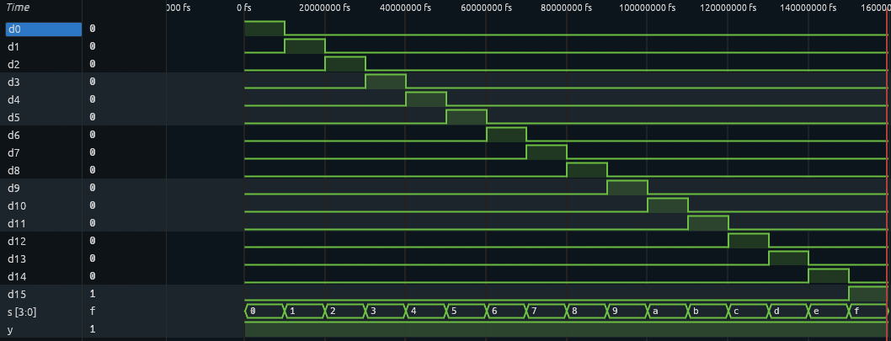

Demultiplexer 1:16 logic
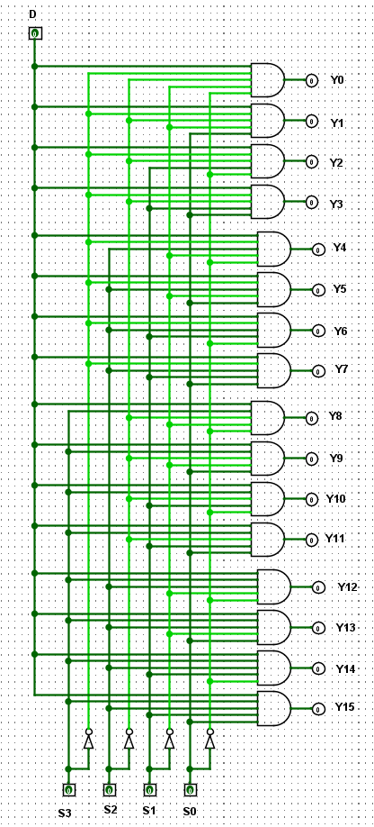
DMUX1to16.vhdl
library IEEE;
use IEEE.STD_LOGIC_1164.all;

entity DMUX1to16 is
port (
D : in std_logic;
S : in std_logic_vector(3 downto 0);
Y : out std_logic_vector(15 downto 0)
);
end DMUX1to16;

architecture GateLevel of DMUX1to16 is
begin

Y(0) <= D and (not S(3)) and (not S(2)) and (not S(1)) and (not S(0)); -- 0000
Y(1) <= D and (not S(3)) and (not S(2)) and (not S(1)) and S(0);
Y(2) <= D and (not S(3)) and (not S(2)) and S(1) and (not S(0));
Y(3) <= D and (not S(3)) and (not S(2)) and S(1) and S(0);

Y(4) <= D and (not S(3)) and S(2) and (not S(1)) and (not S(0));
Y(5) <= D and (not S(3)) and S(2) and (not S(1)) and S(0);
Y(6) <= D and (not S(3)) and S(2) and S(1) and (not S(0));
Y(7) <= D and (not S(3)) and S(2) and S(1) and S(0);

Y(8) <= D and S(3) and (not S(2)) and (not S(1)) and (not S(0));
Y(9) <= D and S(3) and (not S(2)) and (not S(1)) and S(0);
Y(10) <= D and S(3) and (not S(2)) and S(1) and (not S(0));
Y(11) <= D and S(3) and (not S(2)) and S(1) and S(0);

Y(12) <= D and S(3) and S(2) and (not S(1)) and (not S(0));
Y(13) <= D and S(3) and S(2) and (not S(1)) and S(0);
Y(14) <= D and S(3) and S(2) and S(1) and (not S(0));
Y(15) <= D and S(3) and S(2) and S(1) and S(0); -- 1111

end GateLevel;

tb_DMUX1to16.vhdl
library IEEE;
use IEEE.STD_LOGIC_1164.all;

entity tb_DMUX1to16 is
end tb_DMUX1to16;

architecture sim of tb_DMUX1to16 is

signal D : std_logic := '0';
signal S : std_logic_vector(3 downto 0);

signal Y : std_logic_vector(15 downto 0);

signal Y0 : std_logic;
signal Y1 : std_logic;
signal Y2 : std_logic;
signal Y3 : std_logic;
signal Y4 : std_logic;
signal Y5 : std_logic;
signal Y6 : std_logic;
signal Y7 : std_logic;
signal Y8 : std_logic;
signal Y9 : std_logic;
signal Y10 : std_logic;
signal Y11 : std_logic;
signal Y12 : std_logic;
signal Y13 : std_logic;
signal Y14 : std_logic;
signal Y15 : std_logic;

begin

uut : entity work.DMUX1to16
port map
(
D => D,
S => S,
Y => Y
);

Y0 <= Y(0);
Y1 <= Y(1);
Y2 <= Y(2);
Y3 <= Y(3);
Y4 <= Y(4);
Y5 <= Y(5);
Y6 <= Y(6);
Y7 <= Y(7);
Y8 <= Y(8);
Y9 <= Y(9);
Y10 <= Y(10);
Y11 <= Y(11);
Y12 <= Y(12);
Y13 <= Y(13);
Y14 <= Y(14);
Y15 <= Y(15);

process
begin

D <= '1';

S <= "0000";
wait for 10 ns;
S <= "0001";
wait for 10 ns;
S <= "0010";
wait for 10 ns;
S <= "0011";
wait for 10 ns;

S <= "0100";
wait for 10 ns;
S <= "0101";
wait for 10 ns;
S <= "0110";
wait for 10 ns;
S <= "0111";
wait for 10 ns;

S <= "1000";
wait for 10 ns;
S <= "1001";
wait for 10 ns;
S <= "1010";
wait for 10 ns;
S <= "1011";
wait for 10 ns;

S <= "1100";
wait for 10 ns;
S <= "1101";
wait for 10 ns;
S <= "1110";
wait for 10 ns;
S <= "1111";
wait for 10 ns;

D <= '0';

wait;

end process;

end sim;

DMUX1-16-wave.vcd
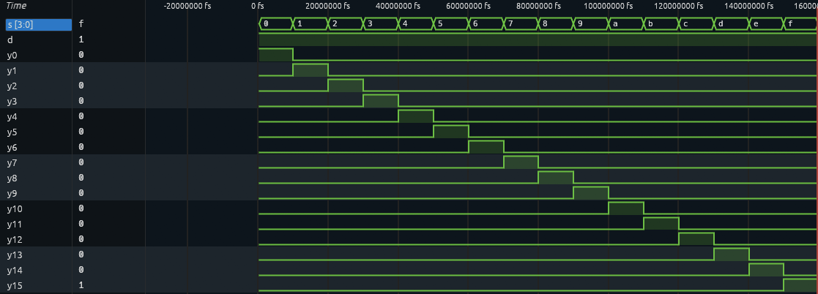

mux_dmux16 curcuit
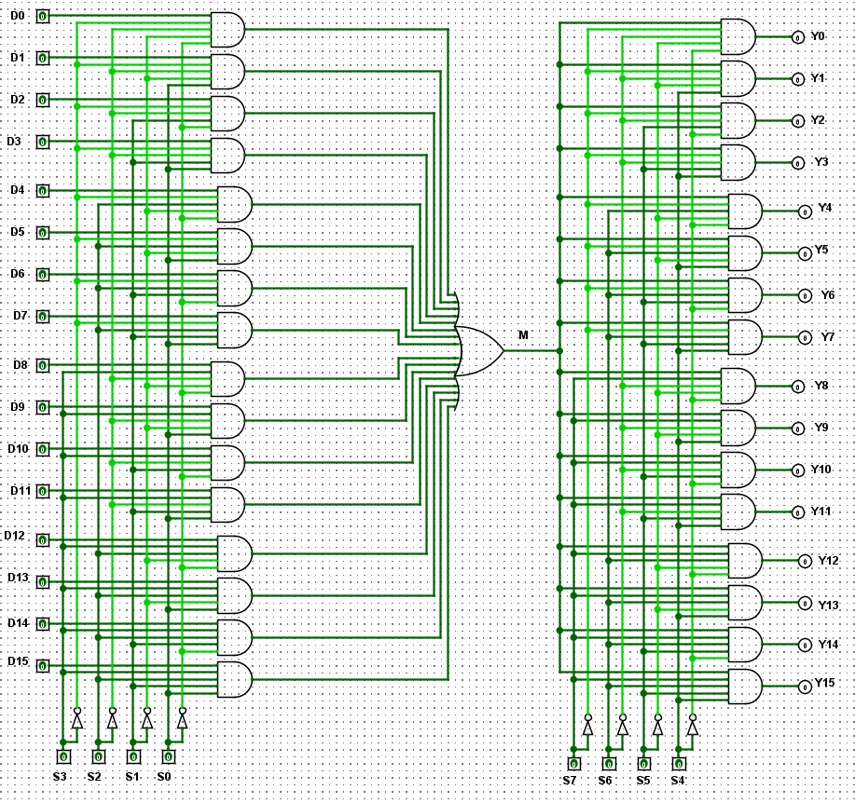

mux_dmux16.vhdl
library IEEE;
use IEEE.STD_LOGIC_1164.all;

entity mux_dmux16 is
port (
D : in std_logic_vector(15 downto 0);

S_MUX : in std_logic_vector(3 downto 0);
S_DMUX : in std_logic_vector(3 downto 0);

Y : out std_logic_vector(15 downto 0)
);
end mux_dmux16;

architecture Structural of mux_dmux16 is

signal M : std_logic;

begin

----------------------------------------------------------------
-- MUX 16:1
----------------------------------------------------------------

M <= (D(0) and not S_MUX(3) and not S_MUX(2) and not S_MUX(1) and not S_MUX(0))
or (D(1) and not S_MUX(3) and not S_MUX(2) and not S_MUX(1) and S_MUX(0))
or (D(2) and not S_MUX(3) and not S_MUX(2) and S_MUX(1) and not S_MUX(0))
or (D(3) and not S_MUX(3) and not S_MUX(2) and S_MUX(1) and S_MUX(0))

or (D(4) and not S_MUX(3) and S_MUX(2) and not S_MUX(1) and not S_MUX(0))
or (D(5) and not S_MUX(3) and S_MUX(2) and not S_MUX(1) and S_MUX(0))
or (D(6) and not S_MUX(3) and S_MUX(2) and S_MUX(1) and not S_MUX(0))
or (D(7) and not S_MUX(3) and S_MUX(2) and S_MUX(1) and S_MUX(0))

or (D(8) and S_MUX(3) and not S_MUX(2) and not S_MUX(1) and not S_MUX(0))
or (D(9) and S_MUX(3) and not S_MUX(2) and not S_MUX(1) and S_MUX(0))
or (D(10) and S_MUX(3) and not S_MUX(2) and S_MUX(1) and not S_MUX(0))
or (D(11) and S_MUX(3) and not S_MUX(2) and S_MUX(1) and S_MUX(0))

or (D(12) and S_MUX(3) and S_MUX(2) and not S_MUX(1) and not S_MUX(0))
or (D(13) and S_MUX(3) and S_MUX(2) and not S_MUX(1) and S_MUX(0))
or (D(14) and S_MUX(3) and S_MUX(2) and S_MUX(1) and not S_MUX(0))
or (D(15) and S_MUX(3) and S_MUX(2) and S_MUX(1) and S_MUX(0));

----------------------------------------------------------------
-- DMUX 1:16
----------------------------------------------------------------

Y(0) <= M and not S_DMUX(3) and not S_DMUX(2) and not S_DMUX(1) and not S_DMUX(0);
Y(1) <= M and not S_DMUX(3) and not S_DMUX(2) and not S_DMUX(1) and S_DMUX(0);
Y(2) <= M and not S_DMUX(3) and not S_DMUX(2) and S_DMUX(1) and not S_DMUX(0);
Y(3) <= M and not S_DMUX(3) and not S_DMUX(2) and S_DMUX(1) and S_DMUX(0);

Y(4) <= M and not S_DMUX(3) and S_DMUX(2) and not S_DMUX(1) and not S_DMUX(0);
Y(5) <= M and not S_DMUX(3) and S_DMUX(2) and not S_DMUX(1) and S_DMUX(0);
Y(6) <= M and not S_DMUX(3) and S_DMUX(2) and S_DMUX(1) and not S_DMUX(0);
Y(7) <= M and not S_DMUX(3) and S_DMUX(2) and S_DMUX(1) and S_DMUX(0);

Y(8) <= M and S_DMUX(3) and not S_DMUX(2) and not S_DMUX(1) and not S_DMUX(0);
Y(9) <= M and S_DMUX(3) and not S_DMUX(2) and not S_DMUX(1) and S_DMUX(0);
Y(10) <= M and S_DMUX(3) and not S_DMUX(2) and S_DMUX(1) and not S_DMUX(0);
Y(11) <= M and S_DMUX(3) and not S_DMUX(2) and S_DMUX(1) and S_DMUX(0);

Y(12) <= M and S_DMUX(3) and S_DMUX(2) and not S_DMUX(1) and not S_DMUX(0);
Y(13) <= M and S_DMUX(3) and S_DMUX(2) and not S_DMUX(1) and S_DMUX(0);
Y(14) <= M and S_DMUX(3) and S_DMUX(2) and S_DMUX(1) and not S_DMUX(0);
Y(15) <= M and S_DMUX(3) and S_DMUX(2) and S_DMUX(1) and S_DMUX(0);

end Structural;

tb_mux_dmux16.vhdl
library IEEE;
use IEEE.STD_LOGIC_1164.all;

entity tb_mux_dmux16 is
end tb_mux_dmux16;

architecture sim of tb_mux_dmux16 is

signal D : std_logic_vector(15 downto 0);

signal S_MUX : std_logic_vector(3 downto 0);
signal S_DMUX : std_logic_vector(3 downto 0);

signal Y : std_logic_vector(15 downto 0);

-- แตก D ออกเป็นรายเส้น
signal D0 : std_logic:= '0';
signal D1 : std_logic:= '0';
signal D2 : std_logic:= '0';
signal D3 : std_logic:= '0';
signal D4 : std_logic:= '0';
signal D5 : std_logic:= '0';
signal D6 : std_logic:= '0';
signal D7 : std_logic:= '0';
signal D8 : std_logic:= '0';
signal D9 : std_logic:= '0';
signal D10 : std_logic:= '0';
signal D11 : std_logic:= '0';
signal D12 : std_logic:= '0';
signal D13 : std_logic:= '0';
signal D14 : std_logic:= '0';
signal D15 : std_logic:= '0';

-- แตก Y ออกเป็นรายเส้น
signal Y0 : std_logic;
signal Y1 : std_logic;
signal Y2 : std_logic;
signal Y3 : std_logic;
signal Y4 : std_logic;
signal Y5 : std_logic;
signal Y6 : std_logic;
signal Y7 : std_logic;
signal Y8 : std_logic;
signal Y9 : std_logic;
signal Y10 : std_logic;
signal Y11 : std_logic;
signal Y12 : std_logic;
signal Y13 : std_logic;
signal Y14 : std_logic;
signal Y15 : std_logic;

begin

----------------------------------------------------------------
-- รวม D0-D15 เป็น Bus
----------------------------------------------------------------

D <= D15 & D14 & D13 & D12 &
D11 & D10 & D9 & D8 &
D7 & D6 & D5 & D4 &
D3 & D2 & D1 & D0;

----------------------------------------------------------------
-- แยก Y
----------------------------------------------------------------

Y0 <= Y(0);
Y1 <= Y(1);
Y2 <= Y(2);
Y3 <= Y(3);
Y4 <= Y(4);
Y5 <= Y(5);
Y6 <= Y(6);
Y7 <= Y(7);
Y8 <= Y(8);
Y9 <= Y(9);
Y10 <= Y(10);
Y11 <= Y(11);
Y12 <= Y(12);
Y13 <= Y(13);
Y14 <= Y(14);
Y15 <= Y(15);

----------------------------------------------------------------
-- DUT
----------------------------------------------------------------

uut : entity work.mux_dmux16
port map
(
D => D,
S_MUX => S_MUX,
S_DMUX => S_DMUX,
Y => Y
);

----------------------------------------------------------------
-- Truth Table Test
----------------------------------------------------------------

process
begin

D0 <= '1';
S_MUX <= "0000";
S_DMUX <= "0000";
wait for 10 ns;
D0 <= '0';

D1 <= '1';
S_MUX <= "0001";
S_DMUX <= "0001";
wait for 10 ns;
D1 <= '0';

D2 <= '1';
S_MUX <= "0010";
S_DMUX <= "0010";
wait for 10 ns;
D2 <= '0';

D3 <= '1';
S_MUX <= "0011";
S_DMUX <= "0011";
wait for 10 ns;
D3 <= '0';

D4 <= '1';
S_MUX <= "0100";
S_DMUX <= "0100";
wait for 10 ns;
D4 <= '0';

D5 <= '1';
S_MUX <= "0101";
S_DMUX <= "0101";
wait for 10 ns;
D5 <= '0';

D6 <= '1';
S_MUX <= "0110";
S_DMUX <= "0110";
wait for 10 ns;
D6 <= '0';

D7 <= '1';
S_MUX <= "0111";
S_DMUX <= "0111";
wait for 10 ns;
D7 <= '0';

D8 <= '1';
S_MUX <= "1000";
S_DMUX <= "1000";
wait for 10 ns;
D8 <= '0';

D9 <= '1';
S_MUX <= "1001";
S_DMUX <= "1001";
wait for 10 ns;
D9 <= '0';

D10 <= '1';
S_MUX <= "1010";
S_DMUX <= "1010";
wait for 10 ns;
D10 <= '0';

D11 <= '1';
S_MUX <= "1011";
S_DMUX <= "1011";
wait for 10 ns;
D11 <= '0';

D12 <= '1';
S_MUX <= "1100";
S_DMUX <= "1100";
wait for 10 ns;
D12 <= '0';

D13 <= '1';
S_MUX <= "1101";
S_DMUX <= "1101";
wait for 10 ns;
D13 <= '0';

D14 <= '1';
S_MUX <= "1110";
S_DMUX <= "1110";
wait for 10 ns;
D14 <= '0';

D15 <= '1';
S_MUX <= "1111";
S_DMUX <= "1111";
wait for 10 ns;
D15 <= '0';

wait;

end process;

end sim;

