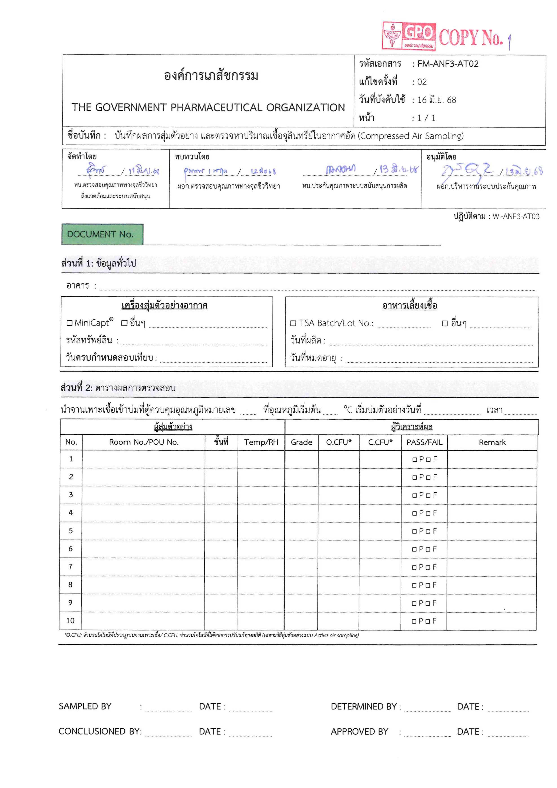
<tempRoom01>

<remark02>

<remark03>

<remark04>

<remark05>

<remark06>

<remark07>

<remark08>

<remark09>

<remark10>

<remark01>

<occResult01>

<occResult02>

<occResult03>

<occResult04>

<occResult05>

<occResult06>

<occResult07>

<occResult08>

<occResult09>

<occResult10>

<grade01>

<grade02>

<grade03>

<grade04>

<grade05>

<grade06>

<grade07>

<grade08>

<grade09>

<grade10>

<rh01>

<rh02>

<rh03>

<rh04>

<rh05>

<rh06>

<rh07>

<rh08>

<rh09>

<rh10>

<temp01>

<temp02>

<temp03>

<temp04>

<temp05>

<temp06>

<temp07>

<temp08>

<temp09>

<temp10>

<roomNo01>

<roomNo02>
<roomNo03>
<roomNo04>
<roomNo05>
<roomNo06>
<roomNo07>
<roomNo08>
<roomNo09>
<roomNo10>
<samplingDate>

<concludedDate>

<determinedDate>

<approvedDate>

<performedDate>
<incNo>
<mfgMedia>

<lotOther>

<lotTSA>

6 Jan 2025
6 Jan 2025
6 Jan 2025
6 Jan 2025
<expMedia>

<building>

<docNo>

