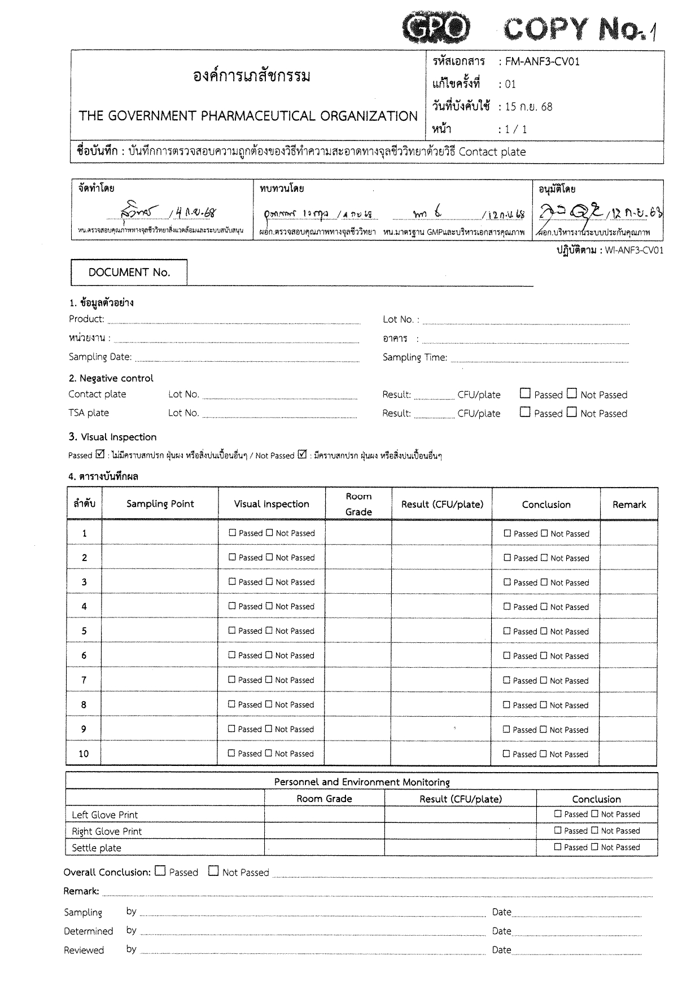
<samplingPoint10>

<samplingPoint09>

<samplingPoint08>

<samplingPoint07
>

<samplingPoint06
>

<samplingPoint05
>

<samplingPoint04
>

<samplingPoint03>

<samplingPoint02>

<samplingPoint01>

<performedDate>

<approvedDate>

<determinedDate>

<sectionName>

<samplingDate>
<samplingDate>

<docNo>

<lotNo>

<building>

<samplingTime >

<ProductName>

<lotContact>

<lotTSA>

<gradeControl>

<gradeControl>

<gradeControl>

<Grade10>

<Grade09>

<Grade08>

<Grade07>

<Grade06>

<Grade05>

<Grade04>

<Grade03>

<Grade02>

<Grade01>

<result10>

<result09>

<result08>

<result07>

<result06>

<result05>

<result04>

<result03>

<result02>

<result01>

