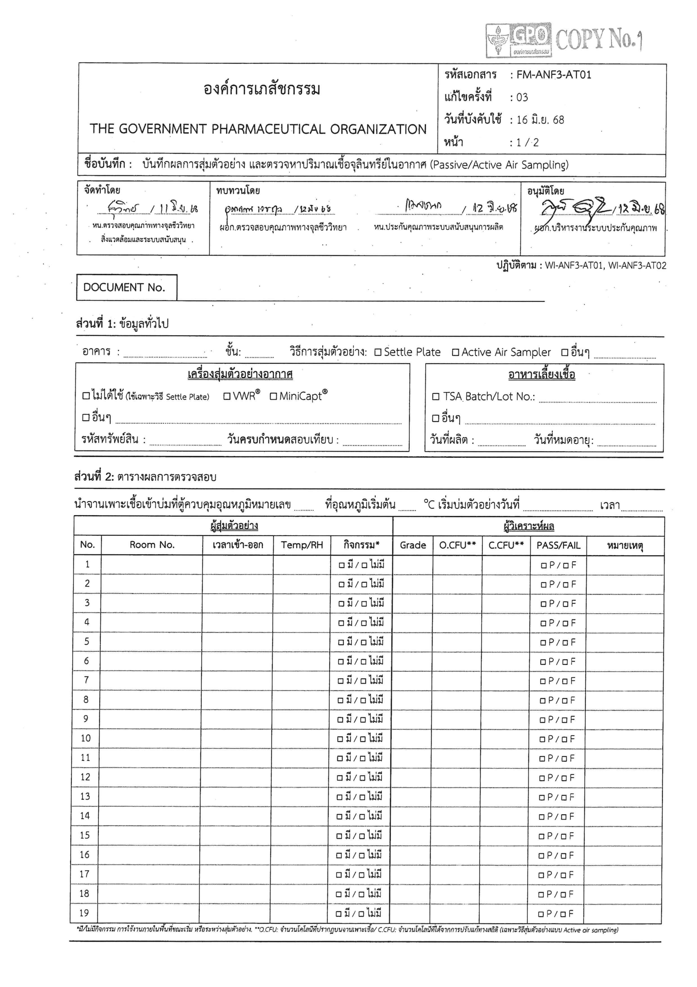
<remark01>
<remark02>

<remark03>

<remark04>

<remark05>

<remark06>

<remark07>

<remark08>

<remark09>

<remark10>

<remark11>

<remark12>

<remark13>

<remark14>

<remark15>

<remark16>

<remark17>

<remark18>

<remark19>

<occurResult01>

<occurResult02>
<occurResult03>
<occurResult04>
<occurResult05>
<occurResult06>
<occurResult07>
<occurResult08>
<occurResult09>
<occurResult10>
<occurResult11>
<occurResult12>
<occurResult13>
<occurResult14>
<occurResult15>
<occurResult16>
<occurResult17>
<occurResult18>
<occurResult19>
<grade01>

<grade02>
<grade03>
<grade04>
<grade05>
<grade06>
<grade07>
<grade08>
<grade09>
<grade10>
<grade11>
<grade12>
<grade13>
<grade14>
<grade15>
<grade16>
<grade17>
<grade18>
<grade19>
<rhRoom01>

<rhRoom02>
<rhRoom03>
<rhRoom04>
<rhRoom05>
<rhRoom06>
<rhRoom07>
<rhRoom08>
<rhRoom09>
<rhRoom10>
<rhRoom11>
<rhRoom12>
<rhRoom13>
<rhRoom14>
<rhRoom15>
<rhRoom16>
<rhRoom17>
<rhRoom18>
<rhRoom19>
<tempRoom01>

<tempRoom02>
<tempRoom03>
<tempRoom04>
<tempRoom05>
<tempRoom06>
<tempRoom07>
<tempRoom08>
<tempRoom09>
<tempRoom10>
<tempRoom11>
<tempRoom12>
<tempRoom13>
<tempRoom14>
<tempRoom15>
<tempRoom16>
<tempRoom17>
<tempRoom18>
<tempRoom19>
<timeOut01>

<timeOut02>
<timeOut03>
<timeOut04>
<timeOut05>
<timeOut06>
<timeOut07>
<timeOut08>
<timeOut09>
<timeOut10>
<timeOut11>
<timeOut12>
<timeOut13>
<timeOut14>
<timeOut15>
<timeOut16>
<timeOut17>
<timeOut18>
<timeOut19>
<timeIn01>

<timeIn02>
<timeIn03>
<timeIn04>
<timeIn05>
<timeIn06>
<timeIn07>
<timeIn08>
<timeIn09>
<timeIn10>
<timeIn11>
<timeIn12>
<timeIn13>
<timeIn14>
<timeIn15>
<timeIn16>
<timeIn17>
<timeIn18>
<timeIn19>
<roomNo01>

<roomNo02>
<roomNo03>
<roomNo04>
<roomNo05>
<roomNo06>
<roomNo07>
<roomNo08>
<roomNo09>
<roomNo10>
<roomNo11>
<roomNo12>
<roomNo13>
<roomNo14>
<roomNo15>
<roomNo16>
<roomNo17>
<roomNo18>
<roomNo19>
<grade20>

<grade21>
<grade22>
<grade23>
<grade24>
<grade25>
<grade26>
<grade27>
<grade28>
<grade29>
<grade30>
<grade31>
<grade32>
<grade33>
<grade34>
<grade35>
<grade36>
<grade37>
<grade38>
<temp>
<incNo>
<performedDate>
<expMedia>
<mfgMedia>
<lotMedia>
<floor>
<building>
<docNo>
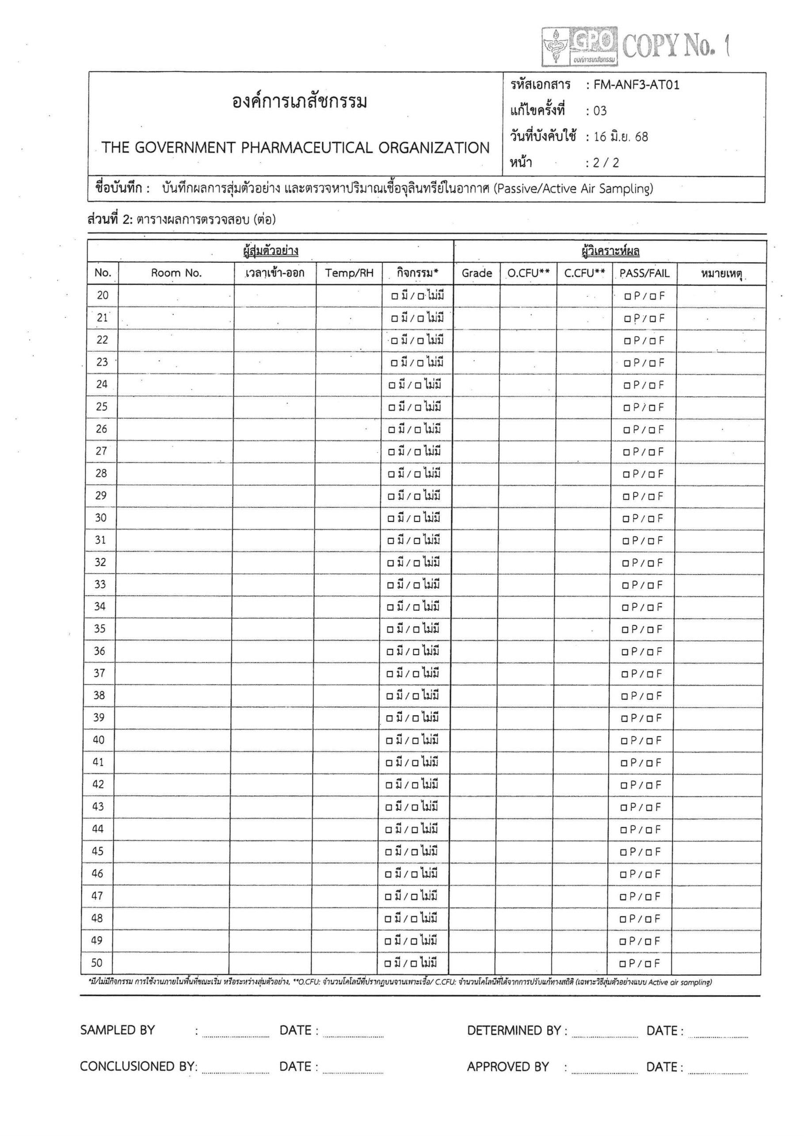
<remark20>
<remark21>

<remark22>

<remark23>

<remark24>

<remark25>

<remark26>

<remark27>

<remark28>

<remark29>

<remark30>

<remark31>

<remark32>

<remark33>

<remark34>

<remark35>

<remark36>

<remark37>

<remark38>

<remark39>

<remark40>

<remark41>

<remark42>

<remark43>

<remark44>

<remark45>

<remark46>

<remark47>

<remark48>

<remark49>

<remark50>

<roomNo20>

<roomNo21>
<roomNo22>
<roomNo23>
<roomNo24>
<roomNo25>
<roomNo26>
<roomNo27>
<roomNo28>
<roomNo29>
<roomNo30>
<roomNo31>
<roomNo32>
<roomNo33>
<roomNo34>
<roomNo35>
<roomNo36>
<roomNo37>
<roomNo38>
<roomNo39>
<roomNo40>
<roomNo41>
<roomNo42>
<roomNo43>
<roomNo44>
<roomNo45>
<roomNo46>
<roomNo47>
<roomNo48>
<roomNo49>
<roomNo50>
<occurResult20>

<occurResult21>
<occurResult22>
<occurResult23>
<occurResult24>
<occurResult25>
<occurResult26>
<occurResult27>
<occurResult28>
<occurResult29>
<occurResult30>
<occurResult31>
<occurResult32>
<occurResult33>
<occurResult34>
<occurResult35>
<occurResult36>
<occurResult37>
<occurResult38>
<occurResult39>
<occurResult40>
<occurResult41>
<occurResult42>
<occurResult43>
<occurResult44>
<occurResult45>
<occurResult46>
<occurResult47>
<occurResult48>
<occurResult49>
<occurResult50>
<grade39>
<grade40>
<grade41>
<grade42>
<grade43>
<grade44>
<grade45>
<grade46>
<grade47>
<grade48>
<grade49>
<grade50>
<grade20>
<grade21>
<grade22>
<grade23>
<grade24>
<grade25>
<grade26>
<grade27>
<grade28>
<grade29>
<grade30>
<grade31>
<grade32>
<grade33>
<grade34>
<grade35>
<grade36>
<grade37>
<grade38>
<rhRoom20>

<rhRoom21>
<rhRoom22>
<rhRoom23>
<rhRoom24>
<rhRoom25>
<rhRoom26>
<rhRoom27>
<rhRoom28>
<rhRoom29>
<rhRoom30>
<rhRoom31>
<rhRoom32>
<rhRoom33>
<rhRoom34>
<rhRoom35>
<rhRoom36>
<rhRoom37>
<rhRoom38>
<rhRoom39>
<rhRoom40>
<rhRoom41>
<rhRoom42>
<rhRoom43>
<rhRoom44>
<rhRoom45>
<rhRoom46>
<rhRoom47>
<rhRoom48>
<rhRoom49>
<rhRoom50>
<tempRoom20>

<tempRoom21>
<tempRoom22>
<tempRoom23>
<tempRoom24>
<tempRoom25>
<tempRoom26>
<tempRoom27>
<tempRoom28>
<tempRoom29>
<tempRoom30>
<tempRoom31>
<tempRoom32>
<tempRoom33>
<tempRoom34>
<tempRoom35>
<tempRoom36>
<tempRoom37>
<tempRoom38>
<tempRoom39>
<tempRoom40>
<tempRoom41>
<tempRoom42>
<tempRoom43>
<tempRoom44>
<tempRoom45>
<tempRoom46>
<tempRoom47>
<tempRoom48>
<tempRoom49>
<tempRoom50>
<timeOut20>

<timeOut21>
<timeOut22>
<timeOut23>
<timeOut24>
<timeOut25>
<timeOut26>
<timeOut27>
<timeOut28>
<timeOut29>
<timeOut30>
<timeOut31>
<timeOut32>
<timeOut33>
<timeOut34>
<timeOut35>
<timeOut36>
<timeOut37>
<timeOut38>
<timeOut39>
<timeOut40>
<timeOut41>
<timeOut42>
<timeOut43>
<timeOut44>
<timeOut45>
<timeOut46>
<timeOut47>
<timeOut48>
<timeOut49>
<timeOut50>
<timeIn20>

<timeIn21>
<timeIn22>
<timeIn23>
<timeIn24>
<timeIn25>
<timeIn26>
<timeIn27>
<timeIn28>
<timeIn29>
<timeIn30>
<timeIn31>
<timeIn32>
<timeIn33>
<timeIn34>
<timeIn35>
<timeIn36>
<timeIn37>
<timeIn38>
<timeIn39>
<timeIn40>
<timeIn41>
<timeIn42>
<timeIn43>
<timeIn44>
<timeIn45>
<timeIn46>
<timeIn47>
<timeIn48>
<timeIn49>
<timeIn50>
<samplingDate>

<concludedDate>

<determinedDate>

<approvedDate>

