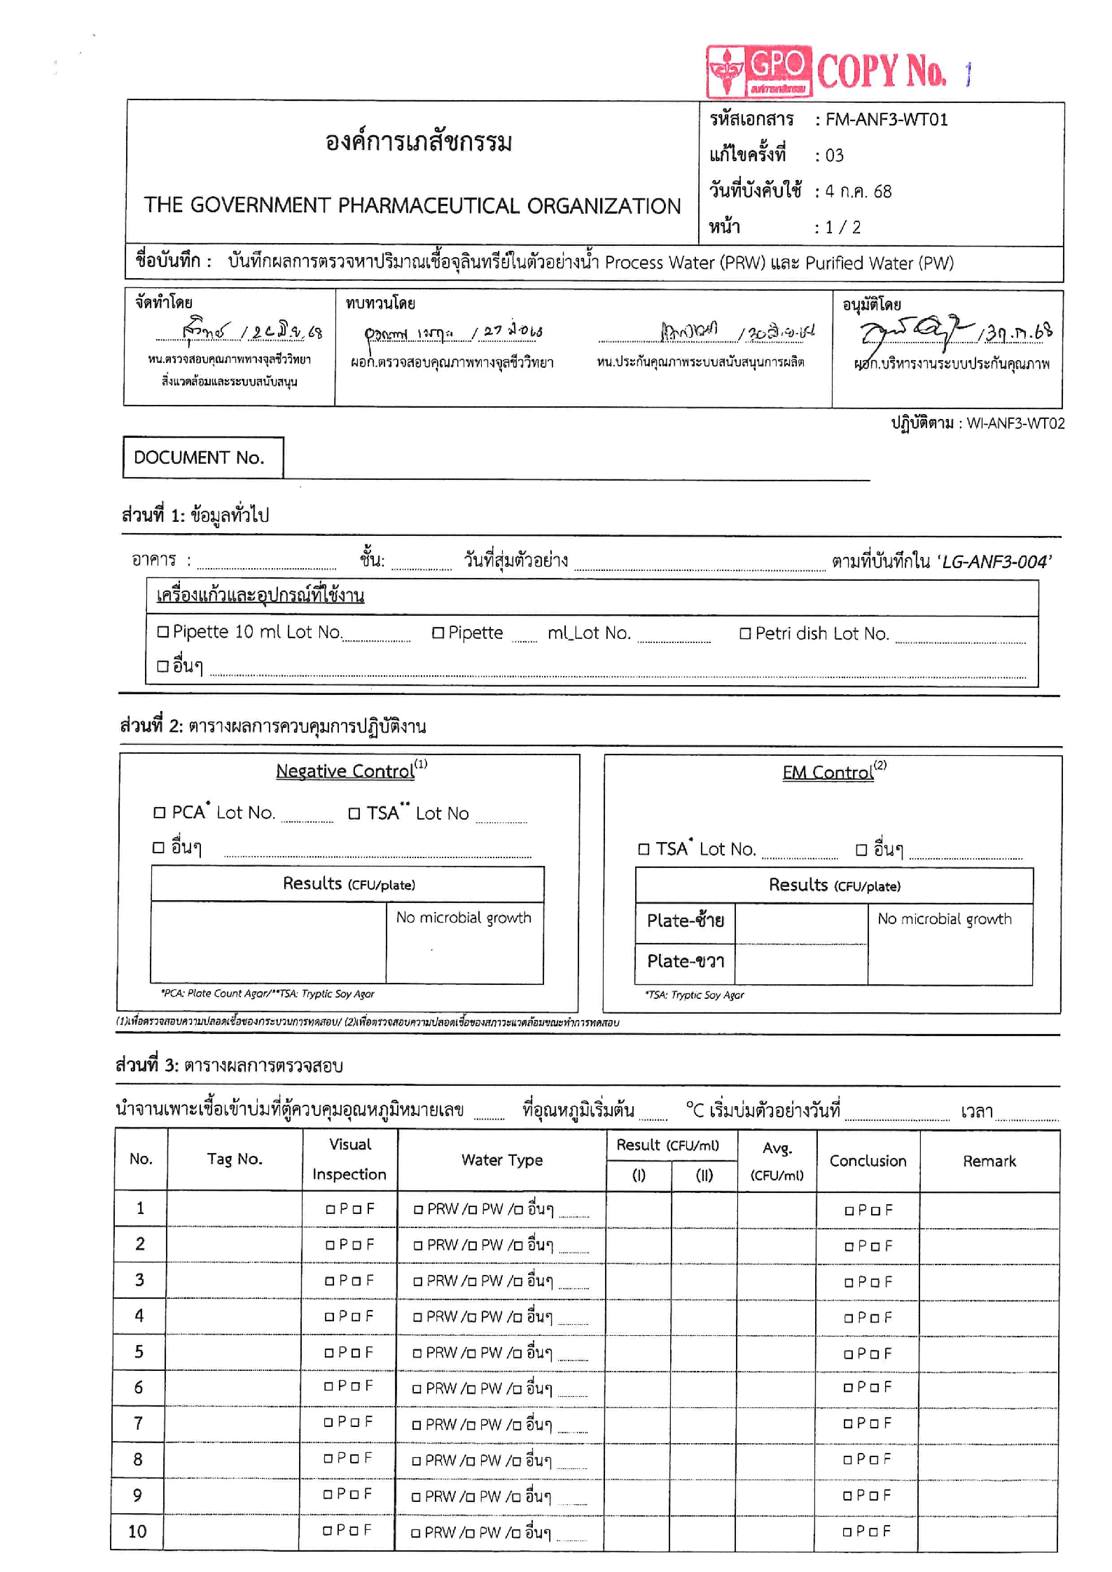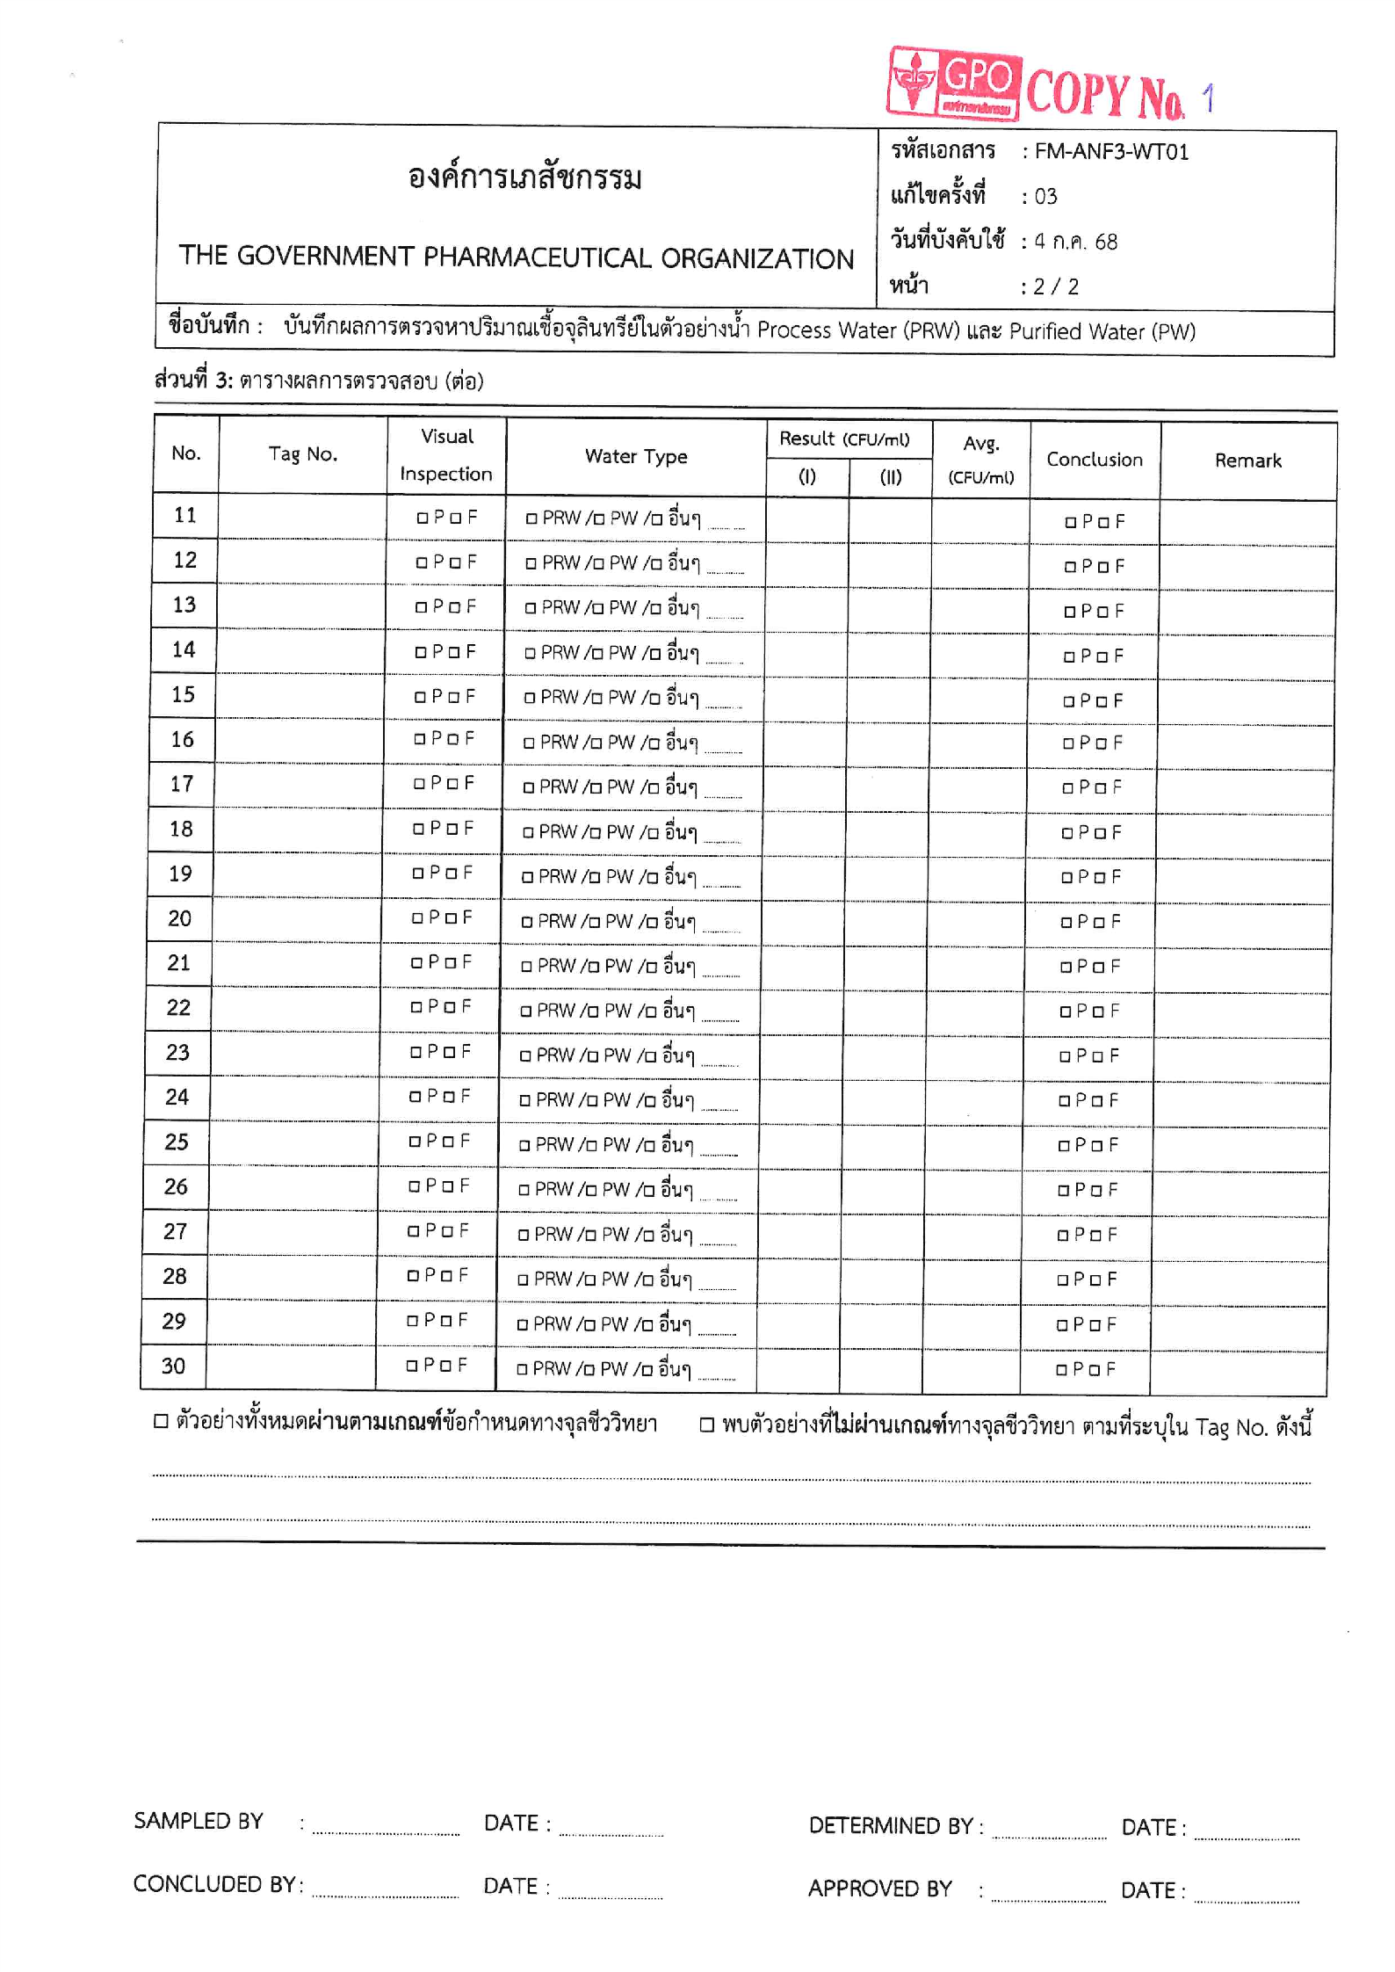
<tagNo05>
<samplingPoint05>
<result105>
<result205>
<resultAvg05>
<tagNo04>
<samplingPoint04>
<result104>
<result204>
<resultAvg04>
<tagNo03>
<samplingPoint03>
<result103>
<result203>
<resultAvg03>
<tagNo02>
<samplingPoint02>
<result102>
<result202>
<resultAvg02>
<tagNo01>
<samplingPoint01>
<result101>
<result201>
<resultAvg01>
<lotPlate>
<tagNo10>
<samplingPoint10>
<result110>
<result210>
<resultAvg10>
<tagNo09>
<samplingPoint09>
<result109>
<result209>
<resultAvg09>
<tagNo08>
<samplingPoint08>
<result108>
<result208>
<resultAvg08>
<tagNo07>
<samplingPoint07>
<result107>
<result207>
<resultAvg07>
<tagNo06>
<samplingPoint06>
<result106>
<result206>
<resultAvg06>
<performedDate>
<temp>
<incNo>
<rightEM>
<leftEM>
<negativeValue>
<lotTSA>
<lotTSA>
<lotPCA>
<lotPipette>
<samplingDate>
<building>
<docNo>
<tagNo29>
<samplingPoint29>
<result129>
<result229>
<resultAvg29>
<tagNo30>
<samplingPoint30>
<result130>
<result230>
<resultAvg30>
<tagNo28>
<samplingPoint28>
<result128>
<result228>
<resultAvg28>
<tagNo27>
<samplingPoint27>
<result127>
<result227>
<resultAvg27>
<tagNo26>
<samplingPoint26>
<result126>
<result226>
<resultAvg26>
<tagNo25>
<samplingPoint25>
<result125>
<result225>
<resultAvg25>
<tagNo24>
<samplingPoint24>
<result124>
<result224>
<resultAvg24>
<tagNo23>
<samplingPoint23>
<result123>
<result223>
<resultAvg23>
<tagNo22>
<samplingPoint22>
<result122>
<result222>
<resultAvg22>
<tagNo21>
<samplingPoint21>
<result121>
<result221>
<resultAvg21>
<tagNo20>
<samplingPoint20>
<result120>
<result220>
<resultAvg20>
<tagNo19>
<samplingPoint19>
<result119>
<result219>
<resultAvg19>
<tagNo18>
<samplingPoint18>
<result118>
<result218>
<resultAvg18>
<tagNo17>
<samplingPoint17>
<result117>
<result217>
<resultAvg17>
<tagNo16>
<samplingPoint16>
<result116>
<result216>
<resultAvg16>
<tagNo15>
<samplingPoint15>
<result115>
<result215>
<resultAvg15>
<tagNo14>
<samplingPoint14>
<result114>
<result214>
<resultAvg14>
<tagNo13>
<samplingPoint13>
<result113>
<result213>
<resultAvg13>
<tagNo12>
<samplingPoint12>
<result112>
<result212>
<resultAvg12>
<tagNo11>
<samplingPoint11>
<result111>
<result211>
<resultAvg11>
<approvedDate>
<concludedDate>
<performedDate>
<determinedDate>
<comment>

