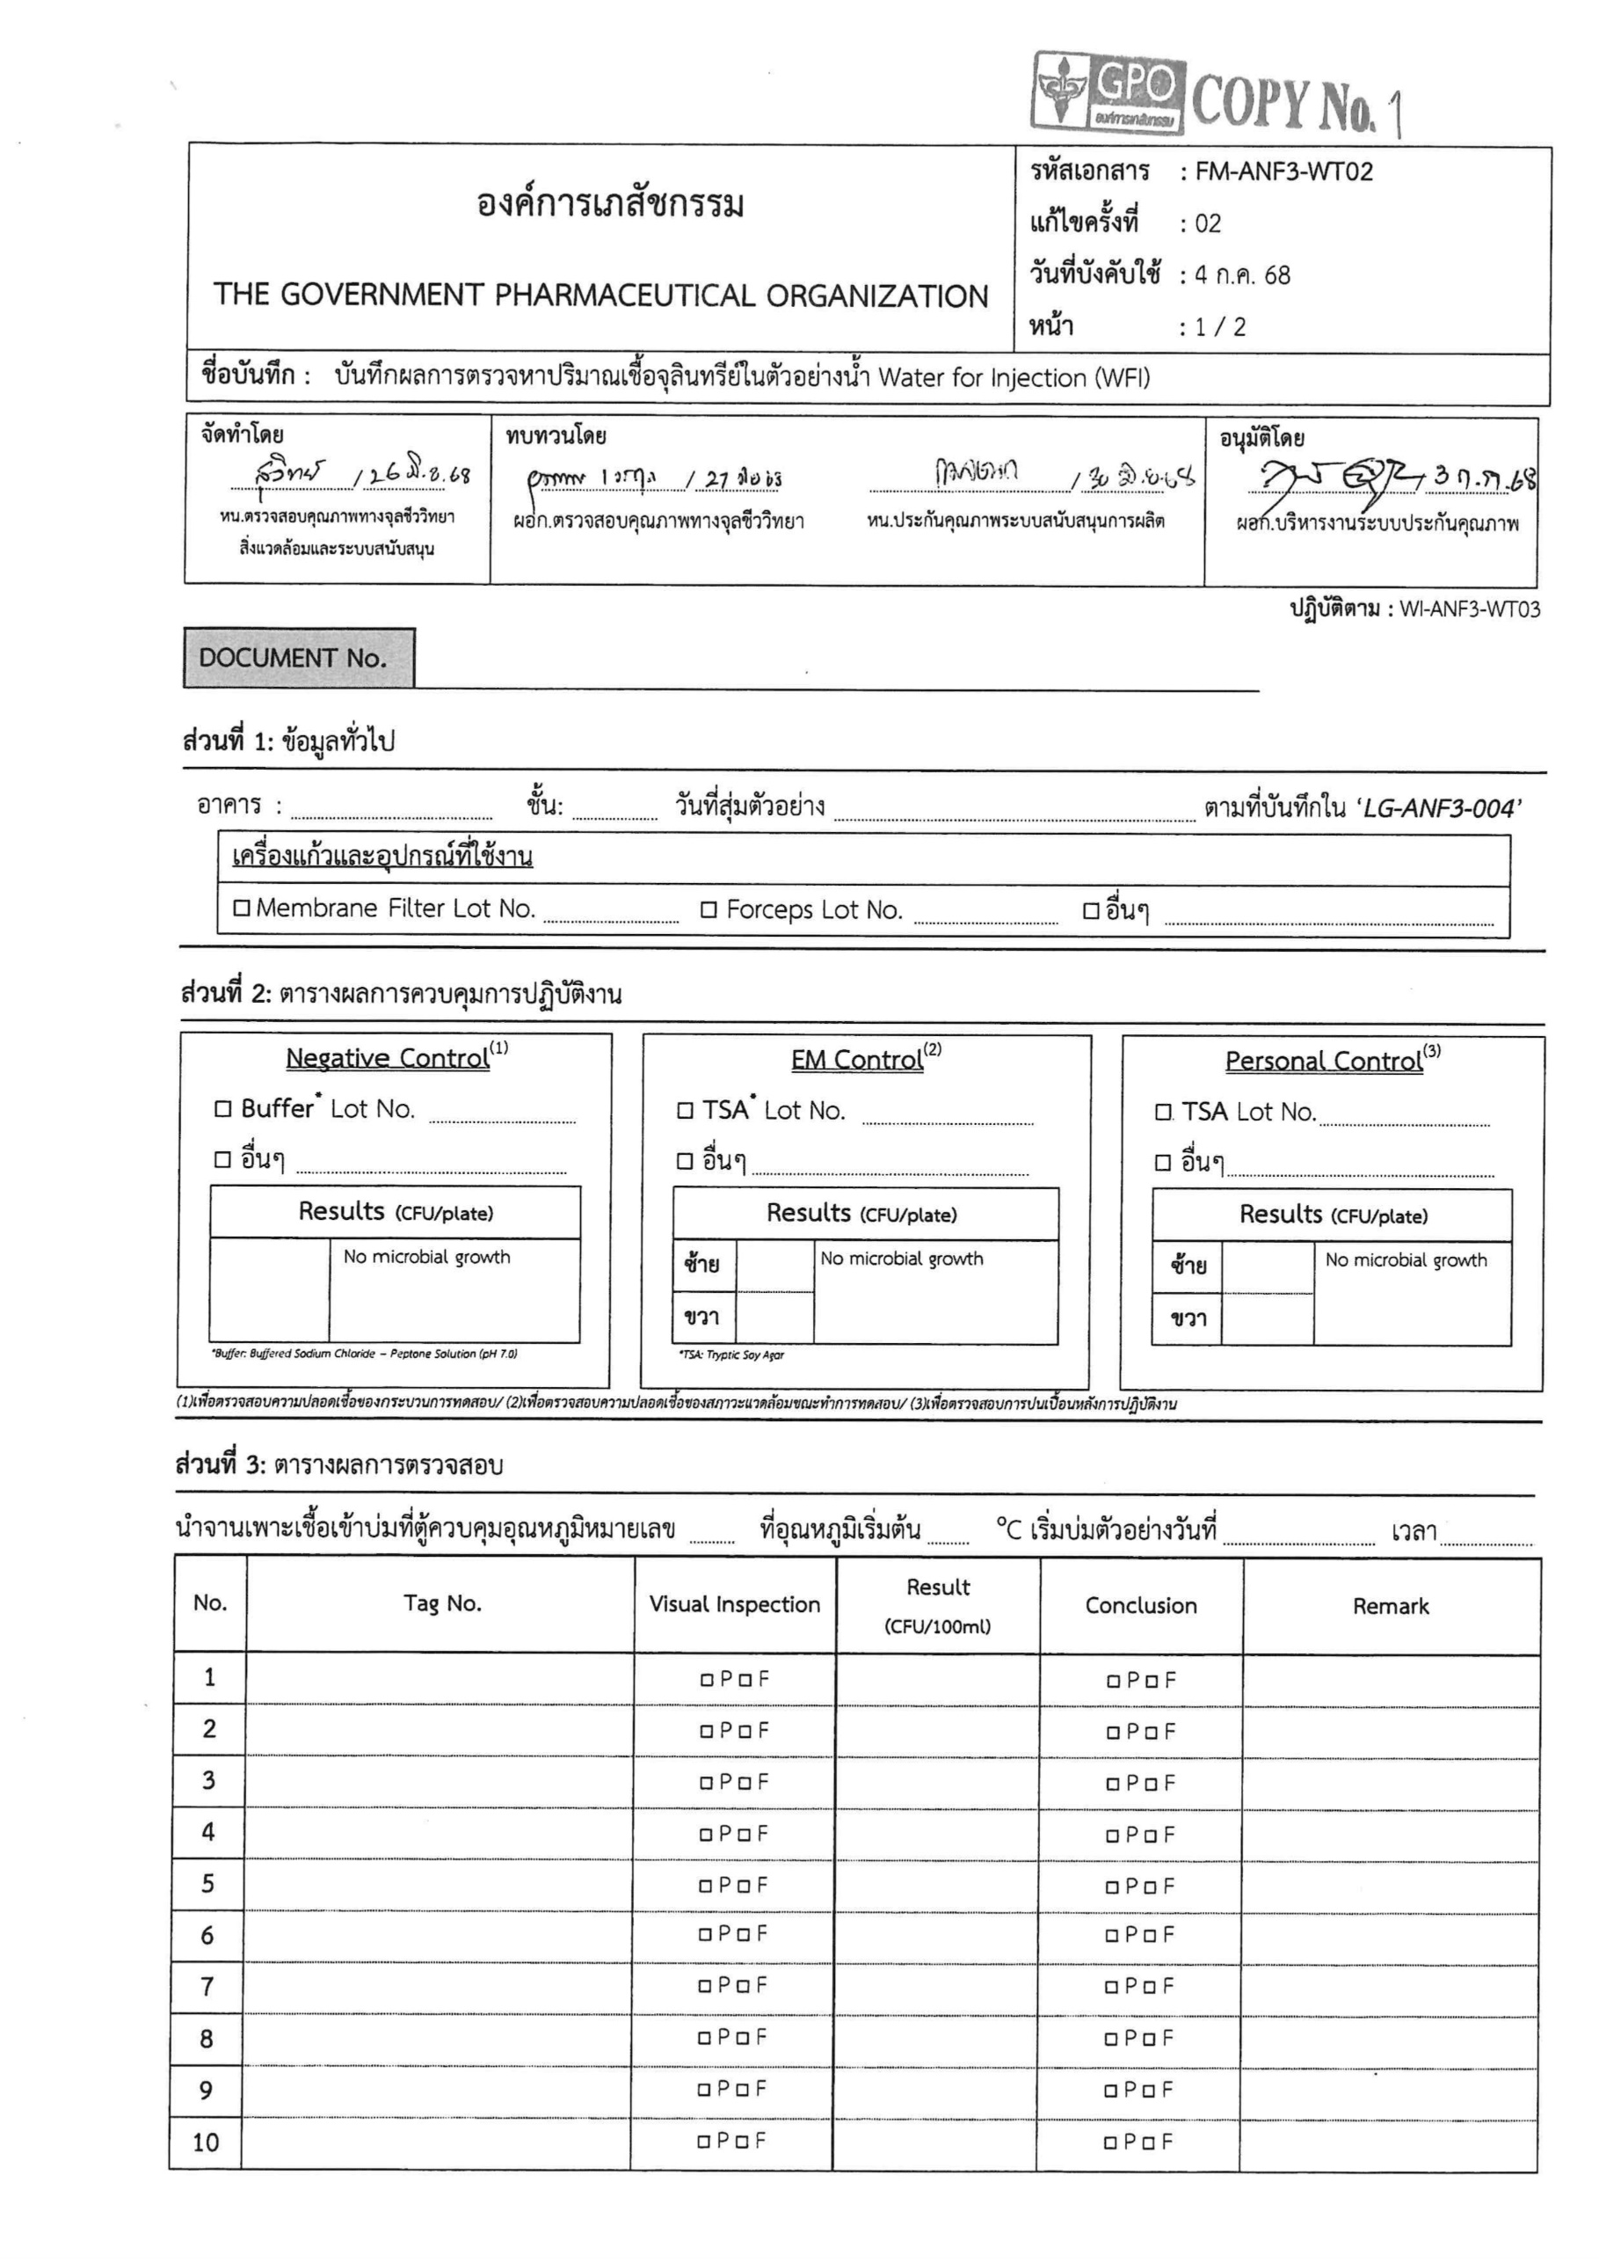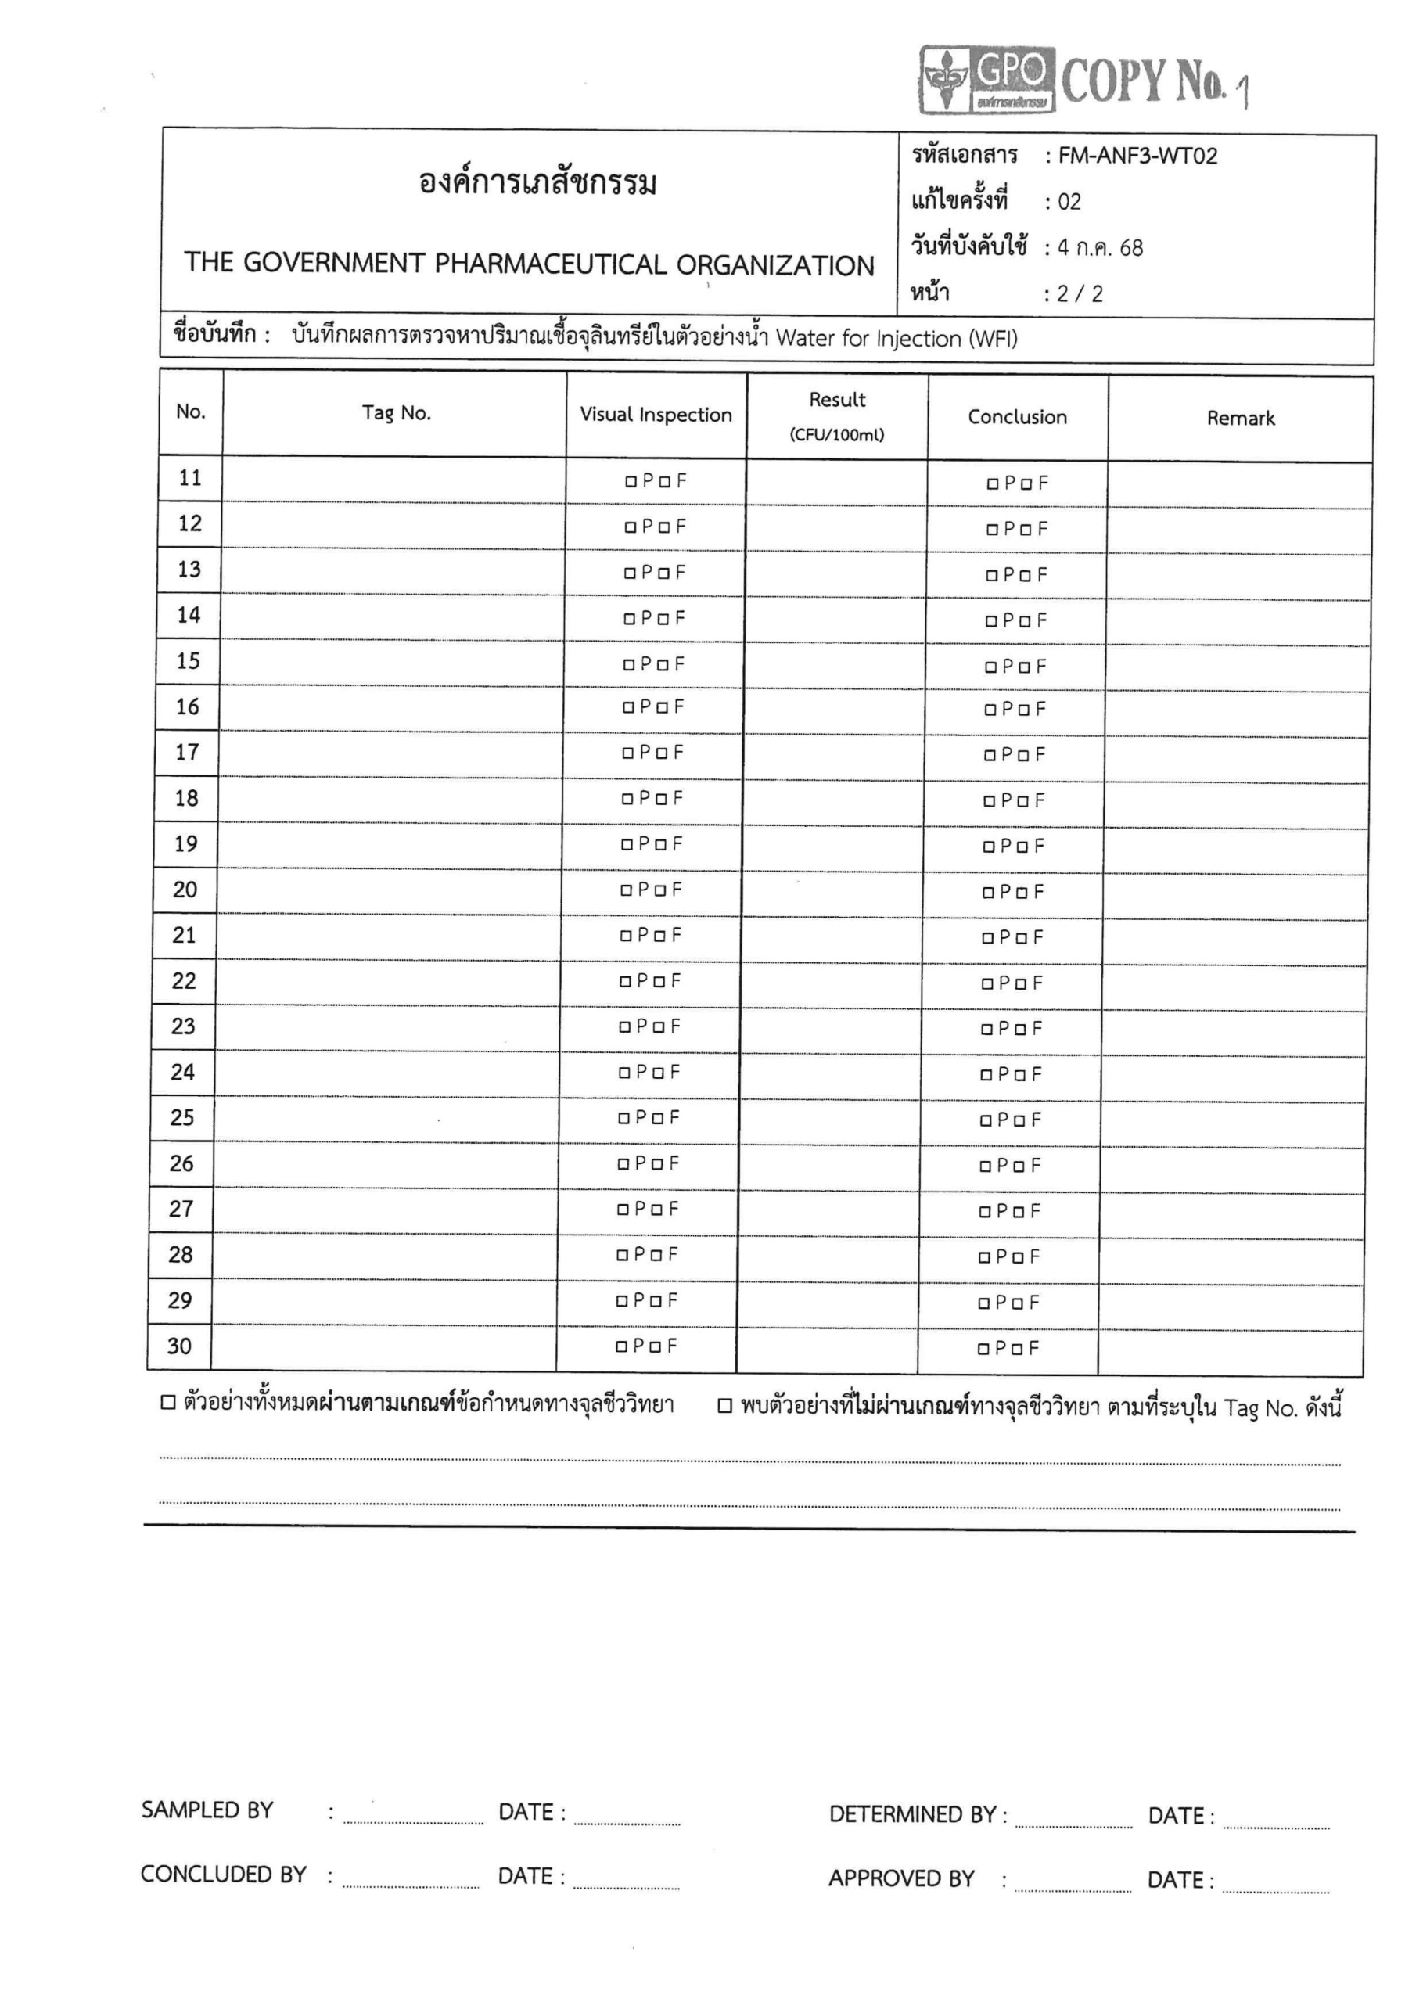
<samplingPoint10>
<samplingPoint09>
<samplingPoint08>
<samplingPoint07>
<samplingPoint06>
<samplingPoint05>
<samplingPoint04>
<samplingPoint03>
<samplingPoint02>

<samplingPoint01>
<tagNo01>
<result01>
<tagNo02>

<result02>
<tagNo03>
<result03>
<tagNo04>
<result04>
<tagNo05>
<result05>
<tagNo06>
<result06>
<tagNo07>
<result07>
<tagNo08>
<result08>
<tagNo09>
<result09>
<tagNo10>
<result10>
<docNo>
<building>
<samplingDate>
<lotMembrane>
<lotForceps>
<lotBuffer>
<lotTSA>
<lotTSA>
<negativeValue>
<leftEm>
<rightEm>
<leftHand>
<rightHand>
<incNo>
<temp>
<performedDate>
<samplingPoint30>
<samplingPoint29>
<samplingPoint28>
<samplingPoint27>
<samplingPoint26>
<samplingPoint25>
<samplingPoint24>
<samplingPoint23>
<samplingPoint22>
<samplingPoint21>
<samplingPoint20>
<samplingPoint19>
<samplingPoint18>
<samplingPoint17>
<samplingPoint16>
<samplingPoint14>
<samplingPoint13>
<samplingPoint12>
<samplingPoint11>
<samplingPoint15>
<tagNo15>
<result15>
<tagNo11>
<result11>
<tagNo12>
<result12>
<tagNo13>
<result13>
<tagNo14>
<result14>
<tagNo16>
<result16>
<tagNo17>
<result17>
<tagNo18>
<result18>
<tagNo19>
<result19>
<tagNo20>
<result20>
<tagNo21>
<result21>
<tagNo22>
<result22>
<tagNo23>
<result23>
<tagNo24>
<result24>
<tagNo25>
<result25>
<tagNo26>
<result26>
<tagNo27>
<result27>
<tagNo28>
<result28>
<tagNo29>
<result29>
<tagNo30>
<result30>
<approvedDate>

<concludedDate>

<determinedDate>

<performedDate>

<comment>

