Milestone -3
Deployment & Visualization in Multi-Label Classification

Overview:
In a multi-label classification system, a single audio input can contain multiple instruments at the same time.
This phase deploys the trained multi-label model and presents all detected instruments clearly to the user.

Deployment:
The deployment stage integrates preprocessing, model inference, and output generation into one pipeline.
Steps performed:
- Audio file is given as input
- Audio is converted into a spectrogram
- Trained multi-label model processes the spectrogram
- Model outputs a binary vector indicating presence of instruments
Example output vector:
[Piano, Guitar, Drums, Violin]
[1, 0, 1, 1]
- 1 → Instrument present
- 0 → Instrument not present

Prediction Handling (Multi-Label)
Unlike single-label classification, multiple instruments are selected simultaneously.

Example prediction:
Predicted Instruments: Piano, Violin
Each instrument is detected independently using sigmoid activation and thre sholding.

Visualization:
Visualization displays all detected instruments instead of just one.
- Text output showing detected instruments
- Probability scores for each class
- Optional bar chart for confidence values
This makes results human-readable and easy to understand.

Step 1: Prepare Deployment Folder
Check your project structure:
Label/
├── deployment /
│ ├── audio_to_spec.py # Converts audio → spectrogram
│ ├── predict.py # Runs CNN model prediction
│ ├── run_pipeline.py # Full pipeline
│ ├── visualize.py # Optional: visualization
│ ├── app.py # Optional: Streamlit web app
│ └── samples/
│ └── test_audio.wav

audio _to spec.py:
import librosa
import librosa.display
import matplotlib.pyplot as plt
import numpy as np

def audio_to_spectrogram(audio_path, output_path):
y, sr = librosa.load(audio_path, sr=None)
S = librosa.feature.melspectrogram(y=y, sr=sr)
S_DB = librosa.power_to_db(S, ref=np.max)

plt.figure(figsize=(3, 3))
librosa.display.specshow(S_DB, sr=sr)
plt.axis("off")
plt.savefig(output_path, bbox_inches="tight", pad_inches=0)
plt.close()

predict.py:
import torch
from torchvision import transforms
from PIL import Image

LABELS = ['Piano', 'Violin', 'Guitar', 'Flute', 'Drums']

def predict_instruments(spec_path):
model = torch.load("../spectrograms/instrument_cnn.pth", map_location="cpu")
model.eval()

transform = transforms.Compose([
transforms.Resize((128, 128)),
transforms.ToTensor()
])

image = Image.open(spec_path).convert("RGB")
image = transform(image).unsqueeze(0)

with torch.no_grad():
outputs = model(image)
predictions = (outputs > 0.5).int()[0]

result = [LABELS[i] for i, val in enumerate(predictions) if val == 1]
return result

run_ pipline .py:
import os

audio_path = "samples/test_audio.wav"
if os.path.exists(audio_path):
print("File found ✅")
else:
print("File not found ❌")

visualize.py :
import matplotlib.pyplot as plt

def visualize_predictions(results):
names = list(results.keys())
values = list(results.values())

plt.figure(figsize=(9,4))
plt.bar(names, values)
plt.xticks(rotation=45)
plt.ylabel("Probability")
plt.title("Detected Instruments")
plt.tight_layout()
plt.show()

app.py:
import streamlit as st
import os
from audio_to_spec import audio_to_spectrogram
from predict import predict_instruments

# Page title
st.title("🎵 Instrument Detection System")
st.write("Upload an audio file to detect instruments (Multi-label classification)")

# File upload
uploaded_file = st.file_uploader("Upload WAV audio file", type=["wav"])

if uploaded_file is not None:
# Save uploaded audio
os.makedirs("samples", exist_ok=True)
audio_path = "samples/uploaded_audio.wav"

with open(audio_path, "wb") as f:
f.write(uploaded_file.read())

st.success("Audio uploaded successfully ✅")

# Generate spectrogram
spec_path = "samples/uploaded_spec.png"
audio_to_spectrogram(audio_path, spec_path)

st.write("Spectrogram generated")

# Predict instruments
predictions = predict_instruments(spec_path)

# Show results
st.subheader("🎯 Predicted Instruments")
for inst in predictions:
st.write(f"- {inst}")

# Save output as JSON
output = {
"audio_file": audio_path,
"predicted_instruments": predictions
}

st.subheader("📄 Output (JSON)")
st.json(output)

st.success("Detection completed 🎉")
#streamlit run "C:/Users/siri reddy/OneDrive/Documents/Desktop/Label/deployment/app.py"

Samples:
text _audio.wav:

Output Export

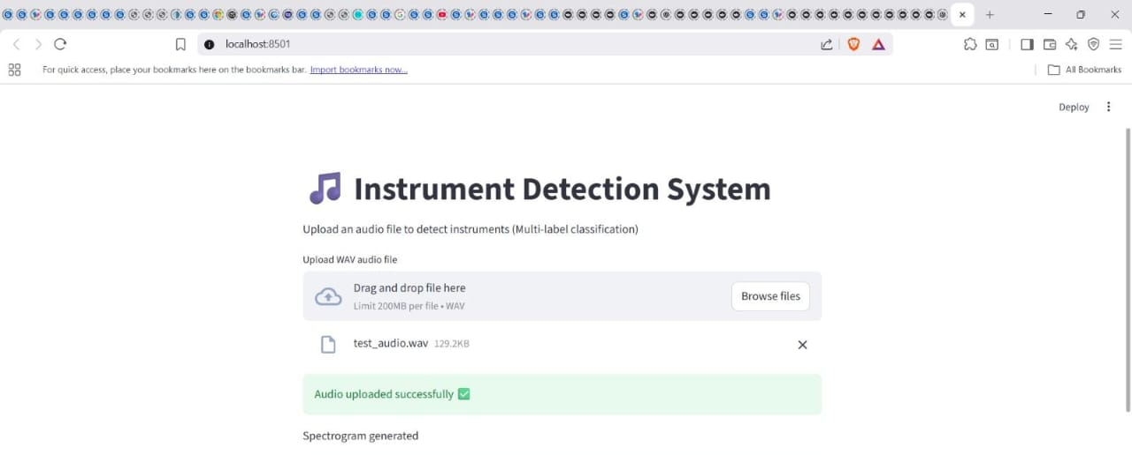
["Piano", "Violin"],

The system stores predictions for documentation and analysis.

JSON Output
{
"audio_ file": "test_audio.wav",
"predicted_ instruments": ["Piano", "Violin"],
"label_ vector": [1, 0, 0, 1]
}

PDF Report (Optional)
- Audio name
- Detected instruments
- Model confidence
- Timestamp

Optional Web Deployment
A Streamlit web app can be used to deploy the multi-label model.
- Upload audio file
- Predict multiple instruments
- Display results visually
- Download JSON/PDF reports

Milestone Completion
This stage achieves a complete end-to-end multi-label classification system:
Audio Input → Multi-Label Prediction → Visualization → Report Generation

Key Advantage of Multi-Label Deployment
- Handles real-world audio with overlapping instruments
- More realistic and practical than single-label systems

