Smart Parking Fee Managment
AIm: To develop a Python program that calculates parking fees using entry time, exit time, vehicle category, overnight parking, daily limits, and penalty conditions. The program also validates the entered times.
1. Parking rules
For this example, the following rules are used:
Vehicle category | Fee per started hour | Daily maximum
Bike | ₹20 | ₹200
Car | ₹50 | ₹500
Heavy vehicle | ₹100 | ₹1,000
Additional rules:
- Time must be entered in HH:MM format using the 24-hour clock.
- Each started hour is charged as one full hour.
- If exit time is earlier than entry time, parking continues overnight until the next day.
- An overnight parking fee of ₹100 is added.
- If the total parking duration exceeds 12 hours, a penalty of ₹200 is added.
- The vehicle's hourly charge is limited to its daily maximum. The overnight fee and penalty are added afterward.
- Entry and exit times cannot be identical.
These are example rules for the programming exercise, not official parking tariffs.
2. Algorithm
- Start.
- Enter the vehicle category.
- Enter entry and exit times.
- Validate the vehicle category and time format.
- Convert both times into minutes.
- If exit time is earlier than entry time, add 24 hours to the exit time and mark overnight parking.
- Calculate the parking duration.
- Round up the duration to the next full hour.
- Calculate the hourly fee and apply the daily maximum.
- Add the overnight fee and applicable penalty.
- Display duration and total parking fee.
- Stop.
3. Flowchart

START

Input vehi category and entry/exit times

Are category and time valid?

N
No → Show error and re-enter

Cillaalculate duration and bble hours

Apply hourly fee and daily maximum

Display total parking fee
Stop

output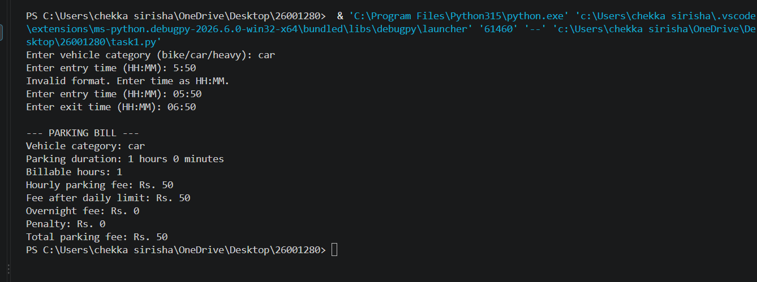
5. Step-by-step calculation
- Duration: From 6:00 PM to 8:30 AM the next day = 14 hours 30 minutes.
- Billable hours: 15 hours, because any started hour is charged as a full hour.
- Hourly fee: \(15 \times ₹100 = ₹1,500\).
- Daily maximum: The heavy-vehicle limit is ₹1,000, so the parking fee becomes ₹1,000.
- Overnight fee: ₹100.
- Penalty: ₹200 because the duration exceeds 12 hours.
Total fee:
\[ ₹1,000+₹100+₹200=\boxed{₹1,300} \]
6. Result
The program calculates parking charges based on vehicle type, entry and exit times, overnight parking, daily limits, and penalties. It also validates time inputs using Python functions, loops, conditions, and dictionaries

