

Department of CSE

B.Tech. CSE Trimester -5

Roll Number:2520030609 Name: V.Siri Chandana

Cloud Infrastructure and Services

25CS2206E

SKILL RECORD
2026

1.Create an IAM user with programmatic access only, download the access key and secret key, and document the steps with screenshots.Then set up a billing alert for the account so that an email is received when the Free Tier limit is about to be crossed.

Description:

IAM (Identity and Access Management) is a service provided by AWS that helps manage users and control their access to different AWS resources. It allows the account owner to create users and assign permissions based on their requirements. IAM helps ensure that only authorized users can access the resources and perform specific actions. It also provides access keys and secret keys for users who need to access AWS services programmatically. By using IAM, we can maintain account security and prevent unauthorized access.

Part A: Creating an IAM User
Step 1: Open AWS Management Console
Description: We are logging into the AWS account to access AWS services.

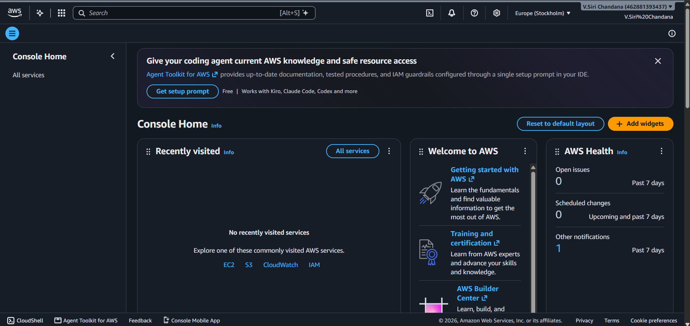

Step 2: Search for IAM
Description: We are searching for the IAM service in the AWS Management Console.

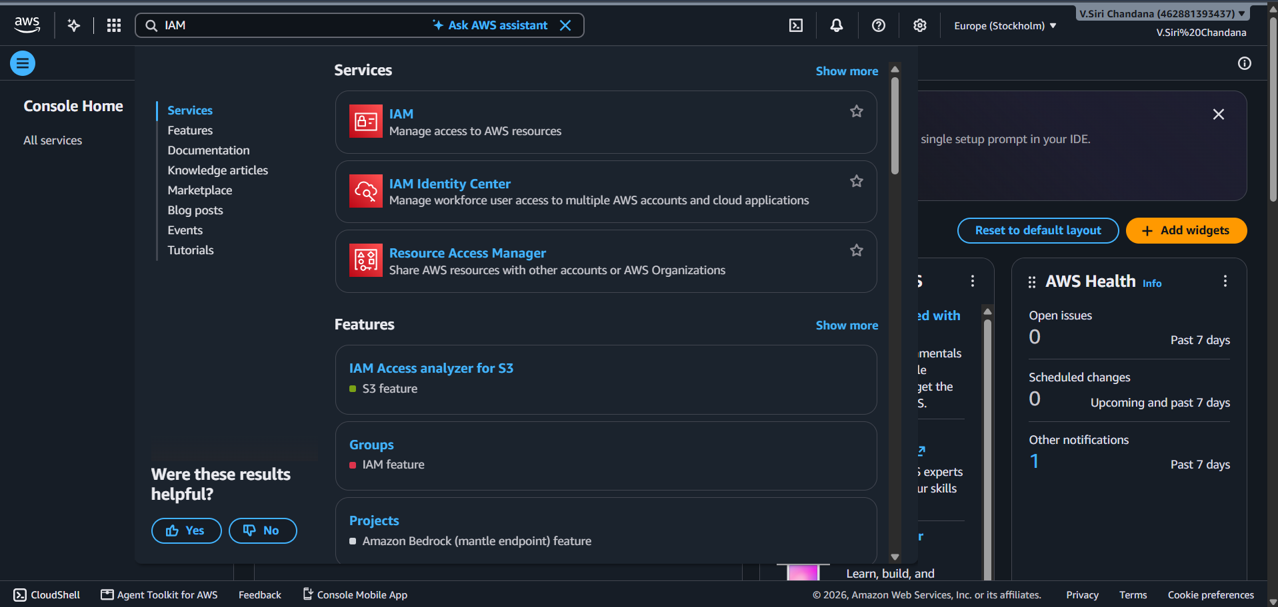

Step 3: Open IAM Dashboard
Description: We are opening the IAM dashboard to manage users and permissions.

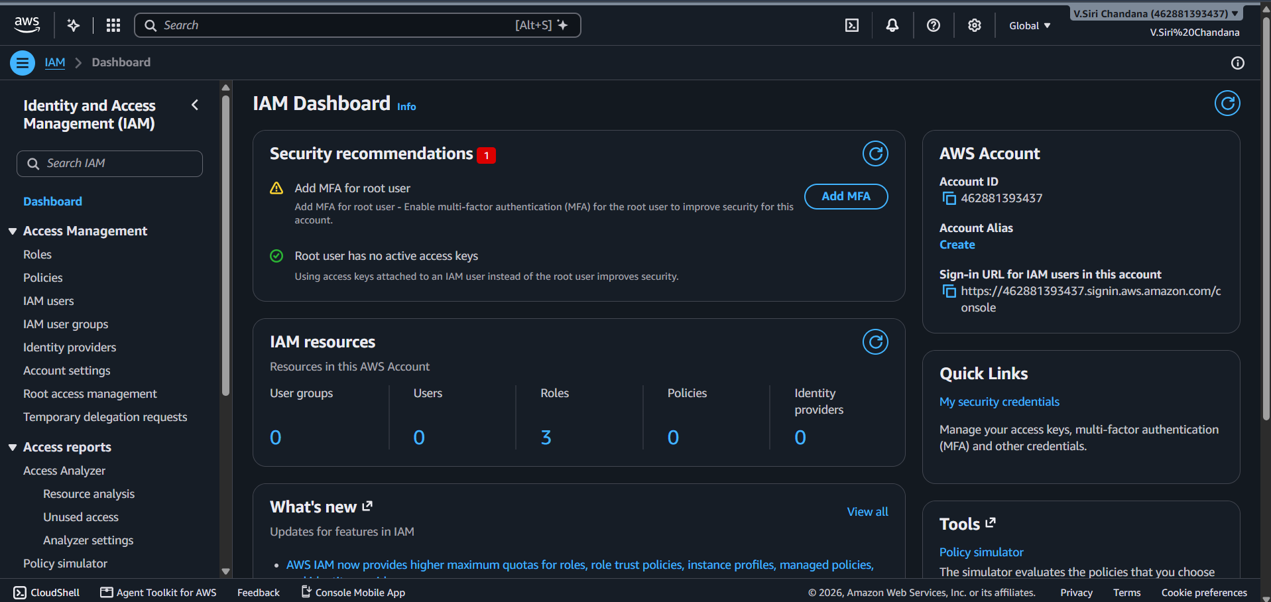

Step 4: Select Users, Create a New User, Enter User Name
Description: We are selecting the Users option to create a new IAM user and we are clicking on Create user to add a new IAM user and w e are entering a username to identify the new IAM user.

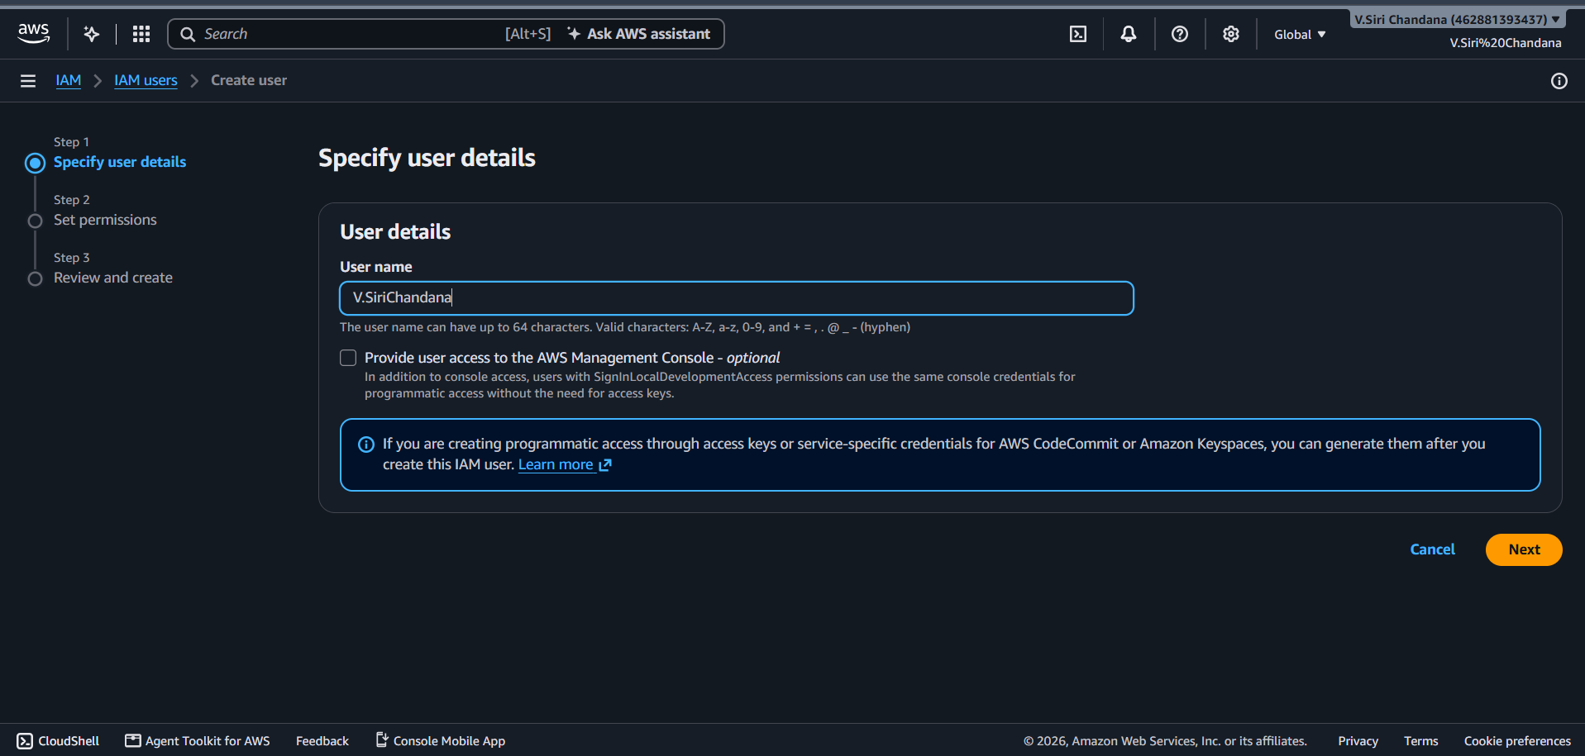

Step 5: Select Programmatic Access, Set Permissions
Description: We are creating access credentials for the user to connect with AWS services through programs instead of console login and we are assigning the required permissions to allow the IAM user to access AWS services.

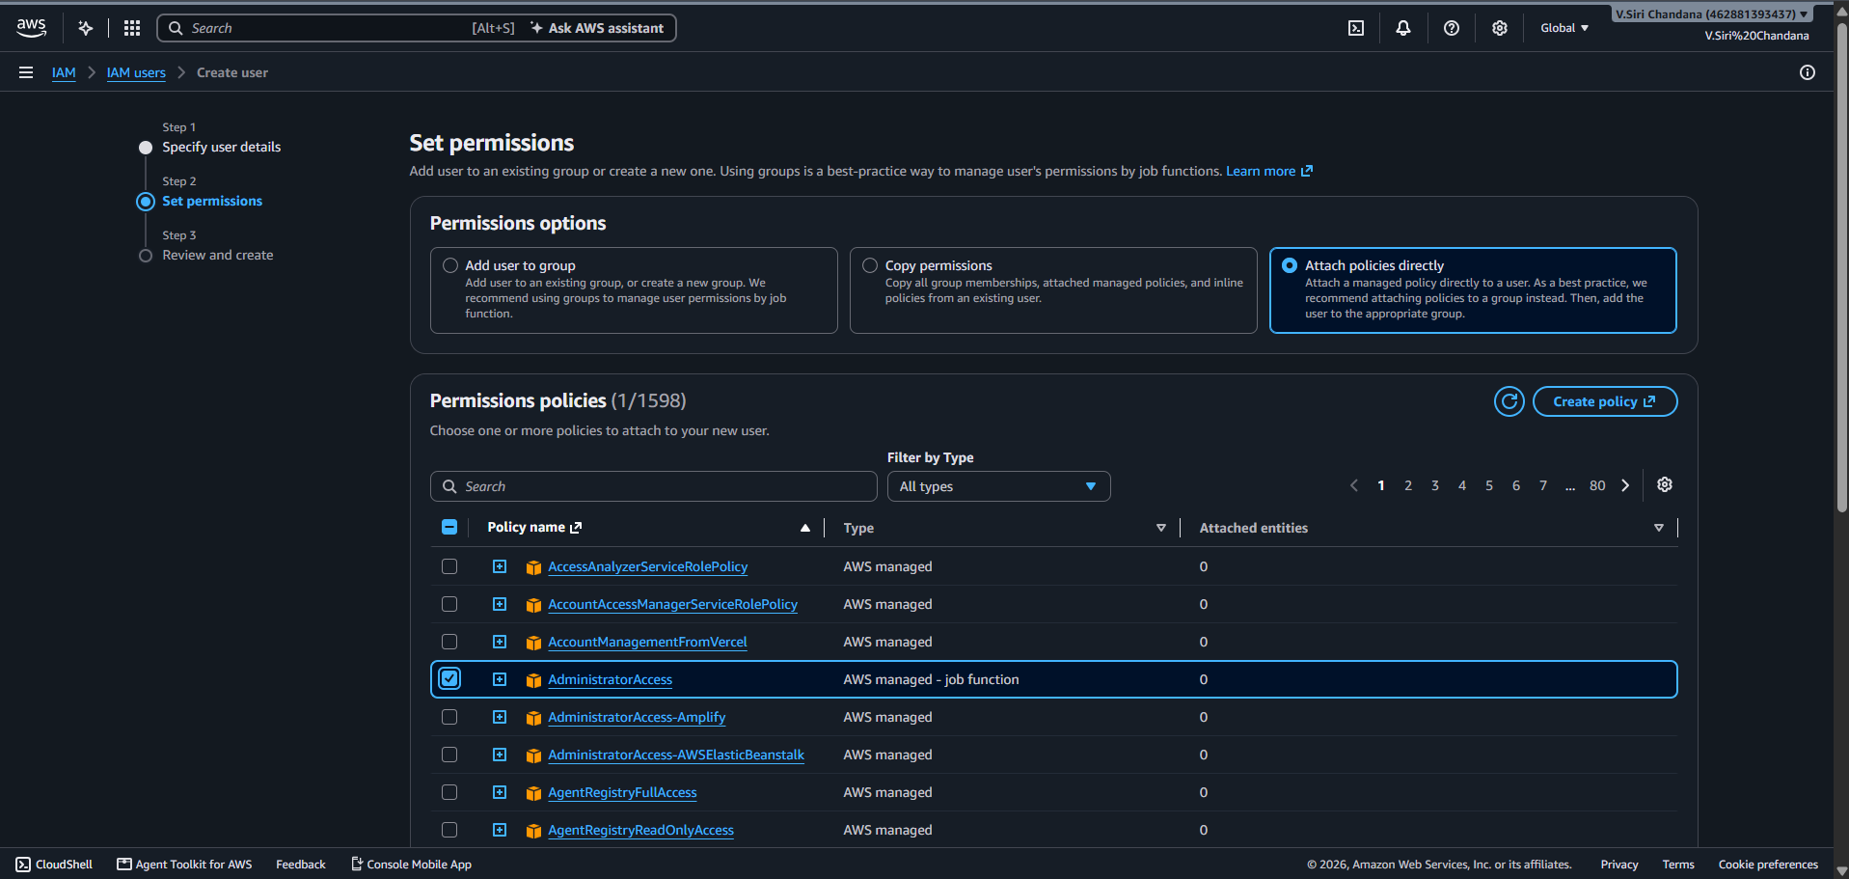

Step 6: Review User Details
Description: We are checking the username and permissions before creating the IAM user.

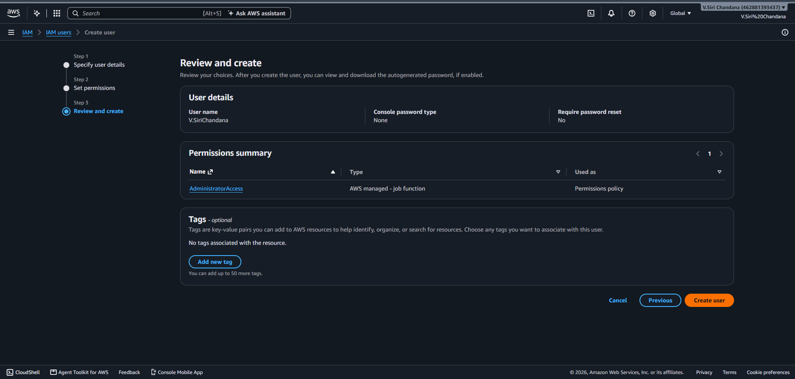

Step 7: Create User
Description: We are creating the IAM user successfully in our AWS account.

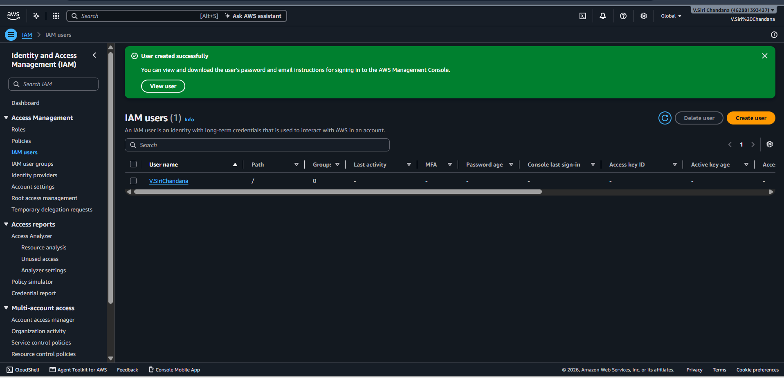

Step 8: Create Access Key
Description: We are generating an Access Key ID and Secret Access Key for programmatic access.

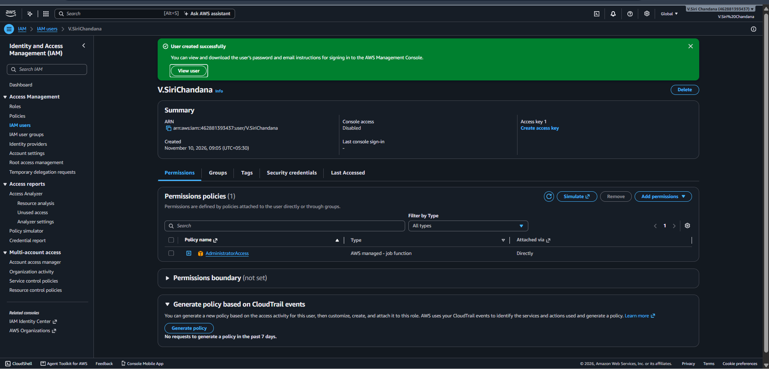

Step 9: Download Access Keys
Description: We are downloading the access key details for future use.

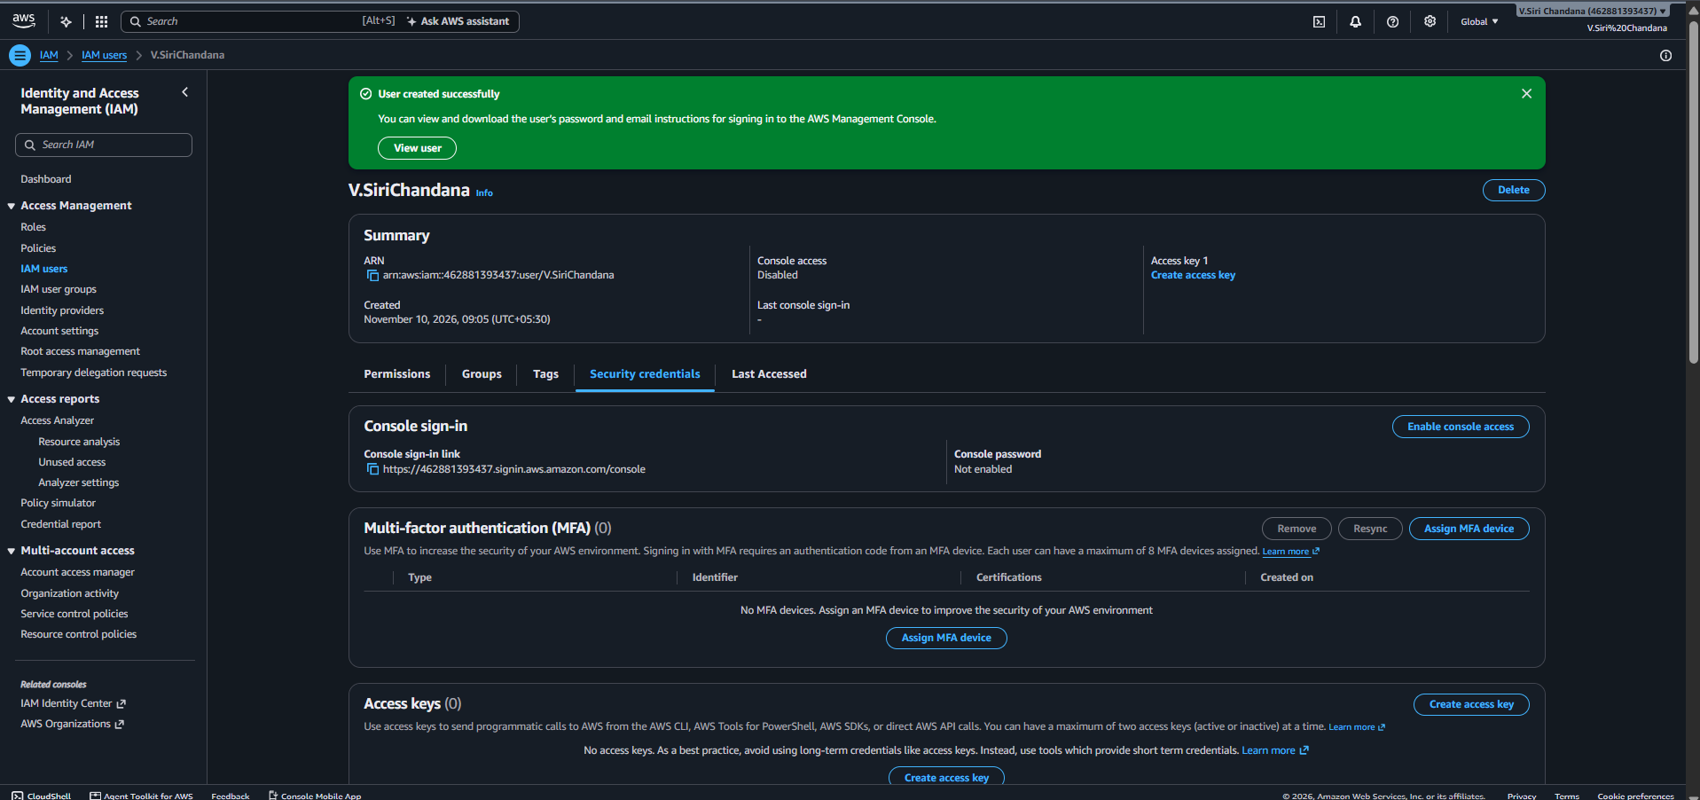

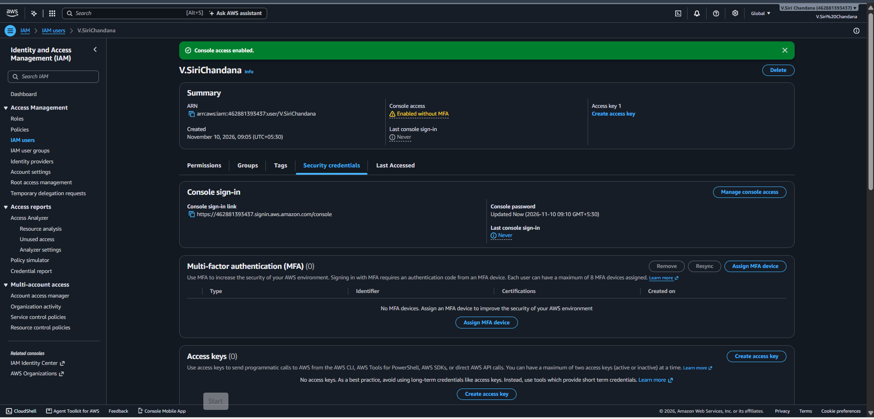

Step10: Signing in as IAM user
Description: Now we are checking whether we are login or not
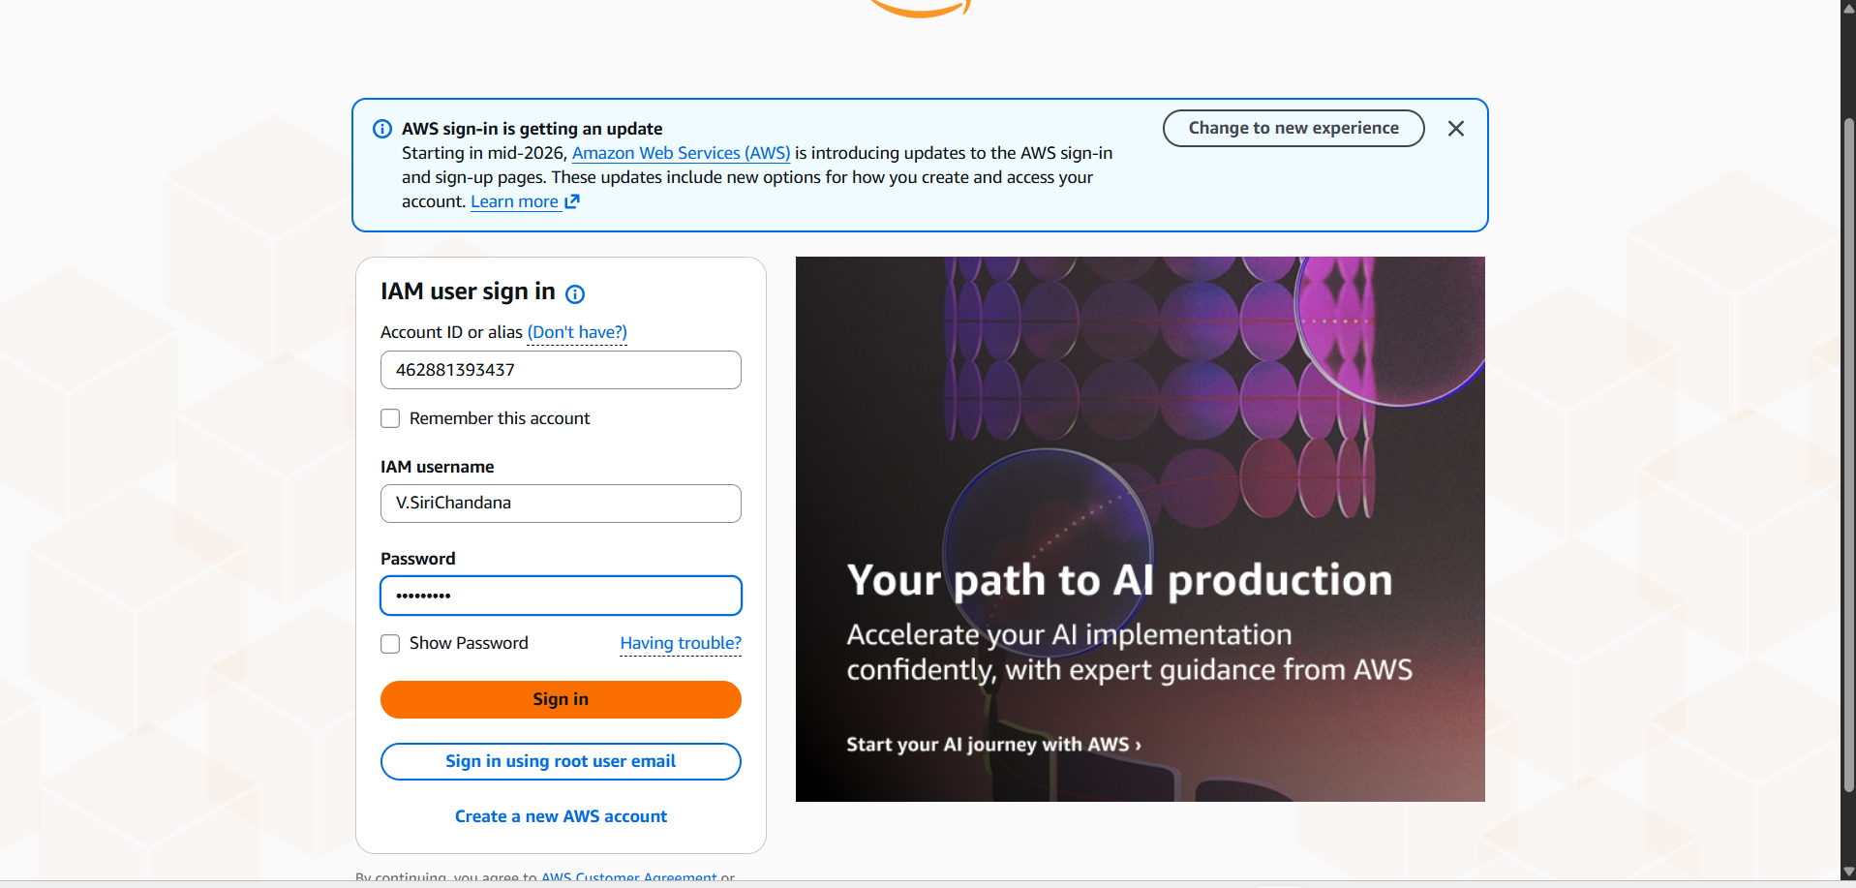

Step 11: Create Access Key
Description: We are generating an Access Key ID and Secret Access Key for programmatic access.

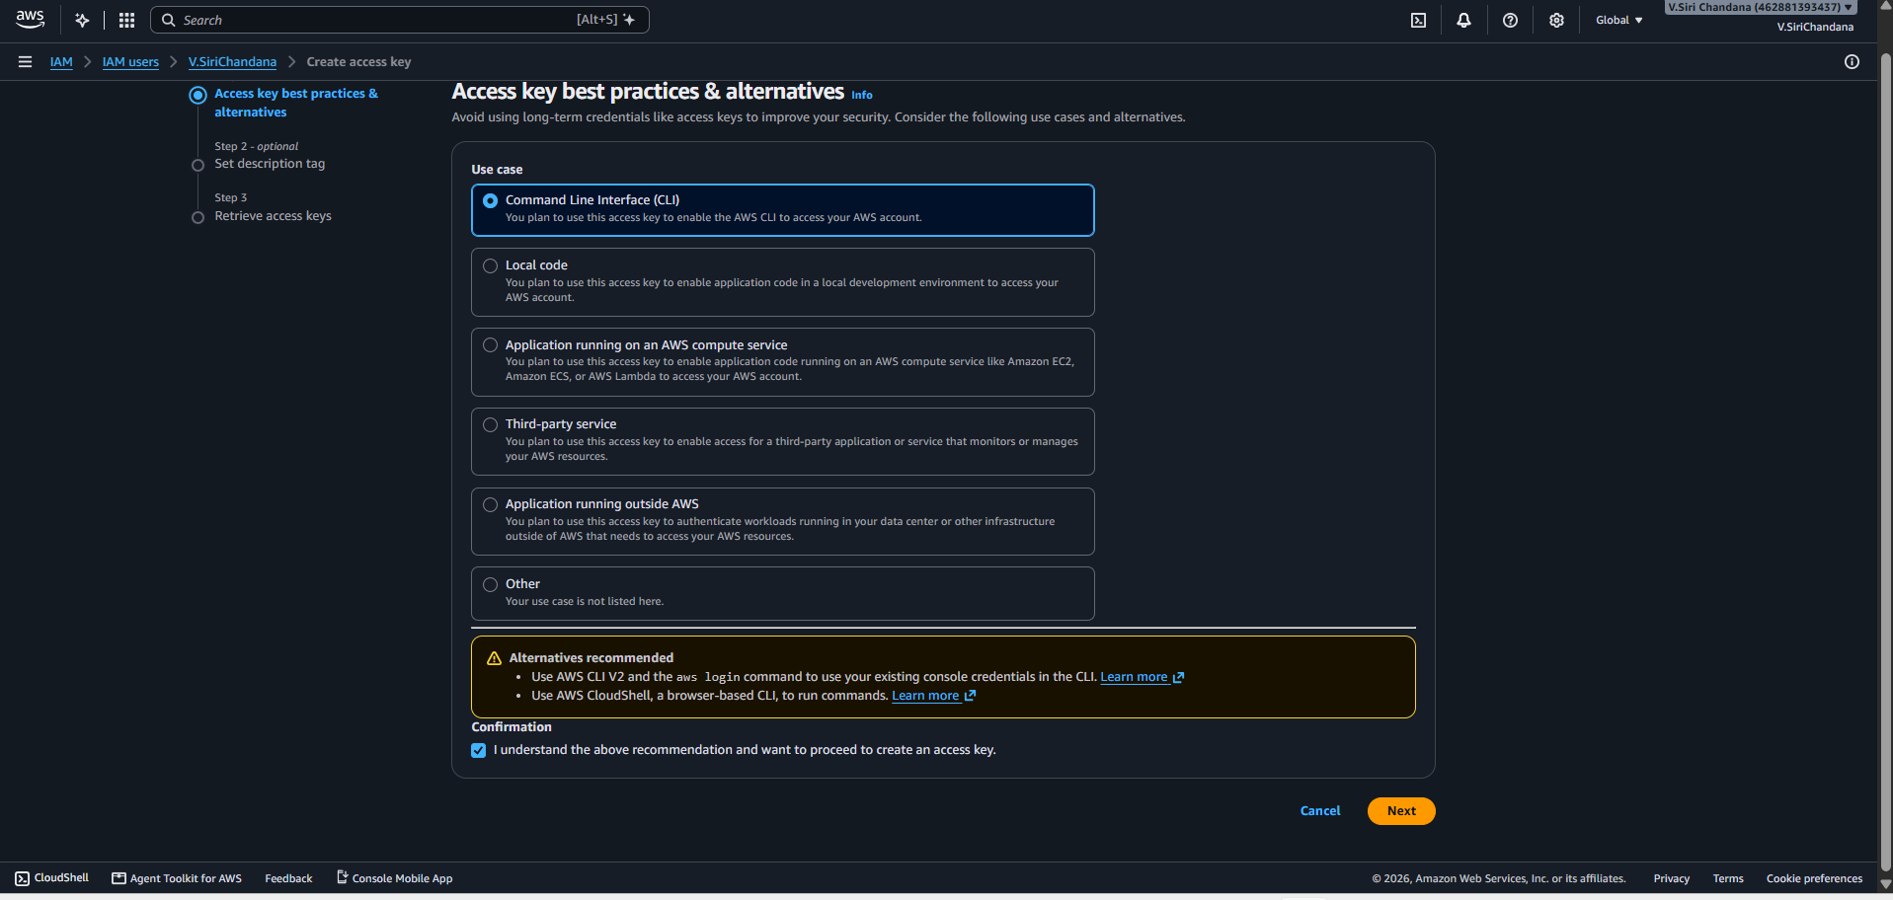

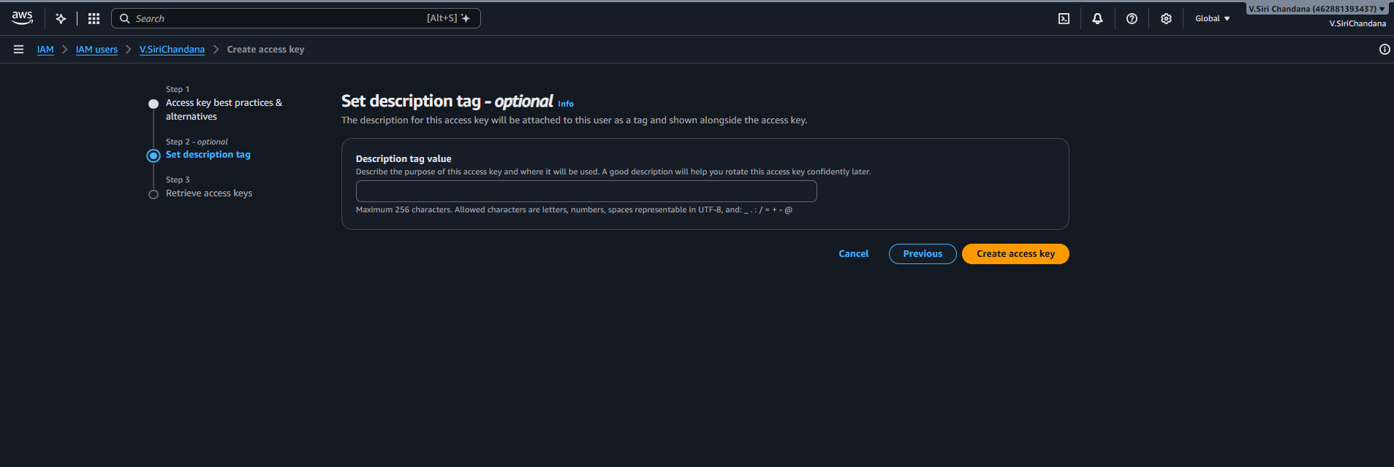

Step 12: Download Access Keys
Description: We are downloading the access key details for future use.

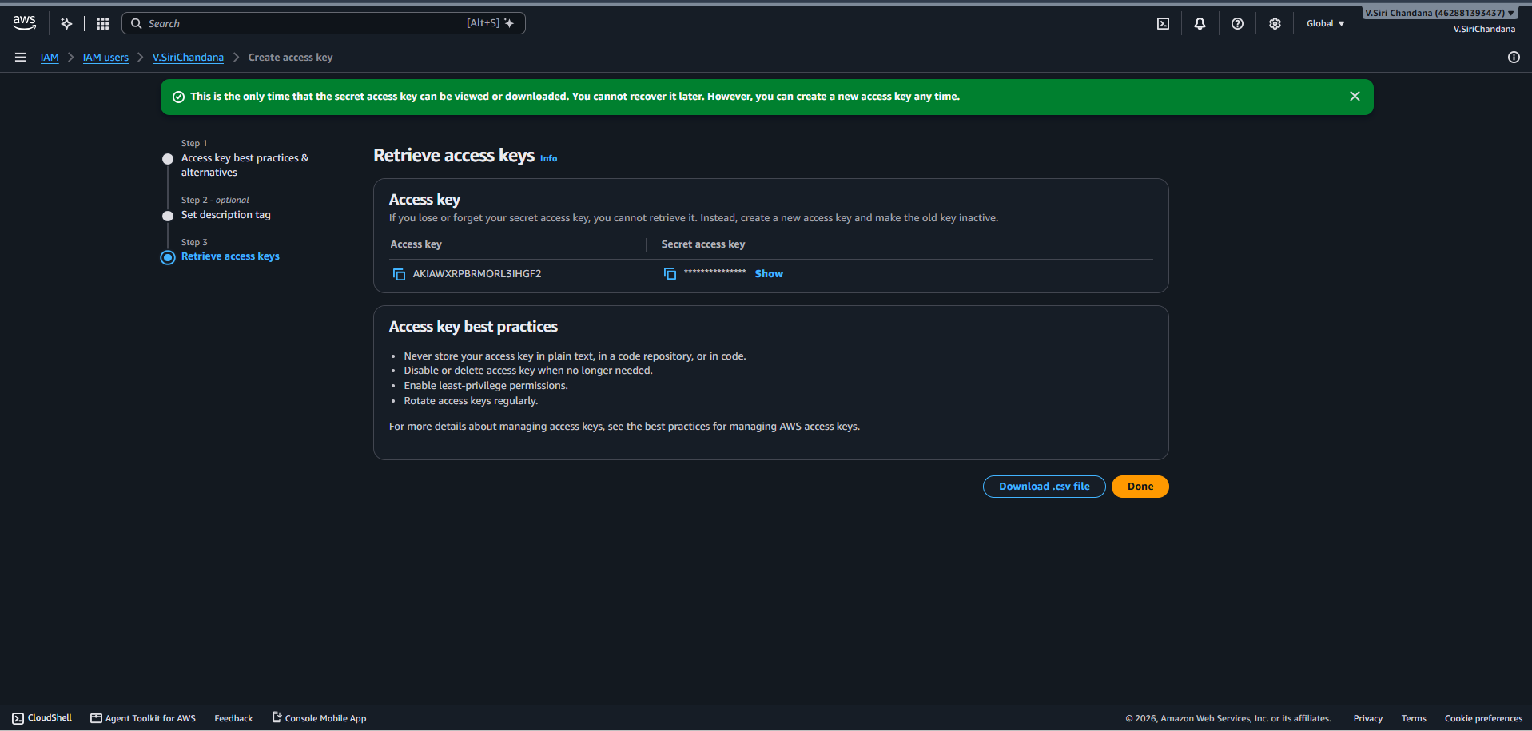

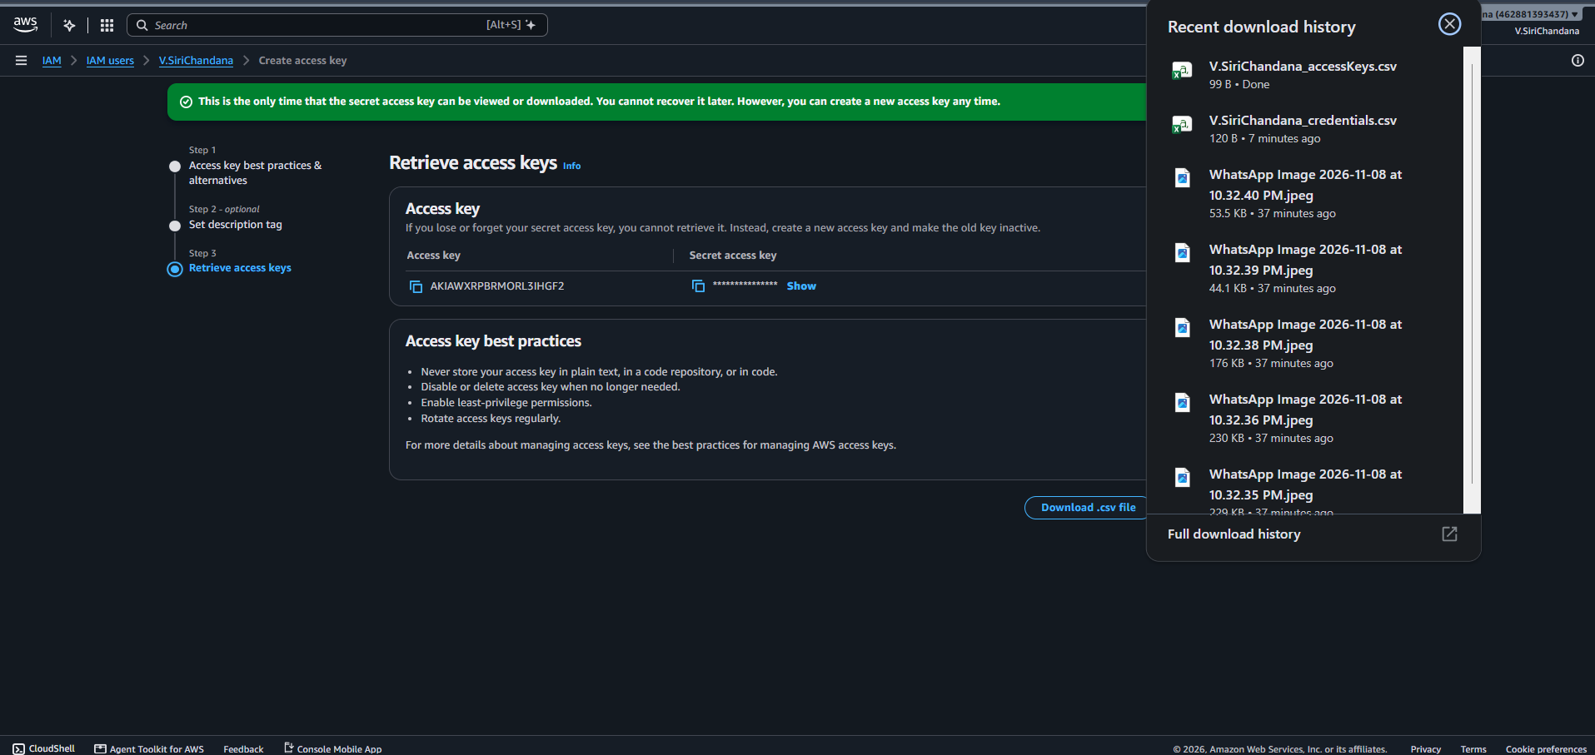

Part B: Setting Up a Billing Alert
Step 13: Open Billing Dashboard
Description: We are opening the Billing and Cost Management dashboard to monitor AWS expenses.

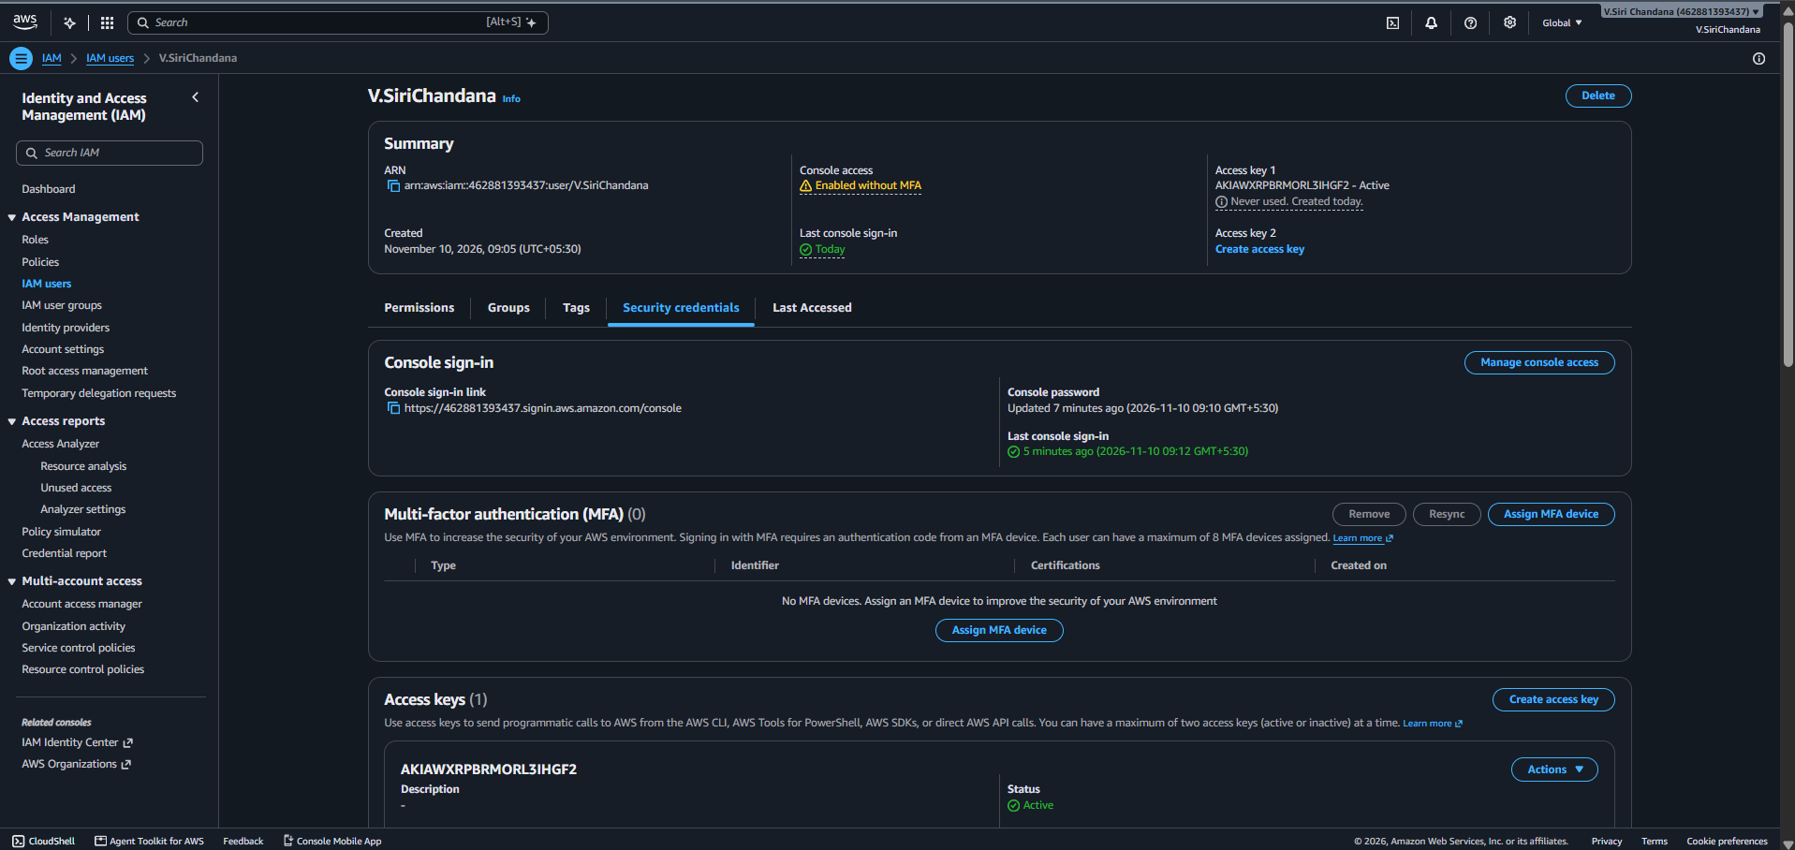

Step 14: Open Billing Preferences
Description: We are selecting Billing Preferences to configure billing notifications.

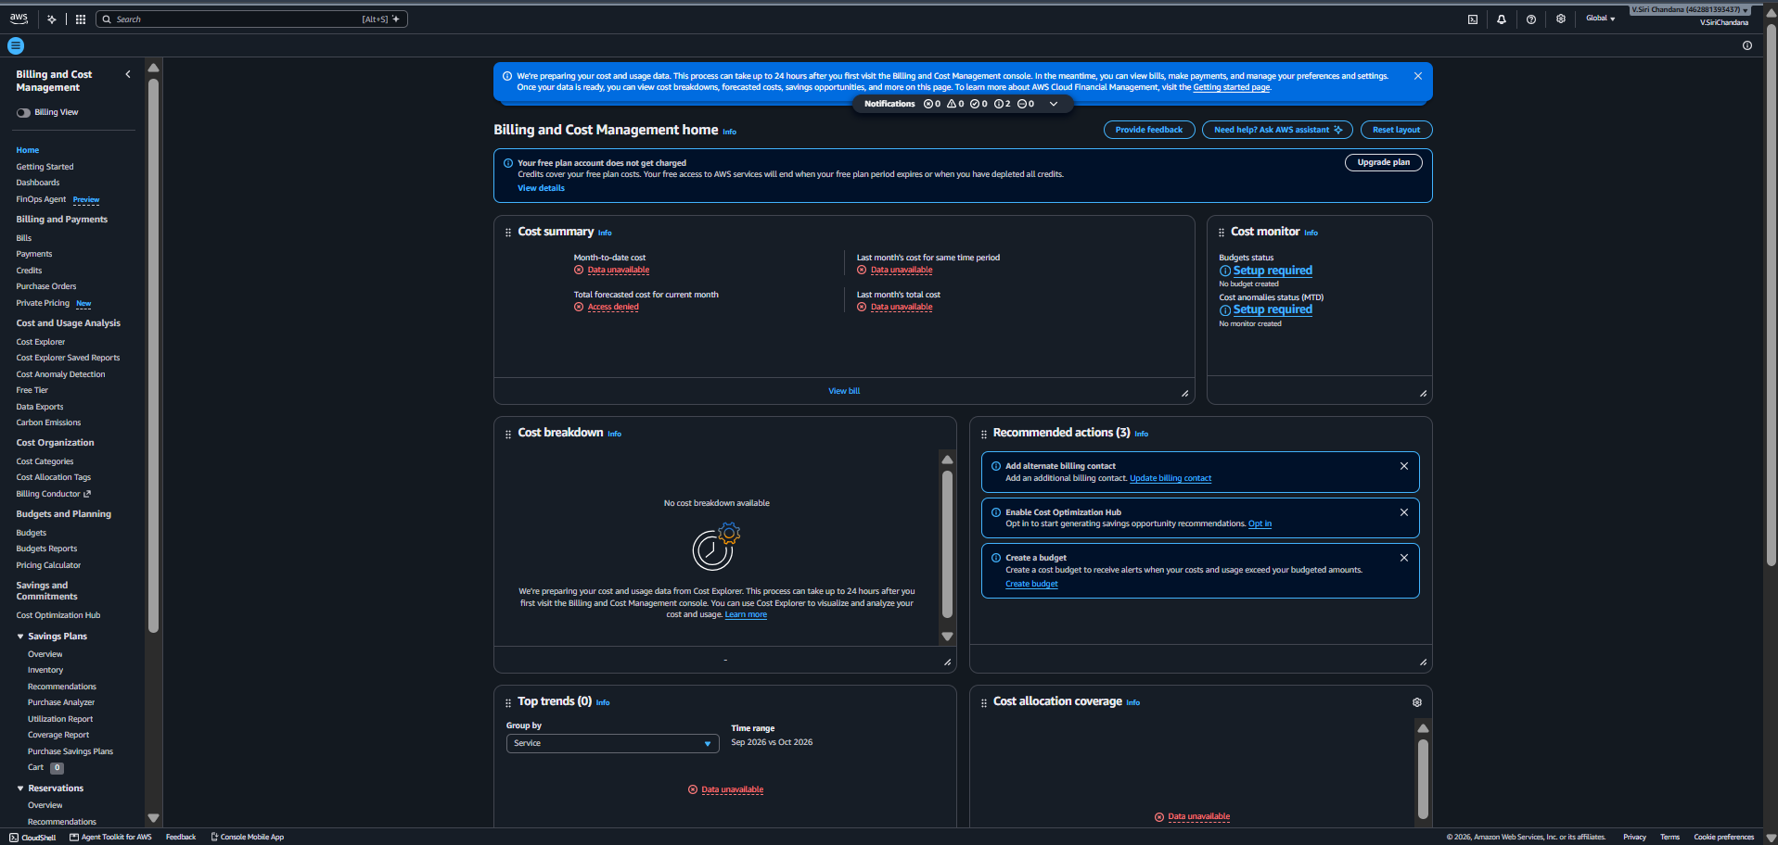

Step 15: Open AWS Budgets, Create a Budget
Description: We are opening AWS Budgets to set a spending limit for our AWS account and we are creating a budget to monitor our monthly AWS spending.

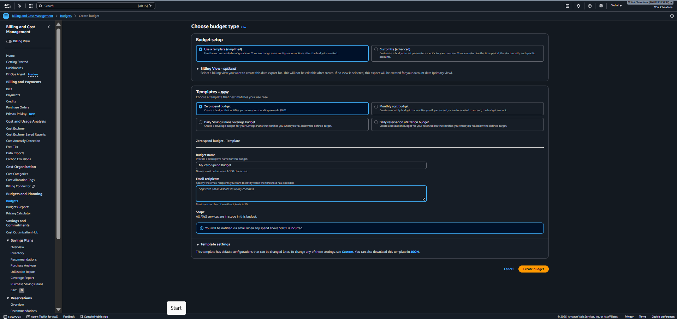

Step 16: Confirm Budget Creation
Description: We are reviewing and creating the budget to complete the billing alert setup.

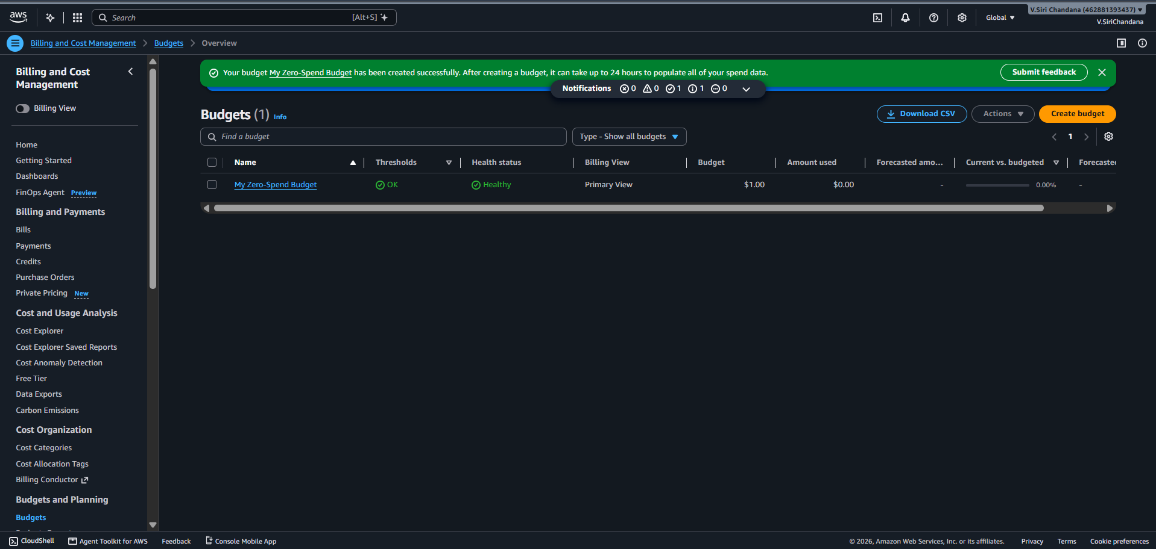
Result:
Successfully created an IAM user with programmatic access and configured AWS billing alerts to monitor usage and receive email notifications.

Here we are deleting the IAM user



