Name: V.Siri Chandana
Roll No:2520030609
Section:2
Subject:OS
Practical Problems:

1. Socketserver
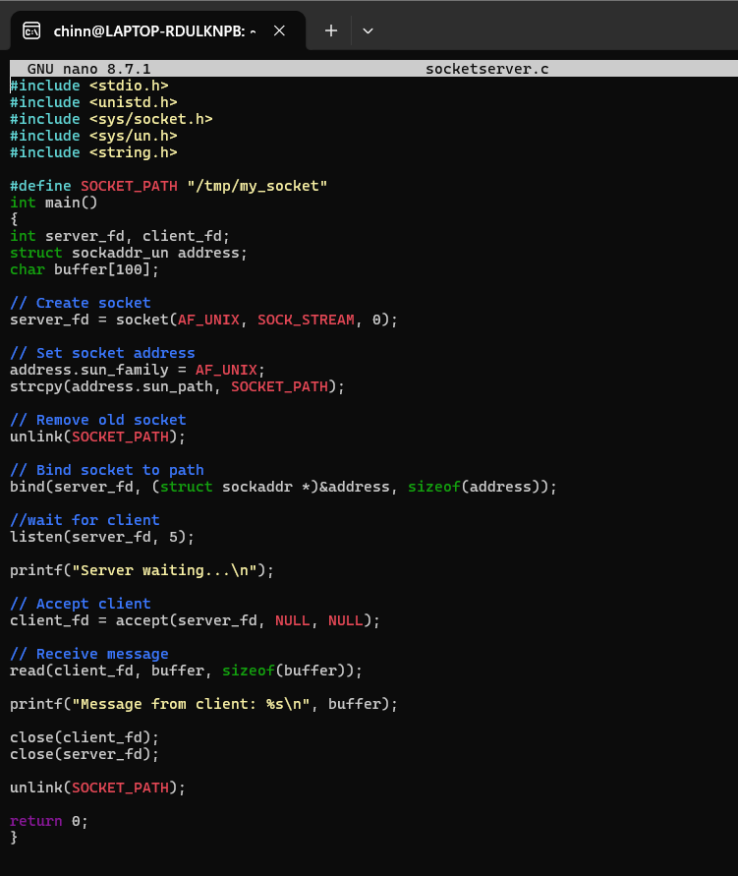
Output:

2.Socketclient

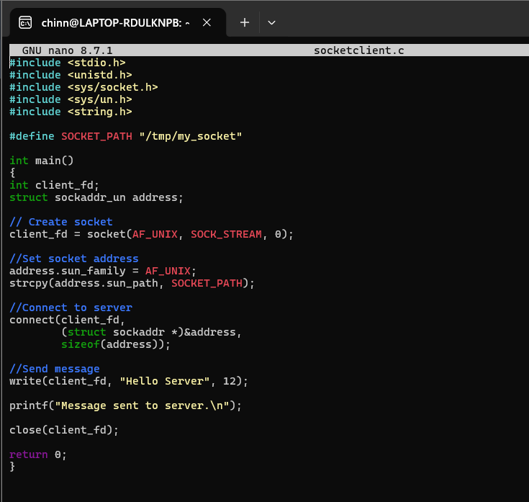

Output:

